**home.html**

<!DOCTYPE html>

<html>

<head>

<title>Space Ride</title>

<h1 style="font-family: Courier New" ><center>A Space Oddyssey</center></h1>

<img src="kurz1.jpg" alt="universe" width="1350" height="400">

</head>

<body>

<style>

table, th, td {

border: 1px solid black;

border-collapse: collapse;

}

</style>

<h2 style="font-family: Courier New">Planets</h2>

<hr>

<div style="width: 250">

<a href="mercury.html" title="mercury..."><h3><center>Mercury</center></h3></a>

<p align="center">

The smallest planet <br> in our solar system and nearest to the Sun,<br> Mercury is only slightly larger than Earth's Moon.<br>

<figure align="center">

<img src="mercury.jpg" alt="mercury" width ="200" height="200" >

<figcaption>Distance from Earth:<b>304.34 mln km</b></figcaption>

</figure>

</p>

<hr>

<a href="#" title="venus..."><h3><center>Venus</center></h3></a>

<p align="center">

Second planet from the Sun <br> and our closest planetary neighbor,<br> Venus is similar in structure and size to Earth, but it is now a very different world.<br>

<figure align="center">

<img src="venus.jpg" alt="venus..." width="200" height="200">

<figcaption>Distance from Earth:<b>354.47 mln km</b></figcaption>

</figure>

</p>

<hr>

<a href="#" title="mars..."><h3><center>Mars</center></h3></a>

<p align="center">

The fourth planet from the Sun,<br> Mars is a dusty, cold, desert world with a very thin atmosphere.

<figure align="center">

<img src="mars.jpg" alt="mars..." width="200" height="200">

<figcaption>Distance from Earth:<b>251.54 mln km</b></figcaption>

</figure>

</p>

<hr>

<a href="#" title="jupiter..."><h3><center>Jupiter</center></h3></a>

<p align="center">

Fifth in line from the Sun,<br> Jupiter is, by far, the largest planet in the solar system<br> – more than twice as massive as all the other planets combined.<br>

<figure align="center">

<img src="jupiter.jpg" alt="jupiter..." width="200" height="200">

<figcaption>Distance from Earth:<b>399.37 mln km</b></figcaption>

</figure>

</p>

<hr>

<a href="#" title="saturn..."><h3><center>Saturn</center></h3></a>

<p align="center">

Adorned with thousands of beautiful ringlets,<br> Saturn is unique among the planets.<br>

<figure align="center">

<img src="saturn.jpg" alt="saturn..." width="200" height="200">

<figcaption>Distance from Earth:<b>1.46 bln km</b></figcaption>

</figure>

</p>

<hr>

<a href="#" title="uranus..."><h3><center>Uranus</center></h3></a>

<p align="center">

Uranus is about four times wider than Earth.<br> If Earth were a large apple, Uranus would be the size of a basketball.

<figure align="center">

<img src="uranus.jpg" alt="uranus..." width="200" height="200">

<figcaption>Distance from Earth:<b>2.53 bln km</b></figcaption>

</figure>

</p>

<hr>

<a href="#" title="neptune..."><h3><center>Neptune</center></h3></a>

<p align="center">

Uranus is about four times wider than Earth.<br> If Earth were a large apple, Uranus would be the size of a basketball.

<figure align="center">

<img src="neptune.jpg" alt="neptune..." width="200" height="200">

<figcaption>Distance from Earth:<b>4.69 bln km</b></figcaption>

</figure>

</p>

<hr>

</div>

<h2 style="font-family: Courier New">To know more...</h2>

<ul>

<li><a href="aboutus.html" title="about-us">About Us</a></li>

<li><a href="#" title="missions">Space Missions</a></li>

<li><a href="#" title="ateroid">Asteroids</a></li>

<li><a href="#" title="comet">Comets</a></li>

<li><a href="#" title="interstellar">Interstellar</a></li>

</ul>

<hr>

<h2 style="font-family: Courier New">Extra Byte</h2>

<img src="ChartGo.png" alt="analysis" width="500" height="500">

<table>

<caption><b>how long is a year in solar system</b></caption>

<thead>

<tr>

<th>Planet</th>

<th>Number of Days</th>

</tr>

</thead>

<tbody>

<tr>

<td>Mercury</td>

<td>88</td>

</tr>

<tr>

<td>Venus</td>

<td>255</td>

</tr>

<tr>

<td>Earth</td>

<td>365</td>

</tr>

<tr>

<td>Mars</td>

<td>687</td>

</tr>

<tr>

<td>Jupiter</td>

<td>4333</td>

</tr>

<tr>

<td>Saturn</td>

<td>10759</td>

</tr>

<tr>

<td>Uranus</td>

<td>30687</td>

</tr>

<tr>

<td>Neptune</td>

<td>60190</td>

</tr>

</tbody>

</table>

<hr>

<ul>

<li>Contact Us:+41-67996668</li>

<li>E-mail:spaceride@gmail.com</li>

<li>Twitter:@space_ride77</li>

</ul>

</body>

</html>

**aboutus.html**

<!DOCTYPE html>

<html>

<head>

<title>Space Ride</title>

<h1 style="font-family: Courier New" ><center>A Space Oddyssey</center></h1>

<img src="kurz1.jpg" alt="universe" width="1350" height="400">

</head>

<body>

<h2 style="font-family: Courier New">About Us</h2>

<hr>

<p align="center">

Space Ride is an organization made by you and for you to know about the space above us.<br> This website 'Space Odyssey' couldn't have been possible without your <br> efforts and passion to share the knowledge about space in a consolidated way.<br> We welcome all your queries and recommendations. </p>

<hr>

<h2 style="font-family: Courier New">Address</h2>

<ul>

<li>Head Branch:45-A,Brooklyn,NY,USA</li>

<li>Local Branch:23-A,Chennai,TN,India</li>

</ul>

<hr>

<h2 style="font-family: Courier New">Wanna talk?</h2>

<ul>

<li>Contact Us:+41-67996668</li>

<li>E-mail:spaceride@gmail.com</li>

<li>Twitter:@space_ride77</li>

</ul>

<img src="2018-11-21-16_27_45-Kerbal-Space-Program.jpg" alt="spaceabove" width="1350" height="400">

</body>

</html>

**mercury.html**

<!DOCTYPE html>

<html>

<head>

<title>Mercury</title>

<h1 style="font-family: Courier New" ><center>A Space Oddyssey</center></h1>

<img src="kurz1.jpg" alt="universe" width="1350" height="400">

</head>

<body>

<h2 style="font-family: Courier New">Mercury</h2>

<hr>

<h3 style="font-family: Courier New">How old is Mercury?</h3>

<p>Mercury is expected to 4.503 billlion years old and is just about 100 million years smaller than Sun.</p><hr>

<h3 style="font-family: Courier New">What is Mercury made up of?</h3>

<p>Astronomers have estimated that the Mercury composition is made up of approximately 70% metals and 30% silicate material. In fact, it’s only slightly less dense than the Earth, with 5.43 g/cm3.</p><hr>

<h3 style="font-family: Courier New">Moons of Mercury?</h3>

<p>Error 404 not found</p><hr>

</body>

</html>

**home.html**

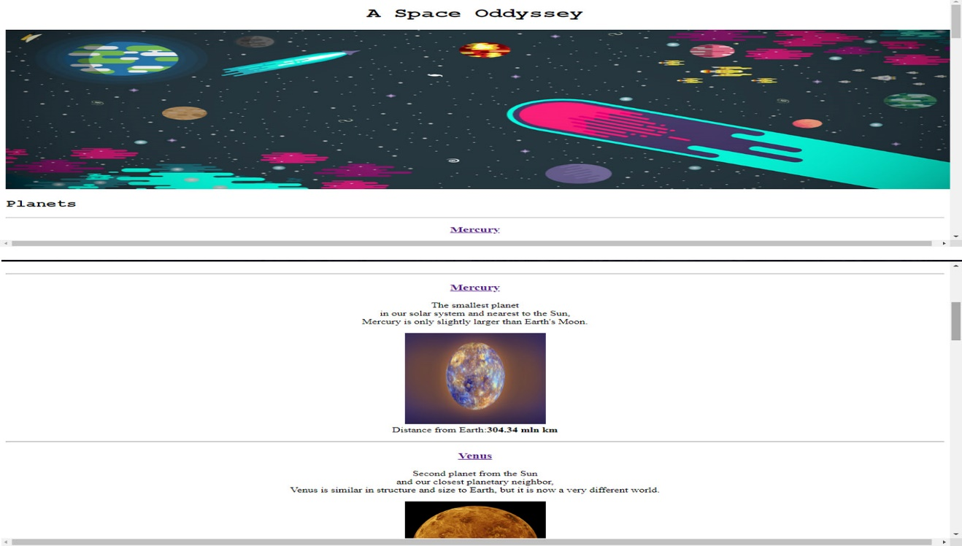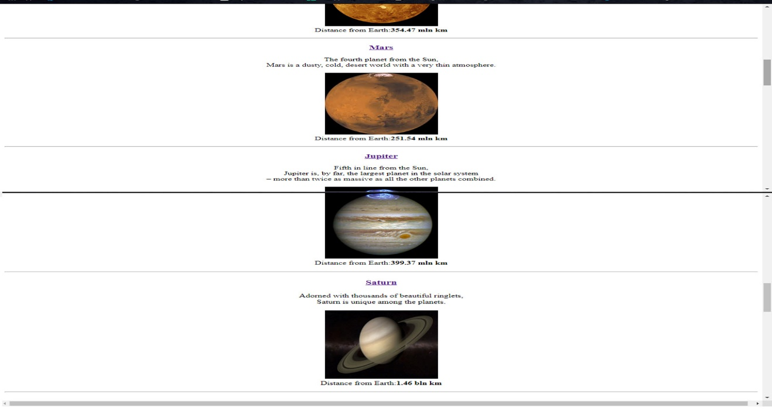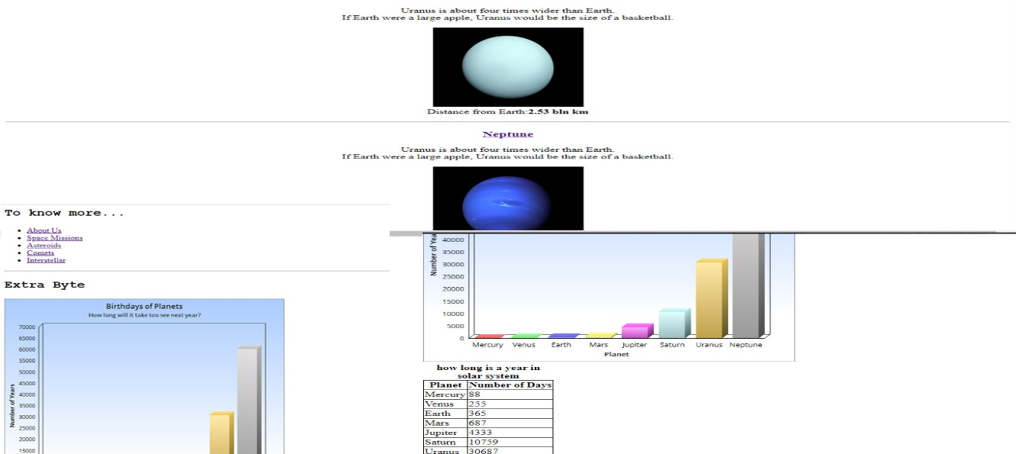

**mercury.html**

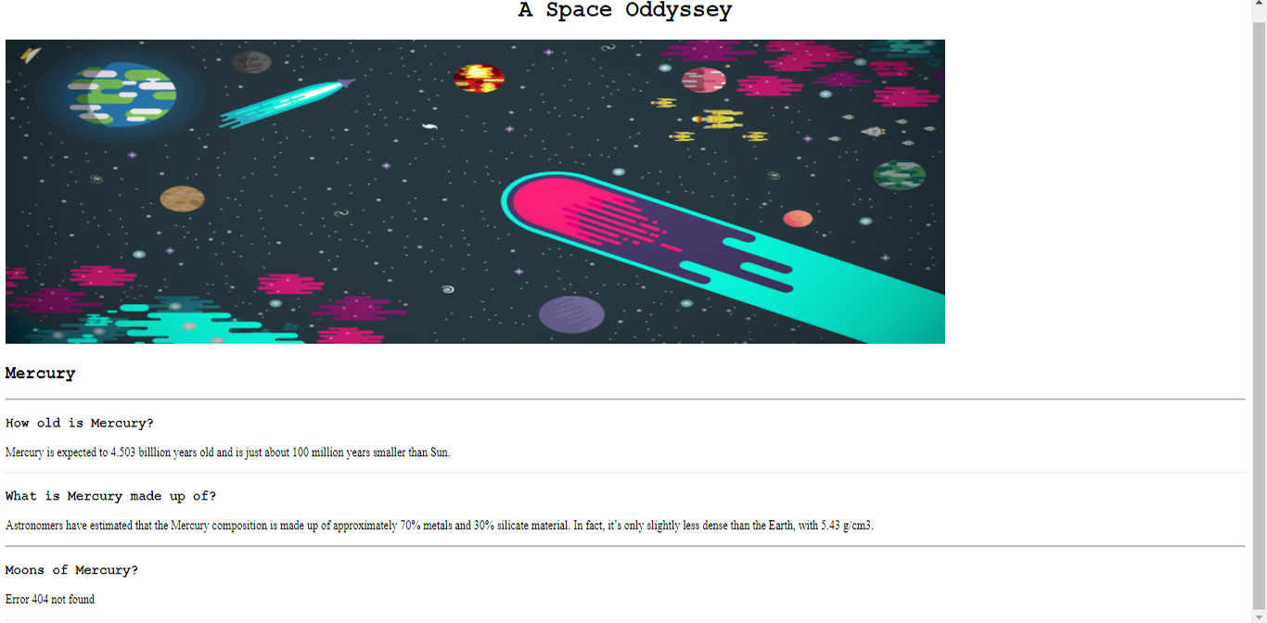

**aboutus.html**

