Assignment 5 :
One Jenkins-Master and three Slaves (1, 2 and 3)
One repo with three branches – master , 2026Q1, 2026Q2
Slave 1 fetches the index file from the master branch
Slave 2 fetches the index file from the 2026Q1 branch
Slave 3 fetches the index file from the 2026Q2 branch

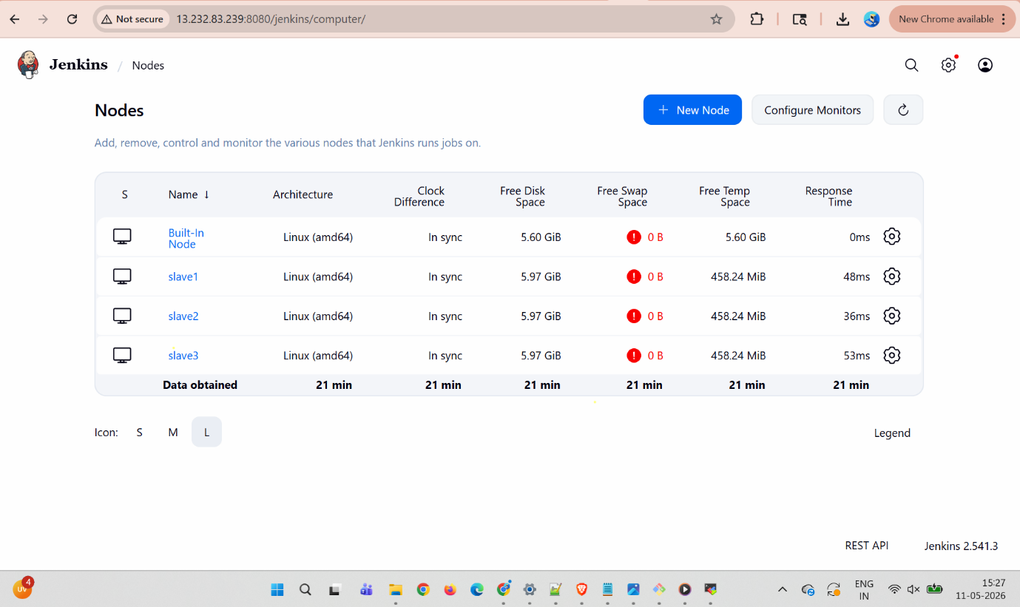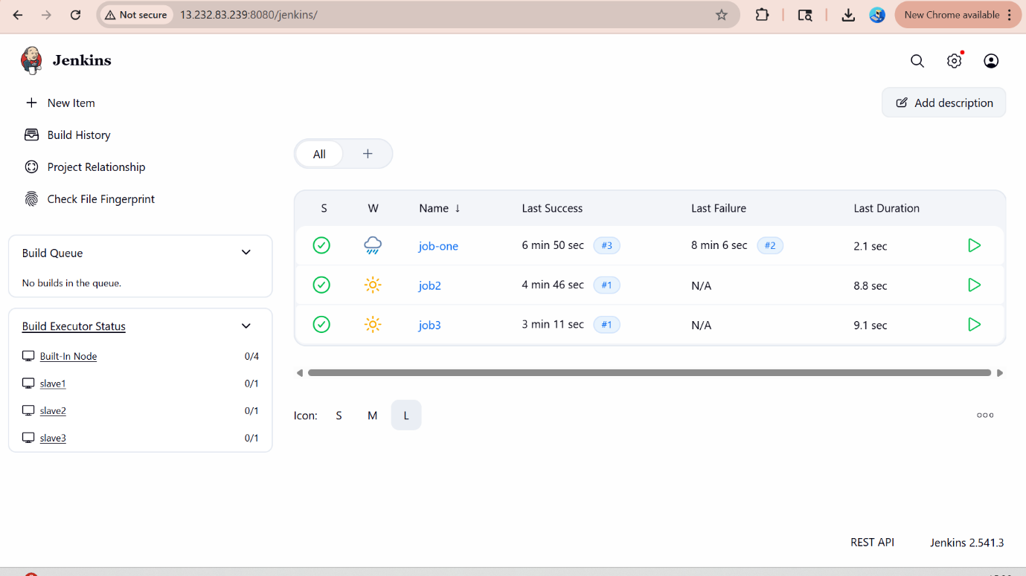
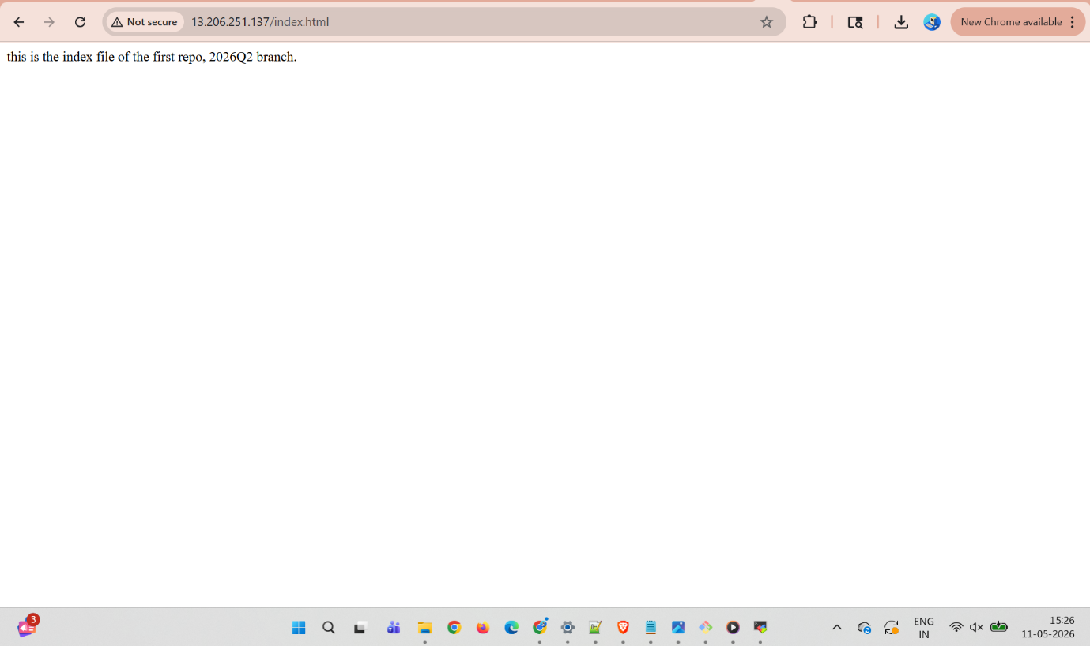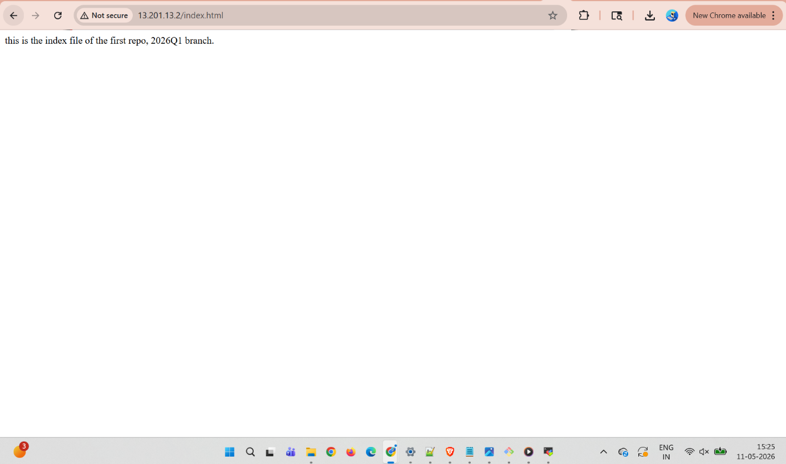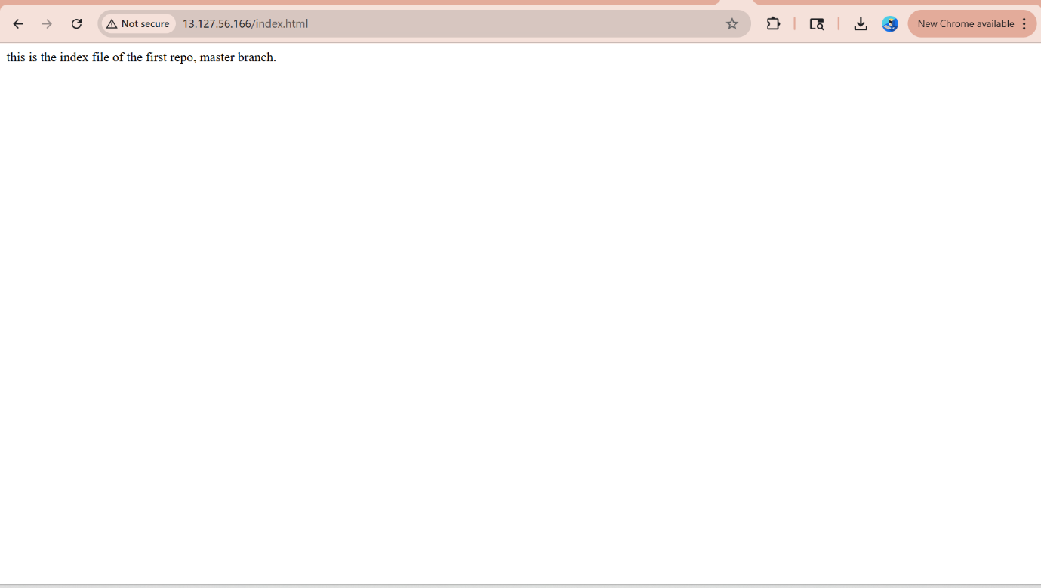

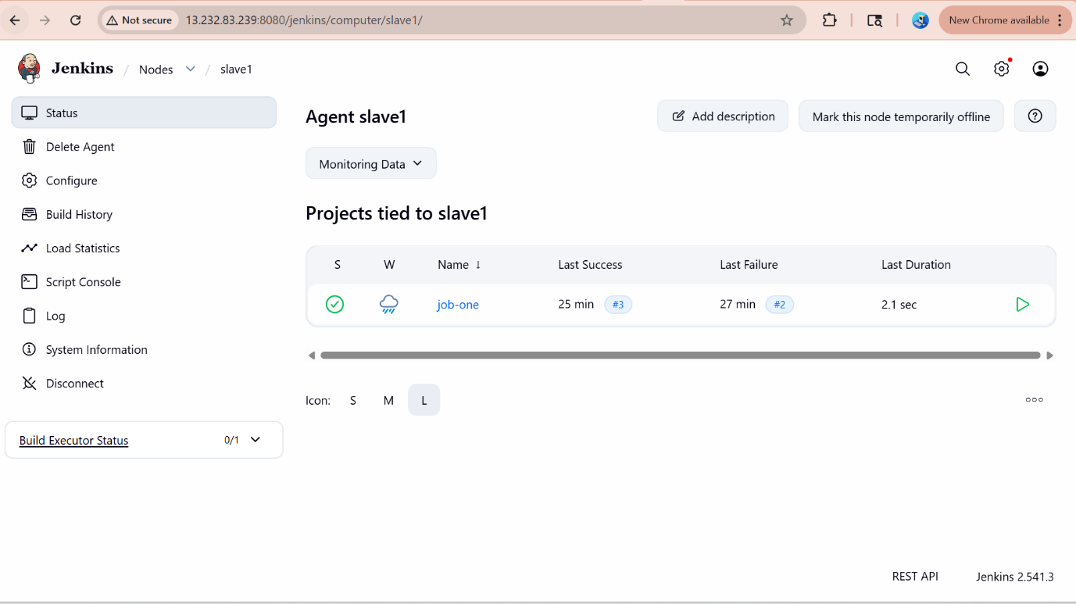

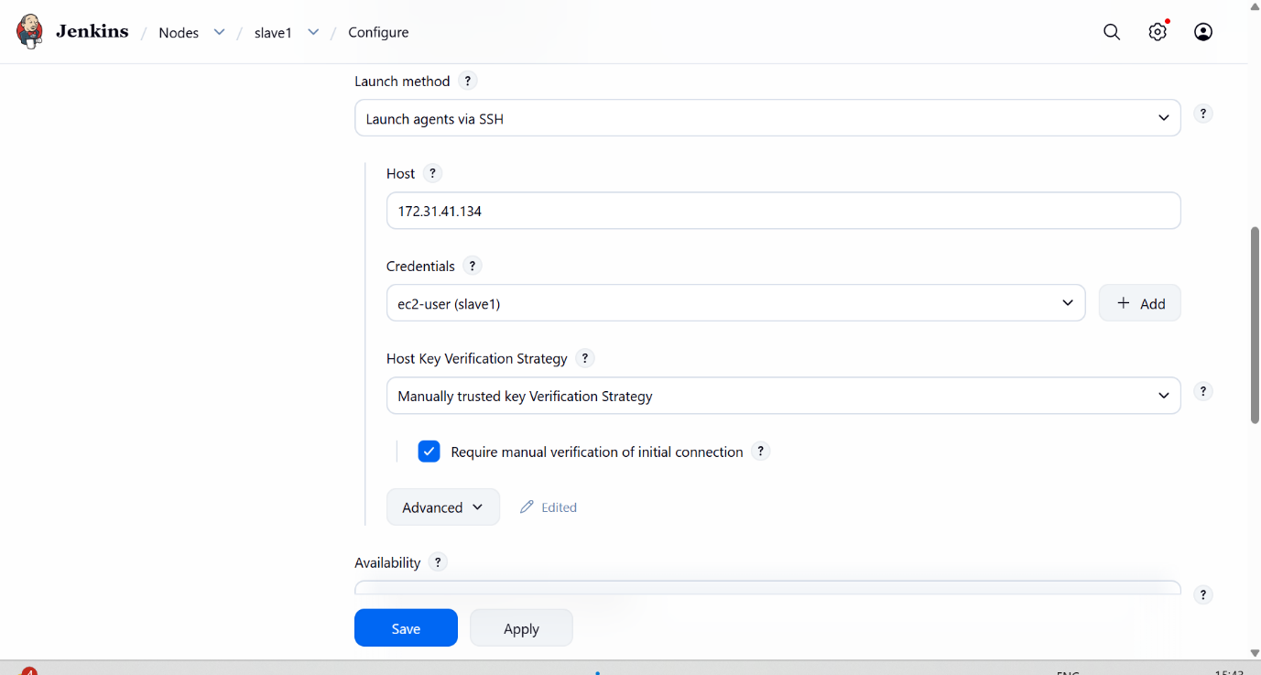

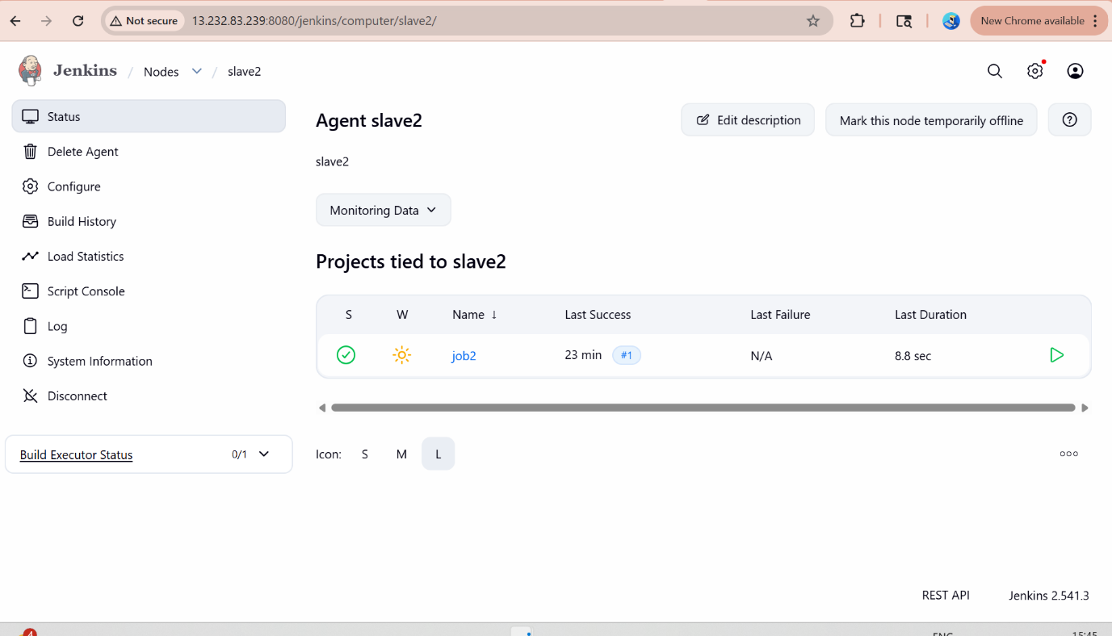

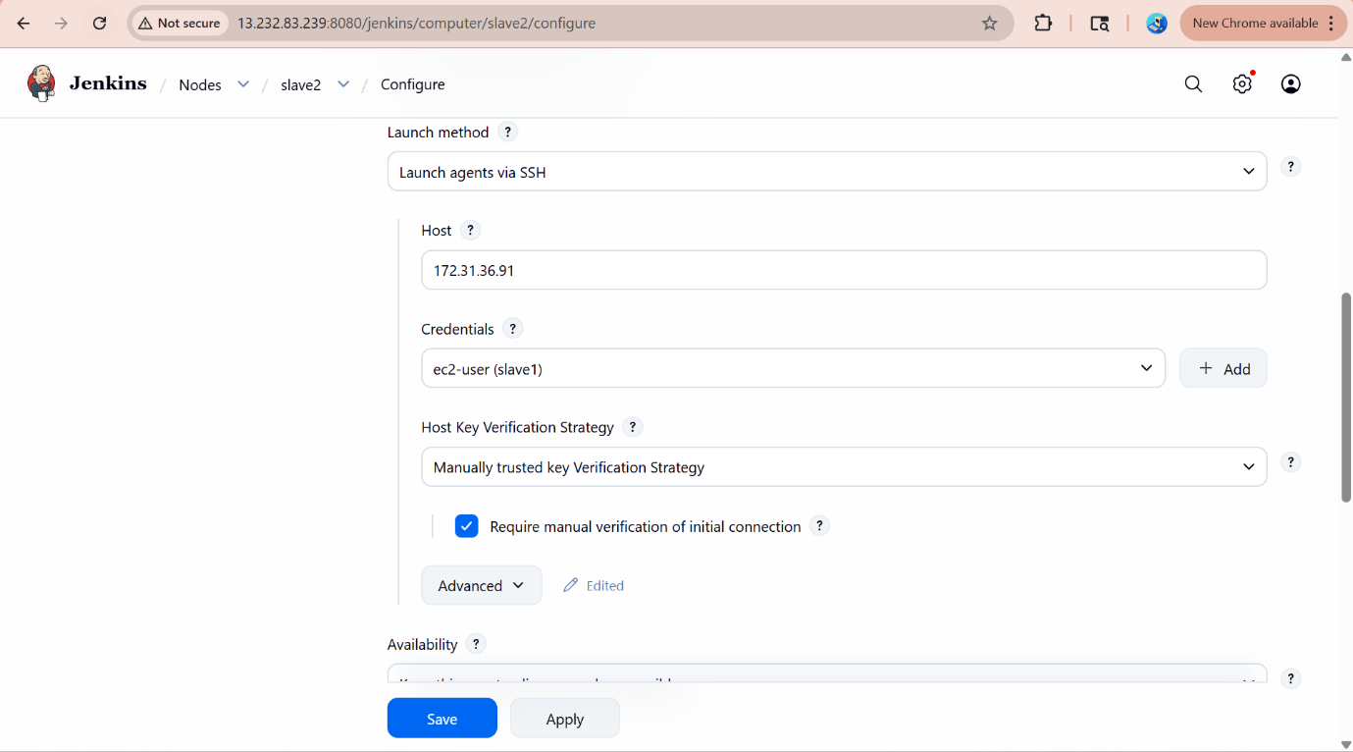

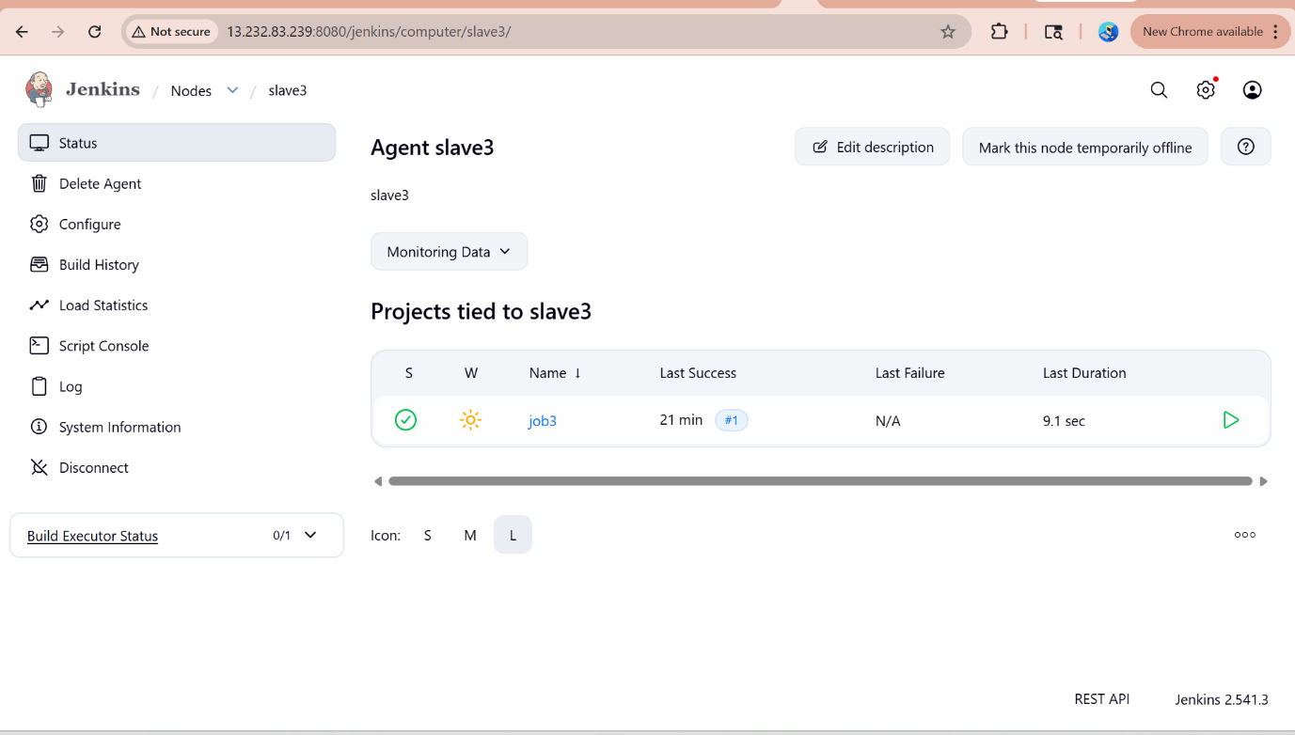

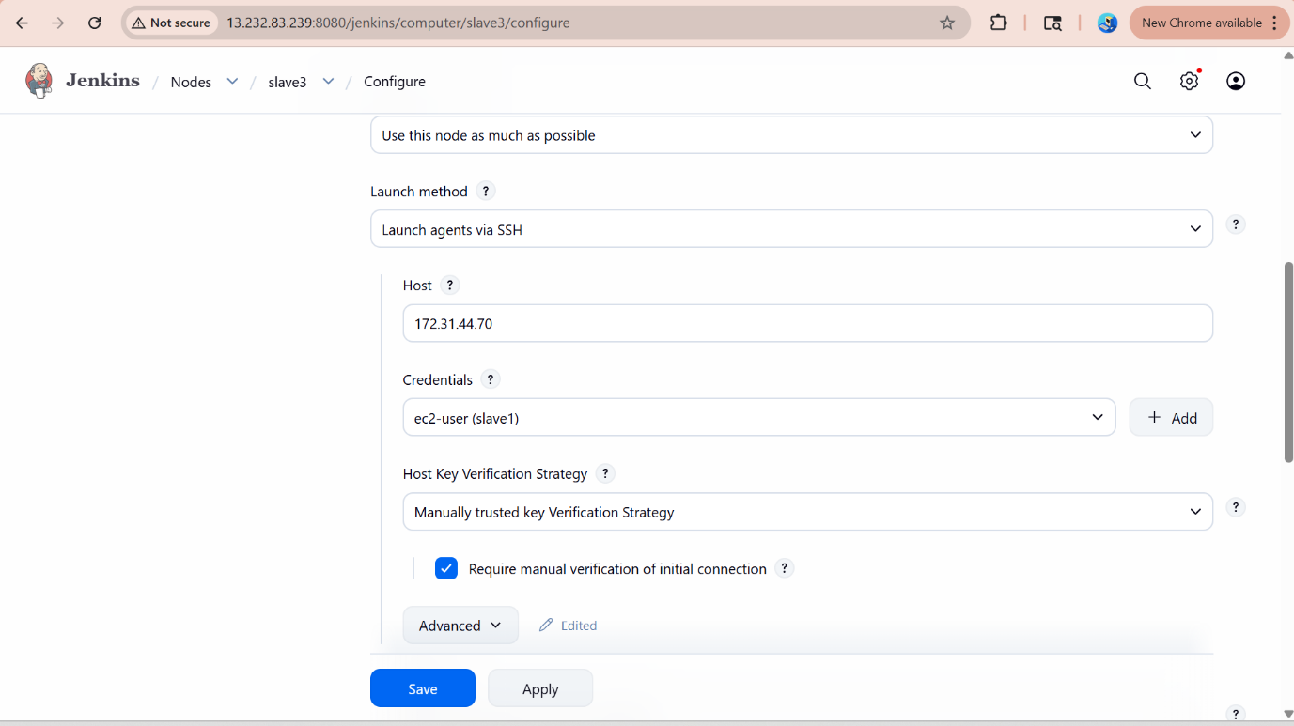History for the jenkins master

Last login: Mon May 11 09:47:13 2026 from 103.30.66.157
[ec2-user@ip-172-31-45-18 ~]$ sudo su -
Last login: Mon May 11 09:47:16 UTC 2026 on pts/3
[root@ip-172-31-45-18 ~]# history
1 yum list java-17*
2 yum install java-17-amazon-corretto.x86_64 -y
3 yum install git
4 cd /mnt
5 mkdir servers
6 cd servers/
7 wget https://dlcdn.apache.org/tomcat/tomcat-10/v10.1.54/bin/apache-tomcat-10.1.54.zip
8 unzip apache-tomcat-10.1.54.zip
9 rm -rf apache-tomcat-10.1.54.zip
10 chmod -R 777 apache-tomcat-10.1.54/
11 cd apache-tomcat-10.1.54/
12 cd webapps/
13 ls -ltr
14 wget https://get.jenkins.io/war-stable/2.541.3/jenkins.war
15 cd ..
16 cd bin
17 ls -ltr
18 ./startup.sh
19 cd
20 ls -lart
21 logout
22 ls -lart
23 cd .jenkins
24 ls -ltr
25 cd secrets/
26 cat initialAdminPassword
27 history

