Jenkins Assignment – 2
Task – Three repos will have three index.html files on them and the Jenkins master will have an httpd server installed on it. Task is to run the jobs and with each job deploy index.html from each repo. When one index.html file is deployed the earlier one should be deleted.

- Cloned the repos and created index.html files inside all tree repos
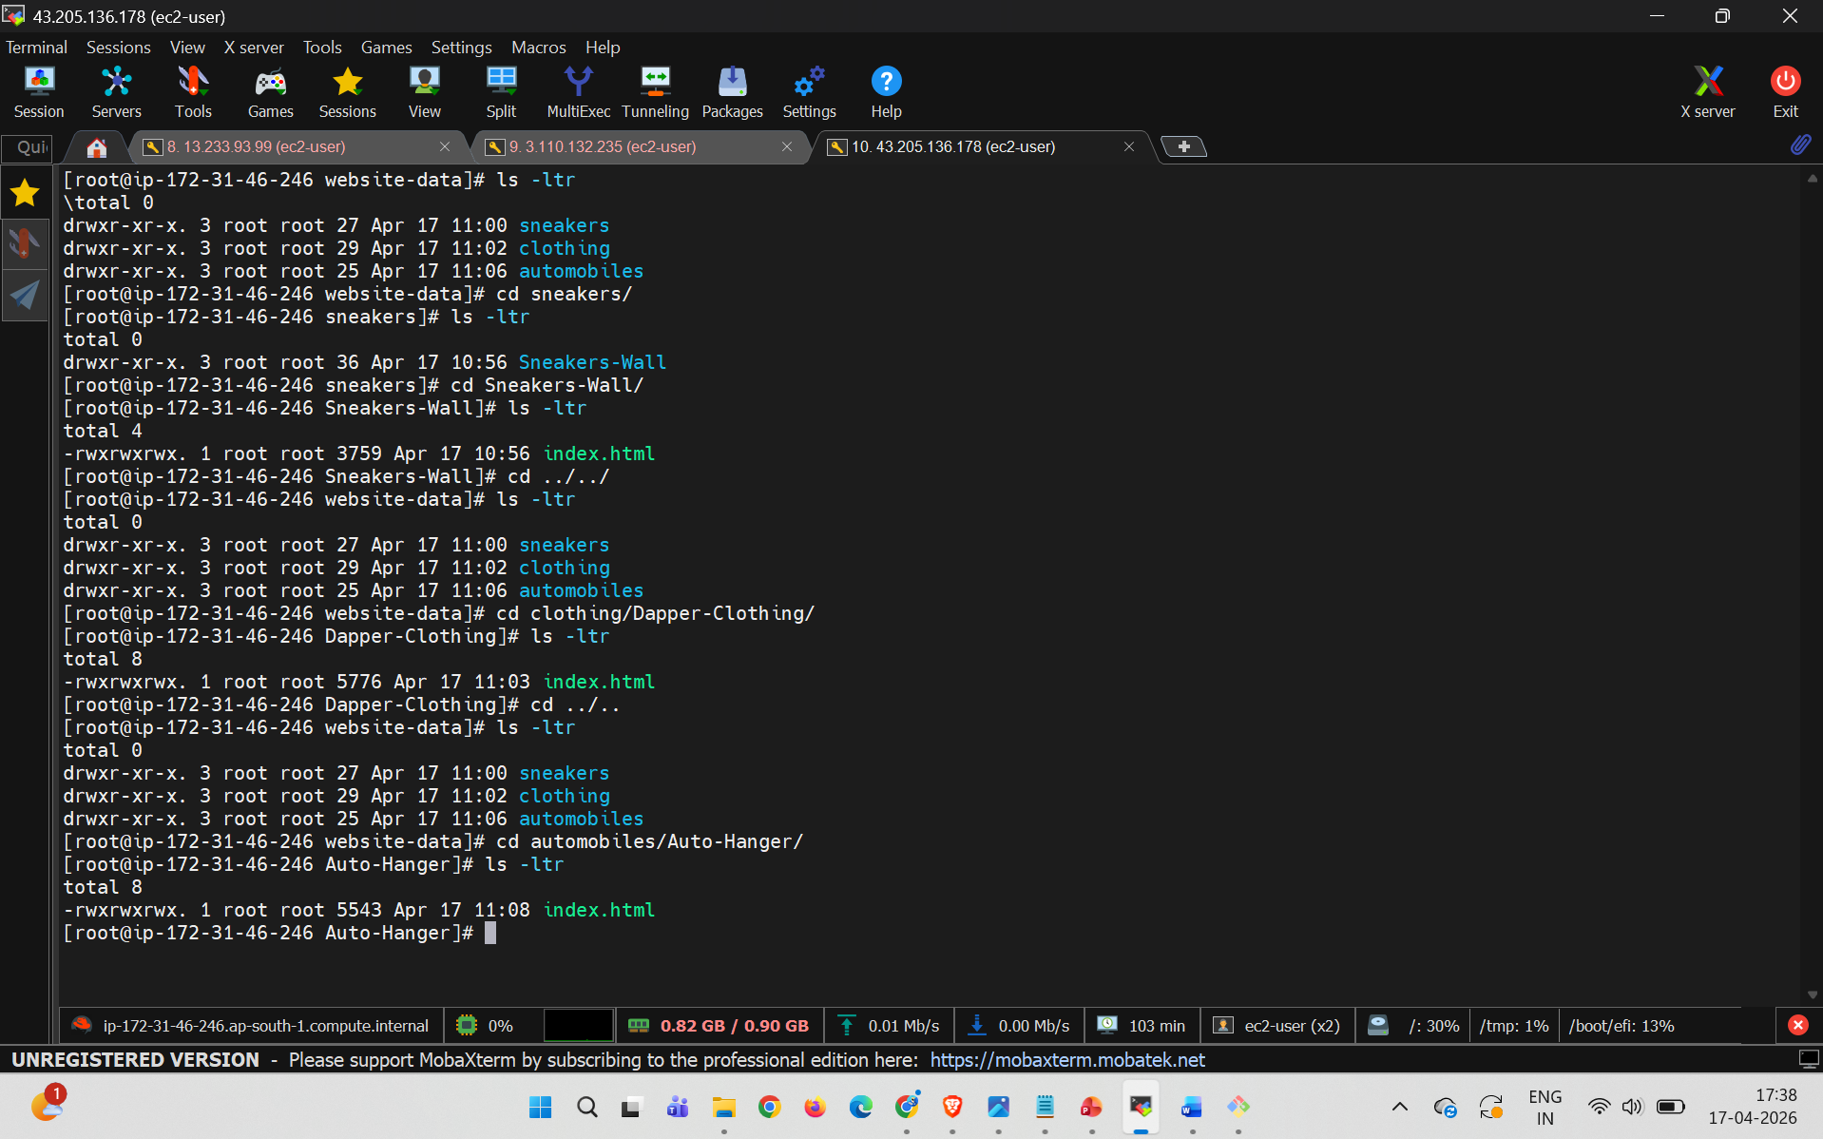

- Created 3 separate jobs with executable scripts to deploy
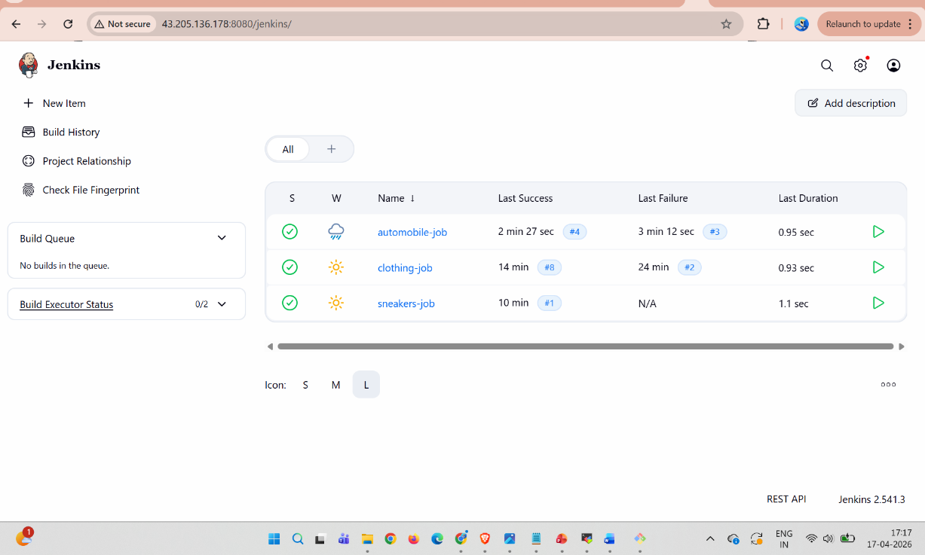
- Configured the git repos in the jenkins
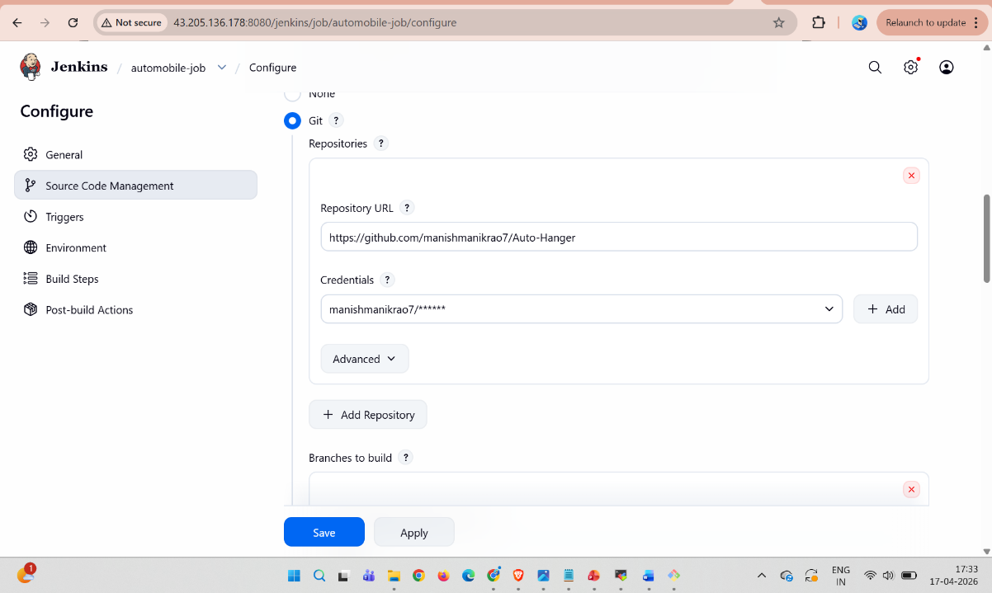
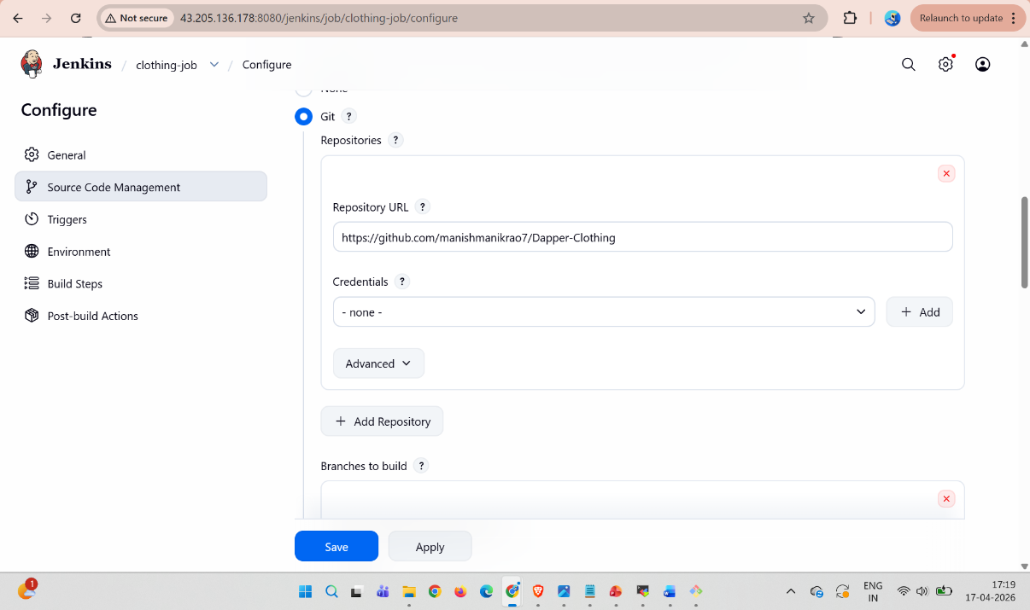
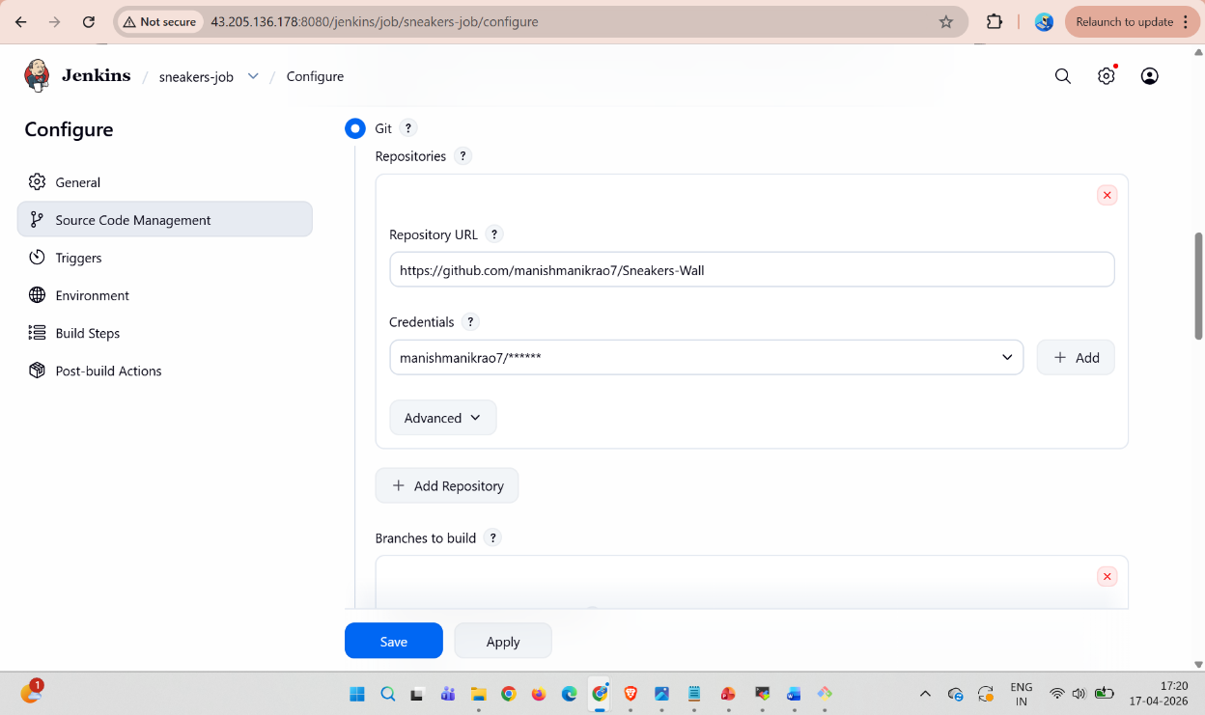

- Scripts to run the tasks on the Jenkins console for all the jobs
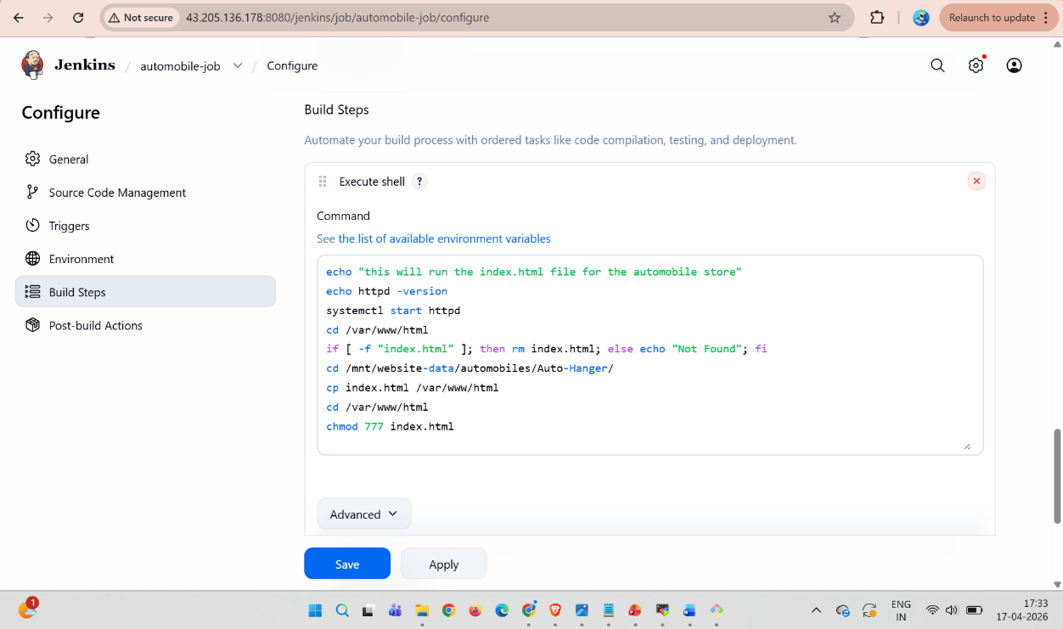
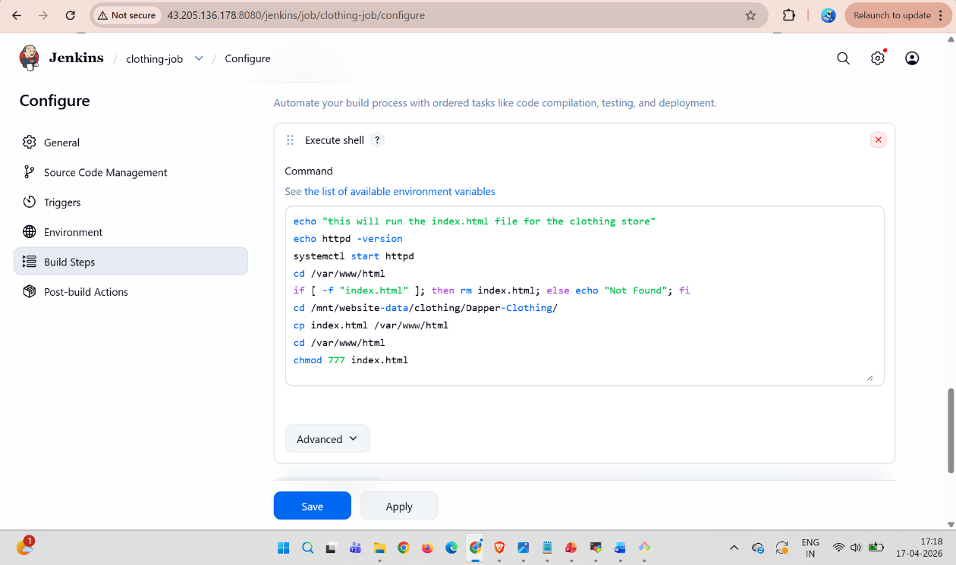
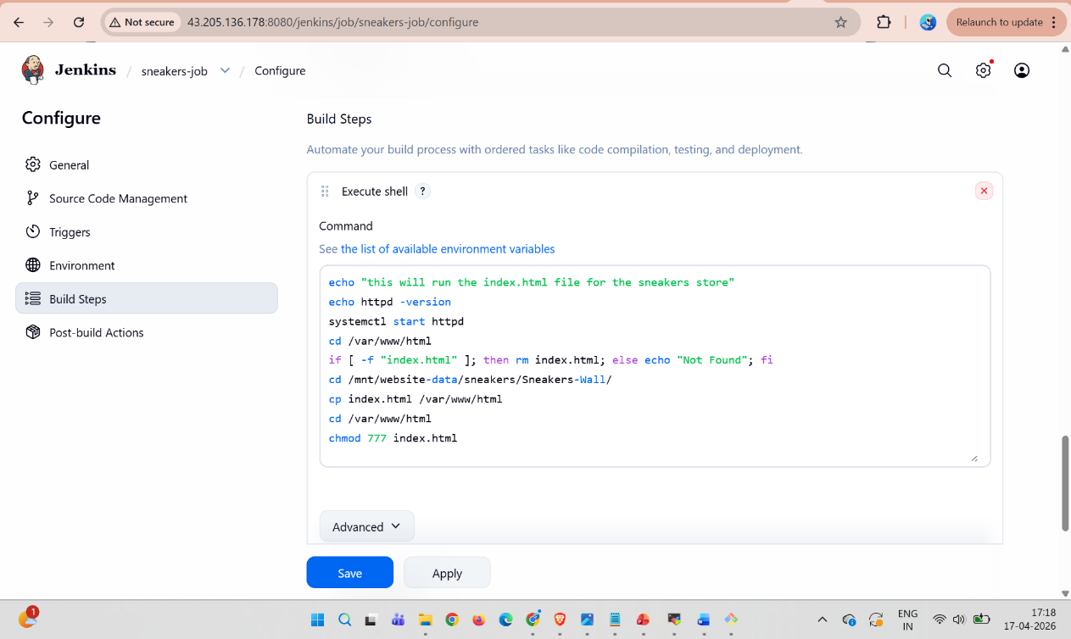

- The Index.html can be accessed while each job is running
