Q1. Write a shell program to find whether a given year is a leap year or not.

Solution:-

```
#!/bin/bash
echo "Enter the year: "
read year

if [ $((year % 4)) -eq 0 ] && [ $((year % 100)) -ne 0 ] || [ $((year % 400)) -eq 0 ]; then
echo "$year is a leap year."
else
echo "$year is not a leap year."
fi
```

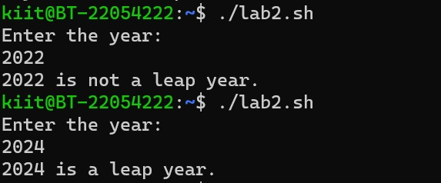

Q2. Write a shell program to find greatest among three numbers.

Solution:-

```
#!/bin/bash

echo "Enter three numbers separated by spaces:"
read num1 num2 num3

if [ $num1 -gt $num2 ] && [ $num1 -gt $num3 ]; then
echo "$num1 is the greatest."
elif [ $num2 -gt $num1 ] && [ $num2 -gt $num3 ]; then
echo "$num2 is the greatest."
else
echo "$num3 is the greatest."
Fi
```

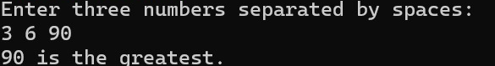

Q3. Write a shell program to display the prime number between 1 and hundred.

Solution:-

```
#!/bin/bash

echo "Prime numbers between 1 and 100 are:"
for (( num=2; num<=100; num++ )); do
is_prime=true
for (( i=2; i<=$num/2; i++ )); do
if [ $((num%i)) -eq 0 ]; then
is_prime=false
break
fi
done
if $is_prime; then
echo $num
fi
Done
```

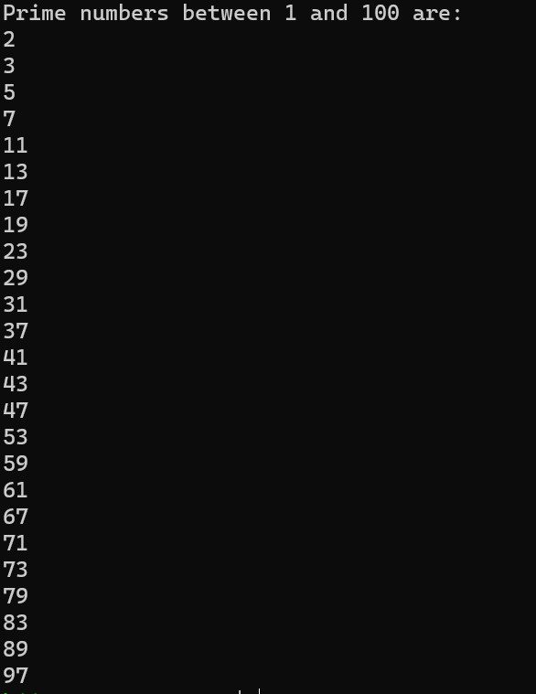

Q4. Execute the “ps -ef” and “ps -ux” command. Write a shell program that takes
the output of these two commands and display the detail about a process
whose parent id is 2. The detail about a process will be shown as it is shown
during the execution of “ps -ux” command.
Solution:-
```
#!/bin/bash
ps_ef_output=$(ps -ef)
ps_ux_output=$(ps -ux)
parent_id_2_details=$(echo "$ps_ux_output" | awk '$3 == 2')
echo "Output of ps -ef:"
echo "$ps_ef_output"
echo -e "\nOutput of ps -ux:"
echo "$ps_ux_output"
echo -e "\nDetails about processes with parent ID 2:"
echo "$parent_id_2_details"
```

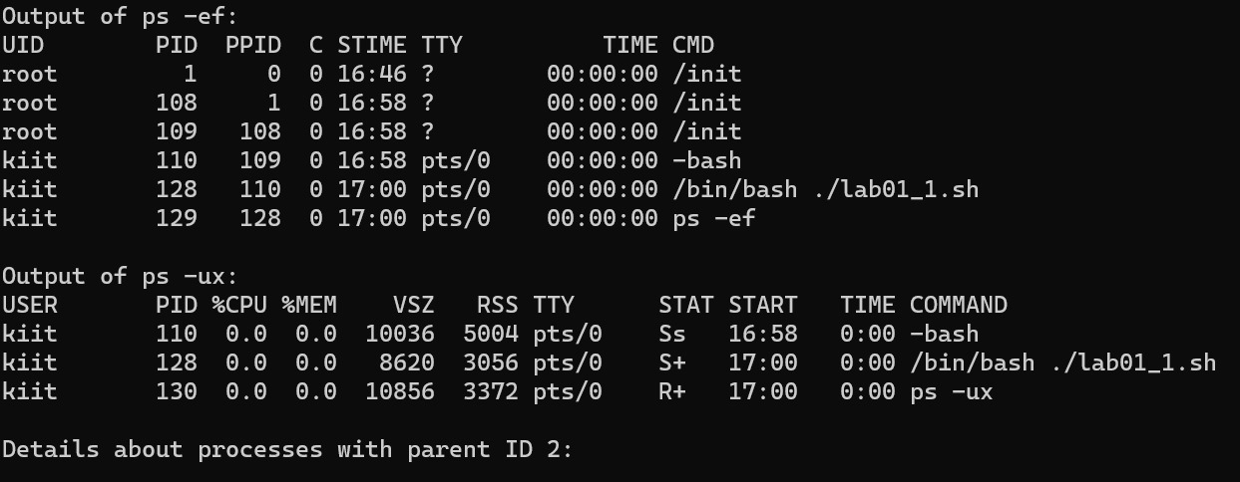

Q5. Write a shell script to extract the data from the date command, and display the result in numerical form with 12 hour format. (if the date command gives
“Thu Jan 2 14:21:54 IST 2014” then display the result in “02/01/2014/2:21:54
PM”)

Solution:-
```
#!/bin/bash
formatted_date=$(date +"%m/%d/%Y/%I:%M:%S %p")
echo "Formatted Date: $formatted_date"
```

Q6. Let a directory present in the home directory called “XYZ” that consists of
few files and directories. Write a shell script to move all the files present in the

“XYZ” directory to a subdirectory called “MyFile” and all the subdirectories
present in the “XYZ” directory to a subdirectory called “MyDir”.

```
Solution:-
#!/bin/bash

directory_path=~/XYZ
mkdir -p "$directory_path/MyFile"
mkdir -p "$directory_path/MyDir"

find "$directory_path" -maxdepth 1 -type f -exec mv {} "$directory_path/MyFile/" \;

find "$directory_path" -maxdepth 1 -type d -exec mv {} "$directory_path/MyDir/" \;

echo "Files moved to MyFile, and directories moved to MyDir."
```

