1.By seeing the Bar chat of profits an category we can find one that “Furniture” is getting less profits compared to other to categories “Technology, Office Supplies ”

Here, the question raises what are cause? What are the factors invovled in getting less profits in “Furniture” category.
Region:-There the four region in this data (Central, East , South , West).
Question 1:-Do the region invovled in getting profits margin ?
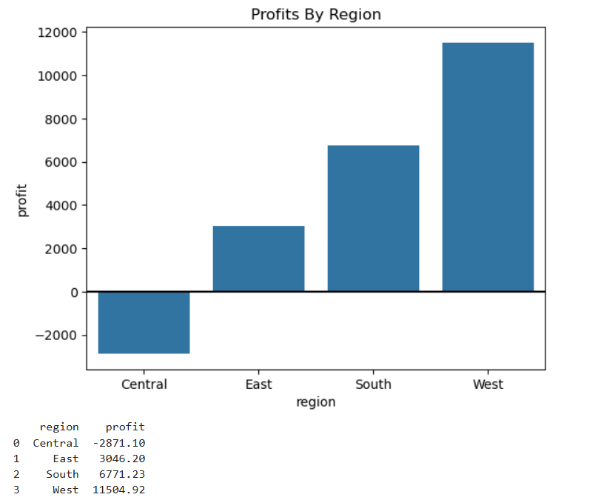
Now, we can see clearly that the “CENTRAL” region is getting heavy losses comapared to other region.

Question 2:- Do that Central region giving same outcome for category?
Now this answere that only the furniture is giving us losses in Central Region?
1.We can see completely the region is invovled into.
2.Region alone don’t gives the losses there should be another feature that’s hiding.

Discount:-Yes, discount is invovled in this losses in Central region.giving more discount getting more losses.
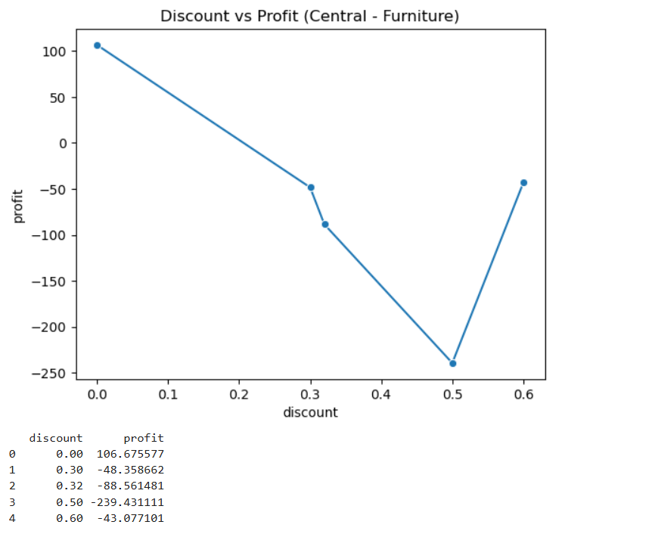
What we can do here?
Reduce the Discount and make a deal we the supplyer to reduce the buying cost .

