2) a)filter Design Pattern

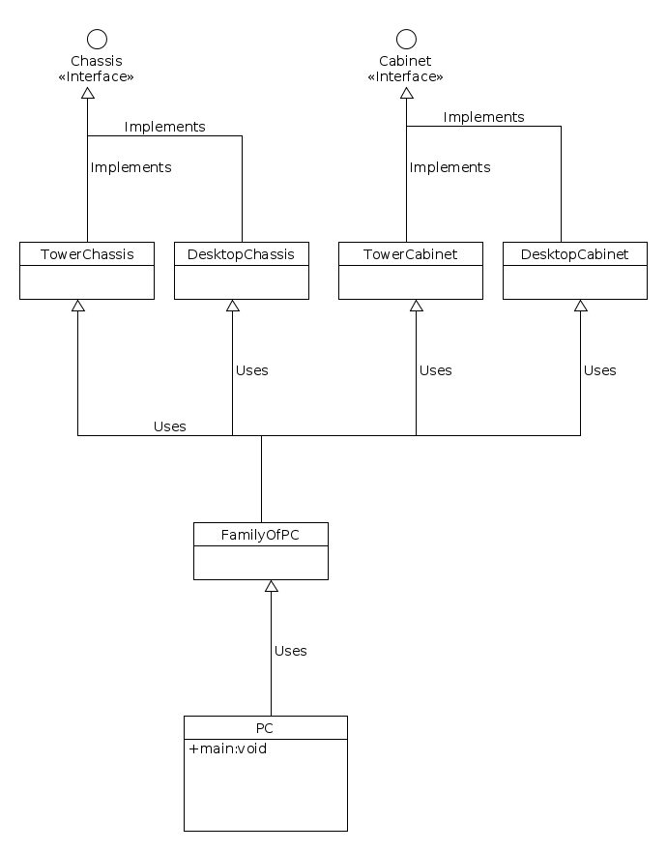

2) b)

interface Chassis{

//may or may not have variable and methods

}

interface Cabinet{

//may or may not have variable and methods

}

class TowerChassis implements Chassis{

// implements Chassis methods and have Tower members

}

class DesktopChassis implements Chassis{

//implements Chassis methods and have Desktop members

}

class TowerCabinet implements Cabinet{

//implements Cabinet methods and have Tower members

}

class DesktopCabinet implements Cabinet {

//implements Cabinet methods and have Desktop members

}

class FamilyOfPC{

getTowerChassis(){

return new TowerChassis();

}

getTowerCabinet(){

return new TowerCabinet();

}

getDesktopChassis(){

return new DesktopChassis();

}

getDesktopCabinet(){

return new DesktopCabinet();

}

}

class PC {

main(){

FamilyOfPC pc= new FamilyOfPC();

Chassis towerChassis = pc.getTowerChassis();

}

}