Question 1: Find out the mail servers of the following domain :

We will find the mail server using mx command.
- Ibm.com
- Wipro.com

WWW.IBM.COM

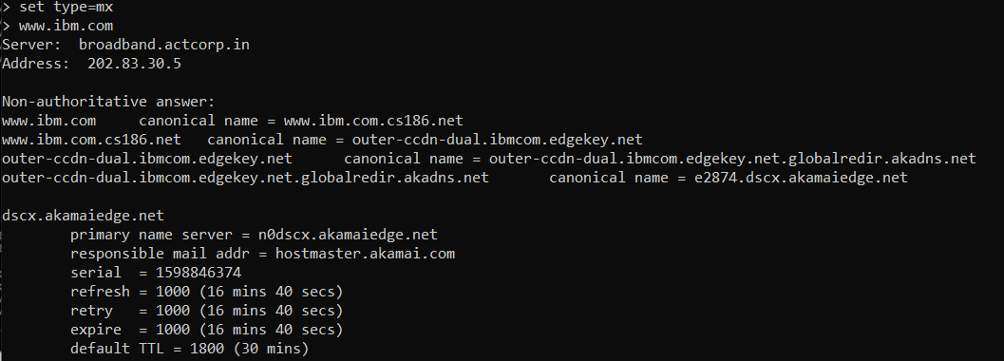

WWW.WIPRO.COM

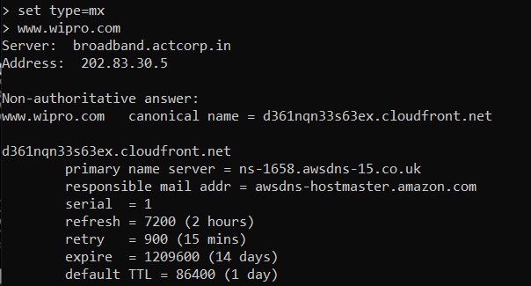

Question 2: Find the locations, where these email servers are hosted.

Wipro.com

Country | United States
Organization | Amazon CloudFront
ISP | Amazon CloudFront
Last Update | 2020-08-28T06:20:41.107675
Hostnames | server-13-225-146-94.lax3.r.cloudfront.net
ASN | AS16509

Ibm.com
Country | United States
Organization | Akamai Technologies
ISP | Akamai Technologies
Last Update | 2020-08-31T02:43:35.128126
Hostnames | a23-41-40-215.deploy.static.akamaitechnologies.com
ASN | AS2914

Question 3: Scan and find out port numbers open 203.163.246.23

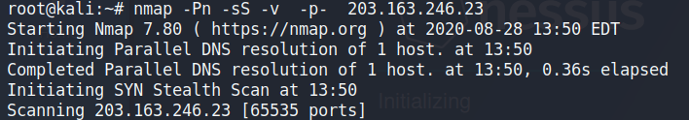

Question 4: Install nessus in a VM and scan your laptop/desktop for CVE.

