VPC-Task02

1. Create one VPC with 1 private subnet and 1 public subnet.

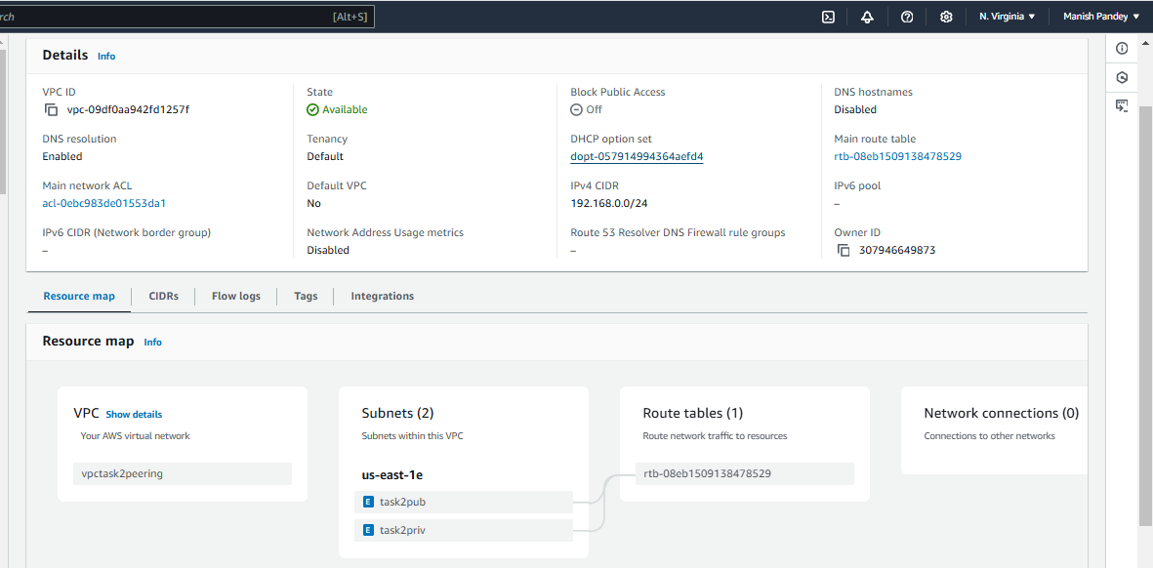

1. Enable VPC peering for cross region.

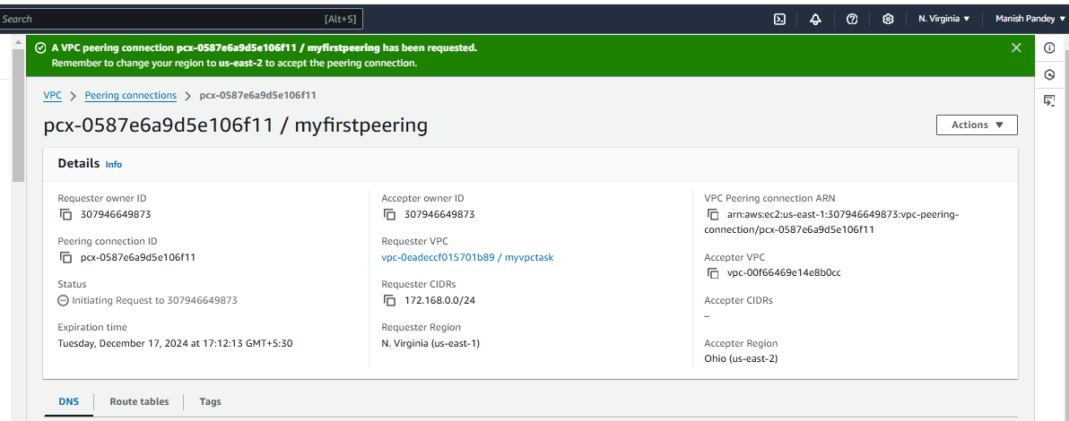

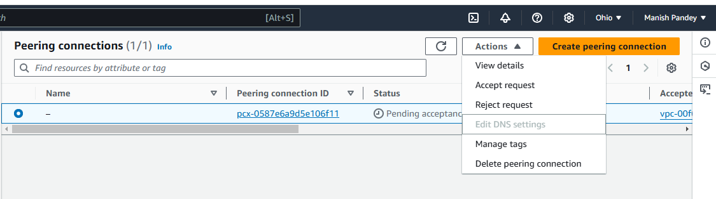

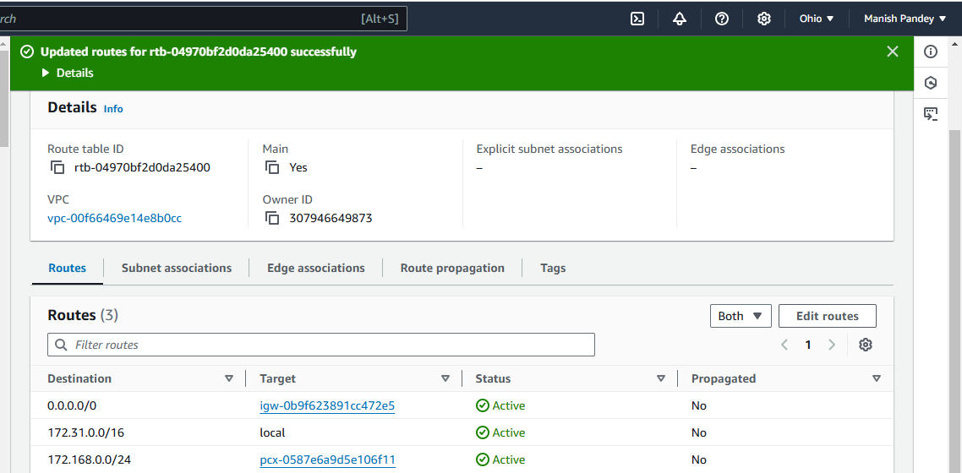

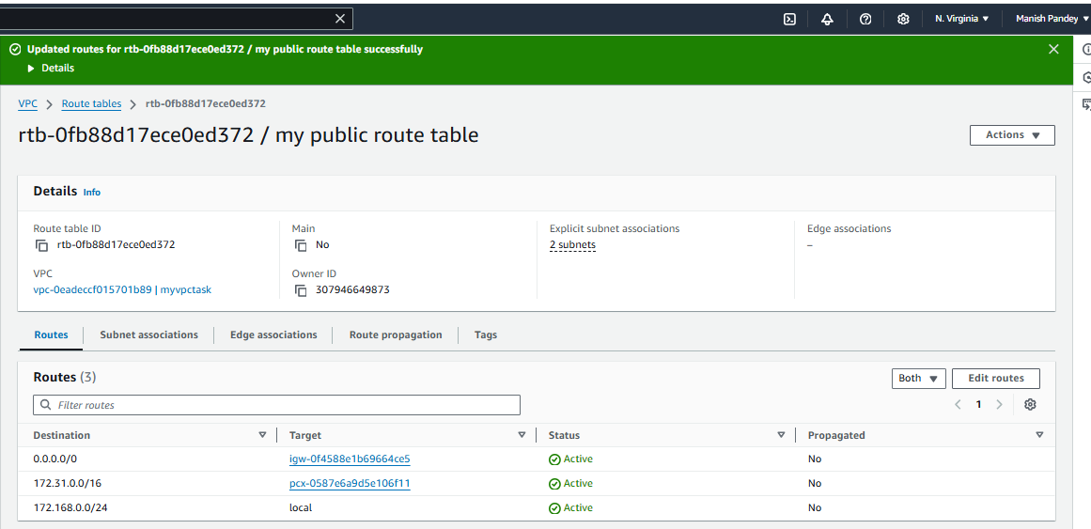

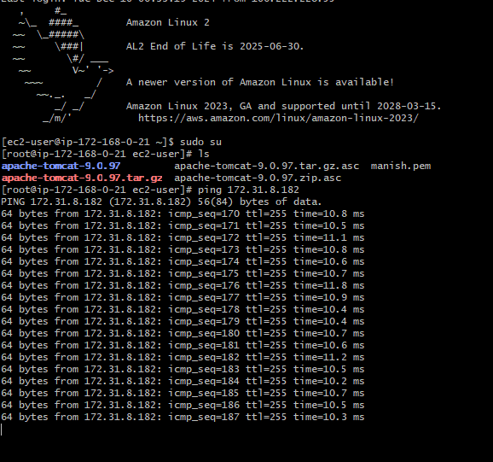

1. Enable VPC peering for cross account.

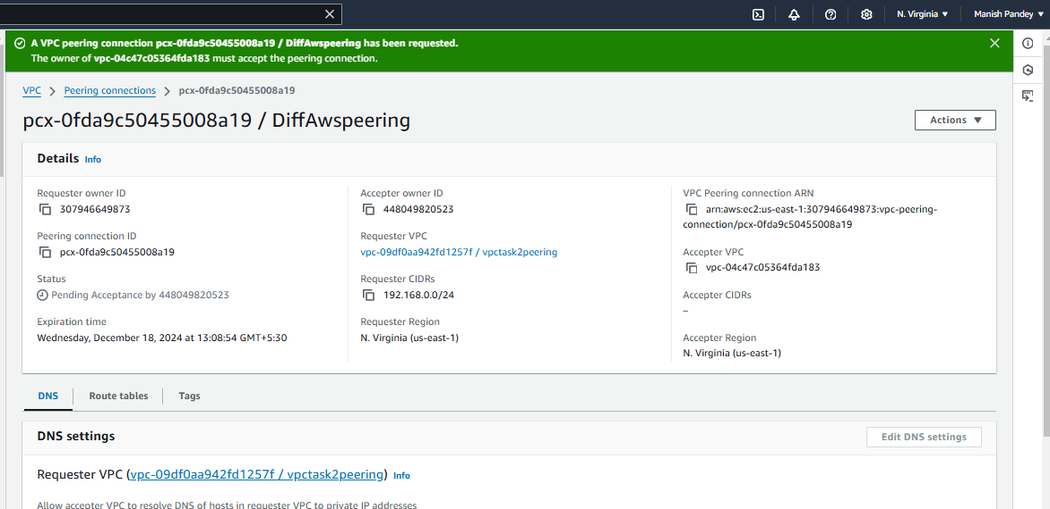

1. Setup VPC transit gateway.

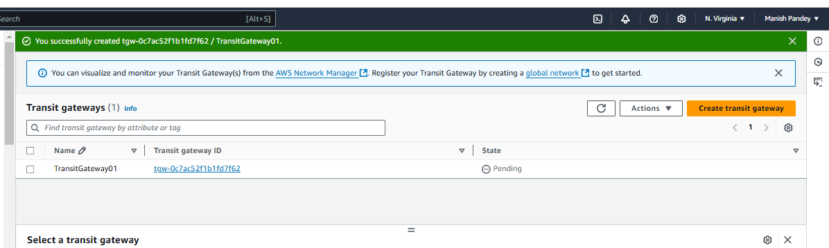

Created transit gateway attachments for 3 VPCs

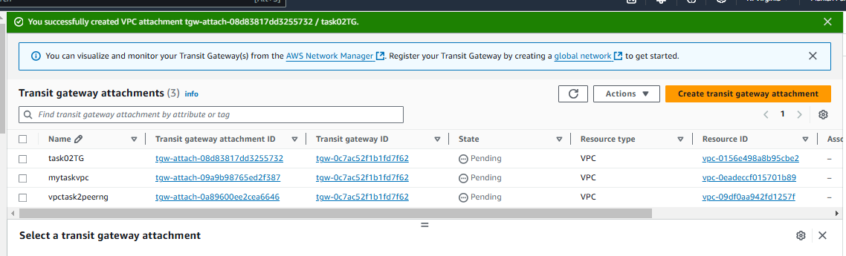

Transait route table created with vpc attachments

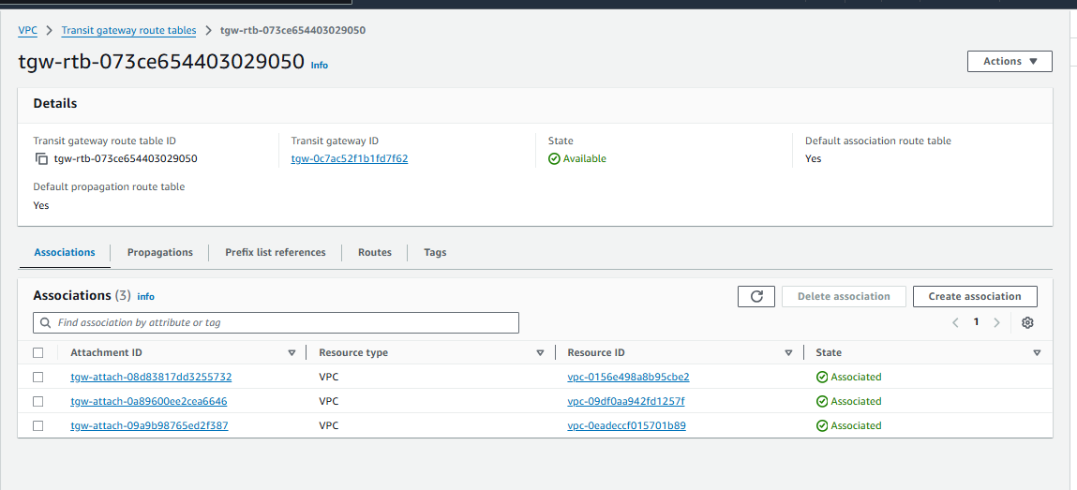

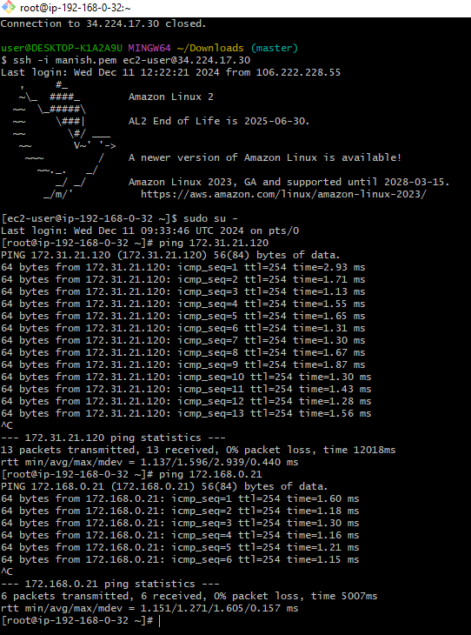

5. Setup VPC End Point.

