Experiment 8 - Step-by-Step Execution Log
Deploying Applications, CI/CD Pipeline and Cluster Monitoring (Minikube on Windows 11)
Step 1: Setup Step 1-4: Installed Minikube v1.39.0 and Helm v4.3.1 via winget; Docker Desktop 28.3.2 and kubectl were already installed.
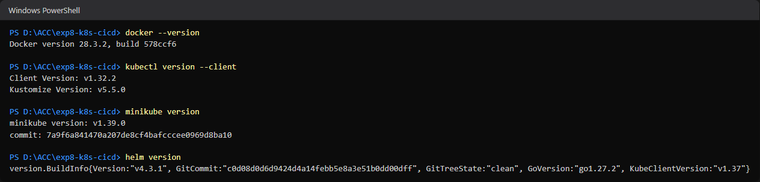
Step 2: Setup Step 5: Started Minikube with 'minikube start --driver=docker' and verified with 'kubectl cluster-info' and 'kubectl get nodes' (node Ready).
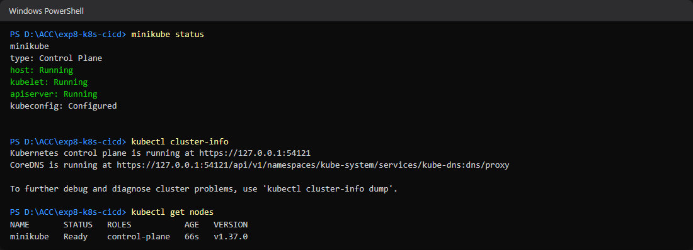
Step 3: Task 1.1: Created the project repo with app/index.html, Dockerfile and the declarative deployment.yaml (2 replicas, nginx:alpine, CPU/memory requests and limits).
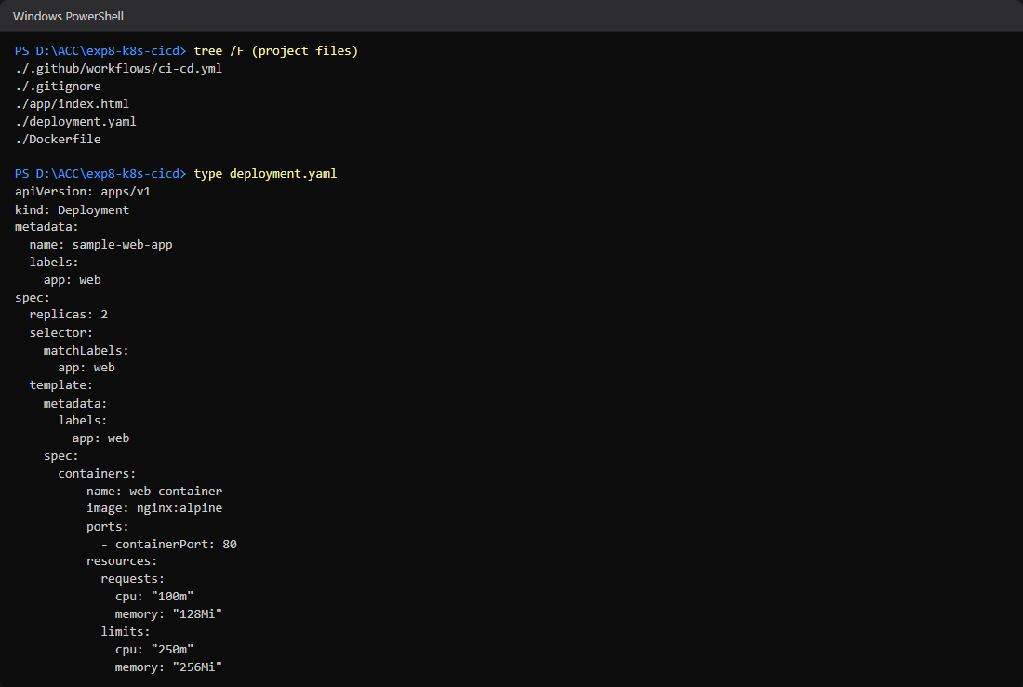
Step 4: Task 2.2: Created .github/workflows/ci-cd.yml (checkout, Docker Hub login from secrets, Buildx, build and push tagged v1.0.<run_number>).
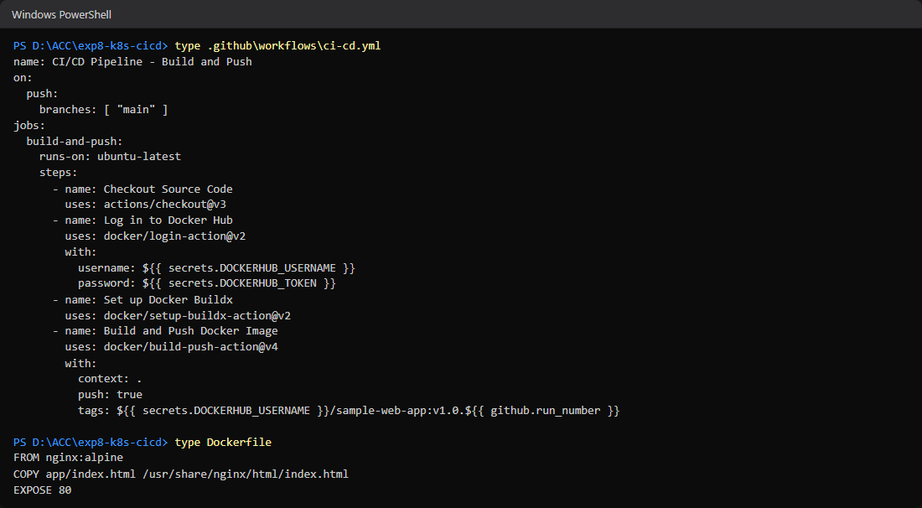
Step 5: Task 1.2: Applied deployment.yaml, inspected deployments and pods, scaled to 5 replicas; all 5 pods are Running (Screenshot 1 deliverable).
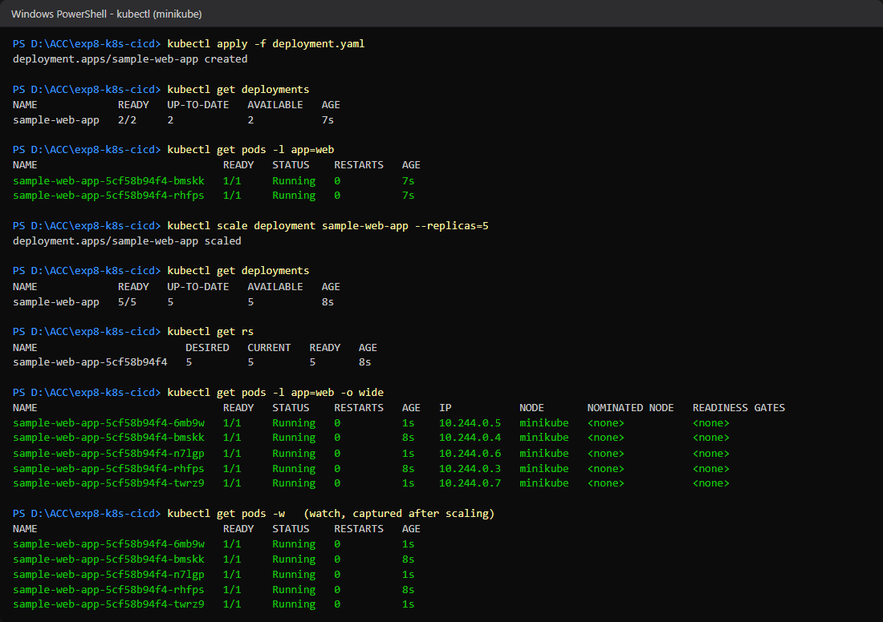
Step 6: Extra check: built the same Docker image locally (docker build), ran it on port 8081 and confirmed the custom page is served - this is exactly what the CI pipeline will build.
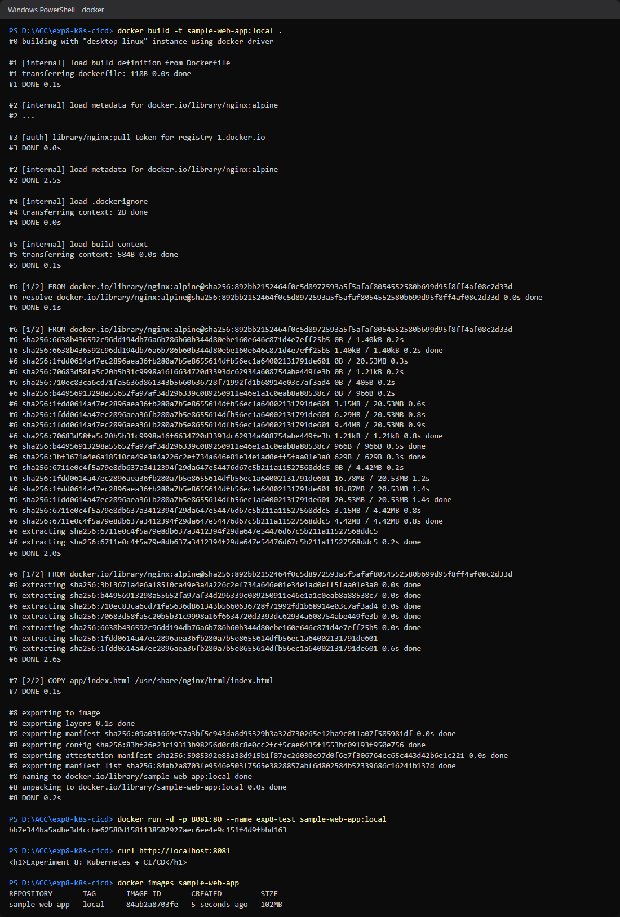
Step 7: Activity 3 Option A: enabled the metrics-server and dashboard addons; 'kubectl top nodes' and 'kubectl top pods' now return live CPU/Memory.
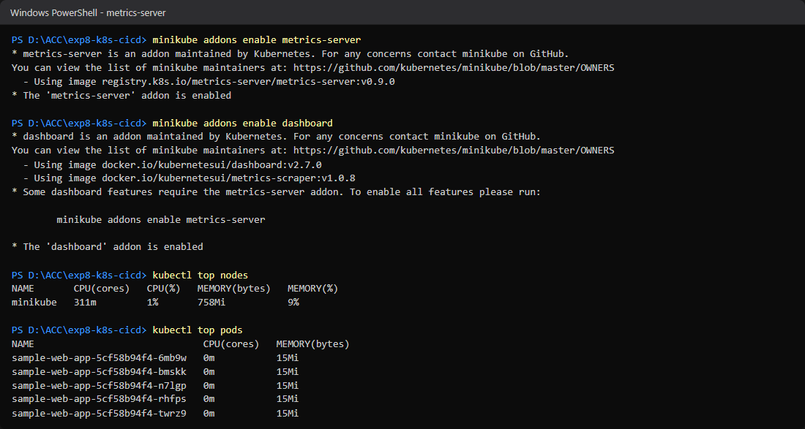
Step 8: Activity 3 Option A: opened the Minikube Kubernetes Dashboard - sample-web-app shows 5/5 pods Running.
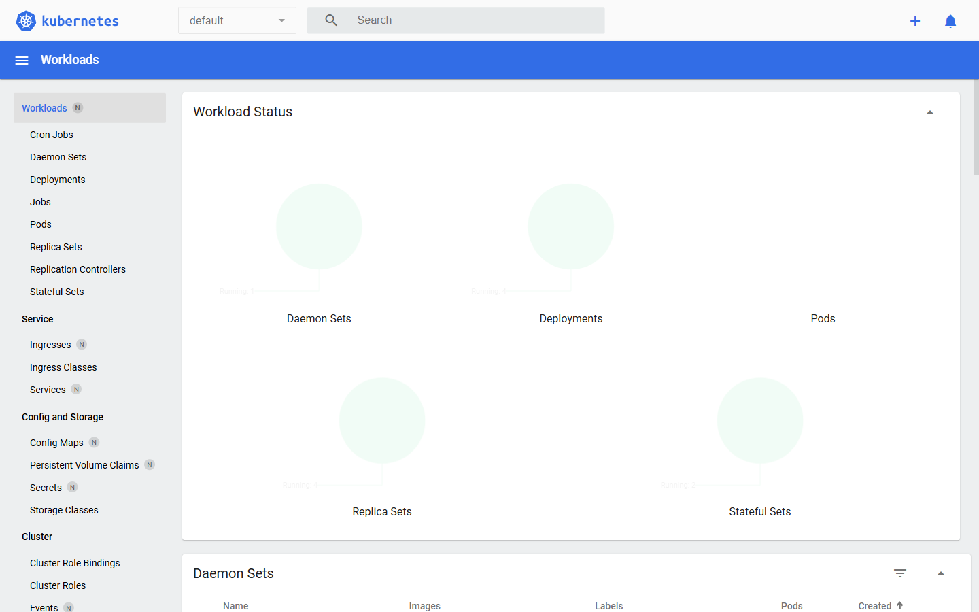
Step 9: Activity 3 Option B: added the prometheus-community Helm repo and installed kube-prometheus-stack; port-forwarded Grafana to localhost:3000.
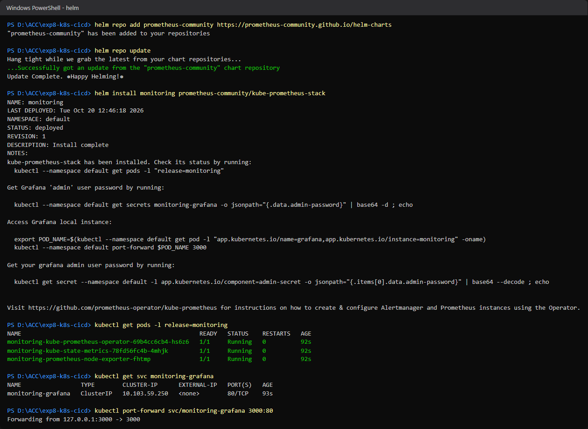
Step 10: Activity 3 Option B: logged into Grafana (admin / prom-operator) and opened 'Kubernetes / Compute Resources / Namespace (Pods)' - live CPU usage per pod (Screenshot 3 deliverable). A busybox load-generator pod sends traffic to the app service.
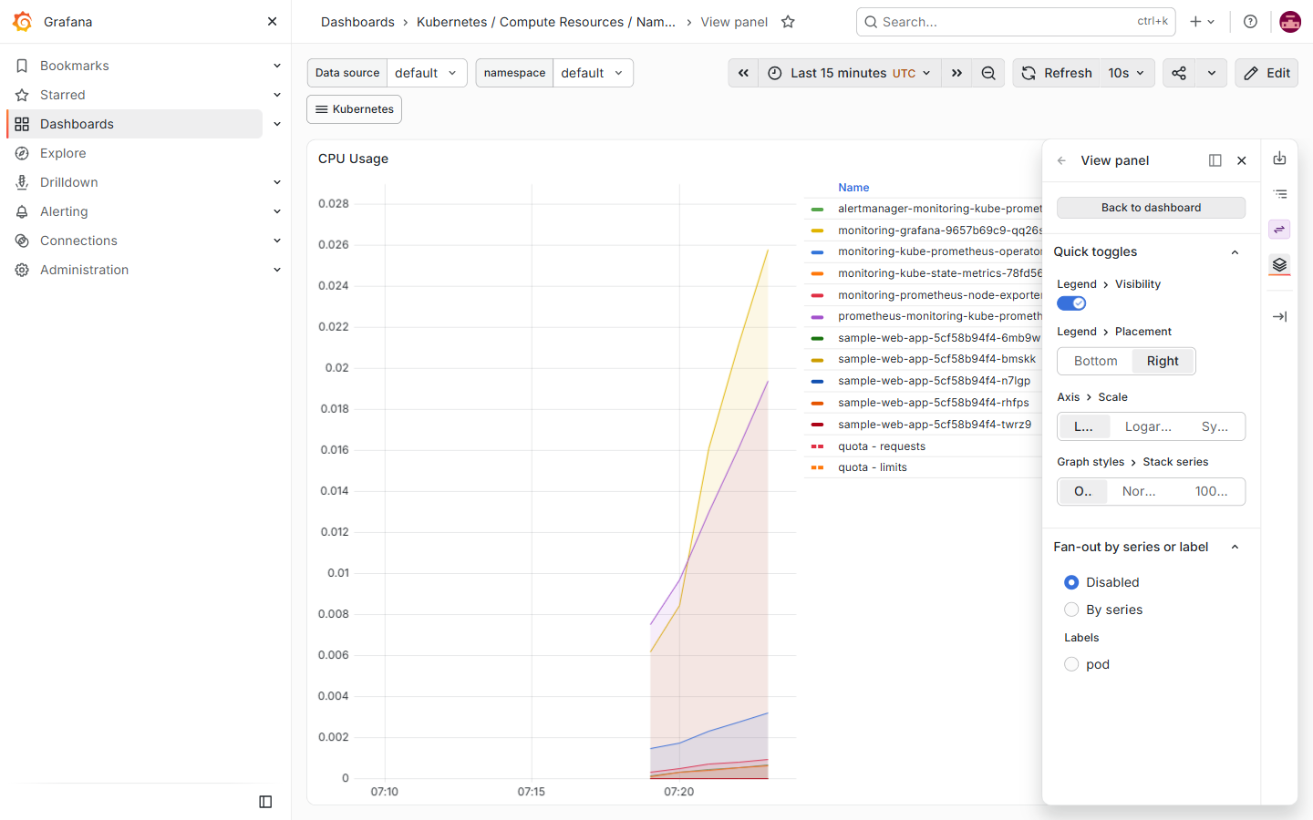
Step 11: Activity 3 Option B: live Memory usage per pod in Grafana, including all 5 sample-web-app replicas.
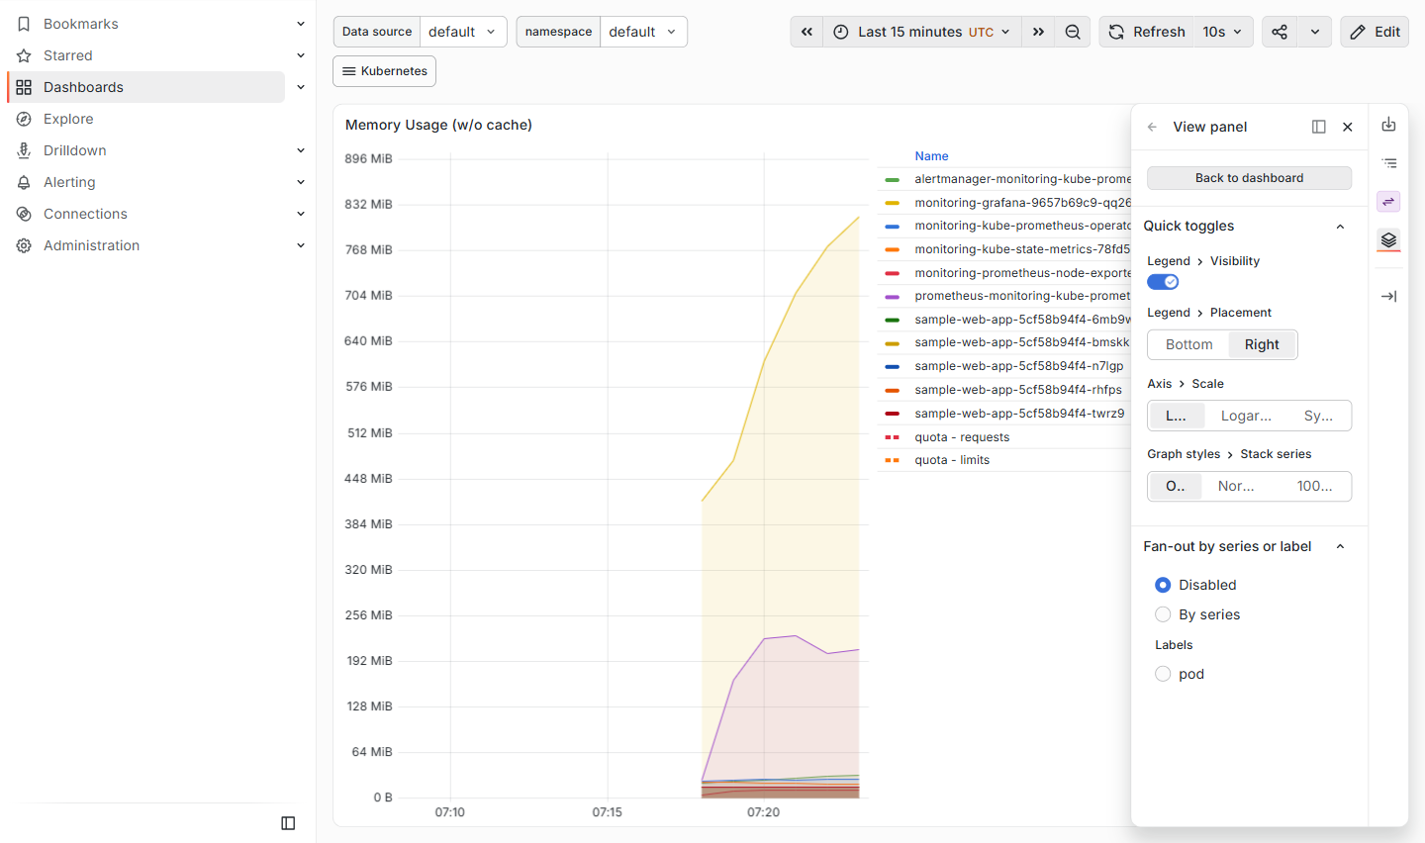
Step 12: Task 2.1 (done by student): created the Docker Hub access token and added the DOCKERHUB_USERNAME and DOCKERHUB_TOKEN repository secrets in GitHub (Settings > Secrets and variables > Actions).
Step 13: Task 2.3: added the GitHub remote, committed with 'feat: configure GitHub Actions CI/CD pipeline' and ran 'git push origin main'.
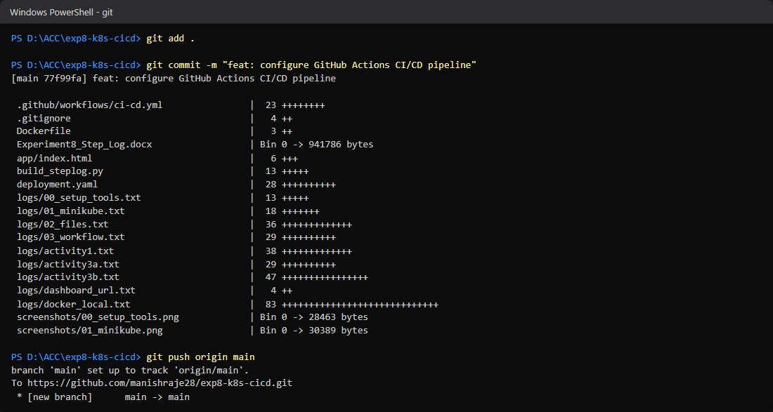
Step 14: Task 2.3: the code is now on GitHub at github.com/manishraje28/exp8-k8s-cicd, with deployment.yaml and .github/workflows/ci-cd.yml.
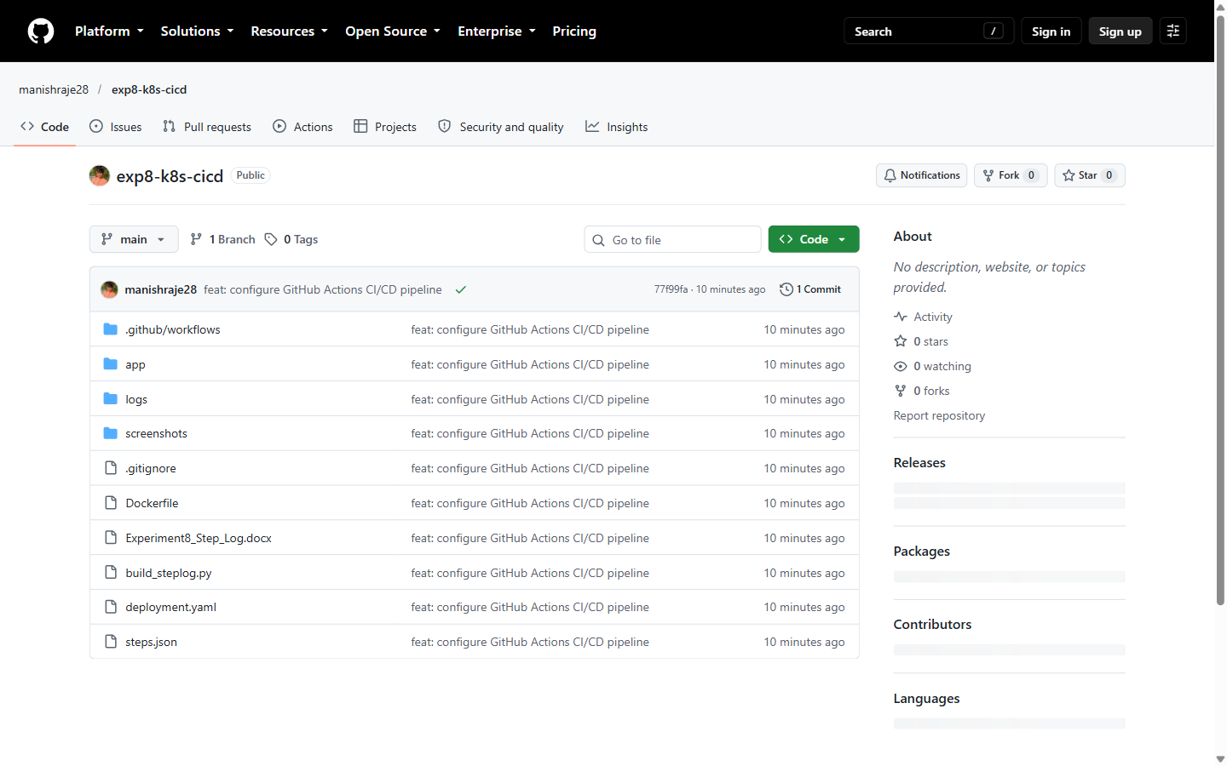
Step 15: Task 2.3: the push triggered the 'CI/CD Pipeline - Build and Push' workflow; run #1 completed green in 26s (Screenshot 2 deliverable).
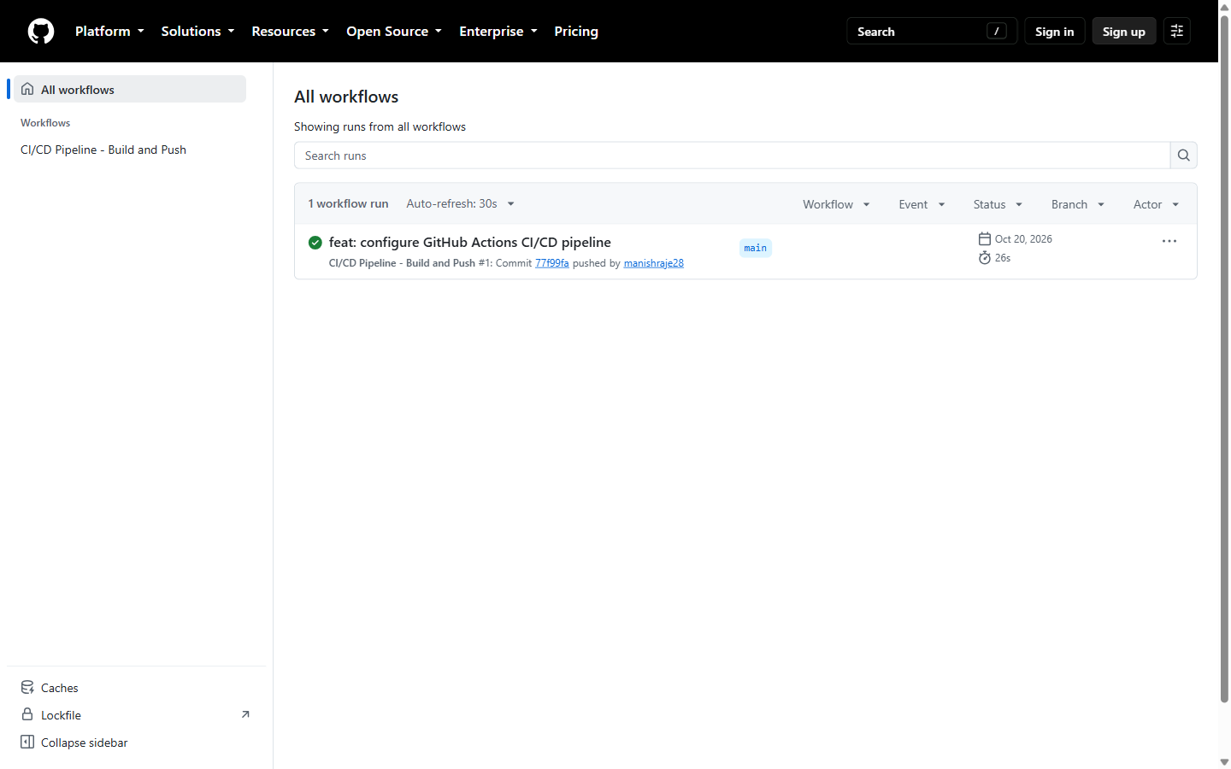
Step 16: Task 2.3: pipeline log - every step of the build-and-push job passed (Checkout, Docker Hub login, Buildx setup, Build and Push).
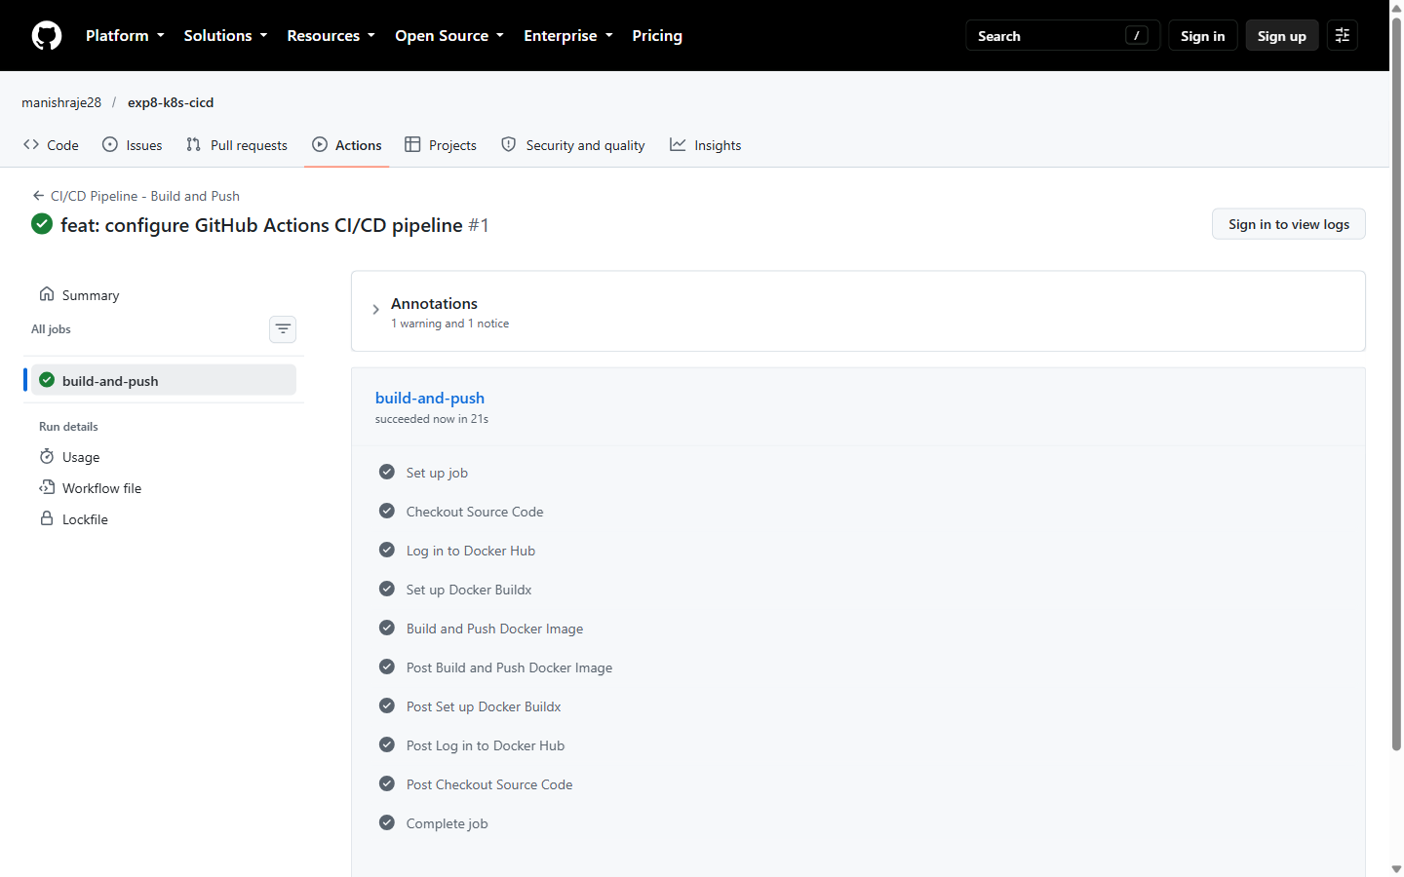
Step 17: Task 2.3: confirmed image delivery in Docker Hub - manishraje28/sample-web-app:v1.0.1 (tag = v1.0.<run_number>).
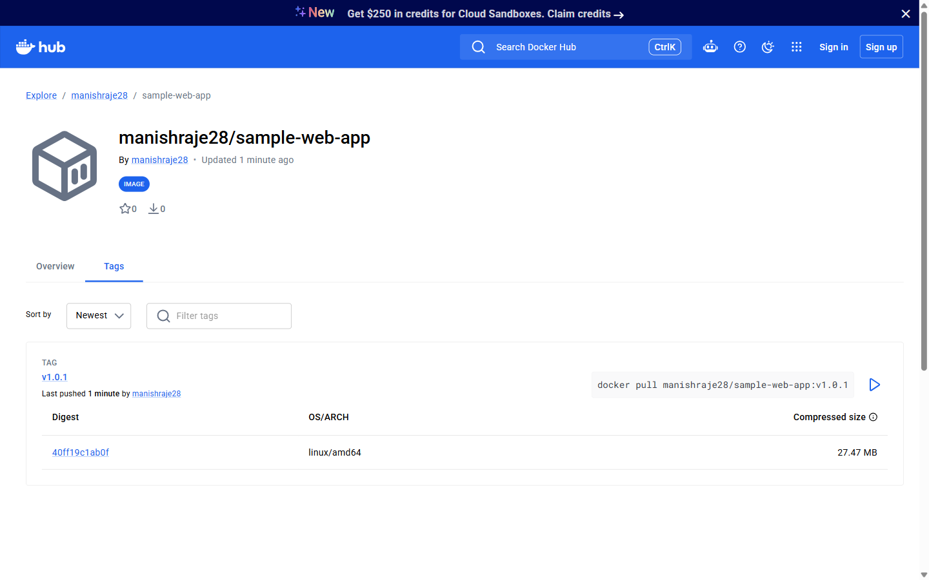
Step 18: Extra: rolled the CI-built image into Minikube with 'kubectl set image'; all 5 replicas now run manishraje28/sample-web-app:v1.0.1 and serve the custom page.
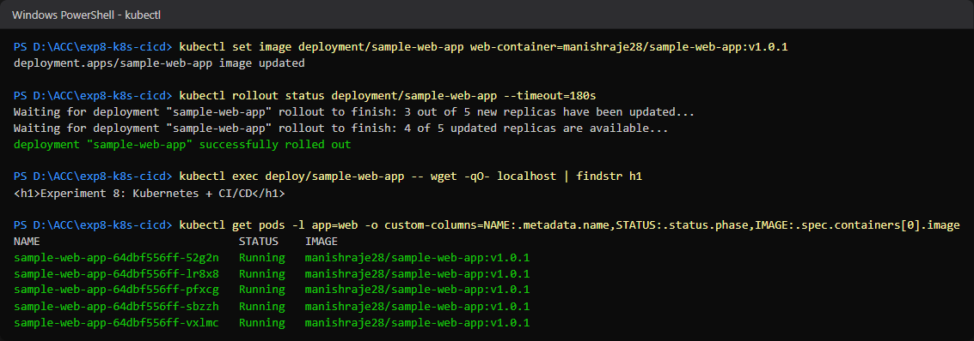
Step 19: Phase 3: generated the submission report Experiment8_Report.pdf (repo link, YAML files, pipeline log, the 3 required screenshots, quiz answers, reflection answers), then pushed screenshots and report to GitHub.

