Real-World AI-Driven Analytics Solution Using Python
Deliverable: Data Preprocessing and Initial Model Development
Dataset: Heart Disease (UCI Cleveland) Task: Binary classification (disease present / absent)
Team: ___________________________ Date: __________
Note: Quantitative results and figures below were produced by the accompanying notebook on the Cleveland dataset. Re-run the notebook to confirm your exact figures (they will vary only slightly) before submission.

1. Introduction & Problem Framing
Business problem. Cardiovascular disease is a leading cause of death worldwide, and early identification of at-risk patients allows clinicians to prioritise testing and intervention. Our team frames this as a decision-support problem: given routinely collected clinical measurements, can we estimate the likelihood that a patient has heart disease, so that high-risk individuals are flagged for further cardiac assessment?
Dataset and stakeholders. We use the UCI Cleveland Heart Disease dataset (303 patient records, 13 clinical attributes). The primary stakeholders are clinicians, who need an interpretable and reliable risk indicator, and patients, who are affected by both missed diagnoses and unnecessary follow-up. This framing shapes our priorities: the model must be transparent, and we weight the cost of a missed case (false negative) more heavily than a false alarm.
Objective and approach. The goal of this deliverable is to explore, clean and transform the dataset, then build and evaluate initial classification models. We treat the diagnosis field as a binary target (0 = no disease; 1 = disease present), engineer the features appropriately, and benchmark a Logistic Regression baseline against a Random Forest, using accuracy and ROC-AUC alongside the confusion matrix to judge clinical usefulness rather than accuracy alone.

2. Dataset Exploration & Preprocessing

2.1 Dataset overview
The dataset contains 303 rows and 14 columns (13 features plus the diagnosis field). Features mix continuous measurements (age, resting blood pressure trestbps, serum cholesterol chol, maximum heart rate thalach, ST depression oldpeak) with categorical clinical indicators (chest pain type cp, resting ECG restecg, ST slope, thalassemia thal, and number of major vessels ca). After binarising the diagnosis field, the classes are reasonably balanced: 168 patients without disease and 135 with disease (about 45% positive), so accuracy is a meaningful headline metric and no resampling is required.
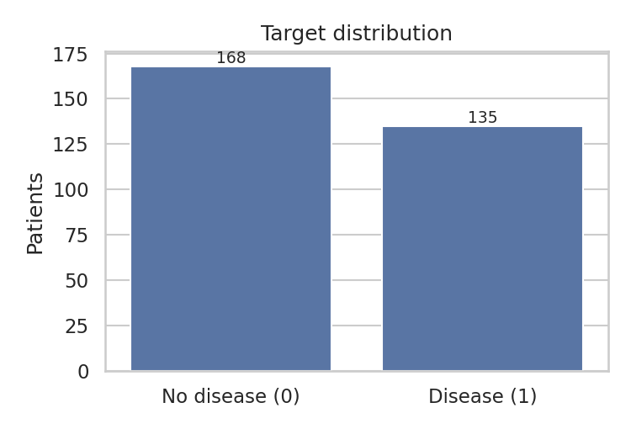
Figure 1. Distribution of the binary target — the two classes are reasonably balanced.

2.2 Data cleaning
Two columns contain missing values encoded as “?” in the source file: ca (4 missing) and thal (2 missing), six values in total. We converted these markers to true nulls, then imputed them with the column median, which is robust to outliers and avoids dropping rows from an already small dataset. We removed any duplicate records and confirmed that all columns were cast to numeric types before modelling.
Preprocessing steps applied:
- Missing values — median imputation for ca and thal (6 values).
- Target engineering — collapsed the 0–4 diagnosis scale into 0 (no disease) vs 1 (disease present).
- Encoding — one-hot encoded the nominal categoricals (cp, restecg, slope, thal) with drop_first=True, giving 18 model features.
- Scaling — standardised features with StandardScaler, fitted on the training split only to prevent data leakage.
- Split — a 75/25 stratified train–test split (227 train / 76 test) preserved the class ratio.

2.3 Exploratory analysis
Correlation analysis identified the strongest signals with the target: thalassemia (thal, r ≈ 0.48), number of major vessels (ca, r ≈ 0.40), chest pain type (r ≈ 0.37), ST slope (r ≈ 0.32) and exercise-induced angina (r ≈ 0.30). Maximum heart rate (thalach) was negatively correlated, consistent with the clinical expectation that patients with disease achieve lower peak heart rates.
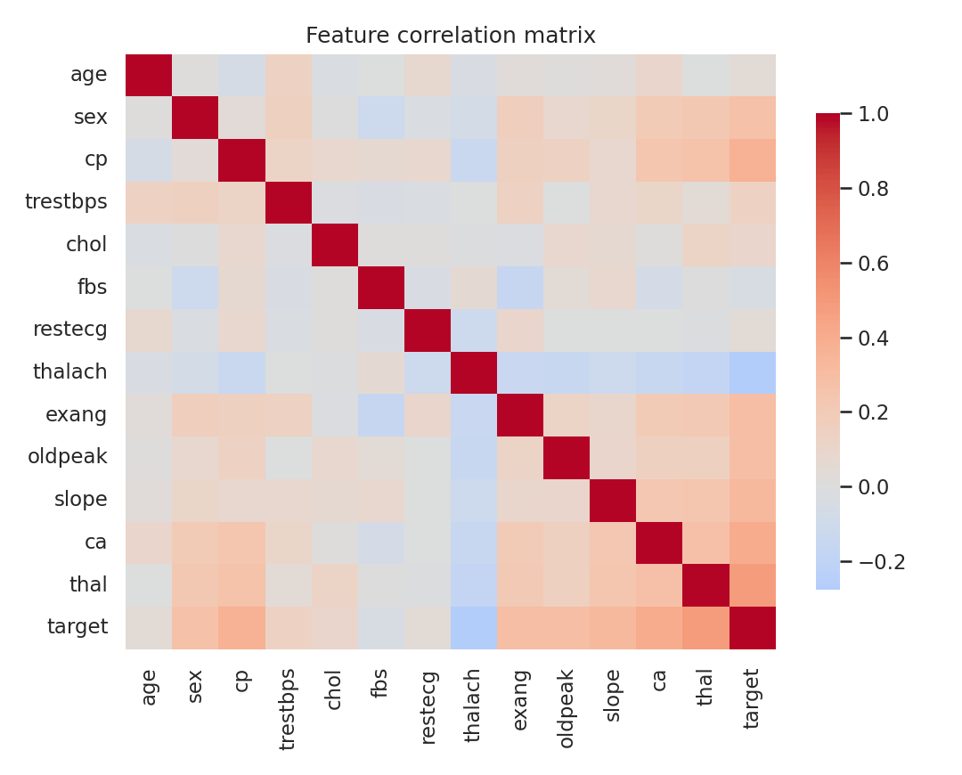
Figure 2. Feature correlation matrix. ca, thal, cp and oldpeak show the clearest relationships with the target.
Distribution plots of the key features by class reinforce these patterns: the disease group shows lower maximum heart rate, higher ST depression (oldpeak), and a strong concentration in chest-pain type 4 (asymptomatic). Age is mildly informative, with the disease group skewing slightly older. These relationships are clinically plausible, which increases our confidence that the model is learning meaningful structure rather than noise.
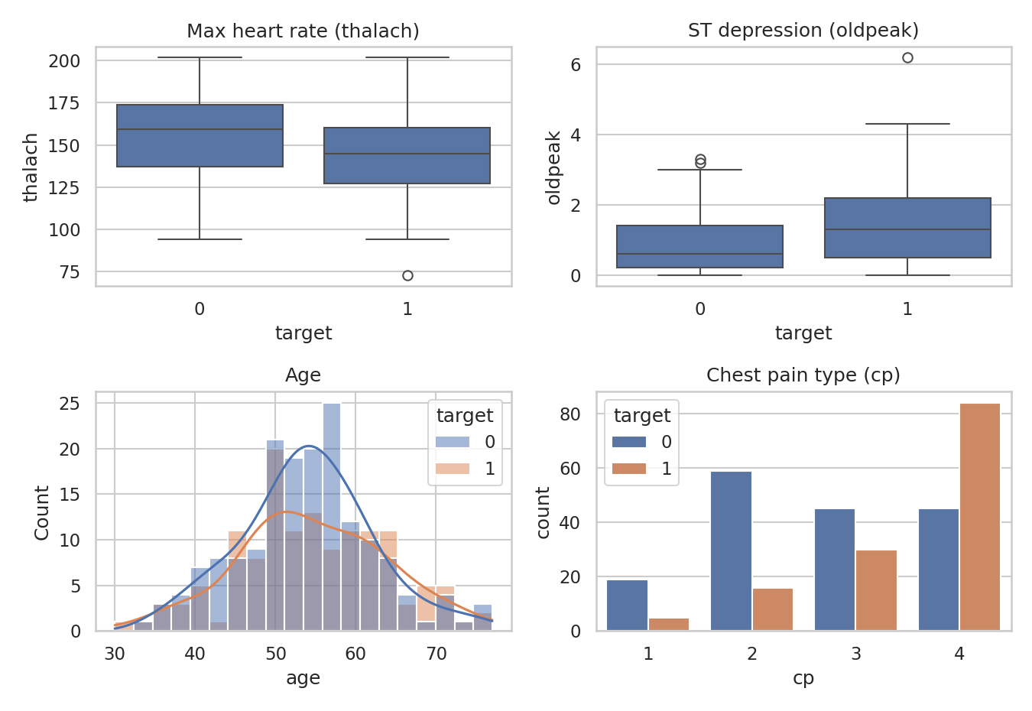
Figure 3. Selected features by class: heart rate, ST depression, age and chest-pain type all separate the groups.

3. Initial Model Development
We trained two complementary baselines. Logistic Regression provides an interpretable linear benchmark and operates on the scaled features; Random Forest captures non-linear interactions and is scale-invariant, so it was trained on the unscaled features. Both used a fixed random seed for reproducibility, and we evaluated on the held-out 25% test set.
Model | Accuracy | Precision | Recall | ROC-AUC
Logistic Regression | 0.855 | 0.848 | 0.824 | 0.877
Random Forest (default) | 0.750 | 0.742 | 0.676 | 0.857
Random Forest (tuned) | 0.776 | — | — | 0.863
Table 1. Test-set performance of the baseline models.
The Logistic Regression baseline performed best, reaching about 85.5% accuracy and a ROC-AUC of 0.88. The default Random Forest reached 75% accuracy / 0.86 AUC; hyperparameter tuning (5-fold grid search over n_estimators, max_depth and min_samples_split, optimising ROC-AUC) selected max_depth=5, min_samples_split=5, n_estimators=200 and lifted the forest to roughly 77.6% accuracy / 0.86 AUC. That the simpler linear model is competitive on a dataset this small is an expected and useful finding — it argues for the more interpretable model as the working baseline.
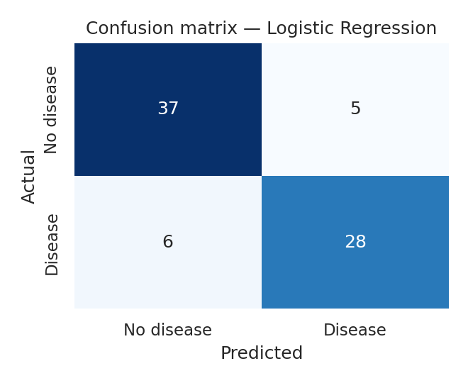
Figure 4. Confusion matrix (Logistic Regression). Six false negatives are the main clinical concern.
The confusion matrix highlights the metric that matters most clinically: there were 6 false negatives — patients with disease classified as healthy. Because a missed diagnosis is more costly than a false alarm, recall on the positive class (0.82) and the decision threshold deserve more attention than headline accuracy in any next iteration. The ROC curves below summarise the trade-off across thresholds, and feature importances from the tuned forest agree with the correlation analysis.
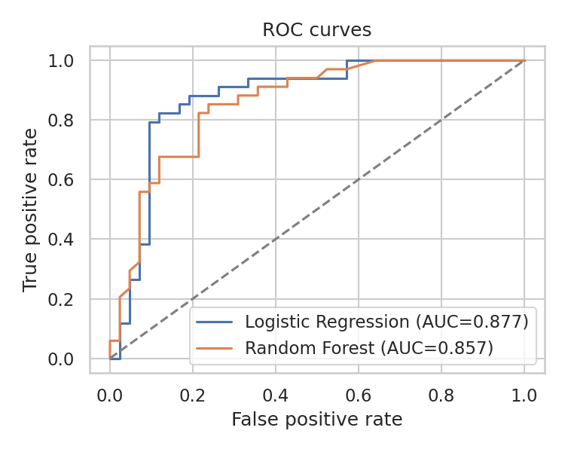 | 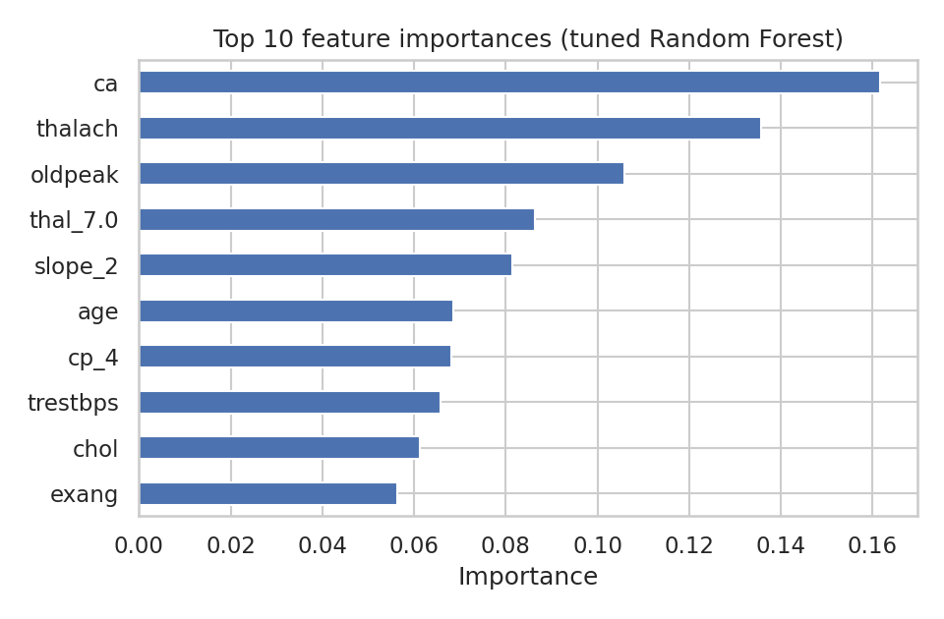
Figures 5 & 6. ROC curves for both models (left) and top feature importances from the tuned Random Forest (right).
Interpretation. The most influential features — ca, thalach, oldpeak, thal and slope — are consistent across the correlation analysis and the tree importances, and they correspond to recognised cardiac risk indicators. This consistency is reassuring for an initial model and gives the team a clear shortlist to focus on when refining features in the next phase.

4. Team Collaboration Process
Replace the placeholders below with your team’s actual roles, tools and process.
Roles. The team divided work to mirror a real analytics project: ____ led data exploration and cleaning, ____ owned feature engineering and preprocessing, ____ developed and tuned the models, and ____ coordinated the report and ethical review. Responsibilities rotated where helpful so every member touched both code and write-up.
Tools and version control. We developed collaboratively in Google Colab, which let team members edit and run the shared notebook in real time, and used GitHub for version control — committing the notebook and report, using branches for major changes, and resolving merge conflicts together. Day-to-day coordination happened over [Teams/Slack/WhatsApp], with short stand-ups to agree priorities.
Workflow and decisions. We worked iteratively: agree the problem framing, split preprocessing tasks, review each other’s code, then jointly evaluate model results. Key decisions — binarising the target, choosing median imputation, and treating Logistic Regression as the working baseline — were made by consensus and recorded in the notebook’s markdown cells so the reasoning is auditable.
Challenges. The main challenges were handling the “?” missing-value encoding and avoiding data leakage during scaling; we resolved both through code review. [Add any team-specific challenges and how you overcame them.]

References & Tools
- Detrano, R. et al. Heart Disease dataset. UCI Machine Learning Repository. archive.ics.uci.edu/dataset/45
- Python libraries: pandas, NumPy, Matplotlib, Seaborn, scikit-learn.
- Environment: Google Colab (development) and GitHub (version control).

