# JavaScript

* JavaScript is Scripting, programming, Server language

->JavaScript is a scripting or programming language that allows you to implement complex features on web pages

**.intro---**

4dec 1995 launched by Brendan Eich.

.Name given ---

* Mocha
* LiveScript
* javaScript
* ECMA Script

.HTML -> Js (we can used js with HTML that’s called internal js )

.JavaScript can be used by two method

1.internal…

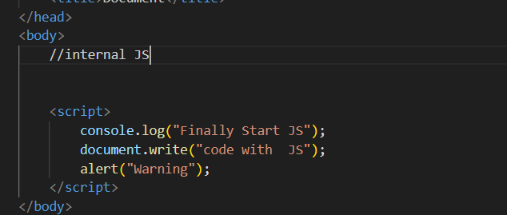

2.external ….

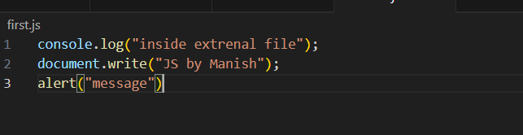

.We have to link js file in HTML file for external js

Like….

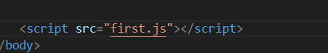

.console, document- is an object

.log, write, alert- is a function

To declare variable ..

we can use ---

1. Const- it can not re-declare and re assign .

2. var-can re declare and re assign the variable.

3. let- can only be re assign

.used parseInt(prompt(“ enter any number”))

-used to take integer from user ,that will show pop in the document page (browser).

-parseInt convert string to integer.

Operator -- 3type

1. unary operator ( increment, decrement , negation,)
2. Binary operator(Arithmetic, Relation, Logical, Assignment =, +=, -=, /= )
3. Ternary operator ( Conditional Statement ? :)

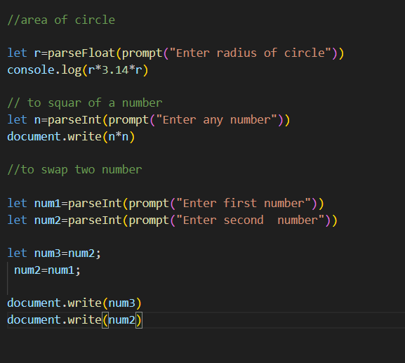

Loops

1. do while loop (where we should run program at least on times)
2. While loop (where terminating value is not known)
3. For loop(where terminating value is known)
4. For in loop
5. For of loop ( to take one by one element from array)

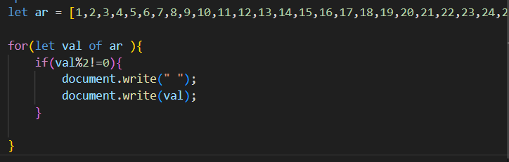

1. For each loop

Function

- function is a block of code or set of instruction

- re-usability is the property of function

- function must have…

1. function declaration
2. Function defination
3. Function calling

--- function is two type…

1. pre defined
2. User defined

De-structuring of array :-

- it is used to access of data from array using variable at the place of indexing.

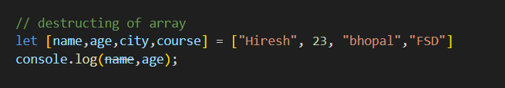

Spread opreator (…)

-use to merge element or data of two array.

- it will fetch only element from array.

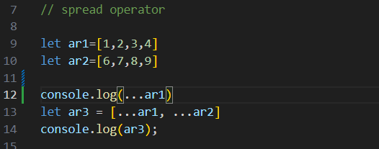

Object

- it is a datatype ,which store multiple data

- assign using {}

- store data in unordered (that position of data is not fixed) .

- store data in key vlues pair.

Nested object : we can use object inside object .

. We can use array inside object .

.we can use function inside object .and we can also pass argument inside function or we can use all to type of using function

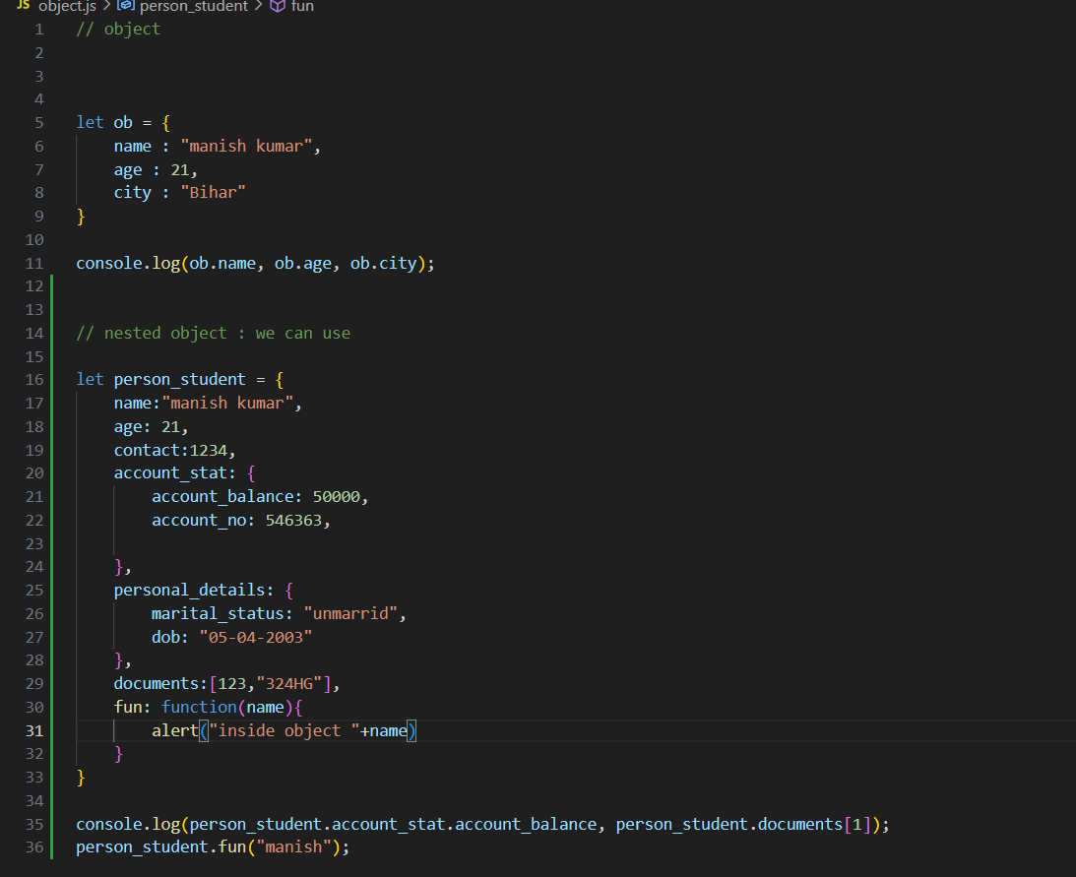

.this(function) : refer to the data of (same) that

Object.

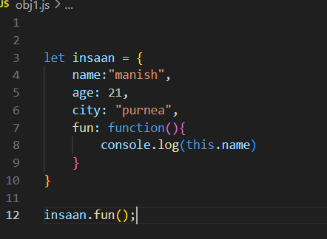

---> it will print the name (manish).

for in Loop: used to fetch key of object or index of array.

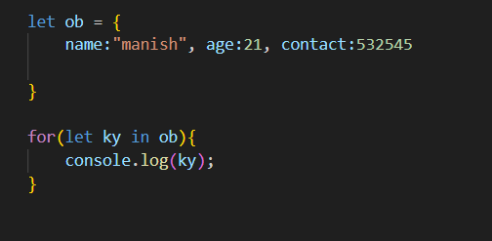

---> it will print name, age,contact

. We can also fetch values of object using ob[variable].

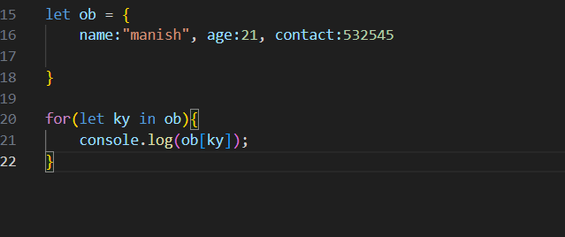

---> it will print manish, 21, 532545.

**Array of object:**

-- it is used to store multiple object in single variable.

- to store data of multiple user in one variable

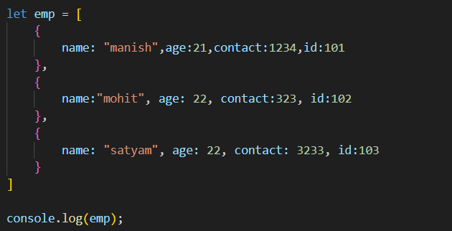

**Arrow function:**

-- made in 2015.

--- used for code concise.

-- one liner function .

-- return will always used with curly braces{}

Syntax are:-

1.() =>{return}

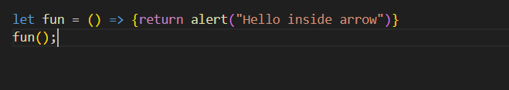

.Argument-ed arrow function:

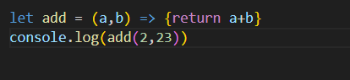

2.() =>()

3.() =>

4. => ()

5. =>

.callback function :

-- when one function is used in argument of other function.

.map function : fetch data from one array and store in other array.

. It accept function in argument.

. If we use operator in map function it will give boolean function .

.filter function :

- filter out the data at any specific condition

- it also accept function in argument.

- if we use operator it will give numerical values.

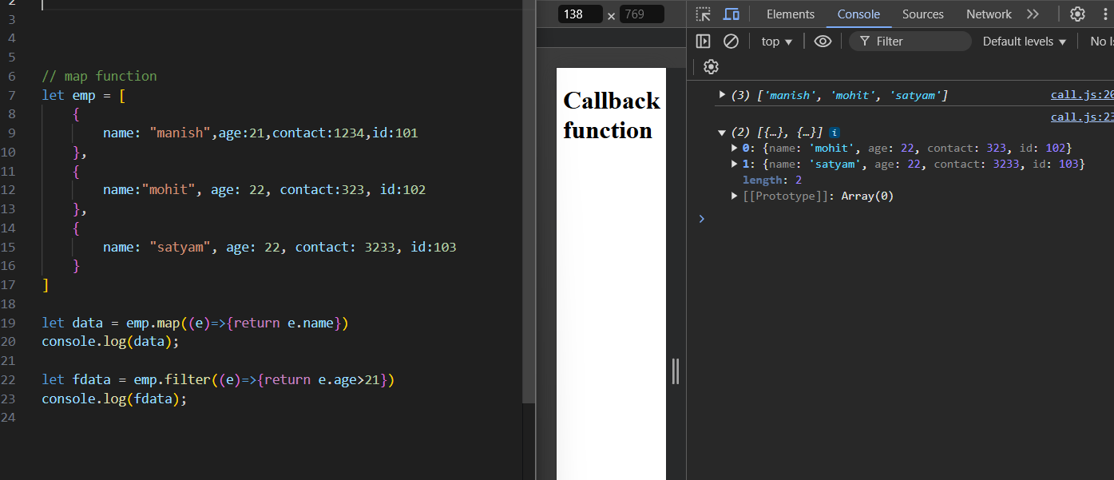

.setInterval function :

-it will give some pop up at some interval

-it will accept 2 argument

1. Function
2. Interval time (in mili sec)

.clearInterval : to stop that pop up executed by setInterval.

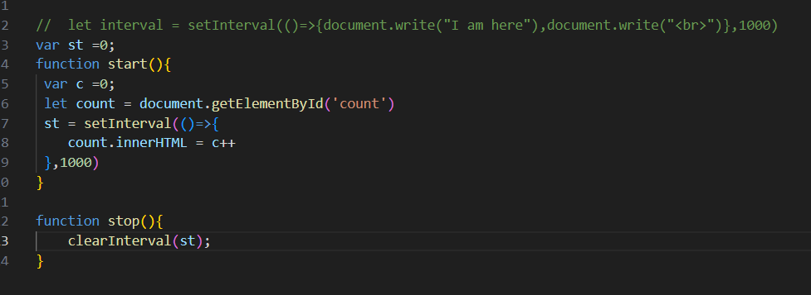

.setTimeout function :

- pr-defined function.

- it will used to take a pop up at after some time for only one time .

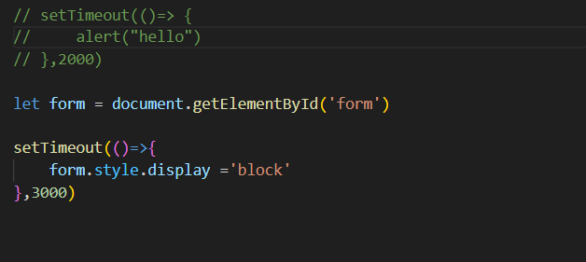

local Storage:

- it store data in string type.

- string store in key and value pair format.

- key is always unique. If we set agin store item it will override.

- local storage store data until we delete that data.

--3 things important

1. Protocol -- http, https
2. Domain -- www.google.com
3. Port -- 5500(number written on the browser at the end)

. Four main function in local storage:

1. setItem() -- store data in local storage.
2. getItem() -- retrive data from local storage.
3. removeItem() -- remove pericular data from local storage.
4. clear() -- clear all data from local storage.

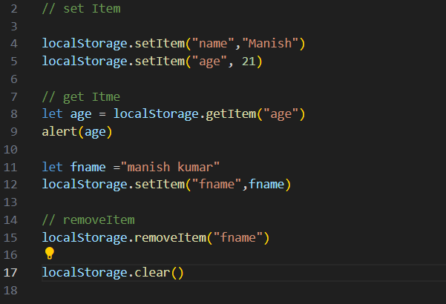

.location.reload() -- is used to reload the page.

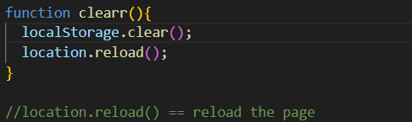

.JSON.Stringify() -- it will convert data into string .

.JSON.parse() -- will convert the string data in its previous format.

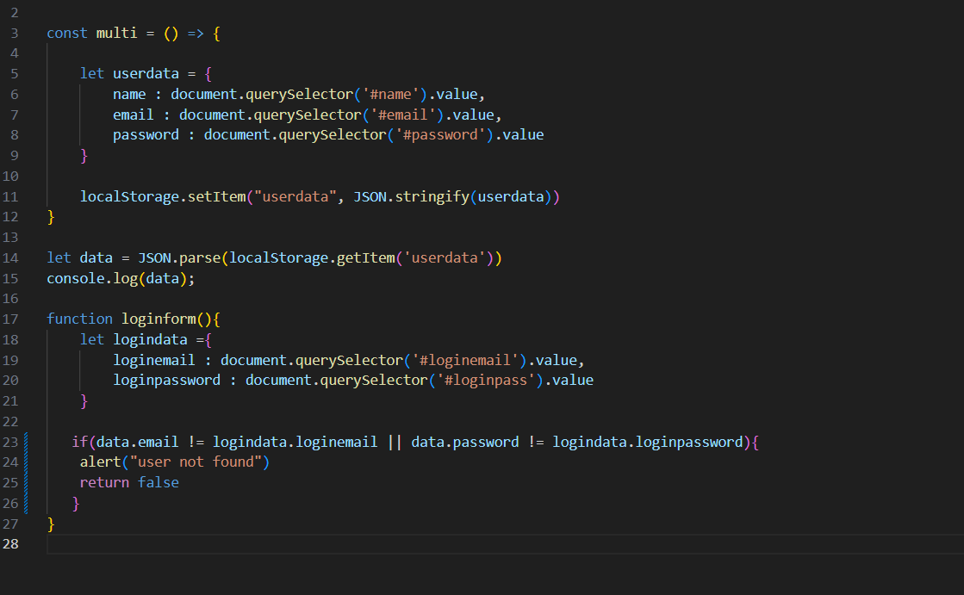

.Authontication: -

- it means that user is authentic (real).

- sign-up id and login id is same.

.API- Application programming interface.

- pre-defined service that we use in our website like pamynt gatway.

1. fatch(url,{method})

-- it will use to fetch api

. It will use methods --> get, post(insert), delete, put/patch(update) --> Http method/request

- fetch function return promise:-

-- promise has 3 stage.

- promise is a object .

1. Reject,
2. Pending
3. Fulfil

-- to handle promise -> async and await is used

.JavaScript - synchronous, lightweight

.Synchronous Asynchronous

.It will execute code line

. it will execute that line of

Code which take less time By line.

.every line of code wait

For his turn.

.if server is slow synchronous will be work as asynchronous.

. For taking fack api we will go on jsonplaceholere website.

