## HTML

8th Nov 2024

**The first version of HTML was written by Tim Berners-Lee in 1993. Since then, there have been many different versions of HTML. The most widely used version throughout the 2000's was HTML 4.01, which became an official standard in December 1999.**

**.HTML-** Hypertext markup language

collection of web pages called website.

< ,>--Angular bracket

.web page

Collection of data & information.

.collection of program is called **software**

**Two** types of software

1.**system software**(operating system ,windows)

2.**Application software**

which work on system software

Eg. Instagram ,and other application

*Extension- software extension is a computer program that add functionality to another program .

-- extension provide additional instruction that the base program doesn’t have.

**\*HTML -**

Markup( mark) , not have error , browser understand ,Hyper linking

.Hyper linking – In HTML every parts connected with linking

.structure design (layout) of website is done using HTML.

. styling of website can be done by using css.

.HTML provides tags(reserve words) to create website.

Syntax of tag.

<tagname>content</tagname>

*Tag has two type -

1.container tag – having contents

2.Non container tag (self closing)-not having any content

10th Nov 2024

. **h tags** is for heading .

. h1 to h6 tag is possible ,we have not h7 tag because , if we use h7 tag then heading will not be

11th Nov 2024

visible.

**.p tag** used to link paragraph ,(lorem)

.two type of list

1.ordered list( to ordered list of data)

2.unordered list( to list some data )

For ex..

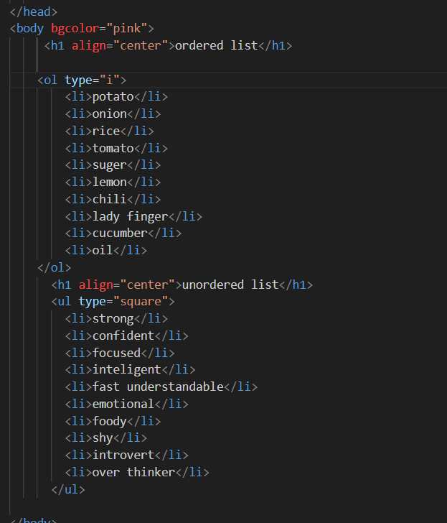

Attribute- which can change character and properties.

Eg- **1.bgcolor**-change background color

For ex..red, pink ,yellow etc

**2. align**-which shift heading or text etc. where we use align.

12th Nov 2024

. Always use align inside opening tag.

For ex..



**.u tag** is used for underline .

**.b tag** is used for bold the letter or para.

(heading can not make bold by using b tag because heading tag is already highlighted).

**.i tag** is used for italic the letter or para.

**.mark** **tag** is used for highlight text.(color of highlight can’t be changed ).



**details tag** is used for get details of any thing.

( for ex. Question in google ).(arrow sign),

**. summary tag** is used to link question inside details tag .

.we can add list, heading para etc inside details tag after summary tag that will be visible after clicking on arrow.

Eg.

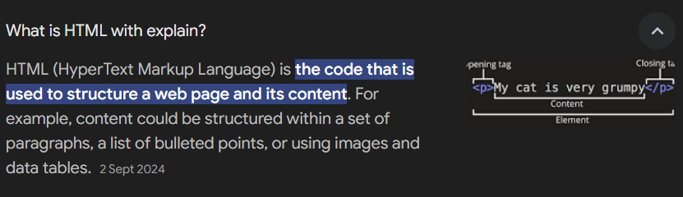

For ex…

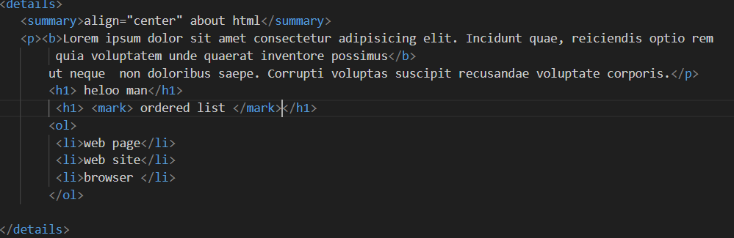

**img tag** is used to link image .(we have to store image in that html file where we put our code).

img tag is a non container tag.

img tag is an inline tag.

**.scr tag** is a attribute of img tag where we put the adders of image.( we can ues / for file name if image in inside that file ).

**.alt tag** is attribute of img tag where we put allternat of img tag .(eg..image not found).

. we can also use **height tag** and **width tag** to assign dimension of image.

  For ex..

Two types of tag—

**1.inline tag**- height &width according to element.

(ex.. img tag )

**2.block tag**- width 100% ,and height is according to element.

. element means tag .

13th 2024

**audio tag**- used to link audio (which is stored in that html file).

.audio tag work after using **controls** attributes.

.it’s attributes are--

1.src- store address of audio.

2.controls-- assign control buttons

3.autoplay --audio will play automatic.

4.loop--audio will play in loop.

5.muted --mute audio.

**video tag-** use to link video ( video should be stored in that html file).

.it’s attributes are--

1.src- store address of video.

2.controls-- assign control buttons

3.autoplay --video will play automatic.

4.loop--video will play in loop.

5.muted --mute video.

6.height,width-- assign dimension of video.

For ex..

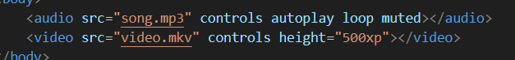

**.button tag**-- use to link click button.

**.hr tag**-- use to link a single line.

For ex..



**14th Nov 2024**

table tag- used to make table .

.Some attribute are..

**1.border tag** – used to link border ,we can also add height and width.

**2.tr tag**- used for table row tag.

**3.th tag** - used for table heading tag.

**4.td tag** – used for link table data.

**4.rowspan**- it is used to collapse multiple row.

**5.colspan**- it is used to collapse multiple column.

. we can also used align tag before colspan tag.

For ex..

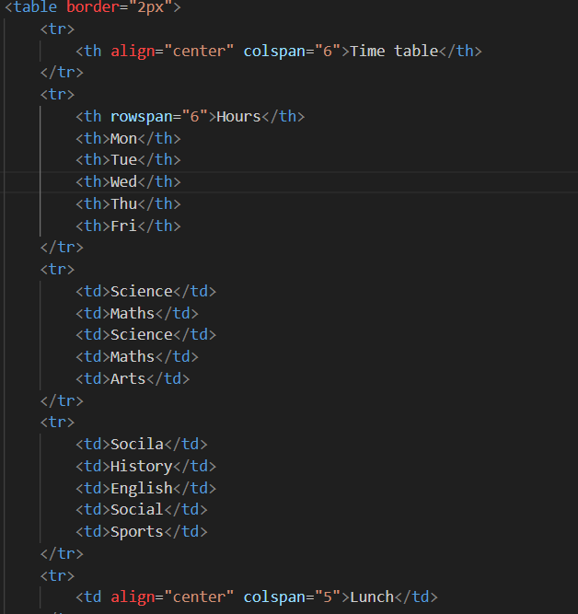

**15th Nov 2024**

form tag- used to make form.

.method=”post” -- if we use this than form data will not show on the search bar, it should be used in opening tag.

.some attributes are…

**1.label tag-** used to link label.

**2.input tag-** used to link text box.

( use text for text , use number for contact no. etc .)

. we can insert ‘e’ in number because ‘e’ is a exponential function and it has some numeric value.

3.br tag – it can to take line space between two label.

( we can use br tag multiple times according to space needed)

4. we have two type to take submit option…

i. button tag

ii. input tag ( write submit at the place of text .)

For ex…

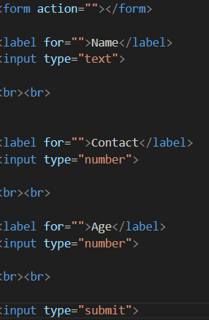

**16th Nov 2024**

1. placeholder- assign some text that will be invisible after typing text.

6.value- to insert save or other option in at the place of submit button.



1. for email we have to take label then insert Email , then take input ,use email at the place of type.( we can also use placeholder .)

8. for DOB use label then insert dob, then take input and use date at the place of type.

(also use placeholder )

9.for password use label insert password after opening bracket , then input use password at the place of type .

10.for range use label, then input use range at the place of text(type).

11. for Gender use label, then take input and at the place of text use radio and write M,F ,other after closing angular bracket .

. Use name tag after radio then insert gender inside double cods, that provide to tick on option at a time , In every input .

12. for services or multiple options we can use checkbox at he place of text(type) inside input tag.

For ex…

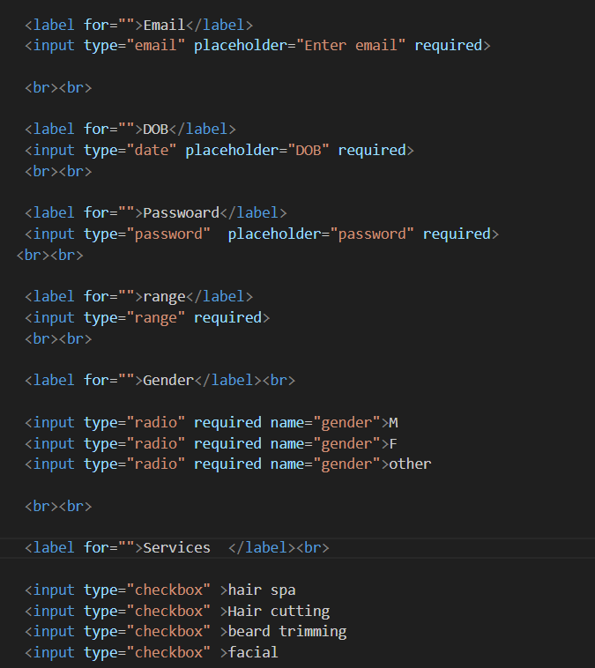

13. for select city or given state we have to use select tag then take option tag and write city name .

For ex…

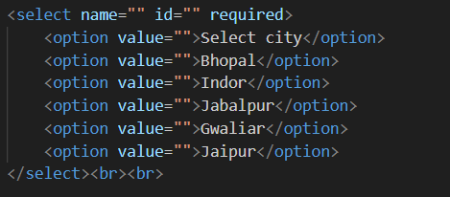

14. to insert image or file we use file type at the place of text.

For ex…



15. required – is used to assign that element is needed to fill at any cost .

18th Nov 2024

16.for boarder in form we use fieldset inside form tag close all tag inside fielset tag.

17.for feedback we use label first then we use textarea at the place of input. ( we use attributes like id , cols, rows.)

18. use for attributes for if we click on label then it goes on text .(use id inside input tag then use same word that we use in for attributes.)

19. use action tag to link other html page.

( if we wanted to go on other page after clicking in sign up button)

1. Use legend tag to provide form name that will be appear in middle of the boarder

For example:

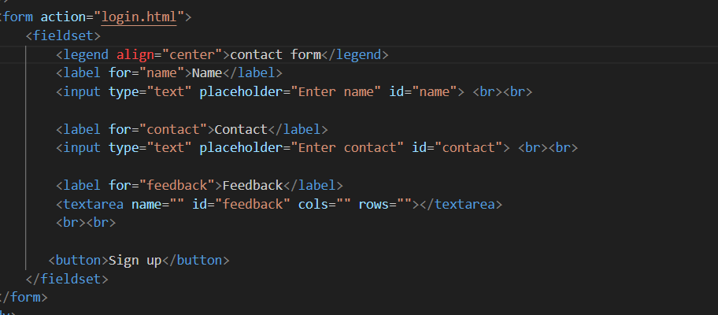

To link two or multiple html page………

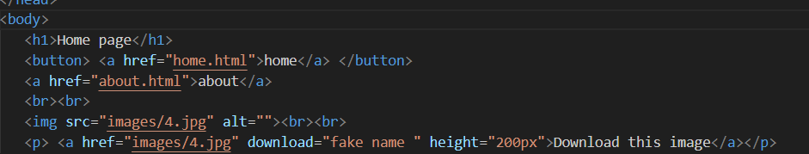

. use a tag(anchor tag) for linking( this tag can be use every where )

. inside a tag use both html file name in href attribute (href—hyper reference )

. Both html page must be make first.

. if we wanted download image or something then we use link of image in href in anchor tag, and use download attribute in a tag .

For ex..



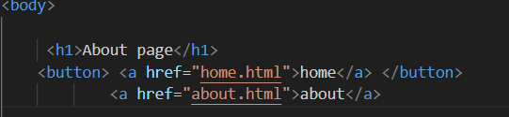Output….

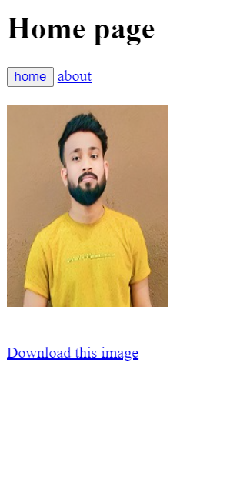

19th Nov 2024

CSS

.CSS- Cascading Style Sheets

. code of css is use of value and properties .

.CSS can be used by three type

1.inline css— in tag

For ex..

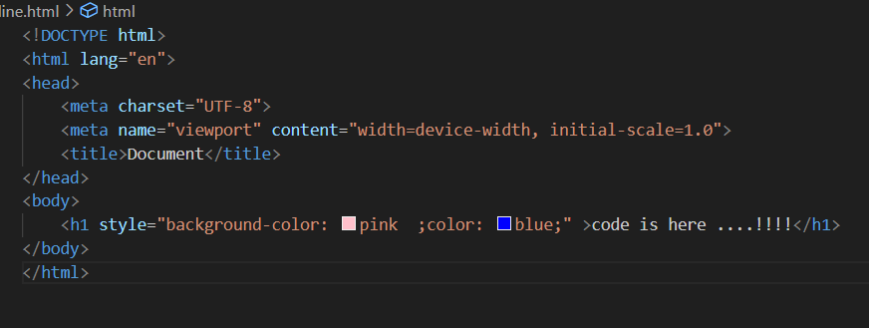

.Drawback of inline tag is we have to use style in every tag on by one , that will take much time.

2.internal css—with in page

For ex..

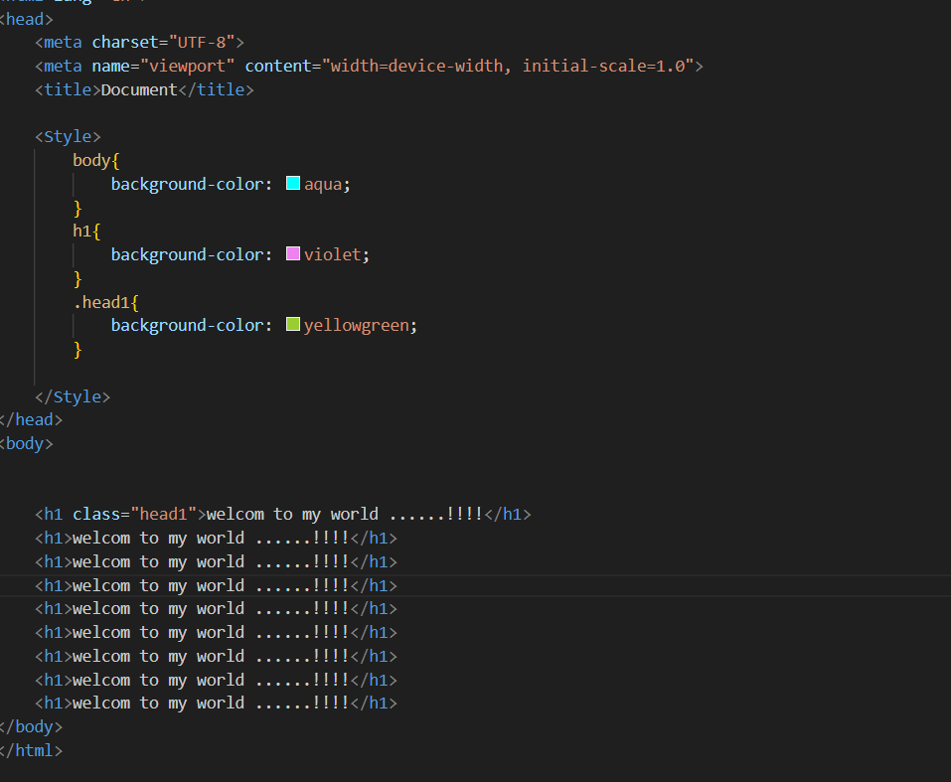

Selector – used to target html element in css

(in internal css it is used inside head tag after taking style tag)

1.tag—tagname

For ex…

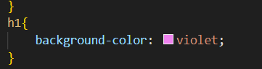

2.class-- .classname // class should be make in opening tag .

For ex..

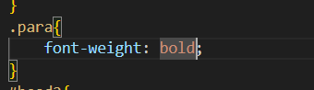

3.id-- #idname // id should be make in opening tag .

For ex…

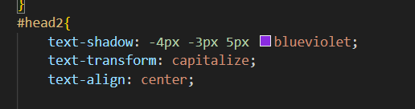

4. universal selector -- *

( when we wanted to not use browser automatic spacing then we use universal selector .)

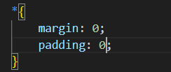

5.grouping--

For ex…

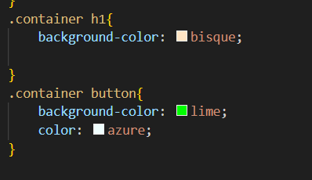

3.external css—whole website

.we have to create a css file and that have to link in html file in head by using link tag and insert css file address in href attributes.

. rel- (relation) it show the relation between css & html file .

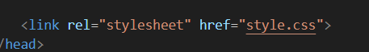

.use selector and block ({ })then use properties

.some properties …

1.color- for text color

2.background-color- for background color

3.text-align- to align text (properties – right ,center, right)

4.font-size—to change size of font .

5.text-decoration— to decorate text.

Value ….

. underline

. overline

. line-through

6.text-decoration-style—

. dotted

. dashed

. double

. wavy

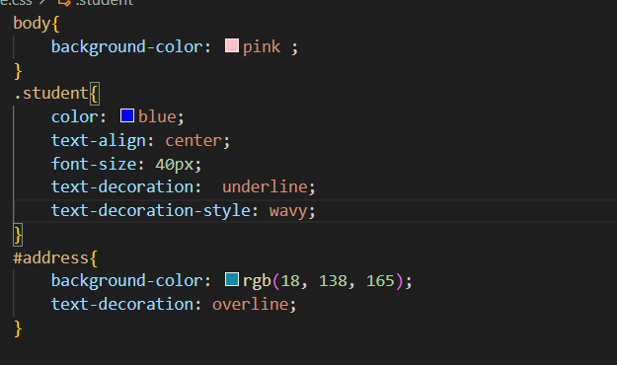

22nd Nov 2024

Git and github

1.git- Software /bash /terminal.

2.github- online server ( where we store our code or folder )

. make repository in github where we store our code or project.

. after installing git open file that we have to store in github open that file in git bash .

Then use command ….

. to config ---

1. git config --global user.name “manishroy09” -used to link github id .

2. git config --global user.email “manishroy2163@gmail.com” - used to link email id .

{ we can check id or email id is linked or not by insertion- git config --global user.name to check id & git config --global user.email to check email id .}

3. git init - to initialized empty git repository .

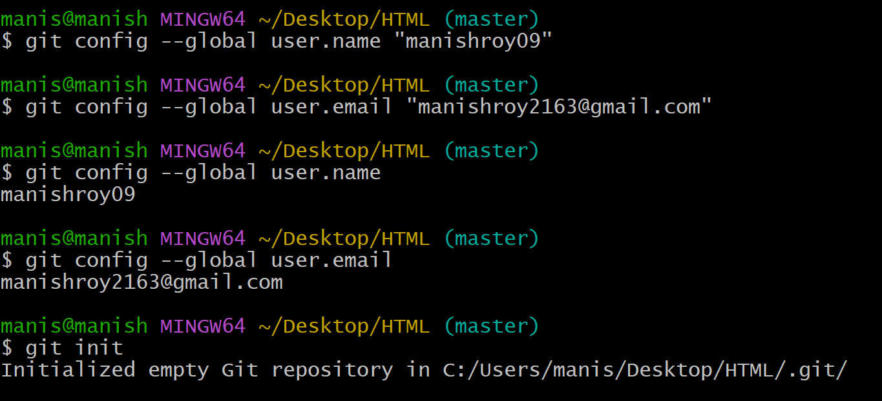

4. git add . – to add file with github.

5. git status – to check status .

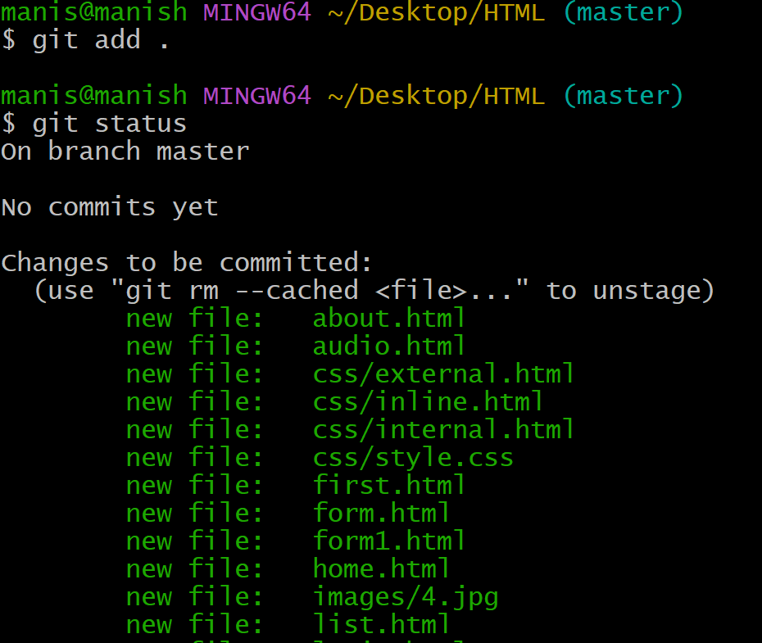

6. git commit -m “message “ – save file in repository .

7. git remote add origin https://github.com/useridofgithub/repositry.git

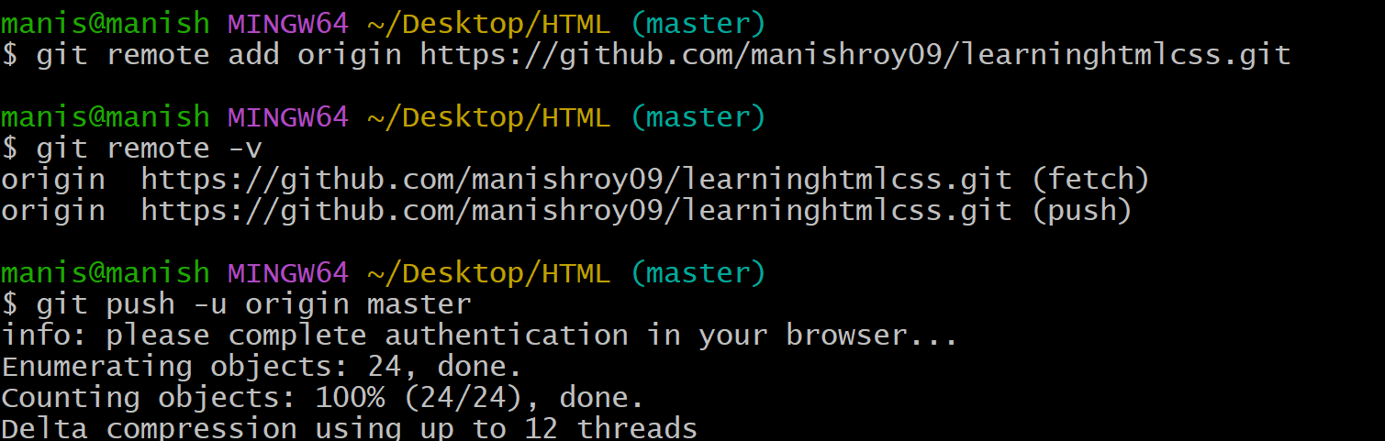

8.git remote -v -- to check origin

9. git push -u origin master/main – to push in repository

For ex…

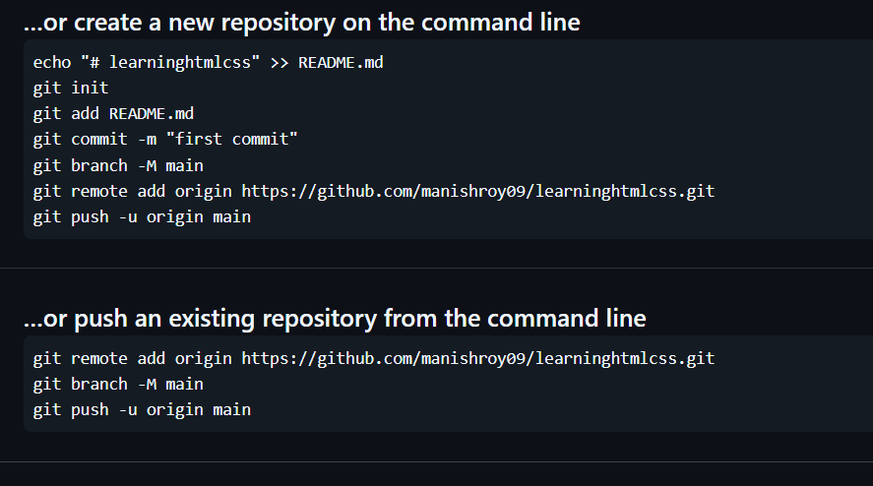

25th Nov 2024

.Some text formatting properties of css ---

7.font-style – to change style of font

8.font-family – to change written style of font

For ex…

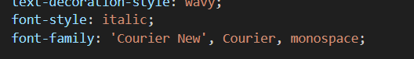

9.font-weight – to bold the paragraph or latter

For ex…

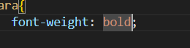

10. text-shadow – to put shadow of the sentence

. it has 4 values –

i. Horizontal dimension

ii. Vertical dimension

iii. blur dimension

iv. color

11. text-transform :- to transform text

. values are …

i. capitalize

ii. uppercase

iii. lowercase

for ex..

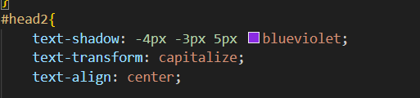

. div tag and section tag in used to divide web page in multiple section .

For ex…

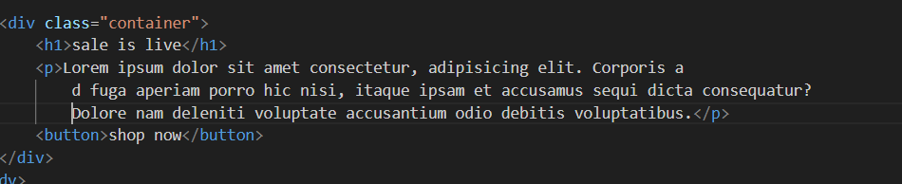

.till now we use font that is available in our system.

Google font— we use google font because i want we use that font in website which is available to every web user, all over the world.

26th Nov 2024

. to use google font…

1.open google font in browser

2.click on get font which font we have to use.

3.open bag in google font then click on get embed code .

4.copy html page and insert inside head tag in html code.

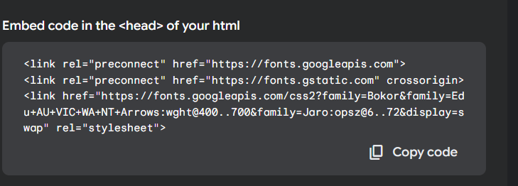

5. copy font-family from font wise css and insert in css code in block where we have to use that font.



Box model :- (it will be used after taking section or div.)

.. some properties are ---

1.padding – to give spacing inside container(bracket);

i. padding-left - to give space in left side

ii. padding-top – to give space from top

iii. padding-bottom – to give space from bottom

iv. padding : 20px ; – it will give space in all side with 20px

v. padding : 8px 20px; -- here 8px give top to bottom space and 20px give left to right space .

for ex..

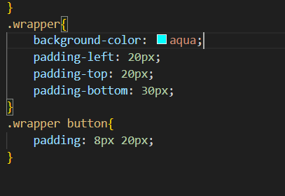

26th Nov 2024

2.margin – give spacing outside of the container.

i.margin: 40px; --- it will spacing from all side.

ii.margin-top – to take spacing from top .

iii.margin-left -- to take spacing from left of container.

iv.margin-right -- to take spacing from right of the container.

v.margin-bottom – to take spacing from bottom of container.

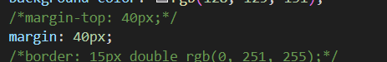

3.border: 30px solid green;

i. thickness – to provide thickness to the border of container.

ii.type of border – to take which type of border we want (solid, dashed,etc)

iii. color- to take color of border.

.border-top- to take top border only .

.border-left-to take left border only.

.border-right- to take right border only.

.border-bottom-

.border : none ; - give no boreder

4.border-radius :- to take radius at the corner of container(border).

.border-top-left-radius -- will give radius to the top left corner.

.border-top-right-radius -- will give radius to the top right corner.

.border-bottom-left-radius -- will give radius to the bottom left corner.

.border-bottom-right-radius -- will give radius to the bottom right corner.

5. box-shadow – to give shadow to the border or container.

..here box-shadow have 5values :-

i.Horizontal

ii.Vertical

iii.Blur

iv.Sprade-

v.Color

. here horizontal and vertical dimension can be taken as negative also.

.if we take horizontal dimension as negative then shadow of border will make in left to the container

.if we take vertical dimension as negative then shadow of border will make in top of the container or border .

For ex..

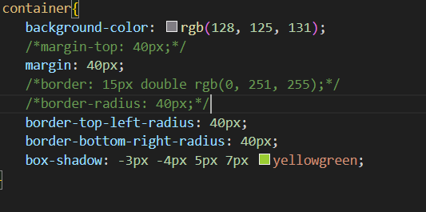

Flex box-

. it will be used when we have multiple div or section inside one section .

1.display: flex ; -- convert child in section from coloumn to row wise

2.justify-content --- give spacing when we have multiple section .

(it will only be used with display flex)

Values are..

i.space-evenly -- give equal spacing to every to every element.

ii. space-around -- give spacing around to the every element.

iii.space-between – give spacing between to the every element.

iv.center – shift all element to the center.

For ex..

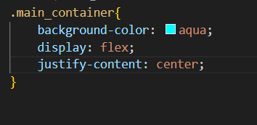

28th Nov 2024

3.align-item:- to align element in column.

(used with display flex)

.. Some values are..

.start – take element from start .

.center – take element in center.

.end – take element at end of the column.

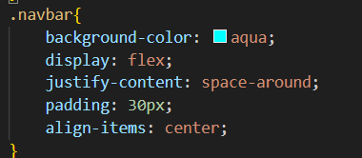

4.navbar(navigation bar) –

.used nav tag to make navigation bar.

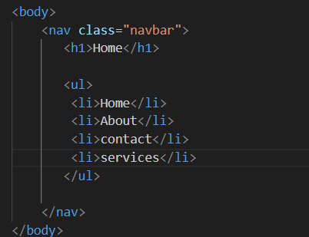

5. gap :- is used to take gap between element.

7. list-style: none; -- to remove circle.

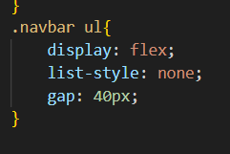

.segmented

. Non semanted tag

30th Nov 2024

. height : 100Vh; (view port height)--- use to assign column height;

.response website – works on all type of devices.(all screen)

8.flex-wrap: wrap; - make website responsive to all devices.

.we can make two class in one class by taking space between both class value.

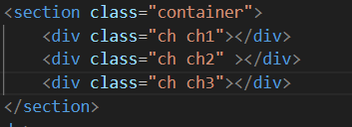

. if we take value warp-reverse at the place of warp in flex-warp tag it will reverse the element inside container.

For ex…

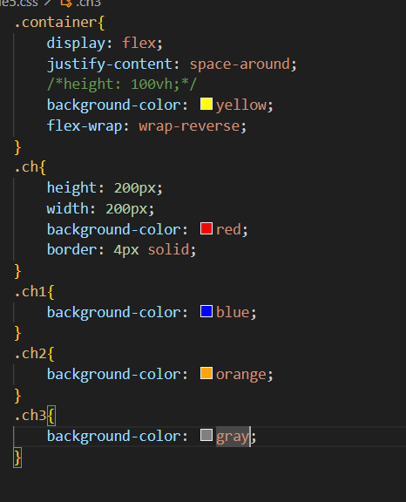

20-04-2025

header tag—is use for navbar and hero tag

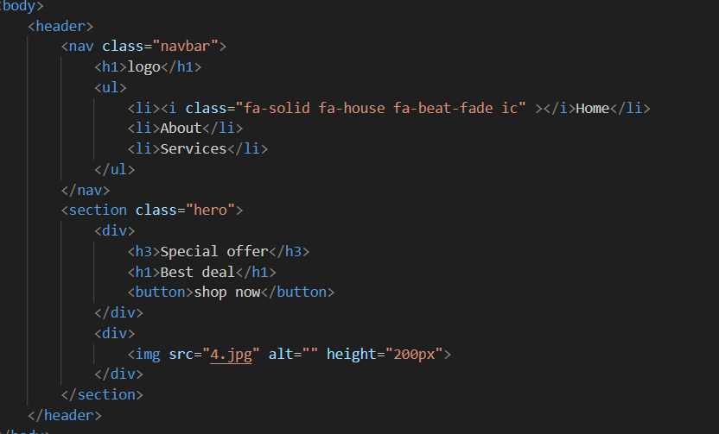

. some css tag used to insert image in the background of any container.

1.background-image : url(address of image that we wanted on background);

2.background-repeat: no-repeat; --to not repeat the image.

3.background-size: cover; -- to cover background complete by that image.

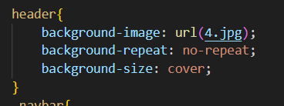

Cdn— content delivery network..

To use icon we go to the font awesome (website) then select free and search for the icon and then copy html code and past where we want that icon in website .

. we can also choose animated icon.

And then go to the font awesome cdn and copy first link and past after inside head tag.

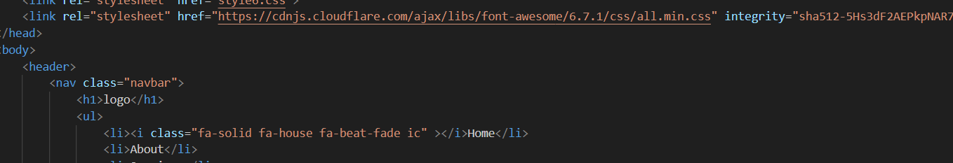

.after adding icon we can apply all text tag on icon, for color , size etc.

.Target with tilt operator to make responsive navigation bar.

