Q1. insert data at starting of the doubly linked list:

/*

* To change this license header, choose License Headers in Project Properties.

* To change this template file, choose Tools | Templates

* and open the template in the editor.

*/

package dsafeb2025;

/**

*

* @author manis

*/

public class Dnode {

Dnode prev;

int data;

Dnode next;

public Dnode(int data){

prev=null;

this.data=data;

next=null;

System.out.println("Node Created in Doubly Linkend list");

}

public void display(Dnode head) {

Dnode temp = head;

while (temp != null) {

System.out.print("======>" + temp.data);

temp = temp.next;

}

}

public Dnode addNodeAtStart(Dnode head, int data){

//Step1: Create a new Node

Dnode newNode = new Dnode(data);

//Step2: Make point newNode to current Node

head.prev=newNode;

newNode.next = head;

newNode.prev = null;

// Step3: Update head

head = newNode;

//Step4: return new head

return head;

}

public void printForwardData(Dnode head){

Dnode temp = head;

while(temp!=null){

System.out.print("===>"+temp.data);

temp = temp.next;

}

}

public void printBackwordData(Dnode tail){

Dnode temp = tail;

while(temp!=null){

System.out.print("===>"+temp.data);

temp = temp.prev;

}

}

public static void main(String[] args) {

Dnode f1=new Dnode(10);

Dnode f2=new Dnode(20);

Dnode f3=new Dnode(30);

Dnode f4=new Dnode(40);

f1.next = f2;

f2.prev = f1;

f2.next = f3;

f3.prev = f2;

f3.next = f4;

f4.prev = f3;

Dnode head=f1;

Dnode tail = f4;

System.out.println("Print data of doubly linked list in forward direction");

head.printForwardData(head);

System.out.println("\nPrint data of doubly linked list in backword direction");

head.printBackwordData(tail);

System.out.println("\nPrint data aftera adding new node at start");

head = head.addNodeAtStart(head, 5);

head.display(head);

}

}

**.Output:**

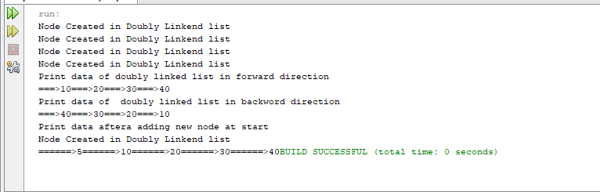

Q2. Insert new Node at specific position of doubly linked list.

Q3.Insert new node at the end of doubly linked list.

Q4.Delete first node of doubly linked list.

Q5.Delete last node of doubly linked list.

Q6.delete specific node of Doubly linked list.