Development of a Traditional Rule-Based Chatbot Using Google Colab and GitHub
Manish Sadam
2026 Spring - Artificial Intelligence for Human-Computer Interaction (MSAI-631-B01)
21th March 2026
Alan Dennis
University of the Cumberlands

Report: Development of a Traditional Rule-Based Chatbot Using Google Colab and GitHub
Introduction
Chatbots are widely used in modern applications to simulate conversations between users and systems. While many current chatbots use advanced artificial intelligence models, traditional chatbots based on predefined rules are still useful for simple and controlled interactions.
In this project, I developed a rule-based chatbot using Python without using any large language models (LLMs). The chatbot was initially built and tested in Google Colab, then converted into a Python file and structured as a local project repository using Linux commands, and finally uploaded to GitHub.
The purpose of this project was to understand how traditional chatbots work and to go through the complete chatbot development lifecycle, from planning to deployment.

Objective
The main objective of this project was to:
- build a simple chatbot using a traditional (non-AI) approach
- implement keyword-based intent recognition
- simulate conversation using predefined responses
- understand the chatbot development lifecycle
- publish the project on GitHub

Development Environment
The chatbot was developed using the following tools:

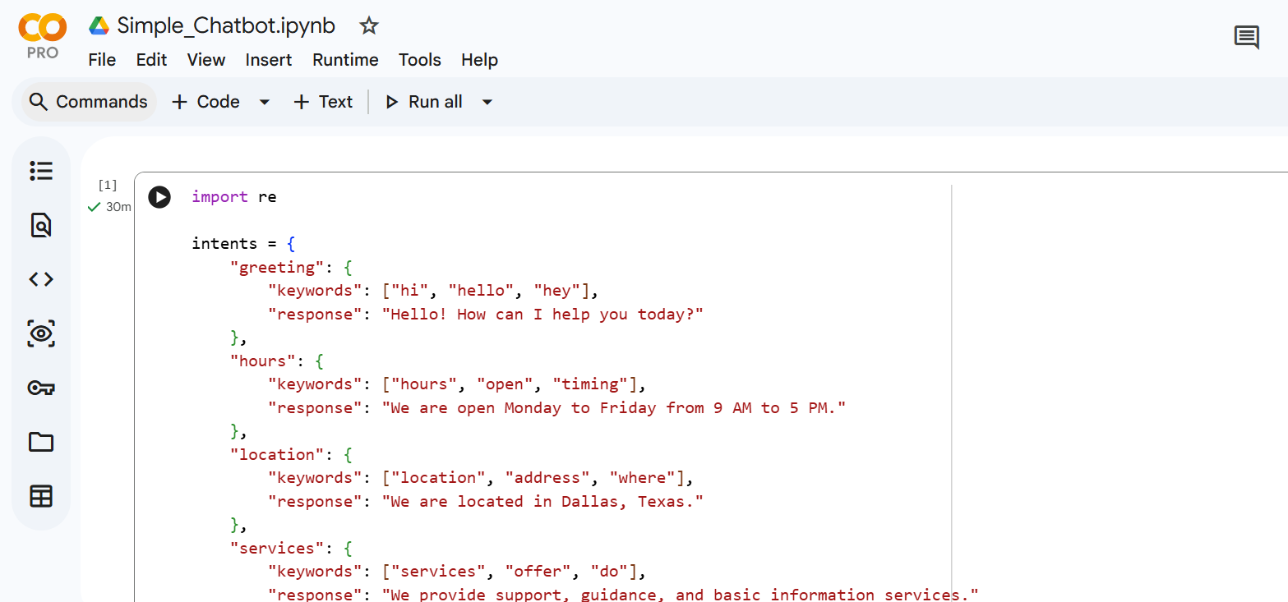
Figure 1 shows the implementation of the rule-based chatbot in Google Colab. The code includes predefined intents, keyword matching logic, and response handling using Python.
- Google Colab – for initial development and testing
- Python – for chatbot logic
- Linux Terminal – for local project setup and Git operations
- Git & GitHub – for version control and repository hosting
Traditional Chatbot Approach
This chatbot follows a rule-based approach, which means:
- it does not generate responses dynamically
- it relies on predefined rules and keyword matching
- it maps user input to fixed responses
For example:
- if the user types “hi” → chatbot returns a greeting
- if the user types “hours” → chatbot returns working hours
- if input is unknown → chatbot returns a fallback response
This approach is simple, predictable, and easy to implement, but it lacks flexibility compared to AI-based chatbots.

Chatbot Development Lifecycle
1. Requirement Analysis
In this phase, I defined the purpose of the chatbot. Since this is a basic project, the chatbot was designed to handle simple interactions such as greetings, help requests, and basic questions like location or services.
2. Design
I planned the chatbot structure by defining:
- supported intents (greeting, help, hours, location, services, farewell)
- keywords for each intent
- responses for each category
This step was important because rule-based chatbots depend heavily on proper design.
3. Data Preparation
Instead of large datasets, I created:
- keyword lists (e.g., “hi”, “hello”, “hey”)
- response templates
These act as the chatbot’s knowledge base.
4. Development
The chatbot was implemented in Python using:
- conditional logic (if-else)
- string processing
- keyword matching
The main steps in the code:
- take user input
- convert input to lowercase
- check for keywords
- return a matching response
- repeat until exit
5. Testing
The chatbot was tested in Google Colab using multiple inputs such as:
- hi
- help
- what are your hours
- where are you located
- bye
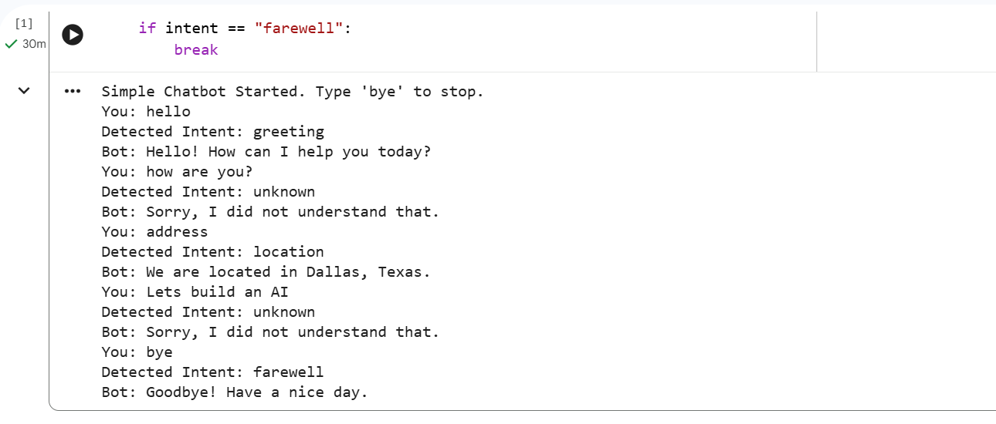
Description:
Figure 2 demonstrates the chatbot responding to user inputs such as greetings, help requests, and general queries. The chatbot returns predefined responses based on keyword matching.
Testing helped identify limitations, especially when the user input did not exactly match predefined keywords.
6. Deployment (GitHub)
After testing,
- downloaded the Python file from Colab
- created a project folder in Linux
- added necessary files like README, requirements, and .gitignore
- initialized a Git repository
- pushed the project to GitHub
This step made the project accessible and professionally documented.
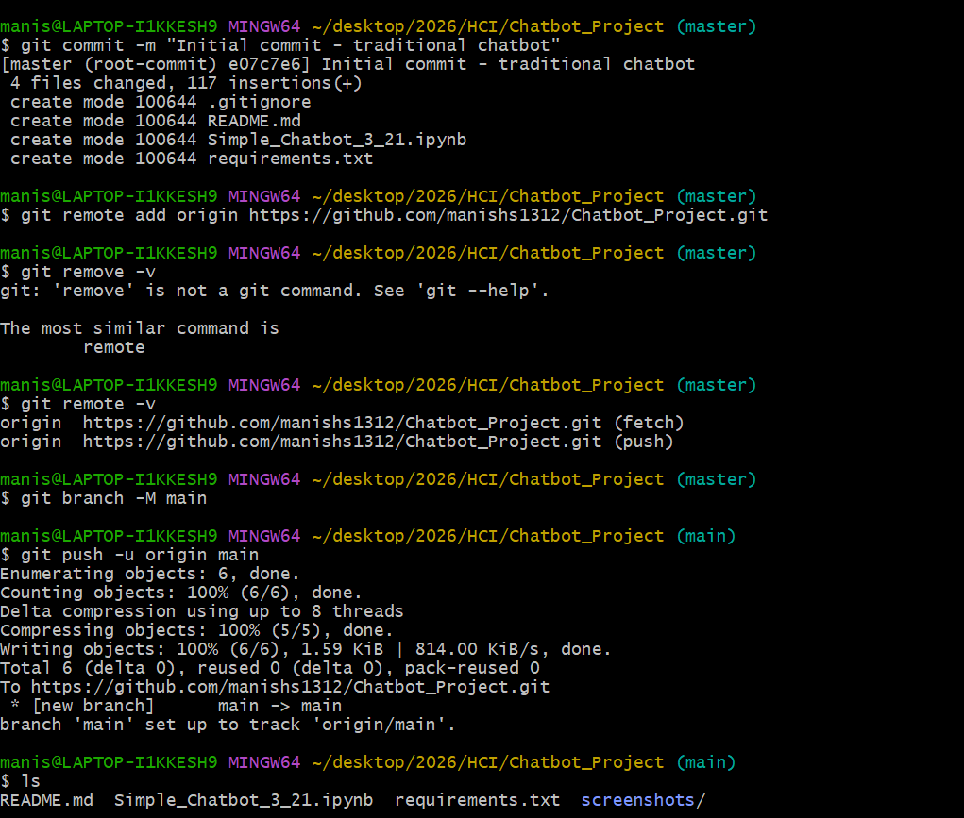

7. Maintenance and Improvement
Future improvements can include:
- adding more intents
- improving keyword matching
- using NLP techniques
- building a UI using web frameworks
Methodology
The following steps were followed:
- Developed chatbot logic in Google Colab
- Tested conversation flow
- Downloaded code as a Python file
- Created a local project structure using Linux
- Added documentation (README.md)
- Initialized Git repository
- Connected to GitHub
- Pushed code to remote repository
Sample Code Logic
The chatbot uses a simple logic like:
if "hi" in user_input:
return "Hello!"
elif "hours" in user_input:
return "We are open 9 AM to 5 PM"
else:
return "I did not understand that."
This demonstrates a basic rule-based system.
Results
The chatbot successfully handled basic conversations and responded correctly to predefined inputs. It demonstrated how traditional chatbots operate without using machine learning or AI models.
The integration with GitHub helped in organizing the project and presenting it in a structured way.
Challenges Faced
- The chatbot could not understand variations in user input
- Limited flexibility compared to AI-based chatbots
- Required manual addition of rules for new questions
- Handling unknown inputs effectively was challenging
Advantages of Traditional Chatbots
- simple to build
- low resource requirement
- predictable behavior
- suitable for limited use cases
- easy to debug and explain

GitHub Repository
The project was uploaded to GitHub as a complete repository containing:
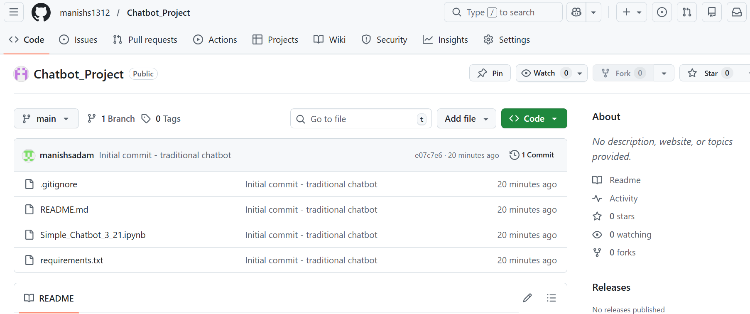
- Simple_Chatbot_3_21.ipyb
- README.md
- requirements.txt
- .gitignore
This helps in version control and sharing the project publicly.
Conclusion
This project helped me understand the fundamentals of chatbot development using a traditional approach. By building the chatbot from scratch, I learned how rule-based systems work and how important planning and design are.
Using Google Colab made development easier, while Linux and GitHub helped in organizing and publishing the project professionally. Overall, this project provided a strong foundation for understanding chatbot systems before moving to more advanced AI-based models.
AI Usage Disclosure
AI-based tools were used as supplementary resources for guidance, explanation, and documentation support during this project. However, the chatbot itself was implemented using traditional programming techniques without relying on AI models for runtime responses. All final code, structure, and implementation decisions were validated and customized by the author.

References
- OpenAI. (2023). ChatGPT (GPT-4) [Large language model]. https://openai.com
- Google. (2023). Google Colaboratory. https://colab.research.google.com/
- GitHub. (2023). GitHub documentation. https://docs.github.com/
- Jurafsky, D., & Martin, J. H. (2023). Speech and language processing (3rd ed.). https://web.stanford.edu/~jurafsky/slp3/
- McKinsey & Company. (n.d.). How to solve problems with design thinking. https://www.mckinsey.com/featured-insights/mckinsey-guide-to-problem-solving/how-to-solve-problems-with-design-thinking

