NutriGuard AI
Event-Driven Multi-Agent Health & Nutrition Tracker
Project Design Document
Primary Type: Recommender | Agentic AI
June 2025

Table of Contents
1. Project Overview & Problem Statement
2. Market Research & Opportunity
3. Proposed Solution
4. Project Type Classification
5. High-Level Architecture
6. Tech Stack & Azure Services
7. Agent Design
8. Data Sources & Schema
9. Guardrails & Safety
10. Observability & Monitoring
11. Success Metrics
12. Scope & Out-of-Scope

1. Project Overview & Problem Statement

1.1 Project Name
NutriGuard AI: Event-Driven Multi-Agent Health & Nutrition Tracker

1.2 Target Users
NutriGuard AI is designed for the following user segments:
- Health-conscious individuals tracking diet improvements
- Working professionals with limited time for detailed meal logging
- Students managing nutrition on a budget
- Fitness beginners with specific body composition goals
- Individuals with basic health conditions (iron deficiency, Vitamin D/B12 deficiency)

1.3 The Pain Point
Most users do not know whether their daily meals align with their health goal or condition. Examples of invisible risks:
- A user with iron deficiency drinks tea with every meal — not knowing it may affect iron absorption.
- A fat-loss user eats mostly carbohydrate-heavy meals and misses daily protein targets.
- A vegetarian with B12 deficiency has no fortified food source in their routine.

Current market tools fail to address this because:
- Standard diet apps require exact gram-level input — too tedious for everyday users.
- Generic AI chatbots give ungrounded advice not tied to trusted nutrition knowledge.
- No simple tool combines natural language meal input, health condition context, and safe recommendations together.

1.4 Final Problem Statement
Problem Statement
For health-conscious users with nutrition goals or basic health conditions, who need simple and safe feedback on daily meals without manually tracking calories, we build NutriGuard AI — a multi-agent nutrition risk and recommendation assistant that provides meal analysis, risk flags, and daily improvement suggestions, measured by risk flag accuracy, JSON validity, safety compliance, and report generation time. Unlike generic calorie trackers or ungrounded chatbot advice, NutriGuard AI uses agents to reason over meal logs, retrieve trusted nutrition knowledge, and act by generating safe personalized reports.

2. Market Research & Opportunity

2.1 Market Size
The global digital health and nutrition tracking market is undergoing rapid growth, driven by increasing awareness of preventive health and chronic disease management.

Segment | Market Size (2024) | Projected (2029)
Global Digital Health Market | USD 280 billion | USD 660 billion (CAGR ~18%)
Nutrition & Diet Apps Market | USD 6.4 billion | USD 13.6 billion (CAGR ~16%)
AI in Healthcare Market | USD 22 billion | USD 120 billion (CAGR ~40%)
India Digital Health (Target) | USD 5 billion | USD 21 billion (CAGR ~33%)

Sources: MarketsandMarkets, Grand View Research, NITI Aayog Digital Health Reports (2024).

2.2 Competitive Landscape
Existing tools in the nutrition and diet tracking space fall into four broad categories:

Tool / Category | What They Do | Key Gap
MyFitnessPal / Cronometer | Calorie & macro tracking via barcode scans and manual entry | Requires exact gram input; no health condition intelligence
Noom / Lifesum | Habit coaching apps with diet plans | Generic plans; no real-time meal risk analysis
ChatGPT / Gemini (raw) | General nutrition Q&A via chat | No trusted knowledge base; no structured risk flags; no personalization
Healthifyme (India) | Diet tracking + dietitian chat | Requires premium subscription; no agentic reasoning
NutriGuard AI | Multi-agent meal analysis with condition-aware risk flags | Fills the gap — natural language + health context + safe recommendations

2.3 Key Differentiators
- Natural language meal input: No gram-level data entry needed.
- Condition-aware intelligence: Personalized to iron deficiency, B12, Vitamin D, fat loss, muscle gain, and vegetarian diet needs.
- Multi-agent reasoning: Three specialized agents handle extraction, risk assessment, and report generation.
- Trusted knowledge base: Risk flags are grounded in curated nutrition knowledge via Azure AI Search — not hallucinated.
- Safe-by-design: Built-in guardrails prevent diagnosis, medication advice, or supplement dosage recommendations.
- India-first use cases: Poha, dal rice, sabzi, and Indian food contexts handled natively.

2.4 Target User Personas

Persona | Profile | Key Need
Priya, 28 — Working Professional | Iron deficiency; eats dal rice + tea daily; no time for detailed logging | Know if her meals are helping or hurting her iron levels
Rahul, 22 — Fitness Beginner | Fat loss goal; eats poha, biscuits, and rice; misses protein | Understand if daily meals are aligned with fat loss
Anita, 45 — Homemaker | Vegetarian; Vitamin D deficiency; follows family cooking | Find out if her diet has adequate Vitamin D and B12 sources
Dev, 19 — Engineering Student | Irregular meals; skips breakfast; low energy | Get simple suggestions to improve energy and nutrition balance

2.5 Market Opportunity Summary
Opportunity
Over 500 million people in India alone are estimated to have some form of micronutrient deficiency (iron, B12, or Vitamin D). Most have smartphones but no accessible, intelligent nutrition guidance tool built for their food culture and language. NutriGuard AI addresses this gap by combining agentic AI, trusted retrieval, and safe recommendation logic.

3. Proposed Solution

3.1 What NutriGuard AI Does
NutriGuard AI is a multi-agent GenAI system that reads a user's daily meal log, checks it against their health goal and health condition, and generates safe nutrition risk flags with simple, actionable recommendations.

The system works in three steps:
- Step 1 — Understand the meal: Extract structured food information from simple natural language (e.g., 'I ate poha with tea').
- Step 2 — Identify risks: Cross-check the meal with the user's health condition and goal using trusted nutrition knowledge.
- Step 3 — Generate a report: Produce a safe daily nutrition report with risk flags and improvement suggestions.

3.2 Sample Input and Output
Sample User Input
User Profile
Health condition: Iron deficiency | Goal: Fat loss | Diet: Vegetarian | Meal: 'I ate poha with tea and missed my iron tablet.'

Sample Report Output
NutriGuard AI — Daily Nutrition Report
Today's breakfast was carbohydrate-heavy with low protein.
Risk Flags:
• Breakfast has low protein — may not support fat loss.
• Tea near meals may need attention for iron deficiency.
• Iron supplement missed today — note for tomorrow.
Suggestions:
• Add sprouts, curd, paneer, tofu, chana, or soy chunks to breakfast.
• Try separating tea from iron-rich meals by 1–2 hours.
Safety Note: This is general nutrition guidance only. Follow your doctor's advice for supplements or medical conditions.

4. Project Type Classification

4.1 Primary Type: Recommender
NutriGuard AI is primarily a Recommender system. Its core output is not a factual answer — it is a ranked set of safe, personalized next-best-action suggestions for improving the user's daily nutrition.

Input | Output
Meal text + user health profile | Risk flags + improvement suggestions
Condition: iron deficiency + tea in meal | Flag: tea may affect iron absorption
Goal: fat loss + low-protein breakfast | Suggestion: add sprouts, curd, or paneer
Missed supplement note | Reminder + safety note to follow doctor's advice

4.2 Agentic Angle
NutriGuard AI has a strong agentic design. Three specialized agents handle distinct reasoning tasks:

Agent | Type | Task
Meal Analyzer Agent | Reasoning | Parse natural language meal text; extract food items, categories, and missing nutrients
Health Risk & Supplement Agent | Reasoning + Retrieval | Retrieve trusted nutrition knowledge from Azure AI Search; generate condition-aware risk flags
Report Agent | Acting | Compose the final daily nutrition report with safe language, suggestions, and safety disclaimers

4.3 Secondary Project Types
- Chatbot (minor): Users enter meals in natural, conversational language — the system understands informal phrasing.
- Summariser (minor): The Report Agent summarises the daily nutrition pattern from multiple meal logs into a single cohesive report.

5. High-Level Architecture

5.0 Architecture Diagram
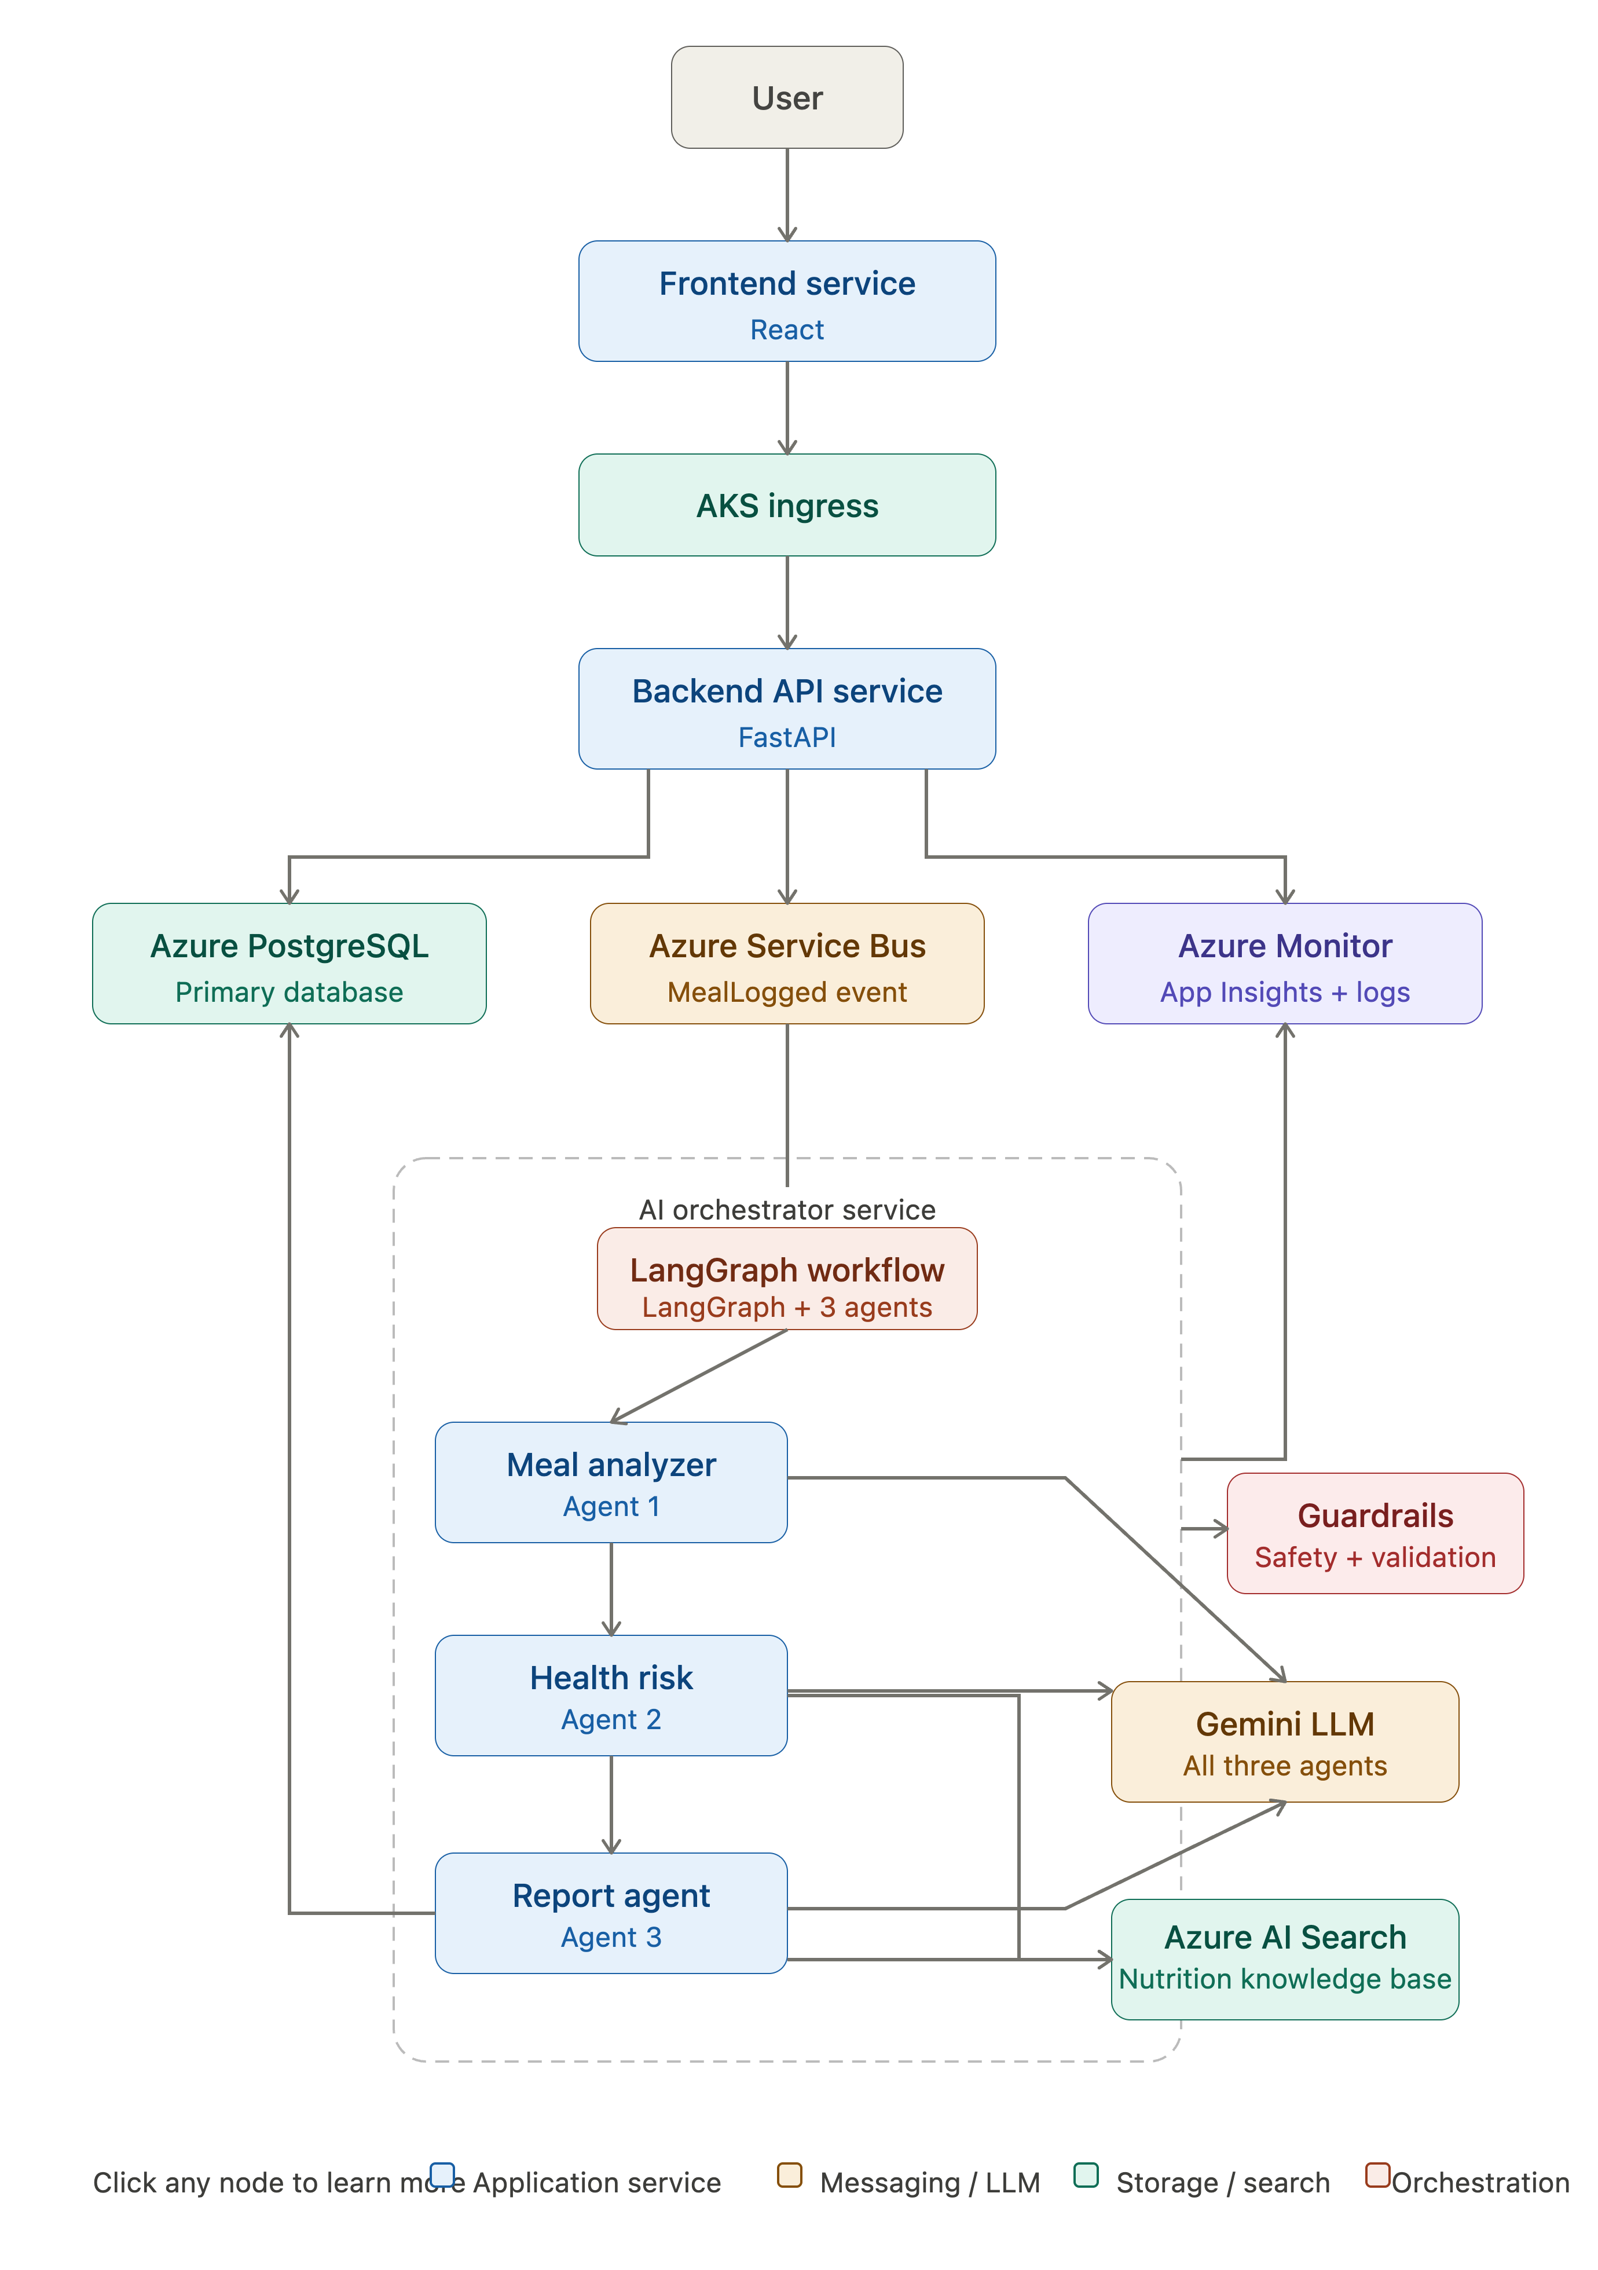
Figure 1: NutriGuard AI — High-Level Architecture Diagram

5.1 Architecture Overview
NutriGuard AI follows an event-driven microservices architecture with three main services:

Service | Responsibility | Technology
Frontend Service | User meal input, profile setup, report display | React
Backend API Service | User data, meal log storage, event publishing | FastAPI + PostgreSQL + Azure Service Bus
AI Orchestrator Service | LangGraph-based 3-agent pipeline execution | LangGraph + Gemini + Azure AI Search

5.2 Event-Driven Flow
The end-to-end flow is:
- 1. User enters meal text and health profile in the React frontend.
- 2. FastAPI backend saves the meal log to PostgreSQL and publishes a MealLogged event to Azure Service Bus.
- 3. The AI Orchestrator consumes the event and triggers the LangGraph agent pipeline.
- 4. Agent 1 (Meal Analyzer) extracts structured food data.
- 5. Agent 2 (Health Risk) retrieves knowledge from Azure AI Search and generates risk flags.
- 6. Agent 3 (Report) composes the final report and writes it back to PostgreSQL.
- 7. The frontend polls or receives a push notification and displays the daily report to the user.

Architecture One-Liner
NutriGuard AI is an event-driven multi-agent nutrition recommender where FastAPI publishes meal events to Azure Service Bus, a LangGraph-based AI Orchestrator runs 3 agents using Gemini and Azure AI Search, PostgreSQL stores the results, and Azure Monitor provides centralized observability.

6. Tech Stack & Azure Services

6.1 Tech Stack

Layer | Technology
Frontend | React
Backend API | FastAPI (Python)
Agent Orchestration | LangGraph
Agent Implementation | Python
LLM | Gemini API (google-generativeai)
RAG / Vector Search | Azure AI Search
Database | PostgreSQL (Azure Database for PostgreSQL)
Event / Queue | Azure Service Bus
Containerization | Docker
Hosting | Azure Kubernetes Service (AKS)
Ingress | AKS Ingress Controller
CI/CD | GitHub Actions
Container Registry | Azure Container Registry
Monitoring | Azure Monitor + Application Insights
Logging | Log Analytics Workspace
Secrets Management | Azure Key Vault
Autoscaling | KEDA on AKS
Guardrails | Safety Prompts + JSON Validation + Azure AI Content Safety (optional)

6.2 Azure Services Mapping

Requirement | Azure Service
Host frontend, backend, and AI Orchestrator | Azure Kubernetes Service (AKS)
Route traffic to services | AKS Ingress Controller
Store Docker images | Azure Container Registry
Store users, profiles, meals, reports | Azure Database for PostgreSQL
Event-driven communication between services | Azure Service Bus
RAG knowledge base for nutrition facts | Azure AI Search
Store secrets and API keys securely | Azure Key Vault
Automate CI/CD deployment pipeline | GitHub Actions
Centralized monitoring and alerting | Azure Monitor
Application-level tracing | Application Insights
Central log storage | Log Analytics Workspace
Monitoring dashboards | Azure Monitor Workbook
Event-based autoscaling of AI Orchestrator | KEDA on AKS
Input/output content safety checks | Azure AI Content Safety (optional)

7. Agent Design

7.1 Agent 1 — Meal Analyzer Agent
Type: Reasoning Agent
Responsibility: Parse the user's natural language meal text and extract structured food item data.

Input | Output (JSON)
'I ate poha with tea and a banana.' | {"foods": ["poha","tea","banana"], "carb_sources": ["poha","banana"], "protein_sources": [], "beverages": ["tea"]}

Key reasoning tasks:
- Identify food items from informal Indian meal descriptions.
- Classify food into macro categories: carbohydrate, protein, fat, beverage, fruit/vegetable.
- Flag missing food groups (e.g., no protein source at breakfast).
- Validate JSON output before passing to the next agent.

7.2 Agent 2 — Health Risk & Supplement Agent
Type: Reasoning + Retrieval Agent
Responsibility: Cross-check the extracted meal against the user's health condition and goal using trusted nutrition knowledge from Azure AI Search.

Input | Output (JSON)
Meal: poha + tea | Condition: iron deficiency | {"risk_flags": [{"type": "iron_attention", "severity": "medium", "message": "Tea near meals may need attention for iron deficiency."}]}

Knowledge base documents (stored in Azure AI Search):
- Iron deficiency guidance and dietary sources
- Tea and tannins — notes on iron absorption
- Vegetarian protein sources for Indian diet
- Fat loss nutrition basics — protein and calorie balance
- Vitamin B12 sources and deficiency notes
- Vitamin D sources and supplementation notes
- Supplement safety notes and interaction flags

7.3 Agent 3 — Report Agent
Type: Acting Agent
Responsibility: Compose the final safe daily nutrition report. Convert risk flags and suggestions into simple, safe language. Always include the safety disclaimer.

Report structure:
- Meal summary: 'Today's breakfast was carbohydrate-heavy with low protein.'
- Risk flags in plain language with medium/low severity labels.
- Actionable suggestions with real Indian food alternatives.
- Safety note: Always appended for any health condition user.

8. Data Sources & Schema

8.1 User Data
Stored in PostgreSQL. Collected at onboarding and updated by the user.

Table | Fields
users | user_id, name, email, created_at
user_profiles | profile_id, user_id, health_goal, diet_type, health_conditions[ ], supplements[ ]
meal_logs | meal_id, user_id, meal_text, meal_time, date, processed
nutrition_flags | flag_id, meal_id, flag_type, severity, message
daily_reports | report_id, user_id, date, report_text, generated_at
outbox_events | event_id, event_type, payload, published, created_at

8.2 Knowledge Base Data (Azure AI Search)
Pre-loaded curated nutrition documents. Retrieved by Agent 2 via semantic search.

Document | Content Summary
iron_deficiency_guide | Dietary iron sources (heme and non-heme); absorption enhancers (Vitamin C); absorption inhibitors (tannins in tea)
tea_iron_absorption | Evidence notes on tannins in tea and their effect on non-heme iron absorption; timing recommendations
vegetarian_protein_sources | Indian vegetarian protein sources: dal, paneer, tofu, soy chunks, chana, sprouts, curd, eggs
fat_loss_nutrition | Protein targets for fat loss; caloric balance; importance of satiety foods
vitamin_b12_notes | B12 sources for vegetarians; deficiency symptoms; supplement safety notes
vitamin_d_notes | Vitamin D food sources; sunlight exposure; supplement safety notes
supplement_safety | General supplement interaction notes; always refer to doctor for dosage

9. Guardrails & Safety

9.1 Safety Rules
NutriGuard AI is built with strict safety guardrails to ensure it never crosses into medical territory:

Rule | Implementation
No medical diagnosis | System prompt explicitly forbids diagnosis language; output validated pre-delivery
No medicine dosage recommendation | Agent 2 and Report Agent prompted to redirect all dosage questions to doctor
No supplement dose changes | Knowledge base entries include 'consult doctor' notes; prompt enforces this
Always add safety disclaimer | Report Agent always appends the safety note for any health condition user
JSON output validation | All agent JSON outputs are schema-validated before passing to the next agent
Block overconfident medical claims | Prompt rules and keyword filters catch terms like 'cures', 'treats', 'proven to fix'
Optional: Azure AI Content Safety | Input and output can be passed through Azure AI Content Safety API for production use

9.2 Standard Safety Disclaimer
Safety Note (always included in reports)
This is general nutrition guidance only. NutriGuard AI is not a medical tool. For supplements, health conditions, or medication, always follow your doctor's advice.

10. Observability & Monitoring

10.1 Correlation ID Strategy
Every request is tagged with a common correlation_id = meal_log_id. This ID flows through all services and agents, enabling full end-to-end tracing in Log Analytics Workspace.
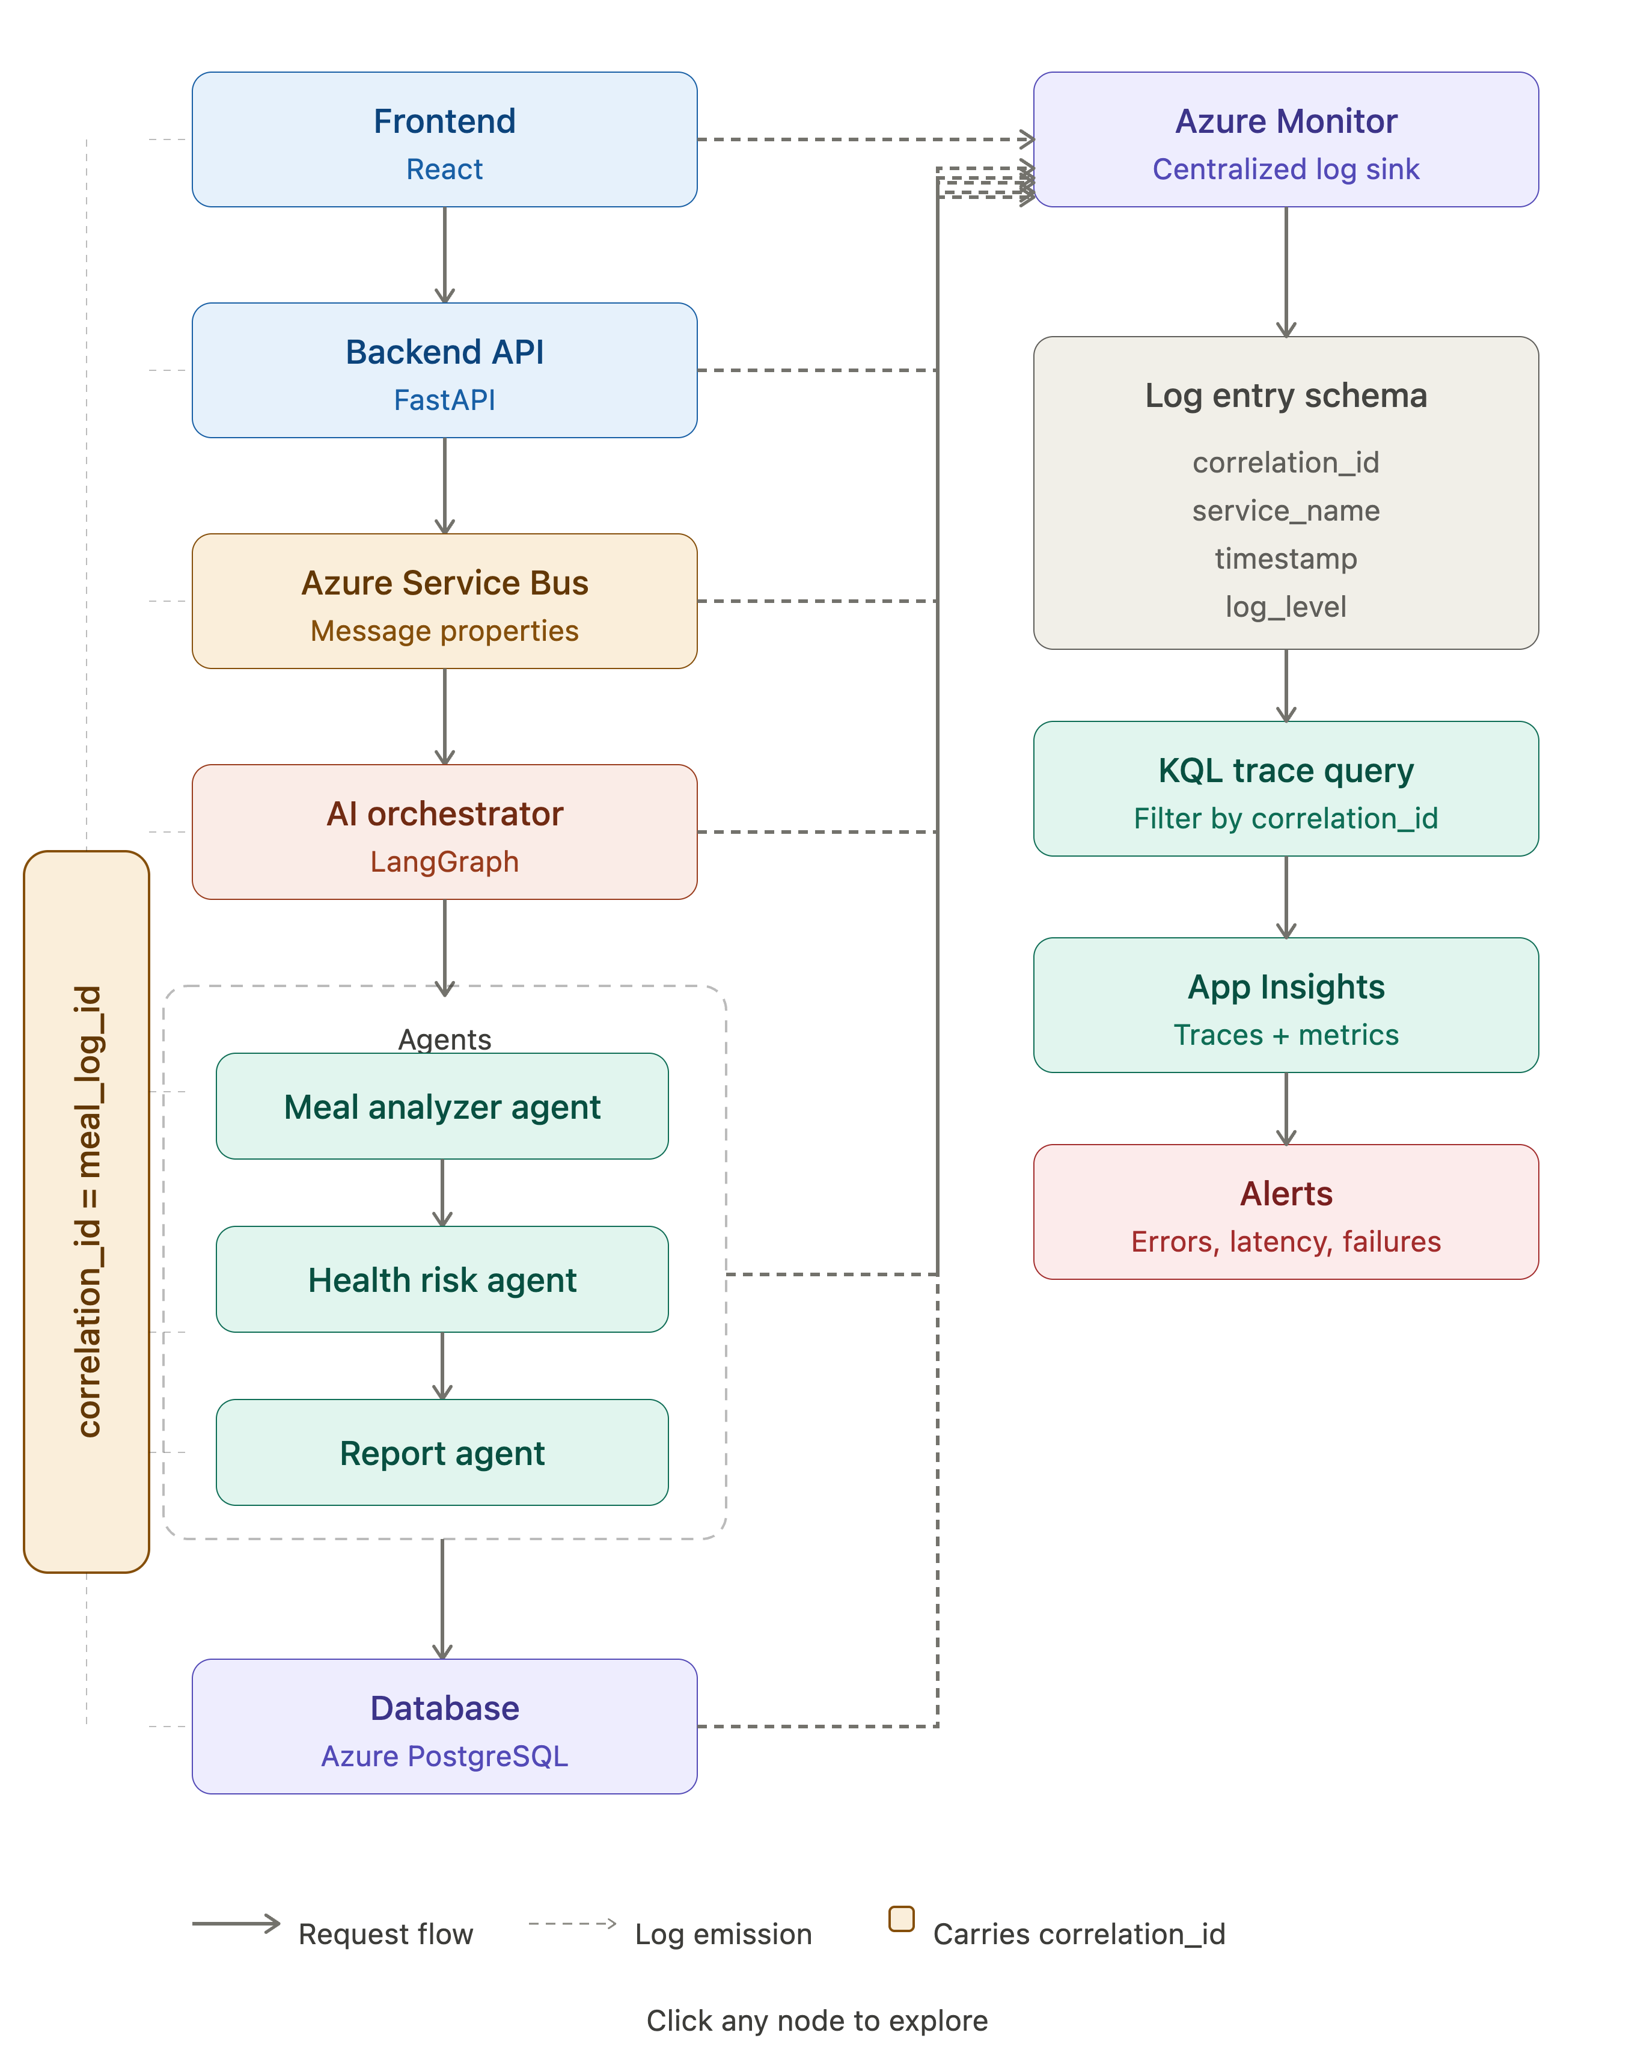
Figure 2: NutriGuard AI — Observability Plan and Correlation ID Flow

10.2 Monitored Metrics

Metric | Tool
API endpoint latency (p50, p95) | Application Insights
AI Orchestrator end-to-end latency | Application Insights + custom spans
Agent-wise latency (per agent step) | LangGraph trace + Application Insights
Azure Service Bus queue depth | Azure Monitor
Failed or dead-lettered events | Azure Monitor + alerts
Gemini API errors and quota exhaustion | Application Insights exceptions
Azure AI Search query errors | Azure Monitor diagnostics
PostgreSQL query latency and errors | Azure Database metrics
AKS pod restarts and OOM events | Azure Monitor container metrics
End-to-end report generation time | Custom Azure Monitor metric

11. Success Metrics

Metric | Target
Food item extraction accuracy | > 90%
Risk flag accuracy | > 85%
Agent JSON output validity rate | > 95%
Safety violation rate (diagnosis / dosage) | 0%
End-to-end report generation latency (demo) | < 20 seconds
Failed workflow rate | < 5%
Correlation ID trace coverage | 100% of requests

12. Scope & Out-of-Scope

12.1 In Scope (MVP)
- Simple natural language meal text input
- User health profile: goal, diet type, conditions, supplements
- 3-agent LangGraph pipeline (Meal Analyzer → Health Risk → Report)
- Safe risk flags with medium/low severity
- Daily nutrition report with suggestions and disclaimer
- Event-driven architecture using Azure Service Bus
- Local development with PostgreSQL
- Azure-ready deployment architecture
- Centralized logging with correlation_id tracing

12.2 Out of Scope (MVP)
- Exact calorie or macro gram calculation
- Medical diagnosis of any health condition
- Medicine or prescription dosage recommendations
- Changes to existing prescriptions
- Image-based food recognition
- Wearable device integration (e.g., Fitbit, Apple Watch)
- Full mobile application (iOS/Android)
- Real doctor consultation or teleconsultation workflow

NutriGuard AI — Project Design Document
Built with LangGraph, Gemini, Azure AI Search, FastAPI, and React

