Assignment 3 (Introduction to Databases)

Q1- Create Database

Ans- 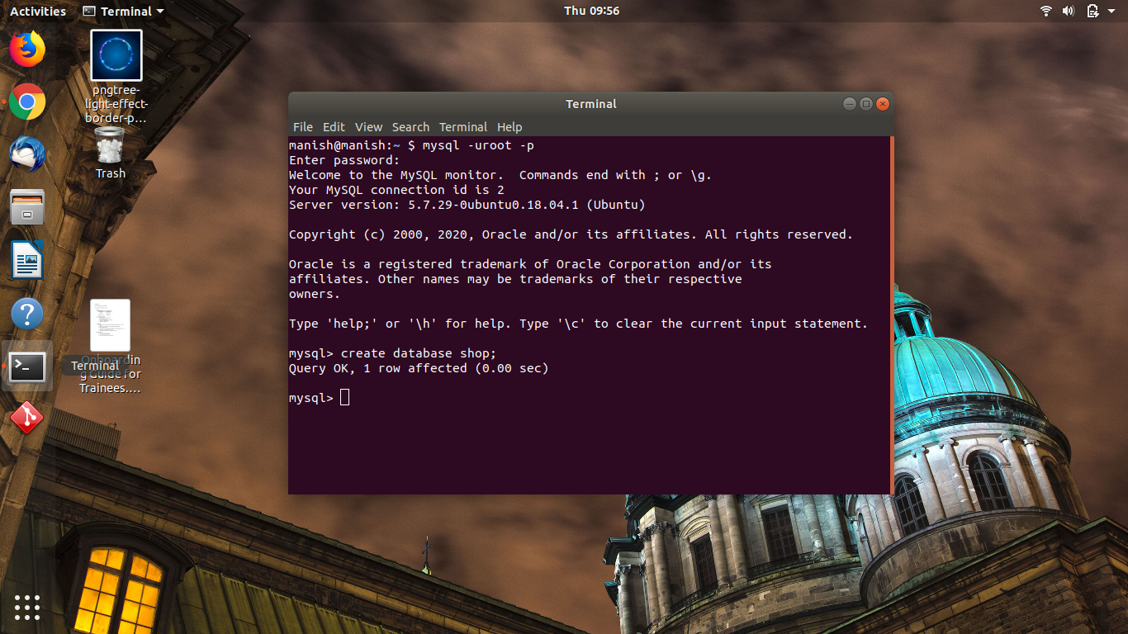

Q2- Design schema

Ans-

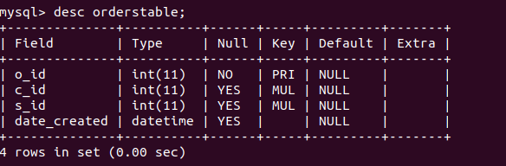

Q3- Create tables

Ans- create table <table_name>;

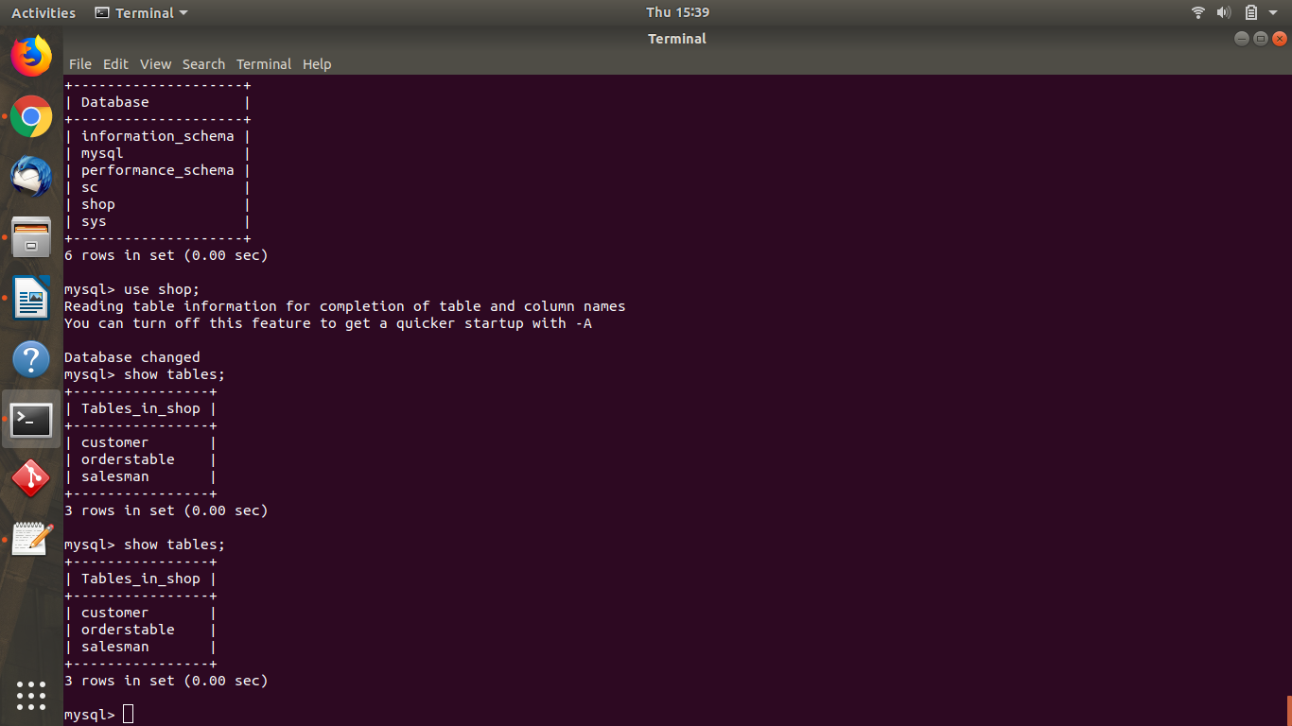

Q4- Insert sample data

Ans- 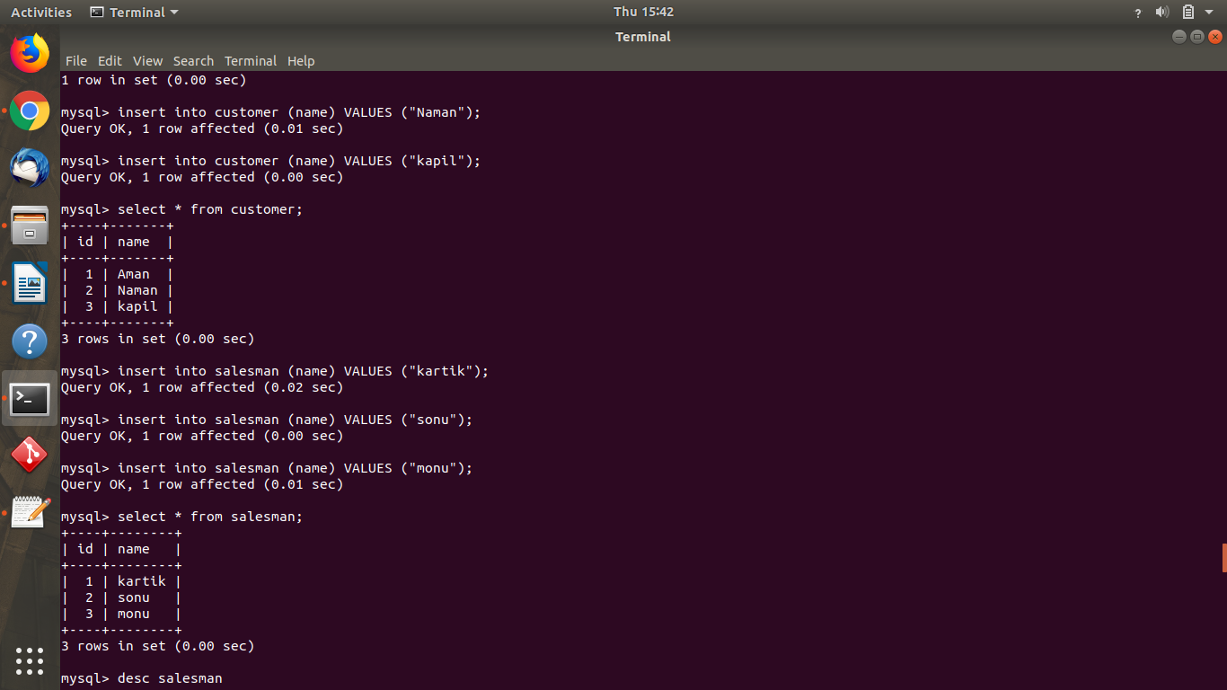

Q5- Find the sales person have multiple orders.

Ans- 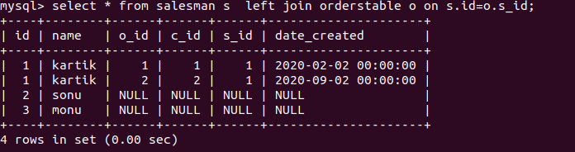

Q6- Find the all sales person details along with order details

Ans- 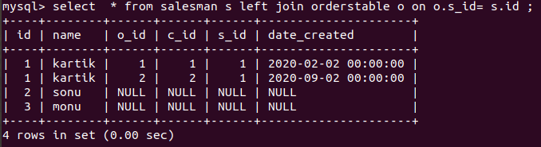

Q7- Create index

Ans- 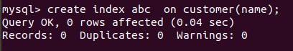

Q8- How to show index on a table

Ans- 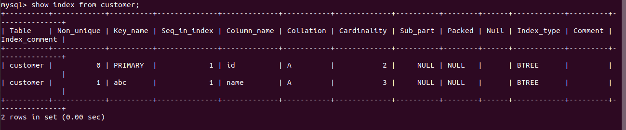

Q9- Find the order number, sale person name, along with the customer to whom that order belongs to

Ans- 