**Assignment-JAVA_1**

//Q1. Write a program to replace a substring inside a string with other string ?

import java.util.Scanner;

public class First {

Scanner sc=new Scanner(System.*in*);

String str,rep_str,new_str;

public void set(){

System.*out*.println("Enter a String:");

str=sc.nextLine();

System.*out*.println("Enter String to replace:");

rep_str=sc.nextLine();

System.*out*.println("Enter new String:");

new_str=sc.nextLine();

}

public void repSubString(){

String replaced_str=str.replace(rep_str,new_str);

System.*out*.println("New String: "+replaced_str);

}

public static void main(String[] args) {

First obj=new First();

obj.set();

obj.repSubString();

}

}

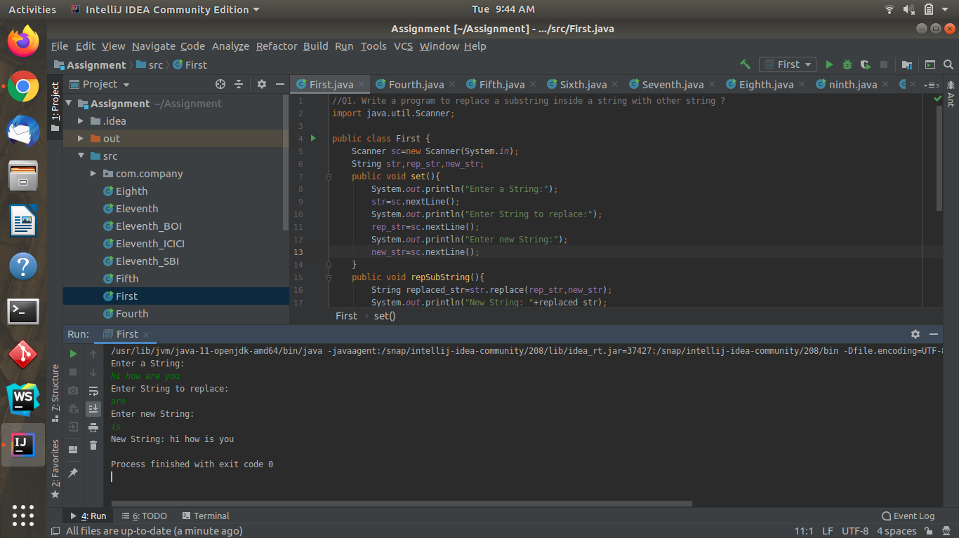

//Q2. Write a program to find the number of occurrences of the duplicate words in a string and print them ?

import java.util.Scanner;

public class Second {

Scanner sc=new Scanner(System.*in*);

public void dublicateWords(){

System.*out*.print("Enter a String: ");

String string =sc.nextLine();

int count;

string = string.toLowerCase();

String words[] = string.split(" ");

System.*out*.println("Duplicate words in a given string : ");

for(int i=0;i<words.length;i++){

count=1;

for(int j=i+1;j<words.length;j++){

if(words[i].equals(words[j])){

count++;

words[j] = "0";

}

}

if(count>1 && words[i]!="0")

System.*out*.println(words[i]+" "+count);

}

}

public static void main(String[] args) {

Second obj = new Second();

obj.dublicateWords();

}

}

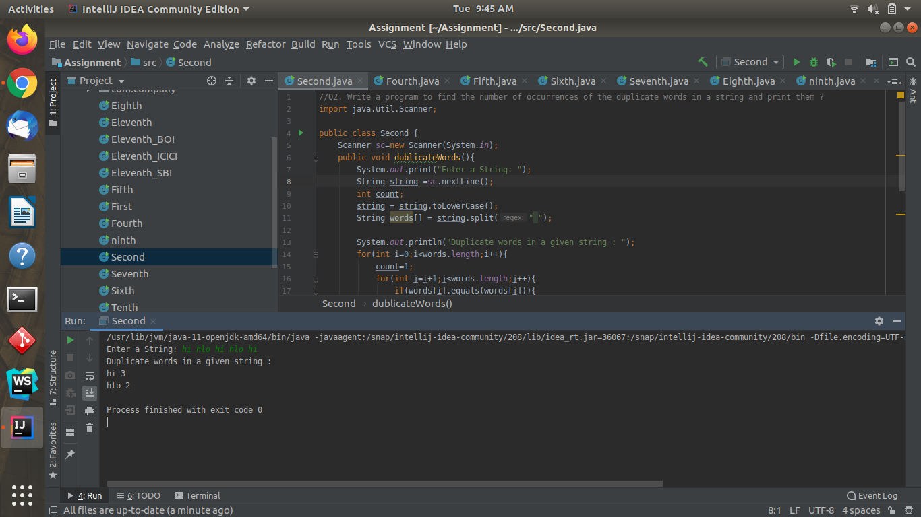

//Q3. Write a program to find the number of occurrences of a character in a string without using loop?

import java.util.Scanner;

public class Third {

Scanner sc=new Scanner(System.*in*);

public void findChar(){

System.*out*.println("Enter String: ");

String str=sc.nextLine();

System.*out*.println("Enter character to count:");

char arr=sc.next().charAt(0);

String temp=str.replaceAll(String.*valueOf*(arr),"");

int count=str.length()-temp.length();

System.*out*.println("count of "+arr+" is "+count);

}

public static void main(String[] args) {

Third obj=new Third();

obj.findChar();

}

}

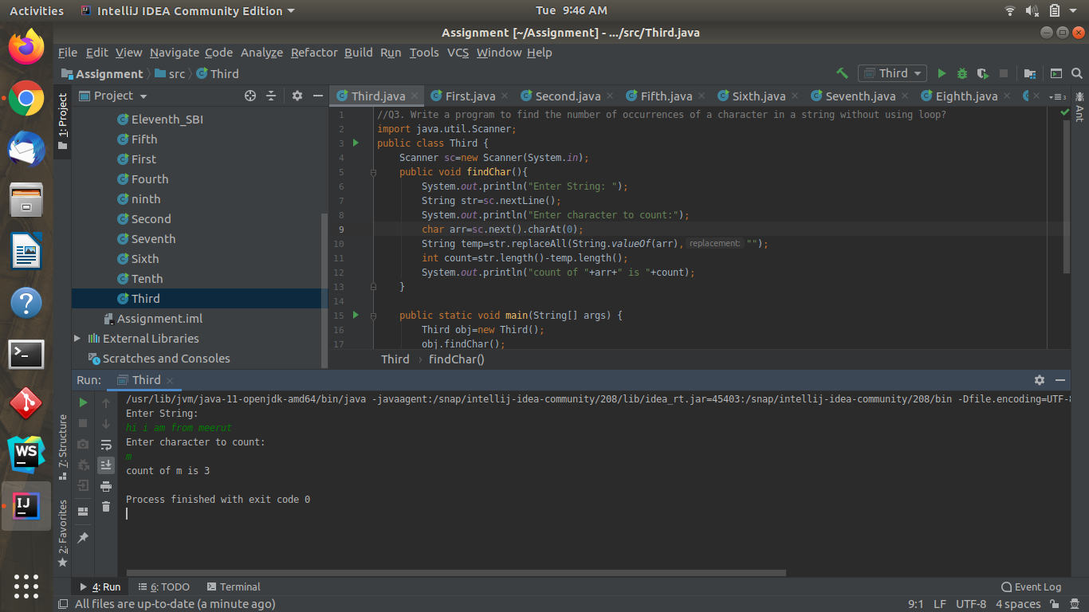

**//Q4. Calculate the number & Percentage Of Lowercase Letters,Uppercase Letters, Digits And Other Special Characters In A String**

**import java.util.Scanner;**

**public class Fourth{**

**public void percentageString(){**

**Scanner sc=new Scanner(System.*in*);**

**System.*out*.println("Enter String");**

**String str=sc.nextLine();**

**int upperCase = 0,lowerCase = 0,digits = 0,others = 0;**

**for (int i=0;i<str.length();i++){**

**char ch=str.charAt(i);**

**if (Character.*isUpperCase*(ch)){**

**upperCase++;**

**}**

**else if(Character.*isLowerCase*(ch)){**

**lowerCase++;**

**}**

**else if(Character.*isDigit*(ch)){**

**digits++;**

**}**

**else {**

**others++;**

**}**

**}**

**int totalChar = str.length();**

**double upperCaseLetterPercentage = (upperCase * 100) / totalChar;**

**double lowerCaseLetterPercentage = (lowerCase * 100) / totalChar;**

**double digitsPercentage = (digits * 100) / totalChar;**

**double otherCharPercentage = (others * 100) / totalChar;**

**System.*out*.println("Your string is: "+str);**

**System.*out*.println("Uppercase letters are ("+upperCase+")" + upperCaseLetterPercentage + "% ");**

**System.*out*.println("Lowercase letters are ("+lowerCase+")" + lowerCaseLetterPercentage + "%");**

**System.*out*.println("Digits Are ("+digits+")" + digitsPercentage + "%");**

**System.*out*.println("Other Characters Are ("+others+")" + otherCharPercentage + "%");**

**}**

**public static void main(String[] args) {**

**Fourth obj=new Fourth();**

**obj.percentageString();**

**}**

**}**

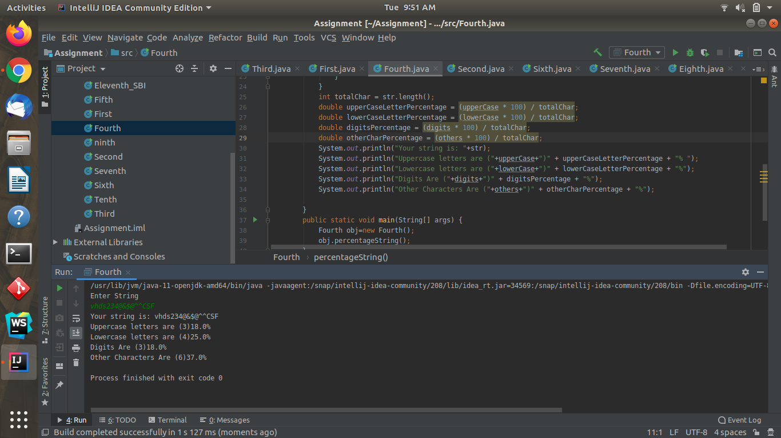

**//Q5. Find common elements between two arrays.**

**import java.util.Scanner;**

**public class Fifth {**

**public void array(){**

**System.*out*.println("How many elements you want in array: ");**

**Scanner sc=new Scanner(System.*in*);**

**int num=sc.nextInt();**

**int arr1[]=new int[num];**

**int arr2[]=new int[num];**

**System.*out*.printf("Enter %d elements in array one",num);**

**for(int i=0;i<num;i++){**

**arr1[i]=sc.nextInt();**

**}**

**System.*out*.printf("Enter %d elements in array two",num);**

**for(int i=0;i<num;i++){**

**arr2[i]=sc.nextInt();**

**}**

**System.*out*.println("Repeted elements are: ");**

**for(int i=0;i<num;i++){**

**for(int j=0;j<num;j++){**

**if(arr1[i]==arr2[j]){**

**System.*out*.println(arr2[j]);**

**arr2[j]=0;**

**}**

**}**

**}**

**}**

**public static void main(String[] args) {**

**Fifth obj=new Fifth();**

**obj.array();**

**}**

**}**

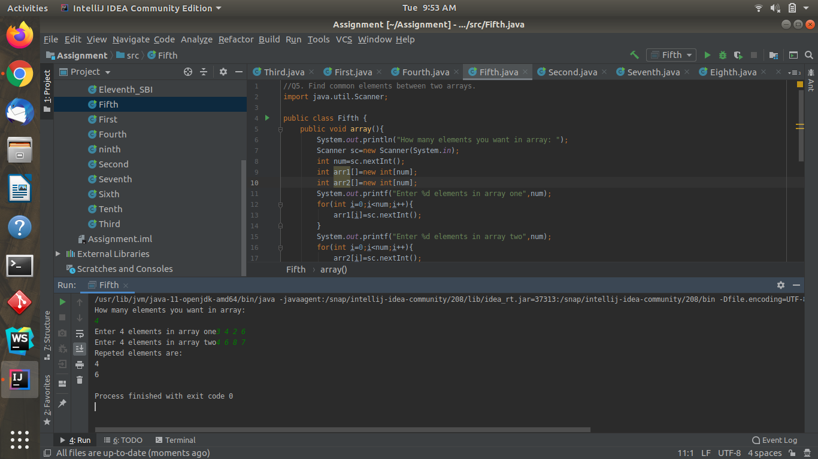

**//Q6. There is an array with every element repeated twice except one. Find that element**

**public class Sixth {**

**public void findSingleElement(){**

**int arr[]={2,3,4,5,6,2,3,6,5};**

**int temp=0;**

**for(int i=0;i<arr.length;i++){**

**temp=temp^arr[i];**

**}**

**System.*out*.println("Single element is:"+temp);**

**}**

**public static void main(String[] args) {**

**Sixth obj=new Sixth();**

**obj.findSingleElement();**

**}**

**}**

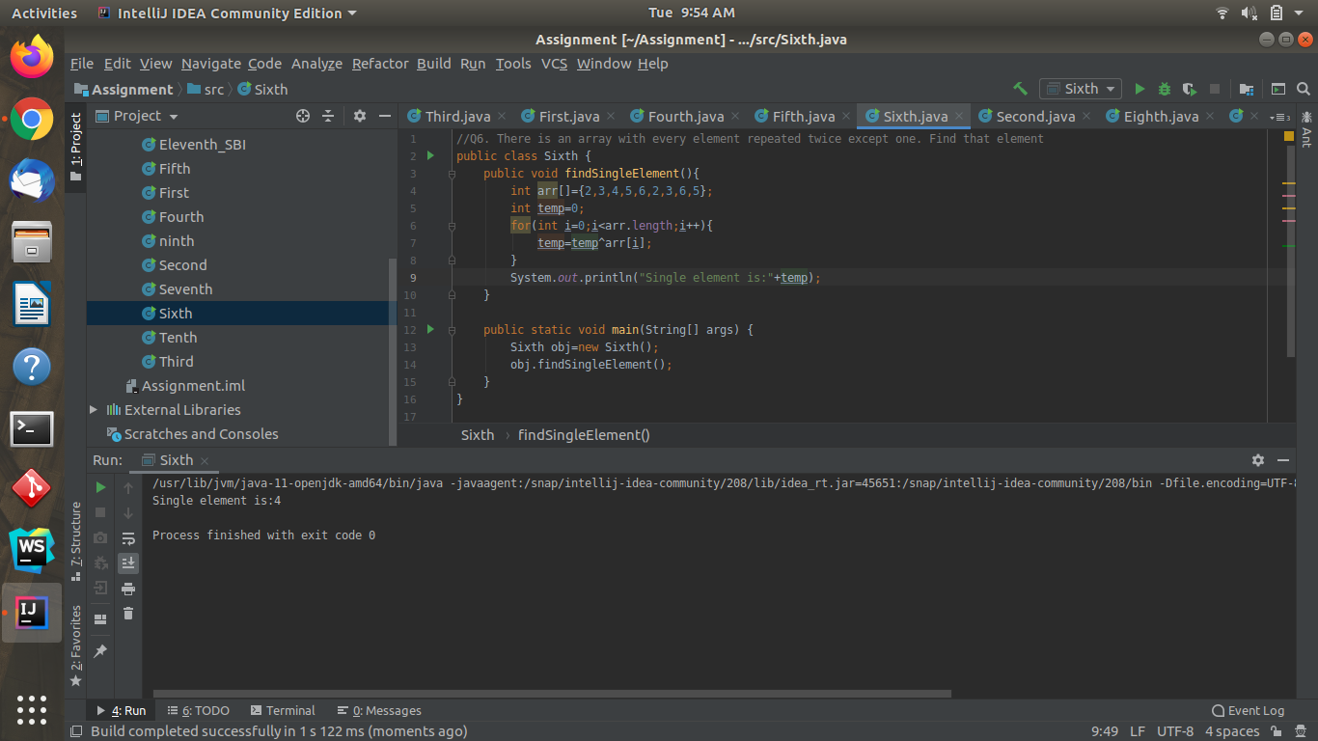

**//Q7. Write a program to print your Firstname,LastName & age using static block,static method & static variable respectively**

**public class Seventh {**

**static {**

**String name="Manish";**

**System.*out*.println(name);**

**}**

**static int *age*=21;**

**static void staticMethod(){**

**String last_name="Saini";**

**System.*out*.println(last_name);**

**}**

**public static void main(String[] args) {**

**Seventh.*staticMethod*();**

**System.*out*.println(Seventh.*age*);**

**}**

**}**

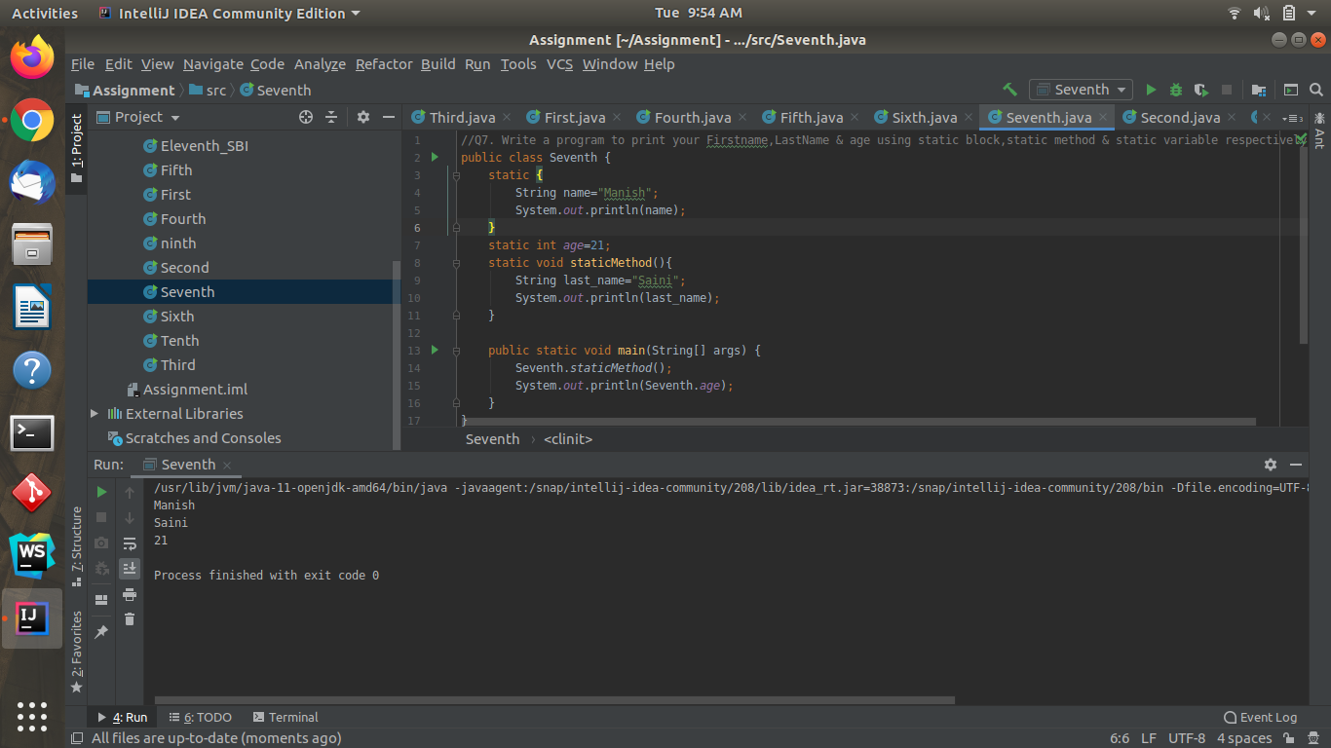

**//Q8. Write a program to reverse a string and remove character from index 4 to index 9 from the reversed string using String Buffer**

**import java.util.Scanner;**

**public class Eighth {**

**public void stringBuffer(){**

**System.*out*.println("Enter a String(minimum 9 characters): ");**

**Scanner sc=new Scanner(System.*in*);**

**String str=sc.nextLine();**

**StringBuffer sb=new StringBuffer(str);**

**sb=sb.reverse();**

**System.*out*.println("Reverse String: "+sb);**

**sb=sb.delete(4,9);**

**System.*out*.println("Modified String: "+sb);**

**}**

**public static void main(String[] args) {**

**Eighth obj=new Eighth();**

**obj.stringBuffer();**

**}**

**}**

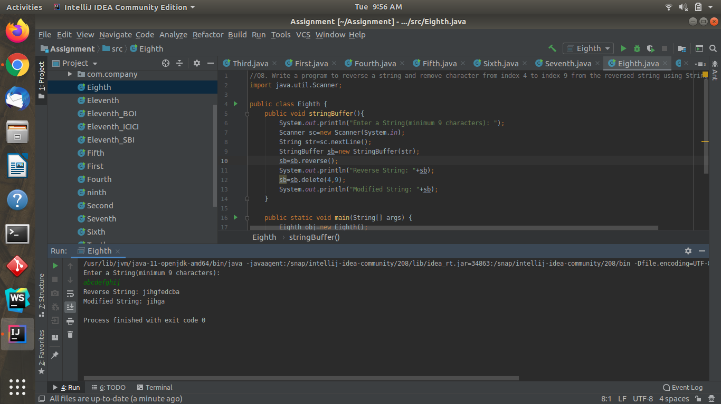

**//Q9.Write a program to display values of enums using a constructor & getPrice() method (Example display house & their prices)**

**public class ninth {**

**enum house{**

***house1*(500000),**

***house2*(800000),**

***house3*(1000000);**

**private int price;**

**house(int price)**

**{**

**this.price=price;**

**}**

**int getPrice(){**

**return price;**

**}**

**}**

**public static void main(String[] args) {**

**for(house h:house.*values*())**

**{**

**System.*out*.println("Price of "+h+" is "+h.getPrice());**

**}**

**}**

**}**

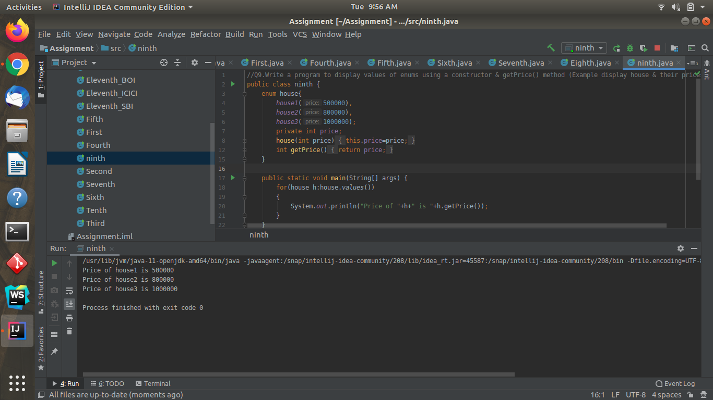

**//Q10.Write a single program for following operation using overloading**

**// A) Adding 2 integer number**

**// B) Adding 2 double**

**// C) multiplying 2 float**

**// D) multiplying 2 int**

**// E) concate 2 string**

**// F) Concate 3 String**

**public class Tenth {**

**public static void main(String[] args) {**

**int a=5,b=10;**

**double c=10.56,d=23.54;**

**float e=10.56f,f=23.54f;**

**String s1="Manish ",s2="Saini ",s3="Meerut ";**

***add*(a,b);**

***add*(c,d);**

***multi*(a,b);**

***multi*(e,f);**

***concat*(s1,s2);**

***concat*(s1,s2,s3);**

**}**

**public static void add(int a,int b){**

**System.*out*.println("Added Int: "+(a+b));**

**}**

**public static void add(double c,double d){**

**System.*out*.println("Added Float: "+(c+d));**

**}**

**public static void multi(float e,float f){**

**System.*out*.println("Multiply Float: "+(e*f));**

**}**

**public static void multi(int a,int b){**

**System.*out*.println("Multiply Int: "+(a*b));**

**}**

**public static void concat(String s1,String s2){**

**System.*out*.println("Concat Two Strings: "+s1.concat(s2));**

**}**

**public static void concat(String s1,String s2,String s3){**

**System.*out*.println("Concat Three String: "+(s1+s2+s3));**

**}**

**}**

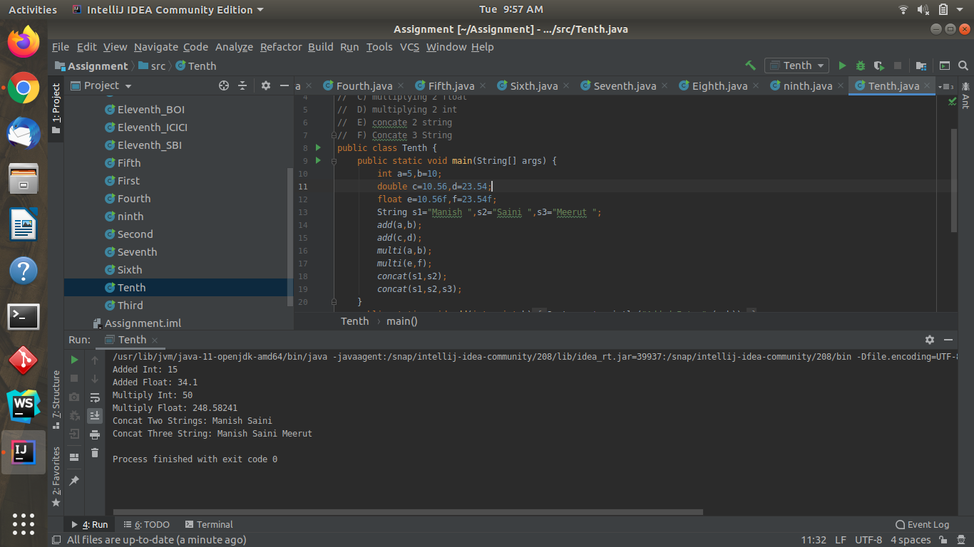

**//Q11.Create 3 sub class of bank SBI,BOI,ICICI all 4 should have method called getDetails which provide there specific details like rateofinterest etc,print details of every banks**

**public class Eleventh {**

**public static void main(String[] args) {**

**Eleventh_ICICI ICICI=new Eleventh_ICICI();**

**ICICI.getDetails();**

**Eleventh_SBI SBI=new Eleventh_SBI();**

**SBI.getDetails();**

**Eleventh_BOI BOI=new Eleventh_BOI();**

**BOI.getDetails();**

**}**

**}**

**public class Eleventh_ICICI extends Eleventh{**

**private static double *rate* = 4.0;**

**private static String *Name*="Welcome ICICI Bank";**

**public double getRate() {**

**return *rate*;**

**}**

**public String getName() {**

**return *Name*;**

**}**

**public void getDetails()**

**{**

**System.*out*.println(getName());**

**System.*out*.println("Rate of interest: "+getRate());**

**}**

**}**

**public class Eleventh_SBI extends Eleventh{**

**private static double *rate* = 5.0;**

**private static String *Name*="Welcome SBI Bank";**

**public double getRate() {**

**return *rate*;**

**}**

**public String getName() {**

**return *Name*;**

**}**

**public void getDetails()**

**{**

**System.*out*.println(getName());**

**System.*out*.println("Rate of interest: "+getRate());**

**}**

**}**

**public class Eleventh_BOI extends Eleventh{**

**private static double *rate* =6.0;**

**private static String *Name*="Welcome BOI Bank";**

**public double getRate() {**

**return *rate*;**

**}**

**public String getName() {**

**return *Name*;**

**}**

**public void getDetails()**

**{**

**System.*out*.println(getName());**

**System.*out*.println("Rate of interest: "+getRate());**

**}**

**}**

