

**TITLE OF THE PROJECT:**

**TUCK SHOP ONLINE**

|  |  |  |  |
| --- | --- | --- | --- |
| **S.no** | **Registration no.** | **Name** | **Roll no.** |
| 1. | 11904986 | Thokala Rohith Reddy | 64 |
| 2. | 11905856 | Gattem Venkata Lakshmi | 65 |
| 3. | 11914446 | Navneet Rishav | 66 |
| 4. | 11913851 | Manish | 67 |

**INTRODUCTION**

Website:

A website is a group of web pages that have information in the various pages that contain similar subject materials. For instance, the web site would have a name (subject) such as GoodFords.com and have several pages related to good Ford vehicles. The website has a main web page commonly called the Homepage(index.html or default.html). The site’s address will display the homepage and you can click on hyperlinks to go to other pages on the website.

A webpage is a text page written in a form of HTML (hyper text markup language) that contains text, links or tags that will display graphics, audio, video, downloadable and of course other web pages.

Tuck Shop Online:

Tuck shop are one of the most valuable places at Lovely Professional University. Tuck Shops facilitates all the student as well professors with all the required equipment and materials. But the problem is limited stocks, lack of information available and different location. So, this website will act as a hub that will unite all the Tuck Shops at Lovely Professional University.

There are many objectives for Online Tuck shops:

The objective of this website is to facilitates a seamless experience of sale and purchase of various equipment and materials at over the network of tuck shop at LPU.

* This website will provide information about location of various tuck shop and the equipment available at there.
* The individual will also get information about the pricing of all the materials varying tuck shop to tuck shop.
* They will also get the information about the stocks of various equipment at different tuck shops.
* We will create another webpage and provide the link to all the tuck shop which will act as a counter system of number of materials available , sold and left with pricing.

DESCRIPTION OF THE PROJECT:

We are preparing the website by using HTML, CSS and Java. Project had divided into three different parts among the group member.

Firstly we had gathered the information about the tuck shop website and their startegics . We think how the first page and how we can show the information of the tuck shop and item available. And we started coding the mark tuck shop website via html, css and java.

CONTRIBUTION OF MEMBERS:

Our group member Manish have done the html design and used java script code for implementation of website. And other member done css styling for website and made the webpage outlay.

SYSTEM DESCRIPTION:

* When the user will open the webpage, He/she will land at the title page where details will be provided which are “Home” , “Different Shop”, “Item Available”, “Timing and Contact Details”, etc.
* The user will be able to see the different shops in the website when it click on “Different Shop”.
* In the same way they are able to see the timing and contact details , items available in the tuck shop.
* At last they can give us feedback also.

MODULES OF WEBSITE

* Login Page

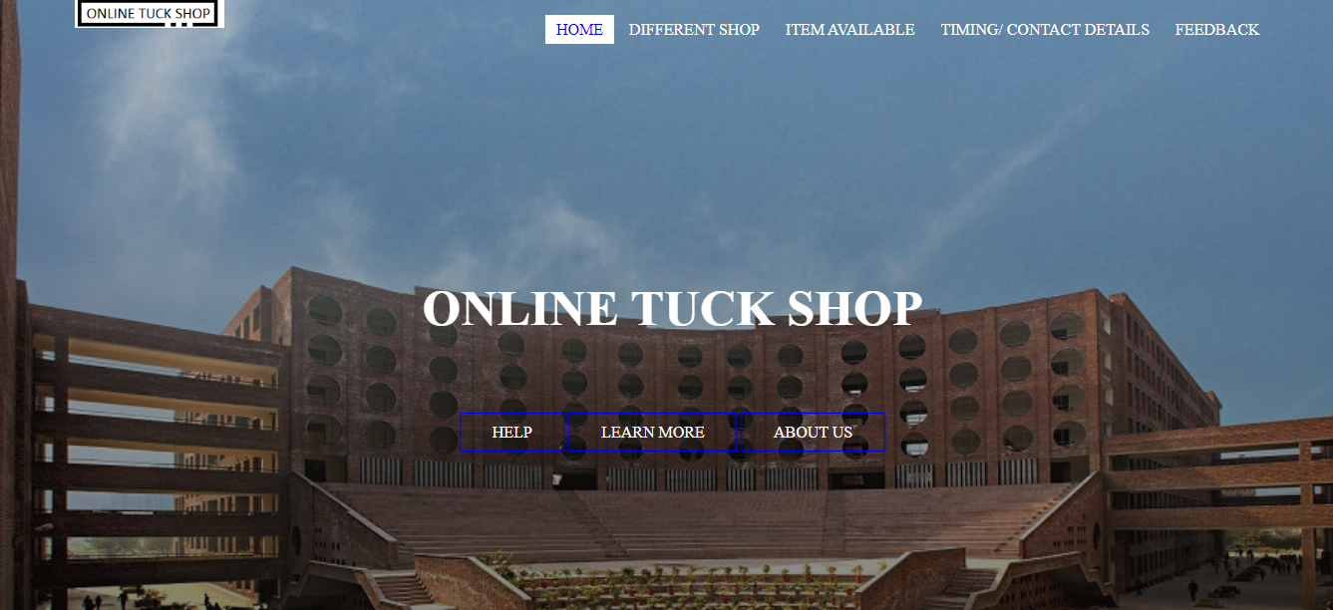

The following page is home page where user has to click on the option that where he want to go.

Explanation of the this page-

* First we create a body in which we make header and after that we make <div> whose class name is main and other <div> for image whose name is logo and then we make so many link.
* Now in header we use css like background positon ,size gradient ,height of the image. We use float right so that link should shift to the right side.
* And with the use of css we use hover to look nice.
* DIFFERENT SHOPS

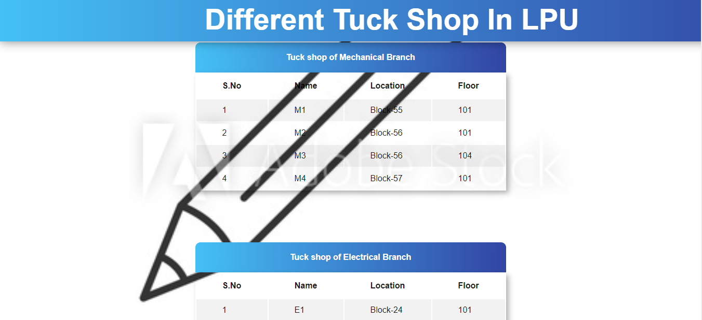

Explanation of this page:

* Firstly we created <div> and class name as table container after that we create table and under it we create another <div> name class name as table name.
* After that we give all the information about the shops like Shop name , location and floor.
* We also use css to make it looks good, we give align of the table name in the center , padding is also done so that their should a proper gap between the box.
* We use different color to make it look nicer, margin is also given, use of the border top radius make it to look nice here in this table we also use margin.
* ITEM AVAILABLE:

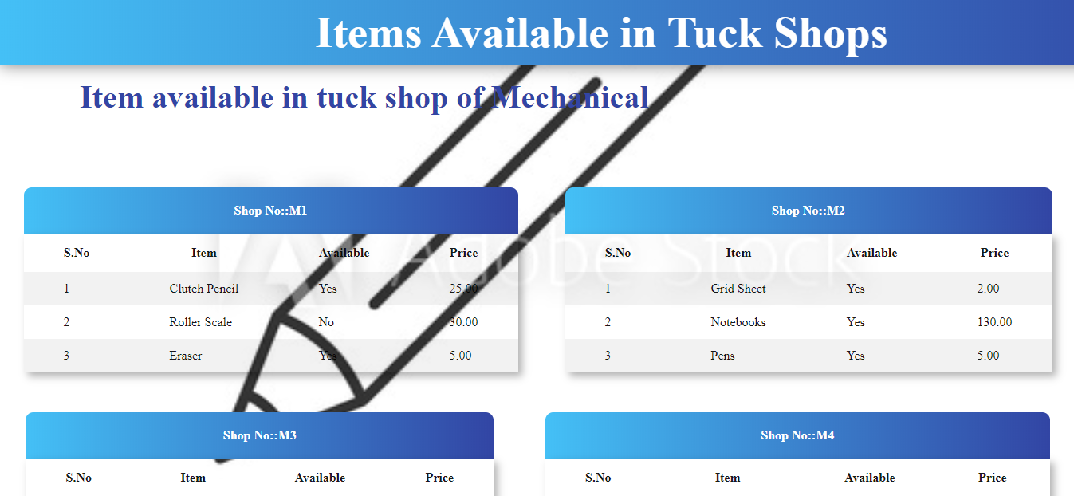

Explanation of this page:

* Firstly we created <div> and class name as table container after that we create table and under it we create another <div> name class name as table name.
* After that we give all the information about the shops like Shop name , location and floor.
* We also use css to make it looks good, we give align of the table name in the center , padding is also done so that their should a proper gap between the box.
* We use different color to make it look nicer, margin is also given, use of the border top radius make it to look nice here in this table we also use margin.
* TIMING AND CONTACT DETAILS:

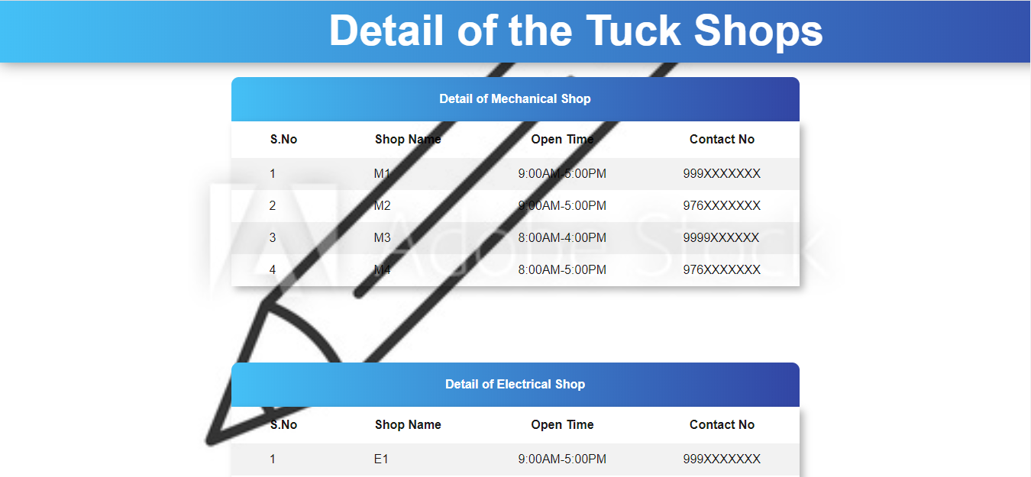

Explanation of this page:

* Firstly we created <div> and class name as table container after that we create table and under it we create another <div> name class name as table name.
* After that we give all the information about the shops like Shop name , location and floor.
* We also use css to make it looks good, we give align of the table name in the center , padding is also done so that their should a proper gap between the box.
* We use different color to make it look nicer, margin is also given, use of the border top radius make it to look nice here in this table we also use margin.
* FEEDBACK:

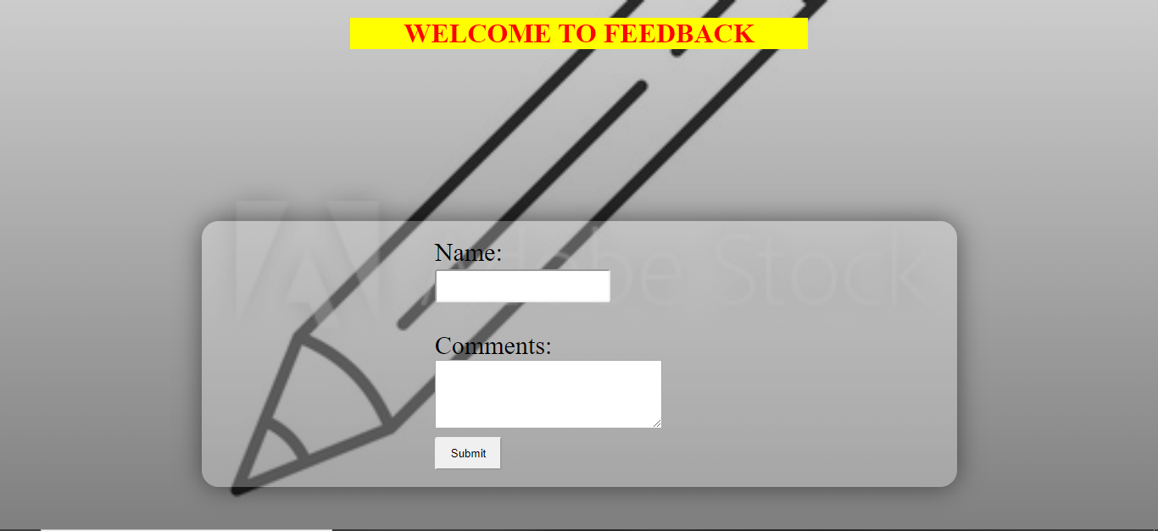

Explanation of this page:

* In this first we create a header and in this header we take three input name are “Name” , “Comment” and “Submit”.
* We also use java script in submit so that when you press submit then it show Thank you for feedback.
* In css we use margin to center the inputs we also define the area for the comment section use padding to gap between the box.
* We also use the border radius to round it from the corner.

**THANK YOU**