**ASSIGNMENT 3**

|  |  |
| --- | --- |
| **NAME** | **MANISH SENCHA** |
| **CLASS** | **B. TECH. III YEAR** |
| **BRANCH** | **CSE** |
| **SUBJECT** | **DESIGN AND ANALYSIS OF ALGORITHMS (CO34563)** |
| **ENROLMENT NUMBER** | **0801CS191048** |

Q1. Min_Point_Distance

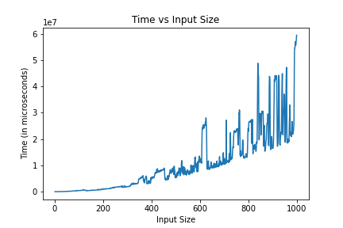

Q2. Max_Jump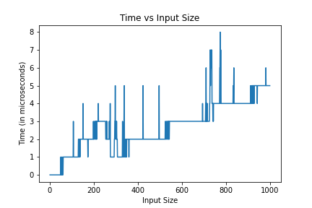

Q3. Fibonacci_Log_N

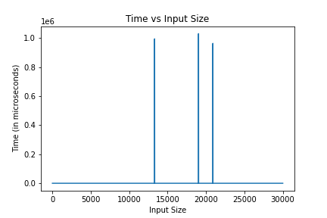

Q4. Majority_Element

