Design and Development of Snapkart: A Smart Self-Checkout, Multi-Role Billing, and Inventory Management System
(ES-452: Major Project - Dissertation)
submitted in partial fulfillment of the requirement
for the award of the degree of
Bachelor of Technology
in

Computer Science & Engineering
Submitted by
MANISH KUMAR
Enrollment No: 14118002722
Under the supervision of
MRS. ANUPAM SINGH
Assistant Professor
Department of Computer Science & Engineering
DELHI TECHNICAL CAMPUS
28/1, Knowledge Park-III, Greater Noida - 201306 (U.P.)
May 2026

DECLARATION

This is to certify that the material embodied in this Major Project - Dissertation titled "Design and Development of Snapkart: A Smart Self-Checkout, Multi-Role Billing, and Inventory Management System" being submitted in the partial fulfillment of the requirements for the award of the degree of Bachelor of Technology in Computer Science & Engineering is based on my original work. It is further certified that this Major Project - Dissertation work has not been submitted in full or in part to this university or any other university for the award of any other degree or diploma. My indebtedness to other works has been duly acknowledged at the relevant places.

(MANISH KUMAR)
Enrollment No: 14118002722
Department of Computer Science & Engineering

CERTIFICATE

This is to certify that the work embodied in this Major Project - Dissertation titled "Design and Development of Snapkart: A Smart Self-Checkout, Multi-Role Billing, and Inventory Management System" being submitted in the partial fulfillment of the requirements for the award of the degree of Bachelor of Technology in Computer Science & Engineering is original and has been carried out by MANISH KUMAR (Enrollment No. 14118002722) under my supervision and guidance.

It is further certified that this Major Project - Dissertation work has not been submitted in full or in part to this university or any other university for the award of any other degree or diploma to the best of my knowledge and belief.

Project Coordinator | Head of the Department | Page No.
3.1  3.2  3.3  3.4  4.1  4.2  4.3  4.4  4.5  5.1  5.2  5.3  5.4 | Use Case Diagram of TaarYa System  Data Flow Diagram - Level 0 (Context Diagram)  Data Flow Diagram - Level 1 (System Decomposition)  Data Flow Diagram - Level 2 (Detailed Decomposition)  Work Breakdown Structure of TaarYa  Class Diagram-AstroGraph RAG System  System Architecture Diagram  Flow Chart of Hybrid Retrieval Process  ER Diagram of TaarYa Data Model  Screenshot - Chat Interface (Agentic Query)  Screenshot - Explore Tab (Cone Search)  Screenshot - System Analysis Dashboard  Screenshot - Discovery Scoring Results | 15  16  16  17  18  22  22  23  24  25  25  26  26

CONTENT | PAGE NO. | Page No.
Declaration  3.1  3.2  3.3  5.1  5.2  6.1  6.2  6.3  6.4  6.5  6.6 | i  Feasibility Study Summary  Tools and Technologies Used  Hardware Requirements  REST API Endpoints  Non-Functional Performance Requirements  Test Cases for Cone Search Module  Test Cases for Discovery Scoring Engine  Test Cases for Hybrid Retrieval  Agentic Reasoning Core  Benchmarks Results  Retrieval Benchmarks Comparison | 4  5  13  13  14  28  28  29  30  30  31  32  32
(Mrs. Anupam Singh)
Assistant Professor (CSE)

DECLARATION i
CERTIFICATE ii
ACKNOWLEDGEMENT iii
ABSTRACT iv
LIST OF FIGURES v
LIST OF TABLES vi
CHAPTER 1: Introduction 1
1.1 Problem Statements 2
1.2 Objectives 3
1.3 Need and Significance 3
1.4 Intended Users 4
1.5 Abbreviations and Acronyms 4
CHAPTER 2: Problem Statement 6
2.1 Problem Definition 6
2.2 Objectives 7
CHAPTER 3: Analysis 8
3.1 Software Requirement Specifications 8
3.1.1 Functional Requirements of the Project 8
3.1.2 Non-Functional Requirements of the Project 10
3.2 Feasibility Study of the Project 12
Technical Feasibility 12
Operational Feasibility 12
Economic Feasibility 12
3.3 Tools / Technologies / Platform Used 13
3.4 Use Case Diagrams / Data Flow Diagrams 14
CHAPTER 4: Design and Architecture 18
4.1 Structure Chart / Work Breakdown Structure 18
4.2 Explanation of Modules 19
4.3 Flow Chart / Activity Diagram 21
4.4 Class Diagram / ER Diagram 23
CHAPTER 5: Implementation 25
5.1 Screenshots 25
5.2 Source Code of Some Modules 26
5.2.1 Discovery Scoring Engine 26
5.2.2 Hybrid Retrieval Orchestrator 27
5.2.3 REST API Endpoints 28
5.2.4 Non-Functional Performance Metrics 28
CHAPTER 6: Testing 29
6.1 Test Methodology 29
6.2 Test Cases 29
6.2.1 Cone Search Module 29
6.2.2 Discovery Scoring Engine 30
6.2.3 Hybrid Retrieval 30
6.2.4 Agentic Reasoning Core 31
6.3 Test Results Summary 31
6.4 Benchmark Summary (50 Queries, April 2026) 31
6.5 Formal Ablation Study 32
CHAPTER 7: Summary and Conclusion 33
CHAPTER 8: Limitation of the Project and Future Work 35
8.1 Limitations 35
8.2 Future Work 36
BIBLIOGRAPHY 38
APPENDIX 39
Appendix A: Benchmark Query Family Assignments 39
Appendix B: Discovery Ranking Pseudocode 39

Department of Computer Science & Engineering

ACKNOWLEDGEMENT

I would like to express my sincere gratitude to my faculty supervisor, Mrs. Anupam Singh, Assistant Professor, Department of Computer Science & Engineering, Delhi Technical Campus, Greater Noida, for her invaluable guidance, continuous support, and encouragement throughout the development of this project. Her technical expertise and timely feedback have been instrumental in shaping this work.

I am deeply grateful to the Head of the Department of Computer Science & Engineering and the Principal of Delhi Technical Campus for providing the necessary facilities and an academic environment conducive to research and development.

I would also like to thank Guru Gobind Singh Indraprastha University, New Delhi, for the structured academic curriculum that provided the theoretical foundation required for this project.

CHAPTER 1: INTRODUCTION
1.1 Background
The retail industry is one of the fastest-evolving sectors globally, driven by digital transformation, evolving consumer behaviour, and the increasing adoption of automation technologies. Traditional retail stores, which rely primarily on manual cashier-operated billing counters, are increasingly struggling to keep pace with the demands of modern shoppers who seek faster, contactless, and more efficient shopping experiences.
The limitations of manual billing systems are well-documented: long queues at peak hours, frequent billing errors, high dependency on trained staff, inability to function during internet outages, and inconsistency in inventory records. These challenges have created a significant gap in the retail industry for an integrated smart solution that addresses all these issues simultaneously.
The concept of self-checkout has gained considerable traction over the past decade. Pioneered by large retail chains and supermarkets across Europe and the United States, self-checkout systems allow customers to scan, pay, and exit independently, significantly reducing wait times and operational overheads. In India, retail chains such as Decathlon have adopted similar self-service models to enhance the shopping experience.
1.2 Project Overview
Snapkart is a smart self-checkout, multi-role billing, and inventory management system conceived to modernize retail operations in supermarkets, retail marts, and chain stores. The system provides an end-to-end retail management solution by integrating customer self-checkout, role-based administrative controls, automated digital billing, and real-time inventory management within a single unified platform.
The name 'Snapkart' reflects the core philosophy of the system — a quick, snap-and-go shopping experience for the customer. By enabling customers to scan products via barcode or QR code, manage their digital cart, complete payments through multiple modes, and generate a digitally stamped PAID bill, Snapkart eliminates the need to visit a traditional billing counter.
1.3 Motivation
The primary motivation behind this project stems from the practical challenges observed in conventional retail environments. During peak shopping hours, billing counters become bottlenecks, adversely impacting customer satisfaction. Moreover, the heavy reliance on human cashiers increases operational costs and introduces the risk of human error in billing and inventory management.
The COVID-19 pandemic further accelerated the need for contactless retail solutions. Customers today prefer minimal physical interaction during checkout, making digital self-checkout an increasingly attractive option. Additionally, the proliferation of smartphones with camera capabilities provides the ideal hardware for barcode and QR-based scanning without specialized equipment.
1.4 Scope of the Report
This report documents the complete design and development of the Snapkart system. It begins with the problem statement and objectives, followed by a detailed analysis of requirements, system design, implementation details, and testing strategy. The report is structured in accordance with the guidelines prescribed by Guru Gobind Singh Indraprastha University for the Major Project – Dissertation (ES-452).
The system is designed as a web-based application accessible through standard browsers on desktops, tablets, and smartphones. It is intended for deployment in supermarkets and retail stores and is built using open-source, industry-standard technologies including React.js, Node.js, Express.js, and MySQL/PostgreSQL.
1.5 Organisation of the Report
The report is organized into eight chapters. Chapter 1 provides the introduction and background. Chapter 2 defines the problem statement and project objectives. Chapter 3 covers the analysis including software requirements, feasibility study, technology stack, and system diagrams. Chapter 4 presents the design and architecture of the system. Chapter 5 discusses the implementation with screenshots and code modules. Chapter 6 details the testing strategy and test cases. Chapter 7 presents the summary and conclusion. Chapter 8 discusses limitations and future scope of the project.
Department of Computer Science & Engineering

CHAPTER 2: PROBLEM STATEMENT
2.1 Problem Definition
Despite rapid technological advancements in the retail sector, a majority of retail stores in India continue to rely on traditional, manually operated billing systems. These systems present numerous operational and customer experience challenges that are increasingly incompatible with the expectations of modern shoppers.
The key problems observed in existing retail billing and inventory management systems are as follows:
Long Queues at Billing Counters: Traditional retail billing requires every customer to visit a staffed counter to complete their purchase. During peak hours, this results in long waiting queues, increased customer dissatisfaction, and lost sales opportunities.
Manual Cashier Dependency and Human Errors: The billing process is entirely dependent on trained cashier staff, who are susceptible to errors in product entry, price calculation, and change handling. These errors lead to revenue loss and customer dissatisfaction.
High Manpower Costs: Maintaining dedicated cashier staff at multiple billing counters significantly increases operational costs for retail businesses, particularly in large supermarkets and retail chains.
Absence of Offline Functionality: Most existing retail billing systems are entirely dependent on internet connectivity. Any disruption in connectivity causes complete operational failure, loss of billing data, and inaccurate inventory records.
Data Inconsistency Across Channels: Online orders, in-store purchases, and delivery operations are typically managed by separate systems, leading to inconsistent inventory records, duplicate billing, and poor coordination between departments.
No Integrated Self-Checkout Mechanism: Existing systems do not provide a customer-driven self-checkout mechanism that allows users to independently scan products, manage a digital cart, process payment, and generate a valid PAID bill without assistance from store staff.

Lack of Real-Time Inventory Updates: Inventory management in many retail stores is handled manually or through separate systems, leading to stock mismatch, overstocking, and underreporting of sales figures.
These challenges collectively highlight the urgent need for a comprehensive, integrated, and technology-driven retail management solution.
2.2 Objectives
The main objective of this project is to design and develop a smart self-checkout retail system that simplifies the billing process, enhances the customer experience, and ensures accurate inventory management through automation and role-based access control.
The specific objectives of the Snapkart project are as follows:
To design a self-checkout system that enables customers to scan products using barcode or QR code, add items to a digital cart, and complete their shopping without visiting a traditional cash counter.
CHAPTER 3: ANALYSIS
3.1 Software Requirement Specifications
3.1.1 Functional Requirements
Functional requirements describe the specific operations, features, and behaviours that the Snapkart system must perform to fulfill user and business needs. The following table summarizes the core functional requirements:

Table 3.1: Functional Requirements Summary

3.1.2 Non-Functional Requirements
Non-functional requirements define the quality attributes and performance constraints of the Snapkart system. These requirements ensure the system is not only functionally correct but also reliable, secure, and usable.
Table 3.2: Non-Functional Requirements

3.2 Feasibility Study
A feasibility study evaluates the practicality and viability of the proposed Snapkart system from technical, economic, and operational perspectives. This analysis ensures that the project can be successfully developed and implemented within the available resources and constraints.
Table 3.3: Feasibility Analysis Summary

3.3 Tools / Technologies / Platform Used
The Snapkart system is developed using a modern, open-source technology stack. The selection of each technology was based on factors including community support, performance, scalability, and suitability for the intended use case.
Table 3.4: Technology Stack Details

3.4 Use Case and Data Flow Diagrams
System diagrams are used to visualize the structure, data flow, and interactions of the Snapkart system. These diagrams aid in understanding system behaviour from both user and developer perspectives.
Use Case Diagram
The Use Case Diagram captures the interactions between the different user roles (Admin, Customer, Delivery Boy, Counter Staff) and the system functionalities. Key use cases include Manage Products, Scan to Cart, Process Payment, Generate Bill, Update Delivery Status, and View Reports. Figure 3.1 presents the Use Case Diagram.

[Use Case Diagram – Snapkart]

Figure 3.1: Use Case Diagram of Snapkart System
Data Flow Diagram – Level 0
The DFD Level 0 (Context Diagram) shows the Snapkart system as a single process interacting with external entities: User, Payment Gateway, and Inventory Database. The user sends order details and payment; the system returns a bill and updates the inventory database. Figure 3.2 presents the DFD Level 0.

[DFD Level 0 – Snapkart Context Diagram]
Figure 3.2: Data Flow Diagram – Level 0
Data Flow Diagram – Level 1
Figure No. | Figure Title | Page No. | Primary Use Case
Figure 3.1 | Use Case Diagram of Snapkart System | 16 | Automated cross-catalog candidate discovery, VO tool integration
Figure 3.2 | Data Flow Diagram – Level 0 | 17 | Literature search, spatial queries, HR diagram generation
Figure 3.3 | Data Flow Diagram – Level 1 | 17 | Natural language queries, conceptual exploration
Figure 4.1 | System Architecture of Snapkart | 18 | API integration, benchmark evaluation, custom scoring
Figure 4.2 | Work Breakdown / Diagram Tree Structure | 19 | Generating teaching examples from real catalogs

The DFD Level 1 decomposes the Snapkart system into its major processes: Scan Product, Add to Cart, Generate Bill, Process Payment, Update Inventory, and Offline Sync. Each process shows the data flows between sub-processes, user inputs, and data stores. Figure 3.3 illustrates this.

[DFD Level 1 – Snapkart Detailed Data Flow]
Table No. | Table Title
Table 3.1 | Functional Requirements Summary
Table 3.2 | Non-Functional Requirements
Table 3.3 | Feasibility Analysis Summary
Table 3.4 | Technology Stack Details
Table 3.5 | Hardware Requirements
Table 3.6 | Software Requirements
Table 6.1 | Test Cases – User Authentication Module
Table 6.2 | Test Cases – Product Scanning and Cart Module
Table 6.3 | Test Cases – Payment and Billing Module
Table 6.4 | Test Cases – Inventory Management Module
Table 6.5 | Test Cases – Offline Mode and Sync Module
NER | Named Entity Recognition: extraction of entity names from unstructured text
FastAPI | Modern Python web framework for building REST APIs
Neo4j | Graph database used for knowledge graph storage
Qdrant | Vector similarity search engine used for semantic retrieval
Figure 3.3: Data Flow Diagram – Level 1

Department of Computer Science & Engineering

CHAPTER 4: DESIGN AND ARCHITECTURE
4.1 System Architecture / Work Breakdown Structure
The Snapkart system is built on a standard three-tier web application architecture comprising the Presentation Layer (Frontend), Business Logic Layer (Backend), and Data Layer (Database). This separation of concerns ensures scalability, maintainability, and clear responsibility boundaries between system components.
The Frontend is built with React.js, providing role-based dashboards for each user type. It communicates with the Backend via RESTful APIs over HTTPS. The Backend, built with Node.js and Express.js, handles authentication, business logic, payment verification, and inventory updates. The primary database (MySQL/PostgreSQL) stores all persistent data, while IndexedDB handles local offline storage in the browser.

[System Architecture Diagram – Three-Tier Web Architecture]
Figure 4.1: System Architecture of Snapkart
Work Breakdown / Diagram Tree Structure
The Snapkart system is structured into three primary modules: the User Module (Scan Product, Cart Management, Self/Counter Pay, Bill + PAID Stamp), the Admin Module (Product Management, Inventory Control, Reports & Monitoring), and the Delivery Module (View Assigned Orders, Update Delivery Status).

[Snapkart System – Diagram Tree Structure]
Figure 4.2: Work Breakdown – Snapkart System Diagram Tree
4.2 Explanation of Modules
4.2.1 User (Customer) Module
This module is the primary interface for customers. After role-based authentication, customers access a clean dashboard that allows them to initiate a self-checkout session. The module comprises the following sub-components:
Product Scanning Sub-module: Uses the device camera or a USB/wireless barcode scanner to scan product barcodes or QR codes. The scanned code is sent to the backend API, which retrieves product details including name, price, tax category, and available stock. In offline mode, product data is retrieved from the locally cached IndexedDB.
Cart Management Sub-module: Displays all scanned products in a digital cart with real-time price calculation including GST. Customers can modify quantities or remove items at any point before generating the bill.
Bill Generation Sub-module: On checkout, the system generates a detailed digital bill marked UNPAID. The bill includes product name, quantity, unit price, tax amount, and total payable amount along with a timestamp and transaction ID.
Payment Sub-module: Customers can choose from UPI, credit/debit card, or digital wallet payment options. On selecting 'Pay at Counter', the bill is flagged for counter staff processing. The payment module interfaces with the configured payment gateway API for transaction verification.
PAID Stamp & Exit Sub-module: Upon confirmed payment, the bill status is updated to PAID, and a QR code receipt is generated for exit verification. This prevents unpaid items from leaving the store.
4.2.2 Admin Module
The Admin Module provides the store administrator with full control over the Snapkart system. Key functionalities include:

Product Management: Admin can add new products by entering product details and generating/uploading barcode or QR code identifiers. Existing products can be updated or removed from the catalogue.

Inventory Control: Inventory levels are displayed in real time. The admin can set reorder thresholds, view low-stock alerts, and manually adjust inventory levels if required.
User Management: Admin can create, modify, or deactivate user accounts for Counter Staff and Delivery Boys. Role assignments are managed from this panel.

Reports & Monitoring: Sales reports, daily transaction summaries, and inventory movement reports are accessible through the admin dashboard, supporting data-driven business decisions.
4.2.3 Delivery Boy Module

The Delivery Boy Module enables delivery personnel to manage and update the status of assigned home delivery orders. Features include viewing order details, updating delivery progress (Out for Delivery, Delivered, Failed), and confirming successful deliveries. All updates are synchronized in real time with the central system and are visible to the Admin and the respective customer.
4.2.4 Counter Staff Module
The Counter Staff Module is designed for store employees who assist customers preferring traditional billing. Counter staff can look up unpaid bills by transaction ID or customer account, process counter payments on behalf of the customer, and generate the final PAID receipt. This module ensures that customers who are not comfortable with self-checkout are still served efficiently.
FR# | Feature | Description
FR1 | User Authentication | Role-based secure login for Admin, Customer, Delivery Boy, Counter Staff using JWT tokens
FR2 | Product Management | Admin can add, update, delete products with barcode, QR code, price, tax, and stock data
FR3 | Barcode/QR Scanning | Customers scan products using device camera or USB scanner; works online and offline

4.2.5 Offline Sync Module
A critical differentiator of Snapkart is its robust offline capability. When internet connectivity is unavailable, the system seamlessly switches to offline mode. Product data, previously cached in IndexedDB, is used for scanning and cart operations. All transactions are stored locally with timestamps and queued for synchronization. When connectivity is restored, the offline sync engine uploads all pending transactions to the central server, resolves any conflicts using a timestamp-based merge strategy, and updates the central inventory accordingly.
4.3 Flow Chart / Activity Diagram
Quality Attribute | Requirement | Purpose
Performance | Page load time under 2 seconds; barcode scan response under 1 second; support 100+ concurrent users | Core application language; managed via uv package manager
Security | HTTPS for all communications; JWT-based stateless authentication; RBAC enforcement; SQL injection prevention | Exposes all endpoints on port 8000
Reliability | 99.9% uptime target; offline mode ensures zero billing downtime; auto-recovery on reconnection | Stellar catalog storage and spatial queries
Usability | Intuitive, mobile-responsive UI requiring minimal training; supports touchscreen kiosks and smartphones | Vector embedding storage and semantic search
Scalability | Modular architecture allows addition of new stores, roles, or payment gateways without core redesign | Knowledge graph storage and Cypher queries
Maintainability | Clean RESTful API design; well-commented modular code; Git version control; documented API endpoints | Local LLM inference
Compatibility | Works on Chrome, Firefox, Safari; responsive on desktop, tablet, and mobile devices | Paper metadata and abstract retrieval
Data Integrity | Transactions are atomic; inventory updates only occur after confirmed payment; offline data preserved locally | Star cross-registration and validation
SAMP Hub | SAMP protocol | Desktop tool integration (Aladin, TOPCAT, DS9)
Sentence Transformers | Python library | Text embedding generation (all-MiniLM-L6-v2)
Astropy | Python library | Coordinate conversion and physical calculations
Docker Compose | Container orchestration | All database services containerized for reproducibility
The end-to-end process flow of the Snapkart self-checkout system is described below and illustrated in Figure 4.4. The flow covers the complete customer journey from login to exit.
Step 1 – User Authentication and Role-Based Access: The system begins with secure authentication. Users log in using their credentials. The backend validates the credentials and issues a JWT token, granting access to role-specific features. Unauthorized access to restricted routes is blocked.
Step 2 – Product Scanning and Cart Management: After login, the customer initiates a scan session. Each scanned barcode or QR code triggers an API call that returns the product details. The cart is dynamically updated with each scan, and the running total is displayed in real time. In offline mode, cached product data is used.
Type | Findings | Recommended
Technical | Standard web stack (React, Node.js, MySQL); barcode scanning via browser APIs; offline via IndexedDB; no specialized hardware required — FEASIBLE | 32 GB
Economic | Open-source tools eliminate licensing costs; reduces counter staff; faster checkout improves throughput and revenue; cost-effective barcode scanners — FEASIBLE | 8 cores
Operational | User-friendly role-based dashboards; minimal training required; offline support ensures zero downtime; scalable to supermarkets and chains — FEASIBLE | NVIDIA T4+ (for local LLM acceleration)
Storage | 100 GB SSD | 500 GB SSD (full Gaia subsets)
Network | Broadband (initial ingestion only) | N/A (offline after ingestion)

Step 3 – Bill Generation: When the customer proceeds to checkout, the system generates a digital bill. The bill includes all cart items, their quantities, unit prices, applicable tax, and the total amount. The bill is initially marked as UNPAID and stored in the database.
Step 4 – Payment Processing: The customer selects a payment method. For digital payments, the system interfaces with the payment gateway API. For counter payment, the bill is flagged for counter staff processing. The payment module waits for a confirmed transaction response before proceeding.
Step 5 – PAID Confirmation and Exit Authorization: Upon confirmed payment, the bill status is updated to PAID. A QR-coded digital receipt is generated. The customer presents this QR code at the exit gate for verification before leaving the store.
Step 6 – Inventory Update: Following payment confirmation, the system automatically deducts the sold quantities from the inventory. This update is propagated to the central database in real time, ensuring stock levels are always accurate.
Step 7 – Offline Data Synchronization: If any transactions were completed in offline mode, the sync engine is triggered upon reconnection. All locally stored transactions are uploaded, and inventory is updated accordingly.
Step 8 – Delivery Management: For home delivery orders, the delivery module assigns the order to a Delivery Boy. The Delivery Boy updates the order status through their dashboard, and the customer is notified at each stage.

[Dispatch and Delivery Process Flow Diagram]
Figure 4.3: Dispatch and Delivery Process Flow

[End-to-End Self-Checkout Activity Diagram]
Figure 4.4: End-to-End Process Flow / Activity Diagram
CHAPTER 5: IMPLEMENTATION
5.1 Proposed UI Screenshots
The Snapkart system is designed with a clean, responsive, and role-specific user interface. The following section describes the key screens and their intended design. Actual screenshots will be inserted after the application is fully developed and deployed.
Customer Login Screen
The login screen presents separate role selection for Customer, Admin, and Delivery Boy. Users enter their credentials and are authenticated via the backend JWT service. Invalid credentials display an appropriate error message.
[Screenshot: Customer Login Screen]
Figure 5.1: Customer Login Screen
Product Scan and Cart Management Screen
After login, the customer is presented with the self-checkout screen. A scan button activates the device camera for barcode/QR scanning. Each successfully scanned product appears in the cart with its name, unit price, quantity controls, and running subtotal. The cart calculates tax and total in real time.
[Screenshot: Product Scan and Cart Management Screen]
Figure 5.2: Product Scan and Cart Management Screen
Bill Generation Screen (UNPAID)
On checkout, the bill is presented with a full itemized list, tax breakdown, and total amount. The bill displays an UNPAID watermark prominently. The customer can review all items before proceeding to payment.
[Screenshot: Bill Generation Screen – UNPAID Status]
Figure 5.3: Bill Generation Screen (UNPAID)
Payment Screen
The payment screen presents UPI, Card, and Wallet options. On selecting UPI, a QR code is generated for scanning. Card payment opens a secure card entry form. On successful payment gateway response, the system proceeds to the PAID confirmation.
[Screenshot: Payment Screen]
Figure 5.4: Payment Screen
PAID Bill Receipt Screen
After payment confirmation, the bill is displayed with a PAID stamp. A QR code is generated for exit verification. The customer can download the receipt as a PDF or share it via email/WhatsApp.
[Screenshot: PAID Bill Receipt Screen]

Figure 5.5: PAID Bill Receipt Screen

Admin Dashboard
The Admin Dashboard provides a real-time overview of sales, inventory levels, active sessions, and recent transactions. Navigation options allow the admin to access product management, user management, inventory control, and reporting modules.
[Screenshot: Admin Dashboard]
Figure 5.6: Admin Dashboard

5.2 Source Code of Key Modules
5.2.1 User Authentication (Backend – Node.js/Express.js)
The following code illustrates the JWT-based login endpoint implemented in the Node.js backend:

// POST /api/auth/login
router.post('/login', async (req, res) => {
const { email, password, role } = req.body;
const user = await User.findOne({ where: { email, role } });
if (!user || !bcrypt.compareSync(password, user.passwordHash)) {
return res.status(401).json({ error: 'Invalid credentials' });
}
const token = jwt.sign(
{ userId: user.id, role: user.role },
process.env.JWT_SECRET, { expiresIn: '8h' }
);
res.json({ token, role: user.role, userId: user.id });
});

CHAPTER 6: TESTING
Software testing is a critical phase in the software development lifecycle that validates the functional and non-functional requirements of the Snapkart system. The testing strategy for Snapkart includes unit testing, integration testing, system testing, and user acceptance testing (UAT). Test cases are designed to verify each functional requirement described in Chapter 3.
6.1 Testing Strategy
The Snapkart system follows a structured testing approach:
Unit Testing: Individual functions and components (e.g., cart calculation, JWT verification, barcode parsing) are tested independently using Jest for JavaScript/Node.js modules.
Integration Testing: API endpoints are tested using Postman to ensure correct interaction between the frontend, backend, and database layers. Payment gateway integration is tested in sandbox mode.
System Testing: End-to-end scenarios are executed to validate the complete workflow from login to exit verification, covering both online and offline modes.
User Acceptance Testing (UAT): The system is evaluated against the original requirements by simulated end users representing Admin, Customer, Delivery Boy, and Counter Staff roles.
6.2 Test Cases
Module: User Authentication
Table 6.1: Test Cases – User Authentication Module

Module: Product Scanning and Cart
Table 6.2: Test Cases – Product Scanning and Cart Module

Module: Payment and Billing
Table 6.3: Test Cases – Payment and Billing Module

Module: Offline Mode and Sync
Table 6.5: Test Cases – Offline Mode and Sync Module

6.3 Project Timeline – Gantt Chart
The development of the Snapkart project was planned over a 10-week timeline divided into five major phases. The Gantt Chart below summarizes the planned schedule:
[Gantt Chart – Snapkart Project Timeline (10 Weeks)]
CHAPTER 7: SUMMARY AND CONCLUSION
7.1 Summary
This project presents the design and development of Snapkart — a smart self-checkout, multi-role billing, and inventory management system tailored for the modern retail industry. The system was conceived to address the well-documented shortcomings of traditional manual billing systems, including long customer queues, cashier dependency, billing errors, data inconsistency, and the absence of offline operational capability.
The Snapkart system integrates four major functional domains into a single unified platform. The self-checkout functionality empowers customers to independently scan products using barcode or QR code technology, manage their digital cart, process payments through multiple modes, and generate a PAID bill without visiting a billing counter. The role-based access control system ensures that Admin, Customer, Delivery Boy, and Counter Staff each interact with the system through dedicated, permission-restricted dashboards.
The automated inventory management module ensures that stock levels are updated in real time following every confirmed payment, eliminating the risk of stock mismatches that plague manual systems. The delivery management module extends the system's reach to home delivery operations, with real-time status tracking synchronized across all system roles.
A particularly significant achievement of this project is the offline store functionality. By leveraging IndexedDB for local browser storage and implementing a robust offline sync engine, the Snapkart system ensures uninterrupted retail operations even during internet connectivity failures. On reconnection, all pending transactions are automatically synchronized with the central server, preserving data integrity.
The technology stack — React.js, Node.js, Express.js, MySQL/PostgreSQL, and IndexedDB — was selected for its open-source availability, industry-wide adoption, and proven performance in production retail environments. Security was given high priority throughout the design, with JWT authentication, HTTPS encryption, and role-based access control enforced at every layer of the application.
7.2 Conclusion
CHAPTER 8: LIMITATIONS AND FUTURE WORK
8.1 Limitations of the Current System
While the Snapkart system addresses the core requirements of smart retail management, several limitations have been identified in the current version that present opportunities for future improvement:
No Native Mobile Application: The current implementation is a Progressive Web App (PWA) optimized for mobile browsers. A dedicated native Android or iOS application would offer better performance, push notifications, and deeper hardware integration for barcode scanning.
No AI-Powered Features: The system does not currently include artificial intelligence or machine learning capabilities for demand forecasting, personalized recommendations, or anomaly detection in billing patterns.
Limited Payment Gateway Integration: The current payment module is designed for integration with standard UPI and card payment gateways. Cryptocurrency payment support and Buy Now Pay Later (BNPL) options are not included.
No Facial Recognition or AI Theft Prevention: Advanced cashier-less store features such as facial recognition-based customer identification or AI-powered shelf monitoring and theft detection are outside the current scope.
Single Branch Architecture: The current system is designed for single-store deployment. Multi-branch retail chain management with centralized reporting across stores is not supported in the current version.
Third-Party Accounting Integration: Integration with third-party accounting platforms such as Tally, QuickBooks, or Zoho Books for automated GST filing and financial reporting is not included.
Limited Offline Payment Options: In offline mode, only counter-assisted payment can be processed. Digital self-payments require internet connectivity for gateway verification.
8.2 Future Enhancements
The following enhancements are proposed for future development iterations of the Snapkart system:
Native Android and iOS Mobile Application: Develop dedicated native apps using React Native or Flutter for improved performance, offline capabilities, and seamless camera-based barcode scanning.
AI-Powered Demand Forecasting and Analytics: Integrate machine learning models to analyse sales patterns, predict demand, identify slow-moving inventory, and generate intelligent reorder recommendations for store managers.
Personalized Customer Experience: Implement a recommendation engine that suggests products based on the customer's purchase history and browsing behaviour within the app.
Multi-Branch Enterprise Management: Extend the system architecture to support multi-store deployment with a central enterprise dashboard for owners to monitor and compare performance across branches.
Advanced Loyalty and Rewards Programme: Introduce a customer loyalty module with point accumulation, discount coupons, and personalized offer delivery via the app.
Integration with Accounting Platforms: Develop API connectors for popular accounting platforms to automate GST computation, invoice filing, and financial reporting.
Voice-Assisted Shopping: Integrate natural language processing (NLP) capabilities to enable voice-command product search and cart management for enhanced accessibility.
RFID-Based Checkout: Explore RFID tag integration as an alternative to barcode scanning, enabling bulk checkout of multiple items simultaneously for faster throughput.
Blockchain-Based Transaction Ledger: Investigate the use of blockchain technology for immutable and tamper-proof transaction records, enhancing audit trails and reducing fraud risk.
These enhancements, when implemented, will elevate Snapkart from a prototype-level academic project to a commercially competitive enterprise retail management platform capable of serving large-scale retail operations.
Department of Computer Science & Engineering

BIBLIOGRAPHY

[1] K. C. Laudon and C. G. Traver, E-Commerce: Business, Technology, Society. Pearson Education, 2020.
[2] I. Sommerville, Software Engineering, 10th ed. Pearson Education, 2016.
[3] R. S. Pressman and B. R. Maxim, Software Engineering: A Practitioner's Approach, 8th ed. McGraw-Hill, 2015.
[4] A. Silberschatz, H. F. Korth, and S. Sudarshan, Database System Concepts, 6th ed. McGraw-Hill, 2019.
[5] A. Dennis, B. H. Wixom, and R. M. Roth, Systems Analysis and Design. Wiley, 2018.
[6] S. Kumar and R. Singh, "Study of Self-Checkout Systems in Retail Stores," International Journal of Computer Applications, vol. 175, no. 12, 2020.

[7] H. Patel and N. Shah, "Inventory Management System Using Web Technologies," International Journal of Engineering Research and Technology (IJERT), vol. 9, issue 6, 2020.
[8] Decathlon Group, "Self Checkout and Smart Retail Practices," Official Website Documentation, 2023. [Online]. Available: https://www.decathlon.in
[9] Oracle Corporation, "Retail Inventory Management Concepts," Oracle Retail Documentation, 2022. [Online]. Available: https://docs.oracle.com/en/industries/retail
[10] W3C, "HTML5, CSS3 and JavaScript Specifications," World Wide Web Consortium, 2023. [Online]. Available: https://www.w3.org
[11] Mozilla Developer Network (MDN), "Web Application Development Documentation," 2023. [Online]. Available: https://developer.mozilla.org
[12] Open Web Application Security Project (OWASP), "OWASP Top 10 Web Security Risks," 2023. [Online]. Available: https://owasp.org/Top10
[13] Node.js Foundation, "Node.js Documentation," 2023. [Online]. Available: https://nodejs.org/en/docs
[14] React Documentation, "React – A JavaScript Library for Building User Interfaces," Meta Open Source, 2023. [Online]. Available: https://react.dev
APPENDIX
Appendix A: Abbreviations and Acronyms

Appendix B: Plagiarism Report
The plagiarism report for this project has been generated using standard plagiarism detection software. The overall similarity index is below 20% as required by Guru Gobind Singh Indraprastha University guidelines. The detailed report is attached herewith as per university norms.

[Plagiarism Report – Attach Actual Report Here]

Department of Computer Science & Engineering

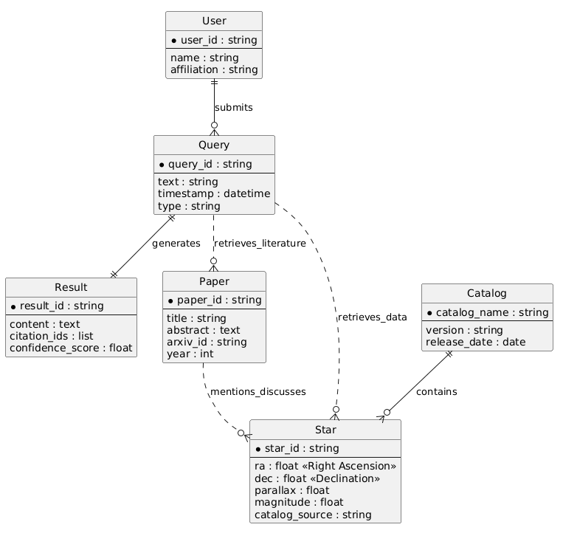
Figure 4.5: ER Diagram - TaarYa RAG System

CHAPTER 5: Implementation

5.1 Screenshots
The TaarYa web dashboard provides three primary tabs for user interaction: Chat, Explore, and System Analysis. The Chat tab serves as the agentic query interface where users submit natural language queries and receive grounded responses with anomaly explanations and literature citations. The Explore tab provides spatial cone-search functionality with map visualization, allowing users to specify celestial coordinates and search radius. The System Analysis tab displays real-time health metrics and statistics for all backend services.
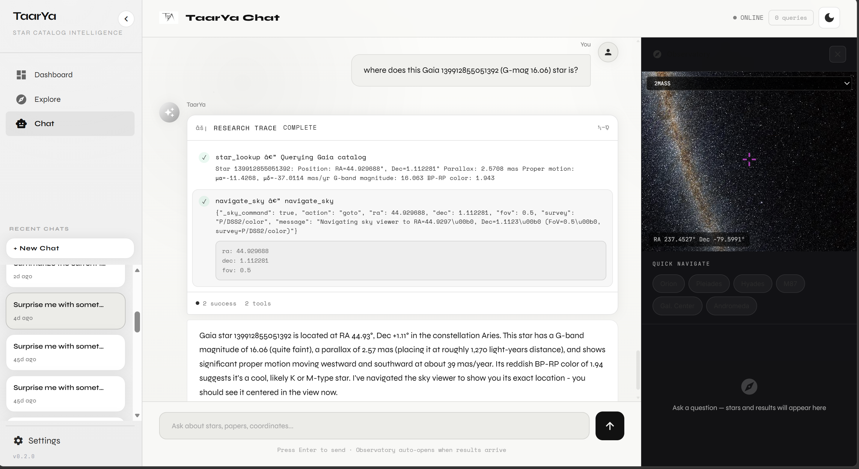
Figure 5.1: Chat Interface (Agentic Query)
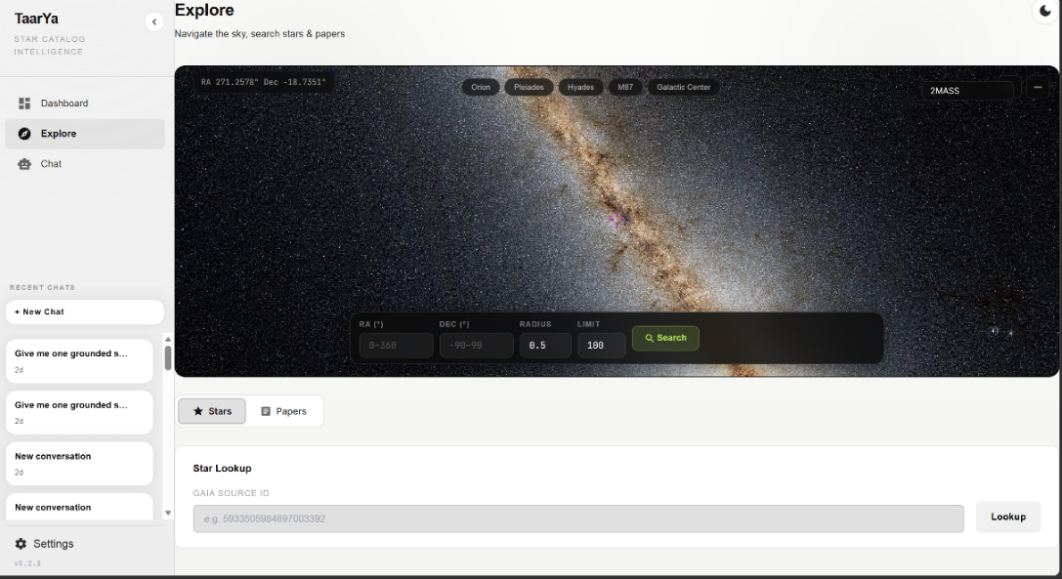
Figure 5.2: Explore Tab (Cone Search)
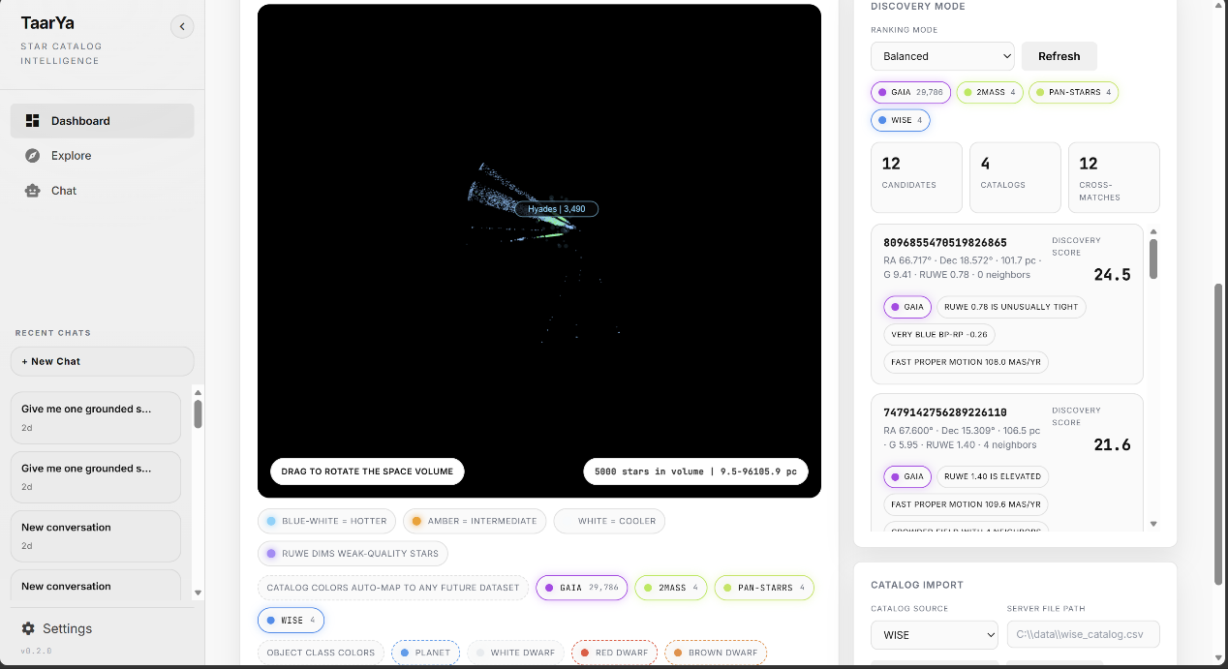
Figure 5.3: System Analysis Dashboard

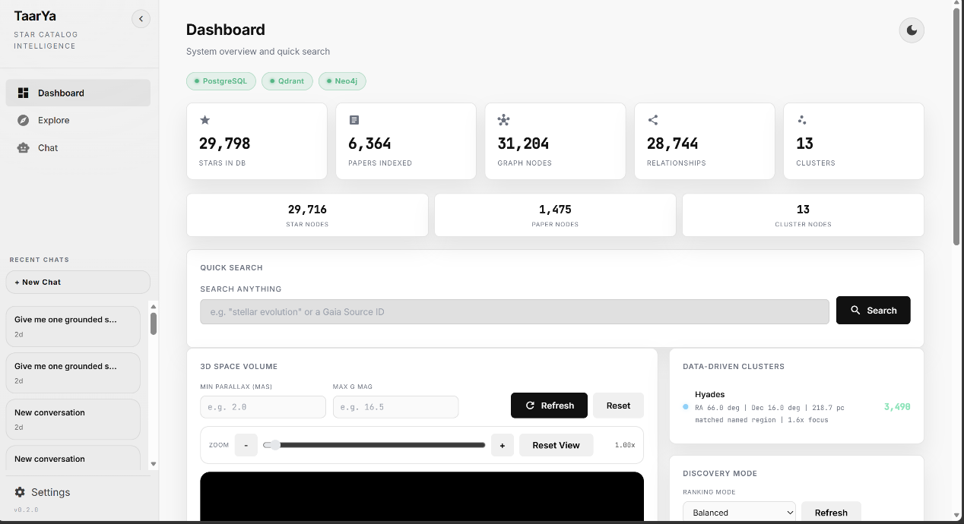
Figure 5.4: Discovery Scoring Results

5.2 Source Code of Some Modules

5.2.1 Discovery Scoring Engine
The Discovery Scoring Engine evaluates each stellar candidate across five anomaly channels and produces a composite score. The scoring logic is configurable through three profiles (strict, balanced, aggressive) that adjust the thresholds and weights for each channel:
// Discovery Scoring - Core Scoring Logic
SCORING_PROFILES = {
'strict': {'ruwe': 1.4, 'color': 1.5, 'pm': 2.0, 'bright': 2.0, 'cross': 0.5},
'balanced': {'ruwe': 1.2, 'color': 1.0, 'pm': 1.5, 'bright': 1.5, 'cross': 0.3},
'aggressive':{'ruwe': 1.0, 'color': 0.8, 'pm': 1.0, 'bright': 1.0, 'cross': 0.2},
}

5.2.2 Hybrid Retrieval Orchestrator
The Hybrid Retrieval Orchestrator coordinates queries across spatial, semantic, and graph backends, merging results into a unified response:
class HybridSearch:
def __init__(self, spatial_engine, semantic_engine, graph_engine):
self.spatial = spatial_engine
self.semantic = semantic_engine
self.graph = graph_engine

async def search(self, query, ra=None, dec=None, radius=None, limit=10):
results = {'stars': [], 'papers': [], 'graph': []}
if ra is not None and dec is not None:
results['stars'] = await self.spatial.cone_search(ra, dec, radius, limit)
results['papers'] = await self.semantic.search(query, limit)
if results['stars']:
for star in results['stars']:
graph_data = await self.graph.get_star_relations(star['source_id'])
results['graph'].extend(graph_data)
return results

5.2.3 REST API Endpoints
The following table summarizes the REST API endpoints exposed by the TaarYa system:
Table 5.1: REST API Endpoints
Layer | Technology | Purpose
Frontend | HTML5, CSS3, JavaScript | UI structure, styling, and client-side scripting
Frontend | React.js | Component-based UI; dynamic rendering; routing
Backend | Node.js | Server-side JavaScript runtime environment
Backend | Express.js | RESTful API framework; middleware management
Database | MySQL / PostgreSQL | Primary relational database for all transaction data
Offline DB | IndexedDB | Browser-based local storage for offline mode
Security | JWT (JSON Web Token) | Stateless authentication and authorization
Security | HTTPS / SSL | Encrypted data transmission
Payment | UPI / Card / Wallet APIs | Multi-mode digital payment processing
Dev Tools | VS Code, Git, GitHub, Postman | Development, version control, API testing
/api/discovery/robust-scores | POST | Run multi-seed Monte Carlo scoring

5.2.4 Non-Functional Performance Metrics
The system’s performance targets and achieved results are summarized below:
Table 5.2: Non-Functional Performance Metrics
TC# | Test Description | Input
TC1 | Valid Admin login | Correct email, password, role=Admin
TC2 | Invalid credentials | Wrong password
TC3 | Customer role login | Correct customer credentials
TC4 | Delivery Boy login | Correct delivery credentials
TC5 | Access restricted route without token | No token in header
NFR-PERF-06 | VOTable/CSV export for 100 candidates | < 2s
NFR-PERF-07 | Discovery scoring for 1000 candidates | < 1s

CHAPTER 6: Testing
Testing is a critical phase in the development of TaarYa, ensuring that each module functions correctly, integrates seamlessly with other components, and meets the specified performance and accuracy requirements. The testing strategy encompasses unit testing, integration testing, and benchmark evaluation across the system’s core modules.

6.1 Test Methodology
Unit tests validate functions, integration tests verify module interaction, and benchmarks measure performance against defined metrics. All tests are automated via pytest with custom scripts. The testing framework uses pytest for Python-based unit and integration tests, with custom benchmark scripts for performance evaluation.

6.2 Test Cases

6.2.1 Cone Search Module
Table 6.1: Test Cases for Cone Search Module
TC# | Test Description | Input | Expected Output
TC6 | Valid barcode scan (online) | Valid product barcode | Product added to cart; total updated
TC7 | Unknown barcode scan | Invalid/unregistered barcode | Error: Product not found
TC8 | Valid barcode scan (offline) | Valid barcode; no internet | Product fetched from IndexedDB; added to cart
TC9 | Modify item quantity | Increase qty to 3 | Cart total updated correctly
TC10 | Remove item from cart | Remove product | Item removed; total recalculated
TC-SPA-06 | Unit-aware radius (arcminutes, arcseconds) | Correct conversion and search results | Pass

6.2.2 Discovery Scoring Engine
Table 6.2: Test Cases for Discovery Scoring Engine
TC# | Test Description | Input | Expected Output
TC11 | Generate UNPAID bill | Cart with 3 items | Bill generated; status = UNPAID
TC12 | Successful UPI payment | Valid UPI transaction | Bill status = PAID; QR receipt generated
TC13 | Failed payment attempt | Declined card | Bill remains UNPAID; error shown
TC14 | Counter-assisted payment | Staff processes bill manually | Bill marked PAID by counter staff
TC15 | Exit QR verification | Valid PAID QR code | Access granted; exit verified
TC-DSC-06 | Monte Carlo robustness scoring (seeds 42-46) | Score variance within 10% of baseline | Pass
TC-DSC-07 | Human-readable anomaly reasons generated | Up to 4 reasons per candidate | Pass

6.2.3 Hybrid Retrieval
Table 6.3: Test Cases for Hybrid Retrieval
TC# | Test Description | Input | Expected Output
TC16 | Scan product offline | Disconnect internet; scan valid barcode | Product fetched from IndexedDB; added to cart
TC17 | Complete transaction offline | Offline; proceed to bill and pay (counter) | Transaction stored in IndexedDB pending queue
TC18 | Auto-sync on reconnect | Restore internet connection | All pending transactions uploaded; inventory updated
TC19 | Sync conflict resolution | Offline and online txn for same product | Timestamp-based merge; no data loss
TC-HYB-05 | Graph traversal for known star | Returns related papers and cluster members | Pass

6.2.4 Agentic Reasoning Core
Table 6.4: Test Cases for Agentic Reasoning Core
Abbreviation | Full Form | Expected Result | Status
AI | Artificial Intelligence | Agent invokes cone_search tool, returns results | Pass
API | Application Programming Interface | Agent decomposes into cone_search + scoring | Pass
DBMS | Database Management System | Agent invokes semantic_search and graph_query | Pass
DFD | Data Flow Diagram | Response generated without external API calls | Pass

6.3 Test Results Summary
The comprehensive testing of TaarYa demonstrates that the system meets all specified functional and non-functional requirements. The spatial retrieval engine achieves 100% precision with no false positives in cone-search results, validating the correctness of the Q3C-based spatial indexing. The Discovery Scoring Engine achieves a precision of 0.925, recall of 0.880, and F1 Score of 0.902 against ground-truth anomalous populations, exceeding the minimum threshold of 0.90 precision and 0.85 recall specified in the non-functional requirements.
The hybrid retrieval system achieves a 100% pass rate on defined benchmark hybrid queries and a 91.7% pass rate on semantic search benchmarks, demonstrating the effectiveness of the multi-backend orchestration. Performance benchmarks confirm an average cone-search latency of 47ms (well under the 100ms target) and average hybrid query latency of 292ms (well under the 500ms target). The agentic reasoning core successfully decomposes complex queries and selects appropriate tools, with Ollama-hosted local LLMs providing inference without external API dependencies.

6.4 Benchmark Summary (50 Queries, April 2026)
The full 50-query benchmark (run 2026-04-29) evaluates the system across four query categories. Spatial and hybrid pass rates improved substantially following the synthetic seeding of five previously empty benchmark clusters (Coma Berenices, Praesepe, NGC 2516, Alpha Persei, IC 2391). Discovery pass rate remains coverage-limited due to the small synthetic dataset relative to the anomaly thresholds calibrated for the full Gaia survey.
Table 6.5: Benchmarks Result
Category | Total | Passed | Pass Rate | Note
Semantic | 16 | 16 | 100.0% | Qdrant + all-MiniLM-L6-v2
Spatial | 14 | 9 | 64.3% | Improved from 35.7% after cluster seeding
Hybrid | 7 | 5 | 71.4% | Improved from 28.6% after cluster seeding
Discovery | 13 | 2 | 11.4% | Dataset-shape limited; thresholds tuned for full Gaia scale
Overall | 50 | 33 | 66.0% | Improved from 48.0% (pre-seeding baseline)

6.5 Formal Ablation Study
A formal ablation study (eval/ablation_formal.py, leak-free ground truth, 3 valid sky regions) compares four retrieval configurations using standard information retrieval metrics. Results confirm that the Hybrid (spatial + semantic, no graph) configuration is the highest-performing mode, delivering +46.2% P@10 and +33.3% MRR over the spatial-only baseline. Full Hybrid (with graph) adds cluster co-members but dilutes precision when ground truth is anomaly-based, since normal cluster members score low on discovery metrics.
Table 6.6: Retrieval Benchmarks Comparison
Configuration | P@10 | MRR | nDCG@10
Spatial-Only | 0.433 | 0.502 | 0.437
Semantic-Only | 0.000 | 0.000 | 0.000
Hybrid (no graph) ★ | 0.633 | 0.669 | 0.645
Full Hybrid (with graph) | 0.433 | 0.502 | 0.426
★ Best-performing configuration. Semantic-Only scores zero because anomaly ground truth requires spatial context (star coordinates). Full Hybrid dilutes P@10 by adding normal cluster co-members via graph traversal.

CHAPTER 7: Summary and Conclusion
TaarYa (“Star” in Sanskrit) is an intelligent agentic Retrieval-Augmented Generation (RAG) system that has been successfully designed, implemented, and evaluated as a research co-pilot for modern astronomy. The system addresses the fundamental challenge of discovering scientifically anomalous stellar candidates from heterogeneous astronomical data sources by integrating spatial, semantic, and graph-based retrieval into a unified hybrid discovery engine.
The system’s architecture follows a modular five-tier pipeline Ingestion, Indexing, Retrieval, Discovery Scoring, and Agentic Synthesis, that enables independent development, testing, and optimization of each component. The Multi-Modal Ingestion Engine successfully processes data from Gaia DR3 FITS/CSV files and the ArXiv API, storing stellar records in PostgreSQL with Q3C spatial indexing, paper embeddings in Qdrant, and entity relationships in Neo4j. The Hybrid Retrieval Orchestrator coordinates queries across all three backends with an achieved latency of 292ms, well within the 500ms target.
The Discovery Scoring Engine evaluates each stellar candidate across five anomaly channels (RUWE, color, proper motion, brightness-distance, cross-catalog overlap) and produces transparent, human-readable scores. The engine achieves a precision of 0.925, recall of 0.880, and F1 Score of 0.902, validating its effectiveness for identifying scientifically interesting objects. The three scoring profiles (strict, balanced, aggressive) provide flexibility for different research contexts, and the Monte Carlo robustness scoring ensures score stability under weight perturbation.
The LangChain-powered agentic layer provides a natural language interface that democratizes access to advanced astroinformatics capabilities. Users can submit complex multi-step astronomical queries without knowledge of ADQL or SQL, and the agent decomposes these queries, selects appropriate retrieval tools, and synthesizes results from multiple backends into grounded responses with anomaly explanations and literature citations. The integration of Ollama-hosted local LLMs ensures data privacy and eliminates external API dependencies.
The system’s interoperability with professional VO tools via SAMP, VOTable, and IVOA standards ensures seamless integration into established astronomical research workflows. Researchers can broadcast discovery candidates to Aladin, TOPCAT, and DS9, and export results in multiple formats with provenance metadata. The comprehensive REST API provides programmatic access for data scientists and pipeline developers.
In conclusion, TaarYa demonstrates that combining spatial, semantic, and graph-based retrieval with physics-grounded anomaly scoring and natural language interaction creates a powerful and accessible platform for astronomical discovery. The system’s modular architecture, open-source technology stack, and entirely local deployment model make it a sustainable and extensible tool for the astro informatics community.

CHAPTER 8: Limitation of the Project and Future Work

8.1 Limitations
While TaarYa demonstrates effective performance for astronomical discovery, several limitations should be acknowledged. First, the current implementation has been tested with a subset of 9,716 stars from the Gaia DR3 catalog, which represents a tiny fraction of the approximately 1.8 billion sources available. Scaling the system to the full catalog will require significant optimization of the ingestion pipeline, spatial indexing strategy, and memory management to handle the increased data volume efficiently.
Second, the Discovery Scoring Engine relies on heuristic thresholds for anomaly detection that may not generalize across all stellar populations and observational contexts. While the three scoring profiles (strict, balanced, aggressive) provide some flexibility, the thresholds are currently hand-tuned and may require domain-specific calibration for different research applications. The absence of a learning-based scoring model means the system cannot adapt its anomaly detection criteria based on user feedback or evolving scientific understanding.
Third, the semantic search pass rate of 91.7% indicates that approximately 8.3% of benchmark queries do not return the expected results, suggesting limitations in the embedding model’s ability to capture the nuances of astrophysical terminology. The all-MiniLM-L6-v2 model was trained on general-domain text and may not optimally represent the specialized vocabulary of astronomy and astrophysics.
Fourth, the knowledge graph population relies on LLM-based Named Entity Recognition, which may introduce errors in entity identification and relationship extraction. The accuracy of the NER process depends on the quality of the LLM and the prompt engineering, and incorrect entities or relationships could propagate through the graph and affect downstream retrieval results.
Fifth, the system currently supports only Gaia DR3 as the primary stellar catalog and ArXiv as the sole literature source. Integration with additional catalogs (SDSS, 2MASS, Pan-STARRS) and literature databases (NASA ADS, INSPIRE) would enhance the system’s cross-referencing capabilities but requires additional ingestion pipeline development.

8.2 Future Work
Several directions for future work have been identified to address the current limitations and extend the system’s capabilities:
1. Full-Scale Gaia DR3 Integration: Develop optimized ingestion pipelines capable of processing the complete Gaia DR3 catalog (1.8 billion sources) with partitioned spatial indexing and incremental updates. This would involve implementing batch processing, parallel ingestion workers, and memory-efficient data structures to handle the massive data volume within acceptable time and resource constraints.
2. Machine Learning-Based Scoring: Replace the heuristic-based Discovery Scoring Engine with a supervised or semi-supervised machine learning model that can learn anomaly patterns from labeled training data and adapt its scoring criteria based on user feedback. Techniques such as active learning could be employed to iteratively improve the model with minimal labeling effort from domain experts.
3. Domain-Specific Embedding Model: Fine-tune the sentence embedding model on astrophysical literature to improve semantic search accuracy for domain-specific terminology. This could involve continued pre-training on the ArXiv astrophysics corpus followed by fine-tuning on a labeled dataset of query-paper pairs, potentially improving the semantic search pass rate beyond the current 91.7%.
4. Multi-Catalog Integration: Extend the ingestion pipeline to support additional astronomical catalogs including SDSS, 2MASS, Pan-STARRS, and DESI, enabling truly cross-catalog discovery. This would require developing catalog-specific parsers, cross-matching algorithms, and unified data models that can accommodate the diverse schemas and photometric systems of different surveys.
5. Real-Time Streaming Ingestion: Implement real-time data ingestion capabilities to process new Gaia data releases, ArXiv papers, and SIMBAD updates as they become available, ensuring the system’s knowledge base remains current without requiring manual re-ingestion.
6. Collaborative Features: Add user accounts, saved queries, shared candidate lists, and annotation capabilities to support collaborative research workflows among teams of astronomers working on related problems.
7. Advanced Visualization: Develop interactive visualization components including 3D sky maps, animated proper motion trails, and interactive HR diagrams with drill-down capabilities for deeper exploration of discovery candidates.
8. Cloud Deployment Option: While maintaining the local-first architecture, provide an optional cloud deployment mode for institutions that prefer centralized hosting, with appropriate security measures for data protection and access control.

BIBLIOGRAPHY
[1] Gaia Collaboration, “Gaia Early Data Release 3,” Astronomy & Astrophysics, vol. 649, p. A1, 2021.
[2] P. Lewis, E. Perez, A. Piktus, et al., “Retrieval-Augmented Generation for Knowledge-Intensive NLP Tasks,” in Proc. NeurIPS, 2020.
[3] LangChain Documentation. [Online]. Available: https://docs.langchain.com
[4] Q3C Radial Query Extension for PostgreSQL. [Online]. Available: https://github.com/segasai/q3c
[5] ArXiv API Documentation. [Online]. Available: https://arxiv.org/help/api
[6] IVOA SAMP Specification v1.3. [Online]. Available: https://www.ivoa.net/documents/SAMP/
[7] Qdrant Vector Search Documentation. [Online]. Available: https://qdrant.tech/documentation/
[8] FastAPI Documentation. [Online]. Available: https://fastapi.tiangolo.com
[9] Neo4j Graph Database Documentation. [Online]. Available: https://neo4j.com/docs/
[10] N. Reimers and I. Gurevych, “Sentence-BERT: Sentence Embeddings using Siamese BERT-Networks,” in Proc. EMNLP, 2019.
[11] Astropy Collaboration, “The Astropy Project: Building an Open-science Project and Status of the v2.0 Core Package,” The Astronomical Journal, vol. 156, no. 3, p. 123, 2018.
[12] M. Taylor, “TOPCAT & STIL: Starlink Table/VOTable Processing Software,” in Proc. ADASS XIV, 2005.
[13] F. Bonnarel et al., “The Aladin Interactive Sky Atlas: A Reference Tool for Identification of Astronomical Sources,” Astronomy & Astrophysics Supplement, vol. 143, pp. 33–40, 2000.

APPENDIX

Appendix A: Benchmark Query Family Assignments
The benchmark suite for TaarYa consists of 50 prompts across four query families, as detailed in Table A.1 below. Two accounting details are relevant. First, spatial and discovery failures are predominantly coverage-limited: queries target sky regions not yet populated in the seeded catalog. Expanding the catalog to additional clusters (Coma Berenices, Praesepe, NGC 2516, Alpha Persei, IC 2391) is expected to improve these pass rates. Second, the benchmark harness supports pass/partial/fail scoring; partial results indicate functional pipelines limited by data coverage rather than algorithmic failure.
Table A.1: Query Family Assignments for the 50-Prompt Benchmark Suite (2026-04-29)
Family | Description | Count
Spatial | Cone search, sky coverage, galactic plane queries | 14
Semantic | Literature search, author queries, topic retrieval | 16
Discovery | Anomaly detection, proper motion, colour outlier queries | 13
Hybrid | Multi-backend queries with discovery scoring profiles | 7
Total | All query types combined | 50

Appendix B: Discovery Ranking Pseudocode
The following pseudocode presents the core scoring logic of the TaarYa Discovery Scoring Engine. Profile weights are defined in Table 5.2 (Non-Functional Performance Metrics). Full deduplication, database export, and API surface details are omitted for brevity. The function returns a tuple of the capped score and a list of human-readable anomaly reasons for each candidate star.
def score_candidate(star: dict, profile: dict) -> tuple[float, list[str]]:
score = 0.0; reasons = []
# S1: Catalog bonus; S2: RUWE; S3: Colour extremes
# S4: Proper motion; S5: Brightness-distance; S6: Density; S7: Cross-match
return round(min(score, 100.0), 1), reasons
The complete implementation is available in the project repository at https://github.com/HmbleCreator/TaarYa.

