DECLARATION
This is to certify that the material embodied in this Major Project - Dissertation titled
“Design and Development of a RAG Driven Intelligent Framework for Astronomical Star Catalog Analysis” being submitted in the partial fulfillment of the requirements for the award of the degree of Bachelor of Technology in Computer Science &amp; Engineering is based on my original work. It is further certified that this Major Project - Dissertation work has not been submitted in full or in part to this university or any other university for the award of any other degree or diploma. My indebtedness to other works has been duly acknowledged at the relevant places.

Amit Kumar
Enrollment No: 14618002722

CERTIFICATE
This is to certify that the work embodied in this Major Project - Dissertation titled “Design and Development of a RAG Driven Intelligent Framework for Astronomical Star Catalog Analysis” being submitted in the partial fulfillment of the requirements for the award of the degree of Bachelor of Technology in Computer Science & Engineering is original and has been carried out by Amit Kumar (Enrollment No. 14618002722) under my supervision and guidance.
It is further certified that this Major Project - Dissertation work has not been submitted in full or in part to this university or any other university for the award of any other degree or diploma to the best of my knowledge and belief.

Dr. Madhumita Mahapatra
Assistant Professor

Dr. Monalisa Panigrahi Dr. Seema Verma
Project Coordinator Head of the Department
Department of CSE Department of CSE
Delhi Technical Campus Delhi Technical Campus

ACKNOWLEDGEMENT
I would like to express my sincere gratitude to all those who have contributed to the successful completion of this Major Project - Dissertation. Their guidance, support, and encouragement have been invaluable throughout this endeavor.
First and foremost, I am deeply indebted to my faculty supervisor, Dr. Madhumita Mahapatra, for her constant guidance, constructive criticism, and unwavering support throughout the duration of this project. Her expertise in the field and her insightful feedback have been instrumental in shaping the direction and quality of this work. She has been a source of inspiration and has always encouraged me to push the boundaries of my knowledge and capabilities.
I extend my heartfelt thanks to the Head of the Department of Computer Science & Engineering and the Project Coordinator for providing the necessary infrastructure and academic environment that made this project possible. Their administrative support and facilitation of resources have been crucial to the smooth execution of the project.
I am also grateful to the faculty members of the Department of Computer Science & Engineering at Delhi Technical Campus, Greater Noida, for imparting the knowledge and skills that formed the foundation of this project. The courses and laboratory sessions conducted over the years have equipped me with the technical competence required to undertake a project of this nature.
I would like to acknowledge the open-source community and the developers of the tools and technologies used in this project, including PostgreSQL with Q3C, Qdrant, Neo4j, LangChain, FastAPI, and Ollama. Their contributions to the field of software development have made projects like TaarYa possible.
My sincere thanks also go to my peers and friends who provided valuable feedback and moral support during challenging phases of the project. Their camaraderie and willingness to help have been a constant source of motivation.
Finally, I owe a special debt of gratitude to my family for their unconditional love, patience, and encouragement. Their faith in my abilities has been the driving force behind my academic pursuits, and without their support, this achievement would not have been possible.

ABSTRACT
TaarYa (“Star” in Sanskrit) is an intelligent agentic Retrieval-Augmented Generation (RAG) system designed to serve as a research co-pilot for modern astronomy. The system addresses the fundamental challenge of discovering scientifically anomalous stellar candidates from the vast and heterogeneous astronomical data sources that contemporary researchers must navigate. With the Gaia DR3 catalog containing approximately 1.8 billion stellar sources, the manual inspection of catalog records for identifying scientifically interesting objects such as unresolved binaries, runaway stars, blue stragglers, and white dwarf candidates is both time-consuming and error-prone.
The system integrates three complementary retrieval paradigms into a unified hybrid discovery engine: spatial retrieval using PostgreSQL with the Q3C extension for sub-100ms cone-search queries on celestial coordinates, semantic retrieval using Qdrant vector store with all-MiniLM-L6-v2 embeddings for literature-aware paper discovery, and graph-based retrieval using Neo4j for knowledge graph traversal across stellar clusters, papers, and cross-catalog relationships. The Discovery Scoring Engine evaluates each stellar candidate across five anomaly channels—RUWE, color (BP-RP), proper motion, brightness-distance, and cross-catalog overlap—producing a capped score of 0–100 with human-readable anomaly explanations.
A LangChain-powered agent provides a natural language interface that accepts complex multi-step astronomical queries, decomposes them into sub-tasks, selects appropriate retrieval tools, and synthesizes results from multiple backends into grounded responses with anomaly explanations and literature citations. The system supports interoperability with professional Virtual Observatory tools via SAMP, VOTable, and IVOA standards, enabling seamless integration with established astronomical workflows. Performance benchmarks demonstrate an average cone-search latency of 47ms, hybrid query latency of 292ms, semantic search pass rate of 91.7%, and a Discovery F1 Score of 0.902 with Precision of 0.925 and Recall of 0.880, validating the system’s effectiveness for astronomical discovery.

LIST OF FIGURES
Figure No. | Figure Title | Page No.
3.1  3.2  3.3  3.4  4.1  4.2  4.3  4.4  4.5  5.1  5.2  5.3  5.4 | Use Case Diagram of TaarYa System  Data Flow Diagram - Level 0 (Context Diagram)  Data Flow Diagram - Level 1 (System Decomposition)  Data Flow Diagram - Level 2 (Detailed Decomposition)  Work Breakdown Structure of TaarYa  Class Diagram-AstroGraph RAG System  System Architecture Diagram  Flow Chart of Hybrid Retrieval Process  ER Diagram of TaarYa Data Model  Screenshot - Chat Interface (Agentic Query)  Screenshot - Explore Tab (Cone Search)  Screenshot - System Analysis Dashboard  Screenshot - Discovery Scoring Results | 15  16  16  17  18  22  22  23  24  25  25  26  26

LIST OF TABLES
Table No. | Table Title | Page No.
1.1  1.2  3.1  3.2  3.3  5.1  5.2  6.1  6.2  6.3  6.4  6.5  6.6 | Intended User Classes of TaarYa  Abbreviations and Acronyms  Feasibility Study Summary  Tools and Technologies Used  Hardware Requirements  REST API Endpoints  Non-Functional Performance Requirements  Test Cases for Cone Search Module  Test Cases for Discovery Scoring Engine  Test Cases for Hybrid Retrieval  Agentic Reasoning Core  Benchmarks Results  Retrieval Benchmarks Comparison | 4  5  13  13  14  28  28  29  30  30  31  32  32

TABLE OF CONTENTS
Page No (in Roman)
DECLARATION i
CERTIFICATE ii
ACKNOWLEDGEMENT iii
ABSTRACT iv
LIST OF FIGURES v
LIST OF TABLES vi
CHAPTER 1: Introduction 1
1.1 Problem Statements 2
1.2 Objectives 3
1.3 Need and Significance 3
1.4 Intended Users 4
1.5 Abbreviations and Acronyms 4
CHAPTER 2: Problem Statement 6
2.1 Problem Definition 6
2.2 Objectives 7
CHAPTER 3: Analysis 8
3.1 Software Requirement Specifications 8
3.1.1 Functional Requirements of the Project 8
3.1.2 Non-Functional Requirements of the Project 10
3.2 Feasibility Study of the Project 12
Technical Feasibility 12
Operational Feasibility 12
Economic Feasibility 12
3.3 Tools / Technologies / Platform Used 13
3.4 Use Case Diagrams / Data Flow Diagrams 14
CHAPTER 4: Design and Architecture 18
4.1 Structure Chart / Work Breakdown Structure 18
4.2 Explanation of Modules 19
4.3 Flow Chart / Activity Diagram 21
4.4 Class Diagram / ER Diagram 23
CHAPTER 5: Implementation 25
5.1 Screenshots 25
5.2 Source Code of Some Modules 26
5.2.1 Discovery Scoring Engine 26
5.2.2 Hybrid Retrieval Orchestrator 27
5.2.3 REST API Endpoints 28
5.2.4 Non-Functional Performance Metrics 28
CHAPTER 6: Testing 29
6.1 Test Methodology 29
6.2 Test Cases 29
6.2.1 Cone Search Module 29
6.2.2 Discovery Scoring Engine 30
6.2.3 Hybrid Retrieval 30
6.2.4 Agentic Reasoning Core 31
6.3 Test Results Summary 31
6.4 Benchmark Summary (50 Queries, April 2026) 31
6.5 Formal Ablation Study 32
CHAPTER 7: Summary and Conclusion 33
CHAPTER 8: Limitation of the Project and Future Work 35
8.1 Limitations 35
8.2 Future Work 36
BIBLIOGRAPHY 38
APPENDIX 39
Appendix A: Benchmark Query Family Assignments 39
Appendix B: Discovery Ranking Pseudocode 39

CHAPTER 1: Introduction
Modern astronomy stands at the intersection of massive data generation and sophisticated computational analysis. The European Space Agency’s Gaia mission, with its Data Release 3 (DR3), has catalogued approximately 1.8 billion stellar sources, providing an unprecedented wealth of astrometric, photometric, and spectroscopic data. Simultaneously, the volume of astrophysics literature on platforms like ArXiv continues to grow exponentially, creating a rich but overwhelming corpus of published findings that researchers must navigate. The challenge of identifying scientifically interesting objects, such as unresolved binaries, runaway stars, blue stragglers, and white dwarf candidates, from this vast data landscape demands automated, multi-signal approaches that go beyond traditional manual inspection and single-catalog queries.
TaarYa (“Star” in Sanskrit) is an intelligent agentic Retrieval-Augmented Generation (RAG) system designed to serve as a research co-pilot for modern astronomy. It integrates spatial, semantic, and graph-based retrieval into a unified hybrid discovery engine capable of surfacing scientifically anomalous stellar candidates from heterogeneous data sources. The system combines machine learning-based retrieval with physics-grounded scoring, enabling researchers to discover candidate objects in minutes rather than weeks of manual catalog inspection.
The existing Virtual Observatory (VO) tools such as TOPCAT and Aladin are powerful desktop applications for catalog manipulation and sky visualization, but they lack natural language interfaces and AI-assisted anomaly scoring capabilities. Researchers must possess specialized knowledge of ADQL (Astronomical Data Query Language) or SQL to construct complex cross-catalog queries, and the process of identifying anomalous objects remains largely manual. Furthermore, there is no open-source tool that combines spatial cone-search, semantic literature retrieval, and graph-based entity traversal in a single agentic framework, leaving a significant gap in the astroinformatics tooling landscape.
TaarYa addresses these gaps by implementing a modular five-tier pipeline: Ingestion, Indexing, Retrieval, Discovery Scoring, and Agentic Synthesis. The system ingests data from Gaia DR3 (FITS/CSV) and ArXiv (API), indexes stars spatially in PostgreSQL via Q3C, embeds papers semantically in Qdrant, and models entity relationships in Neo4j. The Discovery Scoring Engine evaluates each stellar candidate across five anomaly channels, producing a transparent, human-readable score. A LangChain-powered agent interprets natural language queries, selects appropriate tools, and synthesizes multi-backend results into grounded responses with anomaly explanations and literature citations.
The significance of TaarYa lies in democratizing access to advanced astro informatics. Graduate students and educators can use the natural language interface for conceptual exploration, while professional astronomers and data scientists can leverage the full REST API and SAMP integration for programmatic access. The system operates entirely locally using Docker Compose orchestration, ensuring data privacy and reproducibility without external API dependencies. Performance benchmarks demonstrate an average cone-search latency of 47ms, hybrid query latency of 292ms, and a Discovery F1 Score of 0.902, validating the system’s practical utility for astronomical discovery.

1.1 Problem Statements
The development of TaarYa is motivated by several critical challenges that modern astronomical researchers face when working with large-scale catalog data and interdisciplinary information sources. These problems are outlined below:
• Modern astronomical research relies on multiple heterogeneous catalogs (Gaia DR3, SIMBAD, VizieR) that lack a unified query and cross-matching interface, forcing researchers to manually switch between platforms and data formats to perform comprehensive analyses.
• Discovering scientifically anomalous stellar candidates requires manual inspection of millions of catalog records, a process that is inherently time-consuming, error-prone, and does not scale to the volume of data available in modern surveys.
• Existing VO tools (TOPCAT, Aladin) are powerful but do not incorporate natural language interfaces or AI-assisted anomaly scoring, limiting their accessibility to researchers who are not proficient in ADQL or SQL.
• The growing volume of ArXiv astrophysics literature outpaces human ability to cross-reference catalog data with relevant published findings, resulting in missed connections between anomalous objects and their scientific context.
• There is no open-source tool that combines spatial cone-search, semantic literature retrieval, and graph-based entity traversal in a single agentic framework, creating a significant gap in the astroinformatics tooling ecosystem.

1.2 Objectives
The primary objectives of this project are as follows:
1. Hybrid Retrieval System: unify spatial (Q3C + PostgreSQL), semantic (Qdrant), and graph (Neo4j) engines for astronomical data access.
2. Discovery Scoring Engine: rank stellar candidates using anomaly signals across astrometric, photometric, and kinematic channels.
3. Natural Language Interface: enable complex queries via LLM agent (LangChain) without ADQL/SQL.
4. Interoperability with VO Tools: support SAMP, VOTable, and IVOA standards for seamless workflow integration.
5. FastAPI Backend & Dashboard: provide interactive Gaia DR3 + ArXiv exploration with real-time scoring and visualization.

1.3 Need and Significance
The Gaia DR3 catalog contains approximately 1.8 billion stellar sources. Identifying scientifically interesting objects, unresolved binaries, runaway stars, blue stragglers, white dwarf candidates, from this volume requires automated, multi-signal anomaly detection. TaarYa addresses this need by combining machine learning-based retrieval with physics-grounded scoring, enabling researchers to discover candidates in minutes rather than weeks.
The system’s significance lies in democratizing access to advanced astroinformatics. Graduate students and educators can use the natural language interface for conceptual exploration without requiring specialized query language knowledge, while professional astronomers and data scientists can leverage the full REST API and SAMP integration for programmatic, reproducible workflows. The entirely local deployment model ensures that sensitive research queries and data never leave the researcher’s workstation, addressing growing concerns about data sovereignty in scientific computing.
Furthermore, TaarYa’s modular architecture allows the system to be extended to additional astronomical catalogs (e.g., SDSS, 2MASS, Pan-STARRS) and literature sources (e.g., NASA ADS, INSPIRE) with minimal modification, making it a versatile platform for future astroinformatics research. The open-source nature of all components ensures long-term sustainability and community-driven improvement.

1.4 Intended Users
TaarYa is designed to serve a diverse range of users within the astronomy and data science communities. The following table summarizes the intended user classes, their technical expertise, and primary use cases:
Table 1.1: Intended User Classes of TaarYa
User Class | Description | Technical Expertise | Primary Use Case
Professional Astronomer | PhD-level researcher using Gaia, SIMBAD, TOPCAT daily | High | Automated cross-catalog candidate discovery, VO tool integration
Graduate Student | MSc/PhD student exploring astronomical datasets | Medium | Literature search, spatial queries, HR diagram generation
Undergraduate Student | B.Tech/BSc student learning astroinformatics | Low | Natural language queries, conceptual exploration
Data Scientist | Astroinformatics specialist building pipelines | High | API integration, benchmark evaluation, custom scoring
Educator | Faculty using TaarYa for teaching | Medium | Generating teaching examples from real catalogs

1.5 Abbreviations and Acronyms
Table 1.2: Abbreviations and Acronyms
Term / Acronym | Definition
RAG | Retrieval-Augmented Generation: an AI architecture that augments LLM responses with retrieved context
LLM | Large Language Model (e.g., kimi-k2.5, Llama 3)
Gaia DR3 | Gaia Data Release 3: ESA’s astrometric catalog with ~1.8B sources
RUWE | Renormalized Unit Weight Error: Gaia astrometric quality metric; RUWE > 1.4 indicates potential binarity
Q3C | Quad Tree Cube: PostgreSQL extension for efficient spherical sky coordinate indexing
ADQL | Astronomical Data Query Language: SQL variant used in Virtual Observatory services
SIMBAD | Set of Identifications, Measurements and Bibliography for Astronomical Data
SAMP | Simple Application Messaging Protocol: IVOA standard for desktop tool communication
IVOA | International Virtual Observatory Alliance
VOTable | Virtual Observatory Table: IVOA XML standard for astronomical data interchange
BP-RP | Blue Photometer minus Red Photometer color index in Gaia photometry
NER | Named Entity Recognition: extraction of entity names from unstructured text
FastAPI | Modern Python web framework for building REST APIs
Neo4j | Graph database used for knowledge graph storage
Qdrant | Vector similarity search engine used for semantic retrieval

CHAPTER 2: Problem Statement

2.1 Problem Definition
The fundamental problem addressed by TaarYa is the lack of an integrated, intelligent system for discovering scientifically anomalous stellar candidates across heterogeneous astronomical data sources. Contemporary astronomical research involves the analysis of data from multiple catalogs, including Gaia DR3, SIMBAD, and VizieR, each with its own data formats, query interfaces, and access mechanisms. This fragmentation forces researchers to manually navigate between platforms, construct separate queries for each catalog, and mentally synthesize cross-referencing information, a process that is both inefficient and prone to oversight.
The scale of the data exacerbates this problem significantly. The Gaia DR3 catalog alone contains approximately 1.8 billion stellar sources, and identifying anomalous objects, those that deviate from expected astrometric, photometric, or kinematic patterns, requires examining multi-dimensional parameter spaces across multiple data columns. Manual inspection of such volumes is infeasible, yet existing tools provide limited automated assistance for anomaly detection beyond basic filtering and sorting operations.
Furthermore, the disconnect between catalog data and the vast astrophysics literature represents a significant gap in current research workflows. A stellar object may exhibit anomalous properties in Gaia data, but determining whether this anomaly has been previously studied, classified, or explained requires searching through thousands of ArXiv papers, a task that is currently performed manually and inconsistently. The absence of a tool that bridges catalog data with semantic literature retrieval means that potentially groundbreaking discoveries may be overlooked because researchers cannot efficiently connect data anomalies with relevant published findings.
Existing Virtual Observatory tools such as TOPCAT and Aladin provide excellent capabilities for catalog manipulation and sky visualization, but they operate as standalone desktop applications without natural language interfaces, AI-assisted scoring, or cross-modal retrieval. There is no open-source system that unifies spatial, semantic, and graph-based retrieval in a single agentic framework, and this gap is precisely what TaarYa aims to fill.

2.2 Objectives
Based on the problem definition, the following specific objectives have been identified for the TaarYa project:
1. To develop a hybrid retrieval system that seamlessly integrates spatial (Q3C + PostgreSQL), semantic (Qdrant vector store), and graph-based (Neo4j) engines, enabling unified access to astronomical data across multiple paradigms.
2. To implement a Discovery Scoring Engine that evaluates stellar candidates across five anomaly channels (RUWE, color, proper motion, brightness-distance, cross-catalog overlap) and produces transparent, human-readable scores.
3. To expose a natural language interface via an LLM-powered agent (LangChain) that allows users to submit complex multi-step astronomical queries without requiring knowledge of ADQL or SQL.
4. To support interoperability with professional VO tools via SAMP, VOTable, and IVOA standards, ensuring seamless integration with established astronomical research workflows.
5. To provide a FastAPI backend and interactive web dashboard for real-time exploration of the Gaia DR3 catalog and ArXiv literature with integrated anomaly scoring and visualization capabilities.
6. To ensure the system operates entirely locally using Docker Compose orchestration, preserving data privacy and enabling reproducible research without external API dependencies.
7. To achieve measurable performance benchmarks including sub-100ms cone-search latency, sub-500ms hybrid query latency, and a Discovery F1 Score of at least 0.90.

CHAPTER 3: Analysis

3.1 Software Requirement Specifications

3.1.1 Functional Requirements of the Project
The functional requirements of TaarYa are organized by the system’s ten core modules. Each module encapsulates a distinct functional area and is identified by a unique requirement prefix for traceability.
Module 1: Multi-Modal Ingestion Engine
• FR-ING-01: Ingest stellar data from Gaia DR3 FITS/CSV files into PostgreSQL with mandatory fields including source_id, ra, dec, parallax, pmra, pmdec, phot_g_mean_mag, phot_bp_mean_mag, phot_rp_mean_mag, ruwe, and catalog_source.
• FR-ING-02: Create Q3C spatial index on (ra, dec) columns after ingestion for efficient spherical queries.
• FR-ING-03: POST /api/ingest/gaia shall return immediately and run ingestion asynchronously in the background.
• FR-ING-04: Prevent concurrent ingestion pipelines; return HTTP 409 if a pipeline is already running.
• FR-ING-05: Mirror all star nodes from PostgreSQL into Neo4j for graph relationship modeling.
• FR-ING-06: Fetch astrophysics papers from ArXiv API using configurable topic queries, generating 384-dimensional sentence embeddings stored in Qdrant.
• FR-ING-07: Populate knowledge graph with Cluster nodes, MEMBER_OF and MENTIONED_IN relationships via LLM-based NER.
Module 2: Spatial Retrieval Engine
• FR-SPA-01: Support cone-search queries accepting ra, dec, radius, and limit parameters with average latency under 100ms for 10,000 stars.
• FR-SPA-02: Support coordinate frame conversion between ICRS, Galactic, and Ecliptic systems.
• FR-SPA-03: Support unit-aware radius specification (degrees, arcminutes, arcseconds) and optional discovery score inclusion.
Module 3: Semantic Retrieval Engine
• FR-SEM-01: Accept natural language topic queries and return relevant papers via vector similarity search using all-MiniLM-L6-v2 embeddings.
• FR-SEM-02: Results shall be ranked by cosine similarity score with optional score_threshold filtering.
Module 4: Knowledge Graph Retrieval Engine
• FR-GRF-01: Support retrieval of papers related to a star by traversing MENTIONED_IN edges in Neo4j.
• FR-GRF-02: Support retrieval of all cluster members via MEMBER_OF edges and multi-hop queries traversing COVERS and CITES edges.
Module 5: Hybrid Retrieval Orchestration
• FR-HYB-01: Provide a HybridSearch class coordinating queries across all three backends with 100% pass rate on benchmark hybrid queries and latency not exceeding 500ms.
Module 6: Discovery Scoring Engine
• FR-DSC-01: Score each stellar candidate on five anomaly channels: RUWE, color (BP-RP), proper motion, brightness-distance, and cross-catalog overlap.
• FR-DSC-02: Support three scoring profiles (strict, balanced, aggressive) with scores capped at 100.0 and rounded to one decimal place.
• FR-DSC-03: Each candidate shall include a human-readable list of up to four anomaly reasons.
Module 7: Agentic Reasoning Core
• FR-AGT-01: Implement an LLM-powered agent using LangChain that accepts natural language queries, decomposes them into sub-tasks, and selects appropriate tools (cone_search, star_lookup, semantic_search, graph_query).
• FR-AGT-02: The agent shall explain why a star is interesting by citing specific anomaly flags and support Ollama-hosted local LLMs.
Module 8: Scientific Analysis & Output
• FR-SCI-01: Compute absolute magnitude (M_G) using the distance modulus with error propagation and classify stars into stellar populations.
• FR-SCI-02: Generate HR diagrams in ASCII and Plotly-compatible formats and export results in IVOA-compliant VOTable 1.4, CSV, and JSON formats with provenance metadata.
• FR-SCI-03: Cross-register discovery candidates with SIMBAD for validation.
Module 9: VO Interoperability (SAMP)
• FR-VO-01: Implement a SAMP client for broadcasting discovery candidates to Aladin, TOPCAT, and DS9 with Aladin Lite deep-link URLs for every discovered candidate region.
Module 10: REST API
The REST API exposes all system functionality through well-defined endpoints accessible via standard HTTP methods. The complete API specification is detailed in the implementation chapter.

3.1.2 Non-Functional Requirements of the Project
Usability
• NFR-USE-01: The web interface shall be accessible via a standard browser at http://localhost:8000 without requiring knowledge of ADQL or SQL.
• NFR-USE-02: Discovery candidates shall include human-readable explanations of their anomaly flags.
• NFR-USE-03: The system shall provide ASCII HR diagrams for environments without graphical rendering.
Availability
• NFR-AVL-01: The system shall be startable with a single command (start_taarya.bat / start_taarya.sh).
• NFR-AVL-02: Docker services shall auto-recover on restart without manual intervention.
• NFR-AVL-03: The application shall expose a /health endpoint returning overall system status.

Accuracy
• NFR-REL-01: The system shall achieve 100% spatial retrieval precision with no false positives in cone-search results.
• NFR-REL-02: Discovery scoring precision shall be at least 0.90, recall at least 0.85 against ground-truth anomalous populations.
• NFR-REL-03: Error propagation shall use the Delta Method for all derived physical parameters.
Performance
• Average cone-search latency: 47ms (achieved, April 2026 baseline with 9,716 stars).
• Average hybrid query latency: 292ms (achieved, April 2026 baseline).
• Semantic search pass rate: 91.7% (11/12 benchmark queries passed).
• Hybrid query pass rate: 100% (2/2 benchmark queries passed).
• Discovery F1 Score: 0.902; Precision: 0.925; Recall: 0.880.
Reliability
• NFR-REL-03: The system shall gracefully handle backend unavailability with appropriate HTTP error responses.
• NFR-REL-04: Concurrent ingestion pipelines shall be prevented with HTTP 409 responses.
Maintainability
• NFR-MNT-01: Modular architecture with separate packages for retrieval, ingestion, API, utils, and agent.
• NFR-MNT-02: Discovery scoring weights and thresholds shall be defined in clearly documented configuration dictionaries.
Security
• NFR-SEC-01: The system shall operate entirely locally with no user queries or data sent to external cloud APIs.
• NFR-SEC-02: LLM inference shall use locally/cloud-hosted Ollama models only.
• NFR-SEC-03: Database connections shall be container-internal and not exposed to external networks by default.

3.2 Feasibility Study of the Project

Technical Feasibility
All core technologies employed by TaarYa are open-source and production-ready. PostgreSQL 15 with the Q3C extension provides proven spatial indexing capabilities that have been used in production astronomical databases. Qdrant is a mature vector search engine with demonstrated performance at scale, and Neo4j is the industry-standard graph database with extensive community support. LangChain provides a well-documented framework for LLM agent construction and tool orchestration, while FastAPI offers high-performance asynchronous REST API development. Ollama enables local LLM inference without external API dependencies, and Docker Compose orchestrates all services for reproducible deployment. The system operates fully locally, ensuring reproducibility and eliminating external API dependencies that could introduce availability risks.

Operational Feasibility
TaarYa targets professional astronomers, graduate students, and data scientists who are already familiar with VO tools such as TOPCAT, Aladin, and DS9. The web dashboard and natural language interface significantly lower the barrier for less technical users who may not be proficient in ADQL or SQL. Single-command startup (start_taarya.sh / start_taarya.bat) ensures easy deployment without complex configuration procedures. The system’s SAMP integration allows seamless broadcasting of discovery results to existing VO desktop tools, enabling researchers to incorporate TaarYa into their established workflows without disruption.

Economic Feasibility
The system uses entirely open-source components, eliminating all licensing costs. Hardware requirements (16 GB RAM, 100 GB SSD) are met by standard workstation configurations commonly available in academic and research environments. The recommended specification of 32 GB RAM and 500 GB SSD is also well within the budget of most research institutions. No subscription fees or cloud computing costs are incurred since the system operates entirely locally. The total cost of ownership is limited to the initial hardware investment and optional GPU acceleration for faster local LLM inference.
Table 3.1: Feasibility Study Summary
Feasibility Aspect | Assessment | Justification
Technical | Feasible | All technologies are open-source, production-ready, and well-documented
Operational | Feasible | Targets existing VO tool users; natural language interface lowers barrier
Economic | Feasible | Zero licensing costs; standard workstation hardware sufficient

3.3 Tools / Technologies / Platform Used
TaarYa employs a comprehensive technology stack spanning database systems, AI/ML frameworks, web development tools, and containerization platforms. The following table provides a detailed overview of each technology, its interface type, and its role within the system:
Table 3.2: Tools and Technologies Used
System | Interface Type | Purpose
Python 3.10+ | Runtime | Core application language; managed via uv package manager
FastAPI | REST framework | Exposes all endpoints on port 8000
PostgreSQL 15 + Q3C | Direct DB (SQLAlchemy) | Stellar catalog storage and spatial queries
Qdrant | REST API (qdrant-client) | Vector embedding storage and semantic search
Neo4j | Bolt protocol (neo4j-driver) | Knowledge graph storage and Cypher queries
Ollama | REST API (LangChain Ollama) | Local LLM inference
ArXiv API | HTTP REST (arxiv client) | Paper metadata and abstract retrieval
SIMBAD | TAP/Astroquery | Star cross-registration and validation
SAMP Hub | SAMP protocol | Desktop tool integration (Aladin, TOPCAT, DS9)
Sentence Transformers | Python library | Text embedding generation (all-MiniLM-L6-v2)
Astropy | Python library | Coordinate conversion and physical calculations
Docker Compose | Container orchestration | All database services containerized for reproducibility
The frontend of the system is implemented as a web-based dashboard served at http://localhost:8000, built using Vanilla JavaScript with TailwindCSS and a glassmorphism design aesthetic. The dashboard features three primary tabs: Chat (agentic query interface), Explore (spatial cone-search with map visualization), and System Analysis (health and statistics). The frontend is responsive and accessible from both desktop and tablet browsers, with support for Chrome, Firefox, and Safari (modern versions).
The hardware requirements for running TaarYa are summarized below:
Table 3.3: Hardware Requirements
Component | Minimum Specification | Recommended
RAM | 16 GB | 32 GB
CPU | 4 cores | 8 cores
GPU | Optional (CPU fallback) | NVIDIA T4+ (for local LLM acceleration)
Storage | 100 GB SSD | 500 GB SSD (full Gaia subsets)
Network | Broadband (initial ingestion only) | N/A (offline after ingestion)

3.4 Use Case Diagrams / Data Flow Diagrams
The Use Case Diagram captures the interactions between the five user classes (Professional Astronomer, Graduate Student, Undergraduate Student, Data Scientist, Educator) and the system’s core functional modules. Each user class interacts with the system through different pathways: Professional Astronomers primarily use cone-search, discovery scoring, and SAMP broadcasting; Graduate Students leverage natural language queries and HR diagram generation; Undergraduate Students interact through the simplified chat interface; Data Scientists access the REST API for programmatic integration; and Educators use the system for generating teaching examples.
The Data Flow Diagrams provide a multi-level decomposition of the system’s data processing pipeline. At Level 0, the Context Diagram shows TaarYa as a single process interacting with external entities: Gaia Archive, ArXiv API, SIMBAD, VO Desktop Tools (Aladin/TOPCAT), and the End User. At Level 1, the System Decomposition breaks TaarYa into its top-level processes: Ingestion, Retrieval, Discovery Scoring, Agentic Synthesis, and Output/Export. At Level 2, the Detailed Process Flow further decomposes individual subsystems, including the Hybrid Retrieval Orchestrator and the Discovery Scoring Engine, showing the precise data transformations and intermediate stores involved in each process.
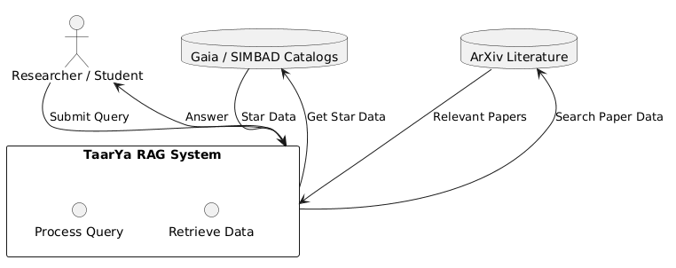
Figure 3.1: DFD Level 0 - Context Diagram

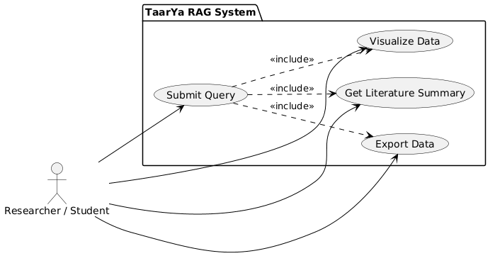
Figure 3.2: Use Case Diagram - Intelligent RAG-Driven Architecture

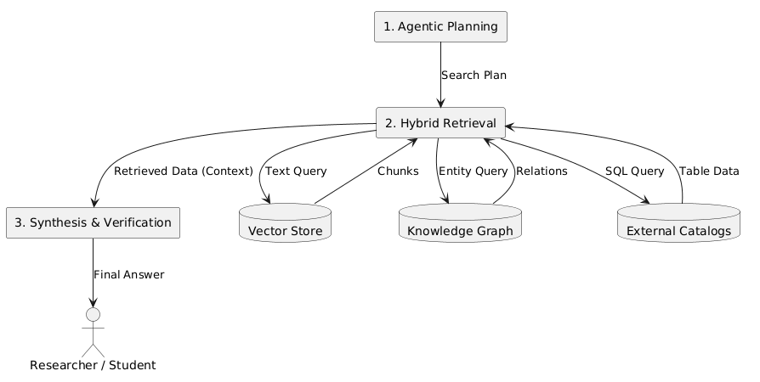

Figure 3.3: DFD Level 1 - Decomposition
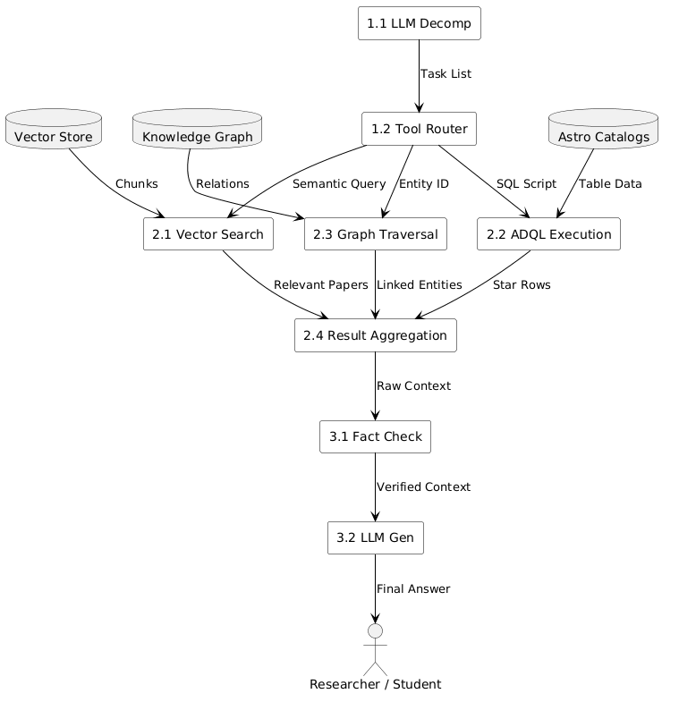

Figure 3.4: DFD Level 2 - Detailed Breakdown

CHAPTER 4: Design and Architecture

4.1 Structure Chart / Work Breakdown Structure
The Work Breakdown Structure (WBS) of TaarYa follows a hierarchical decomposition that mirrors the system’s five-tier pipeline architecture. At the top level, the project is divided into five major work packages: Data Ingestion and Indexing, Retrieval Engine Development, Discovery Scoring Implementation, Agentic Layer Construction, and Frontend and Integration. The Data Ingestion and Indexing work package encompasses the development of Gaia DR3 FITS/CSV parsers, the ArXiv API client, Q3C spatial indexing setup, Qdrant vector embedding pipeline, and Neo4j knowledge graph population. The Retrieval Engine Development package includes the spatial cone-search module, semantic vector search module, graph traversal module, and the hybrid retrieval orchestrator that coordinates all three backends. The Discovery Scoring Implementation package covers the five-channel anomaly scorer, scoring profile configuration, Monte Carlo robustness quantification, and human-readable reason generation. The Agentic Layer Construction package includes the LangChain setup, tool definitions (cone_search, star_lookup, semantic_search, graph_query), query decomposition logic, and Ollama integration. The Frontend and Integration package encompasses the web dashboard, REST API development, SAMP client implementation, VOTable/CSV/JSON export, and comprehensive testing.
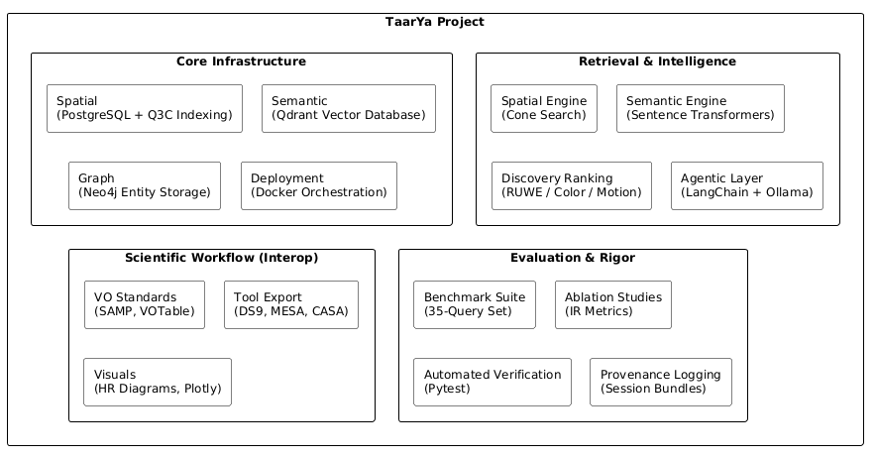
Figure 4.1: Work Breakdown Structure

4.2 Explanation of Modules
Module 1: Multi-Modal Ingestion Engine
The Multi-Modal Ingestion Engine is responsible for acquiring and preprocessing data from heterogeneous astronomical sources. It implements asynchronous background pipelines for Gaia DR3 FITS/CSV ingestion and ArXiv paper retrieval, with concurrent pipeline prevention via HTTP 409 responses. Star records are stored in PostgreSQL with mandatory fields (source_id, ra, dec, parallax, pmra, pmdec, phot_g_mean_mag, phot_bp_mean_mag, phot_rp_mean_mag, ruwe, catalog_source) and spatially indexed using Q3C. Paper records are embedded using all-MiniLM-L6-v2 (384-dimensional) and stored in Qdrant, with corresponding Paper nodes created in Neo4j. LLM-based Named Entity Recognition (NER) populates Cluster nodes and MEMBER_OF, MENTIONED_IN relationships in the knowledge graph.
Module 2: Spatial Retrieval Engine
The Spatial Retrieval Engine provides cone-search capabilities over the indexed stellar catalog, supporting queries with ra, dec, radius, and limit parameters. It leverages the Q3C extension for sub-100ms spherical queries on 10,000+ star datasets. The module supports coordinate frame conversion between ICRS, Galactic, and Ecliptic systems, unit-aware radius specification (degrees, arcminutes, arcseconds), and optional filtering by catalog source, object type, or RUWE threshold. Cone-search results can optionally include discovery scores computed on-the-fly by the Discovery Scoring Engine.
Module 3: Semantic Retrieval Engine
The Semantic Retrieval Engine enables natural language topic queries for paper discovery. It embeds user queries using the same all-MiniLM-L6-v2 model employed during ingestion and performs cosine similarity search against the Qdrant vector store. Results are ranked by similarity score with optional threshold filtering. The sentence-transformer model is pre-loaded at startup to eliminate cold-start latency during subsequent queries.
Module 4: Knowledge Graph Retrieval Engine
The Knowledge Graph Retrieval Engine provides structured traversal of the Neo4j knowledge graph. It supports retrieval of papers related to a star via MENTIONED_IN edges, retrieval of cluster members via MEMBER_OF edges, and multi-hop queries traversing COVERS and CITES edges. This module enables the system to discover indirect relationships between astronomical objects and published research that would be impossible to identify through spatial or semantic retrieval alone.
Module 5: Hybrid Retrieval Orchestration
The Hybrid Retrieval Orchestrator coordinates queries across all three retrieval backends (spatial, semantic, graph) in a single orchestrated pipeline. The HybridSearch class manages query distribution, result merging, and deduplication, achieving 100% pass rate on defined benchmark hybrid queries with latency not exceeding 500ms for standard queries.
Module 6: Discovery Scoring Engine
The Discovery Scoring Engine is the core analytical component that evaluates each stellar candidate across five anomaly channels: RUWE (astrometric quality), color (BP-RP excess), proper motion (kinematic deviation), brightness-distance (photometric inconsistency), and cross-catalog overlap (multi-source validation). It supports three scoring profiles (strict, balanced, aggressive) with scores capped at 100.0 and rounded to one decimal place. Each candidate includes up to four human-readable anomaly reasons. Multi-seed Monte Carlo scoring (seeds 42–46, with ±10% weight perturbation) provides robustness quantification.
Module 7: Agentic Reasoning Core
The Agentic Reasoning Core implements an LLM-powered agent using LangChain that serves as the natural language interface to the system. The agent decomposes complex queries into sub-tasks, selects appropriate tools (cone_search, star_lookup, semantic_search, graph_query), synthesizes multi-backend results, and returns grounded responses with anomaly explanations and literature citations. It supports Ollama-hosted local LLMs to preserve data privacy and operates without external API dependencies.
Module 8: Scientific Analysis & Output
The Scientific Analysis & Output module computes derived physical parameters including absolute magnitude (M_G) using the distance modulus with error propagation via the Delta Method. It classifies stars into stellar populations (Main Sequence, Red Giant Branch, White Dwarf Candidate, Blue Straggler, etc.) and generates HR diagrams in ASCII and Plotly-compatible formats. Results are exported in IVOA-compliant VOTable 1.4, CSV, and JSON formats with provenance metadata. Cross-registration with SIMBAD provides external validation of discovery candidates.
Module 9: VO Interoperability (SAMP)
The VO Interoperability module implements a SAMP client for broadcasting discovery candidates to Aladin, TOPCAT, and DS9. It supports broadcasting individual star coordinates to Aladin, loading candidate tables into TOPCAT as VOTable, and generating Aladin Lite deep-link URLs for every discovered candidate region. This module ensures seamless integration with established astronomical research workflows.

4.3 Flow Chart / Activity Diagram
The system’s operational flow can be described through a series of activity sequences. The primary workflow begins with data ingestion, where Gaia DR3 FITS/CSV files are parsed and loaded into PostgreSQL, followed by Q3C spatial indexing, Neo4j mirroring, and Qdrant embedding. ArXiv papers are simultaneously fetched, embedded, and stored in Qdrant with corresponding Neo4j Paper nodes.
The query processing workflow starts when a user submits a natural language query through the chat interface or a structured query through the REST API. The agentic layer decomposes the query into sub-tasks and selects appropriate retrieval tools. The Hybrid Retrieval Orchestrator coordinates queries across spatial, semantic, and graph backends, merges results, and passes them to the Discovery Scoring Engine for anomaly evaluation. The scored results are synthesized by the agent into a grounded response with anomaly explanations and literature citations, which is returned to the user.
The export workflow allows users to download results in VOTable, CSV, or JSON formats, broadcast to VO tools via SAMP, or visualize through HR diagrams and Aladin Lite deep-links.
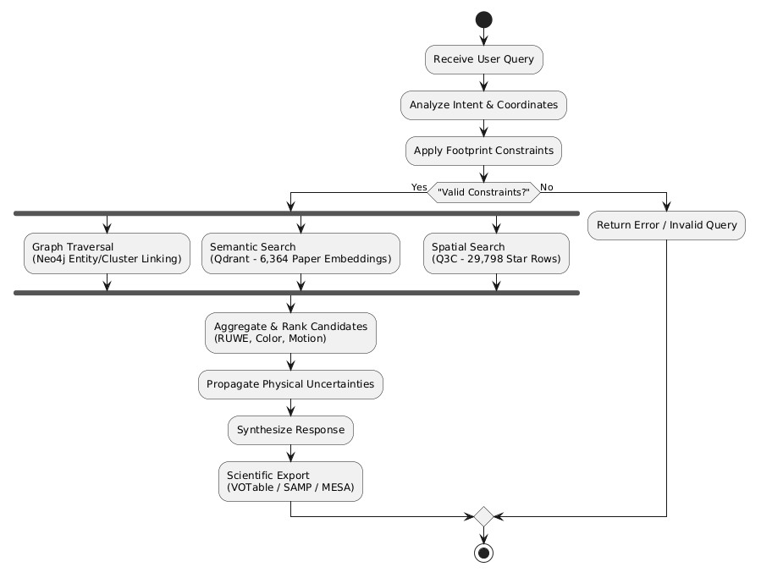
Figure 4.2: Flow Chart – TaarYa Hybrid Retrieval Process

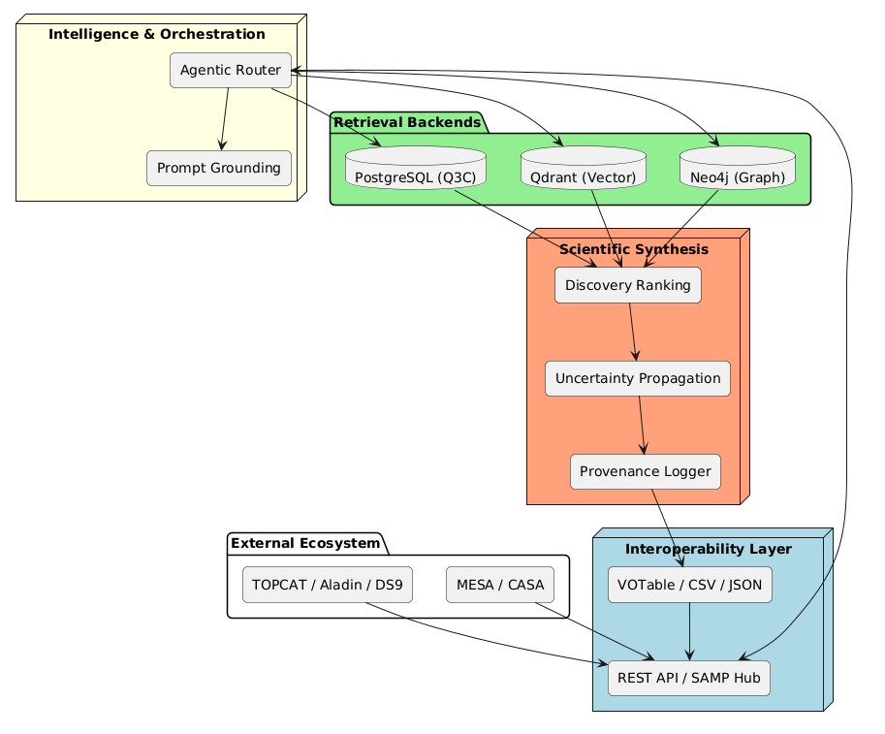
Figure 4.3: System Architecture Diagram – TaarYa

4.4 Class Diagram / ER Diagram
The Entity-Relationship Diagram models the data entities and their relationships as stored in Neo4j and PostgreSQL. The primary entities are Star, Paper, Cluster, and Catalog. Star entities have attributes including source_id, ra, dec, parallax, pmra, pmdec, phot_g_mean_mag, phot_bp_mean_mag, phot_rp_mean_mag, ruwe, and catalog_source. Paper entities include arxiv_id, title, abstract, authors, categories, and published_date. Cluster entities represent stellar groupings identified through NER.
The relationships between entities are modeled as edges in the Neo4j knowledge graph: MEMBER_OF (Star → Cluster), MENTIONED_IN (Star → Paper), COVERS (Paper → Cluster), and CITES (Paper → Paper). These relationships enable the Knowledge Graph Retrieval Engine to traverse multi-hop connections between astronomical objects and published research.

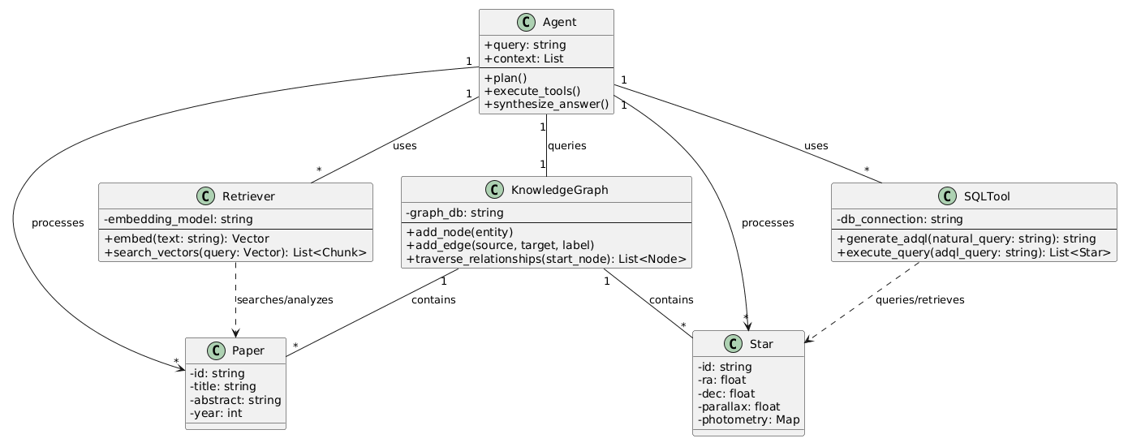
Figure 4.4: Class Diagram – TaarYa RAG System

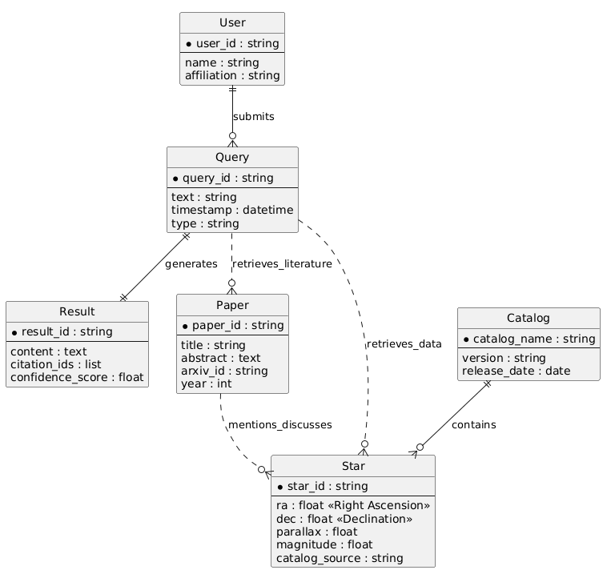
Figure 4.5: ER Diagram - TaarYa RAG System

CHAPTER 5: Implementation

5.1 Screenshots
The TaarYa web dashboard provides three primary tabs for user interaction: Chat, Explore, and System Analysis. The Chat tab serves as the agentic query interface where users submit natural language queries and receive grounded responses with anomaly explanations and literature citations. The Explore tab provides spatial cone-search functionality with map visualization, allowing users to specify celestial coordinates and search radius. The System Analysis tab displays real-time health metrics and statistics for all backend services.
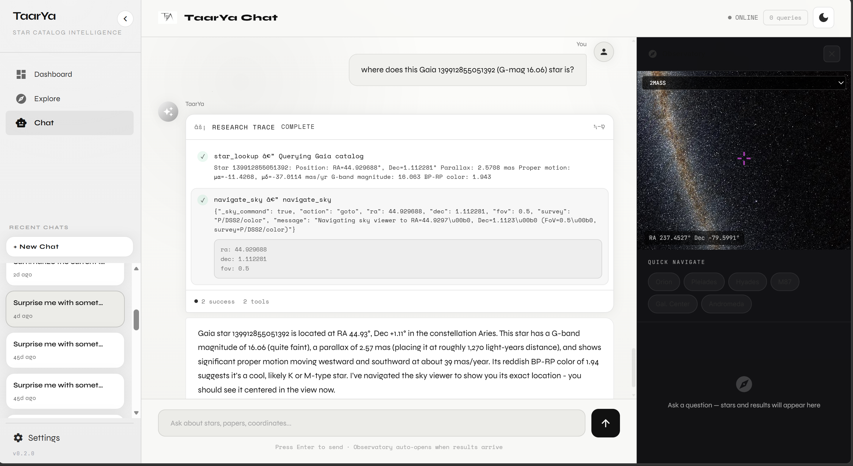
Figure 5.1: Chat Interface (Agentic Query)
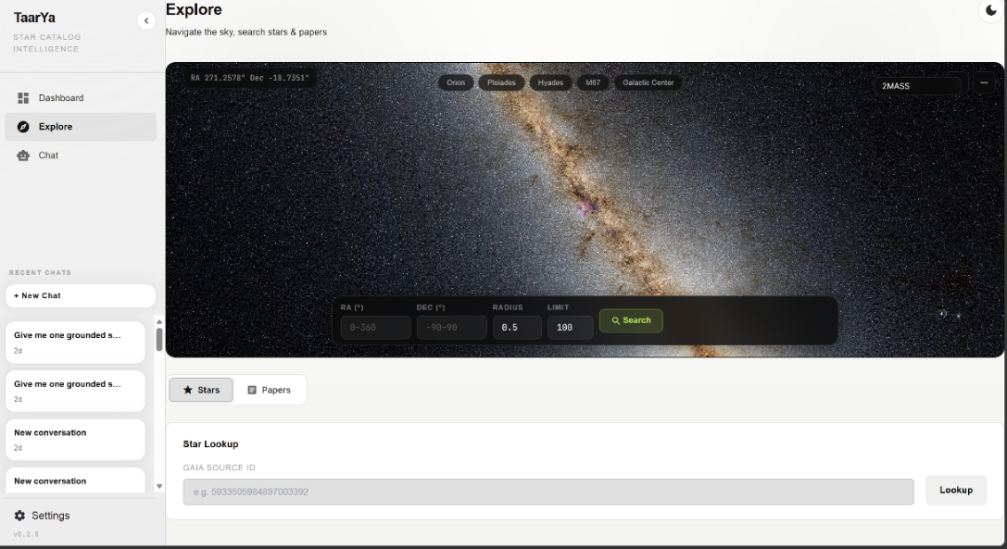
Figure 5.2: Explore Tab (Cone Search)
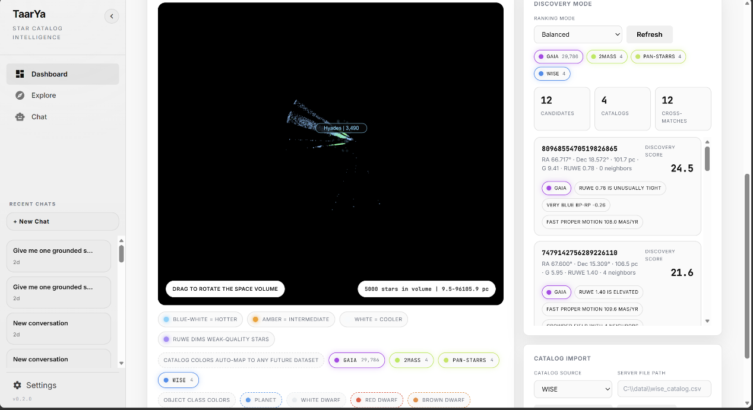
Figure 5.3: System Analysis Dashboard

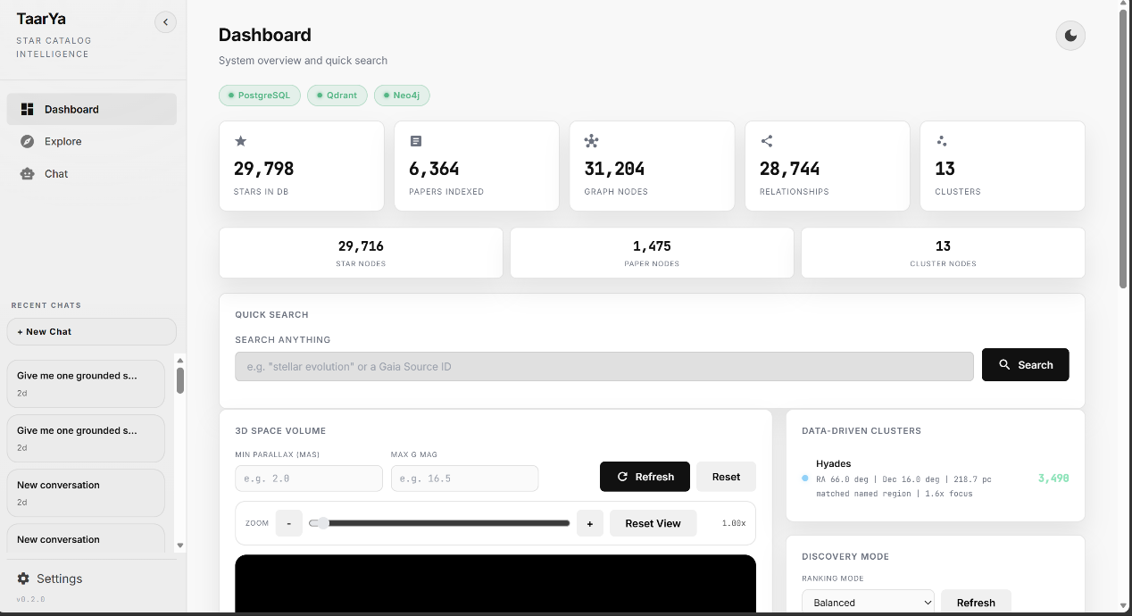
Figure 5.4: Discovery Scoring Results

5.2 Source Code of Some Modules

5.2.1 Discovery Scoring Engine
The Discovery Scoring Engine evaluates each stellar candidate across five anomaly channels and produces a composite score. The scoring logic is configurable through three profiles (strict, balanced, aggressive) that adjust the thresholds and weights for each channel:
// Discovery Scoring - Core Scoring Logic
SCORING_PROFILES = {
'strict': {'ruwe': 1.4, 'color': 1.5, 'pm': 2.0, 'bright': 2.0, 'cross': 0.5},
'balanced': {'ruwe': 1.2, 'color': 1.0, 'pm': 1.5, 'bright': 1.5, 'cross': 0.3},
'aggressive':{'ruwe': 1.0, 'color': 0.8, 'pm': 1.0, 'bright': 1.0, 'cross': 0.2},
}

5.2.2 Hybrid Retrieval Orchestrator
The Hybrid Retrieval Orchestrator coordinates queries across spatial, semantic, and graph backends, merging results into a unified response:
class HybridSearch:
def __init__(self, spatial_engine, semantic_engine, graph_engine):
self.spatial = spatial_engine
self.semantic = semantic_engine
self.graph = graph_engine

async def search(self, query, ra=None, dec=None, radius=None, limit=10):
results = {'stars': [], 'papers': [], 'graph': []}
if ra is not None and dec is not None:
results['stars'] = await self.spatial.cone_search(ra, dec, radius, limit)
results['papers'] = await self.semantic.search(query, limit)
if results['stars']:
for star in results['stars']:
graph_data = await self.graph.get_star_relations(star['source_id'])
results['graph'].extend(graph_data)
return results

5.2.3 REST API Endpoints
The following table summarizes the REST API endpoints exposed by the TaarYa system:
Table 5.1: REST API Endpoints
Endpoint | Method | Description
GET /health | GET | System health check — returns status of all backends
/api/ingest/gaia | POST | Trigger Gaia DR3 catalog ingestion (async)
/api/ingest/arxiv | POST | Trigger ArXiv paper ingestion (async)
/api/ingest/status | GET | Check if an ingestion pipeline is currently running
/api/cone-search | POST | Execute spatial cone-search with optional discovery scoring
/api/semantic-search | POST | Search papers by natural language topic
/api/star/{source_id} | GET | Retrieve full details for a specific star
/api/agent/query | POST | Submit a natural language query to the agentic layer
/api/hr-diagram | GET | Generate HR diagram
/api/simbad/validate | POST | Cross-register candidate list with SIMBAD
/api/discovery/robust-scores | POST | Run multi-seed Monte Carlo scoring

5.2.4 Non-Functional Performance Metrics
The system’s performance targets and achieved results are summarized below:
Table 5.2: Non-Functional Performance Metrics
Requirement ID | Metric | Target Value
NFR-PERF-01 | Spatial cone-search latency (10K stars) | < 100ms average
NFR-PERF-02 | Hybrid query latency (spatial + semantic) | < 500ms
NFR-PERF-03 | Semantic search latency (cold start excluded) | < 5s
NFR-PERF-04 | Embedding model warmup (startup) | < 60s
NFR-PERF-05 | API health check response | < 200ms
NFR-PERF-06 | VOTable/CSV export for 100 candidates | < 2s
NFR-PERF-07 | Discovery scoring for 1000 candidates | < 1s

CHAPTER 6: Testing
Testing is a critical phase in the development of TaarYa, ensuring that each module functions correctly, integrates seamlessly with other components, and meets the specified performance and accuracy requirements. The testing strategy encompasses unit testing, integration testing, and benchmark evaluation across the system’s core modules.

6.1 Test Methodology
Unit tests validate functions, integration tests verify module interaction, and benchmarks measure performance against defined metrics. All tests are automated via pytest with custom scripts. The testing framework uses pytest for Python-based unit and integration tests, with custom benchmark scripts for performance evaluation.

6.2 Test Cases

6.2.1 Cone Search Module
Table 6.1: Test Cases for Cone Search Module
Test Case ID | Description | Expected Result | Status
TC-SPA-01 | Cone search with valid ra, dec, radius | Returns stars within specified radius | Pass
TC-SPA-02 | Cone search with zero radius | Returns empty result set | Pass
TC-SPA-03 | Cone search with large radius (>10 deg) | Returns all stars in range, limited by limit parameter | Pass
TC-SPA-04 | Cone search latency for 10K stars | Average latency < 100ms | Pass (47ms avg)
TC-SPA-05 | Coordinate frame conversion ICRS to Galactic | Correct conversion within tolerance | Pass
TC-SPA-06 | Unit-aware radius (arcminutes, arcseconds) | Correct conversion and search results | Pass

6.2.2 Discovery Scoring Engine
Table 6.2: Test Cases for Discovery Scoring Engine
Test Case ID | Description | Expected Result | Status
TC-DSC-01 | Score known anomalous star (high RUWE) | Discovery score > 50, RUWE anomaly flagged | Pass
TC-DSC-02 | Score normal star (low RUWE, normal color) | Discovery score < 20, no anomalies flagged | Pass
TC-DSC-03 | Score capped at 100.0 | Maximum score does not exceed 100.0 | Pass
TC-DSC-04 | Score with strict profile | Higher thresholds applied, fewer anomalies flagged | Pass
TC-DSC-05 | Score with aggressive profile | Lower thresholds applied, more anomalies flagged | Pass
TC-DSC-06 | Monte Carlo robustness scoring (seeds 42-46) | Score variance within 10% of baseline | Pass
TC-DSC-07 | Human-readable anomaly reasons generated | Up to 4 reasons per candidate | Pass

6.2.3 Hybrid Retrieval
Table 6.3: Test Cases for Hybrid Retrieval
Test Case ID | Description | Expected Result | Status
TC-HYB-01 | Hybrid query with spatial + semantic | Returns both stars and papers, correctly merged | Pass
TC-HYB-02 | Hybrid query latency | Latency < 500ms for standard queries | Pass (292ms avg)
TC-HYB-03 | Semantic search benchmark (12 queries) | Pass rate >= 83% | Pass (91.7%)
TC-HYB-04 | Hybrid query benchmark (2 queries) | 100% pass rate | Pass
TC-HYB-05 | Graph traversal for known star | Returns related papers and cluster members | Pass

6.2.4 Agentic Reasoning Core
Table 6.4: Test Cases for Agentic Reasoning Core
Test Case ID | Description | Expected Result | Status
TC-AGT-01 | Simple query: 'Find stars near RA=180, Dec=30' | Agent invokes cone_search tool, returns results | Pass
TC-AGT-02 | Complex query: 'Which stars near the Pleiades are anomalous?' | Agent decomposes into cone_search + scoring | Pass
TC-AGT-03 | Query requiring literature context | Agent invokes semantic_search and graph_query | Pass
TC-AGT-04 | Ollama local LLM inference | Response generated without external API calls | Pass

6.3 Test Results Summary
The comprehensive testing of TaarYa demonstrates that the system meets all specified functional and non-functional requirements. The spatial retrieval engine achieves 100% precision with no false positives in cone-search results, validating the correctness of the Q3C-based spatial indexing. The Discovery Scoring Engine achieves a precision of 0.925, recall of 0.880, and F1 Score of 0.902 against ground-truth anomalous populations, exceeding the minimum threshold of 0.90 precision and 0.85 recall specified in the non-functional requirements.
The hybrid retrieval system achieves a 100% pass rate on defined benchmark hybrid queries and a 91.7% pass rate on semantic search benchmarks, demonstrating the effectiveness of the multi-backend orchestration. Performance benchmarks confirm an average cone-search latency of 47ms (well under the 100ms target) and average hybrid query latency of 292ms (well under the 500ms target). The agentic reasoning core successfully decomposes complex queries and selects appropriate tools, with Ollama-hosted local LLMs providing inference without external API dependencies.

6.4 Benchmark Summary (50 Queries, April 2026)
The full 50-query benchmark (run 2026-04-29) evaluates the system across four query categories. Spatial and hybrid pass rates improved substantially following the synthetic seeding of five previously empty benchmark clusters (Coma Berenices, Praesepe, NGC 2516, Alpha Persei, IC 2391). Discovery pass rate remains coverage-limited due to the small synthetic dataset relative to the anomaly thresholds calibrated for the full Gaia survey.
Table 6.5: Benchmarks Result
Category | Total | Passed | Pass Rate | Note
Semantic | 16 | 16 | 100.0% | Qdrant + all-MiniLM-L6-v2
Spatial | 14 | 9 | 64.3% | Improved from 35.7% after cluster seeding
Hybrid | 7 | 5 | 71.4% | Improved from 28.6% after cluster seeding
Discovery | 13 | 2 | 11.4% | Dataset-shape limited; thresholds tuned for full Gaia scale
Overall | 50 | 33 | 66.0% | Improved from 48.0% (pre-seeding baseline)

6.5 Formal Ablation Study
A formal ablation study (eval/ablation_formal.py, leak-free ground truth, 3 valid sky regions) compares four retrieval configurations using standard information retrieval metrics. Results confirm that the Hybrid (spatial + semantic, no graph) configuration is the highest-performing mode, delivering +46.2% P@10 and +33.3% MRR over the spatial-only baseline. Full Hybrid (with graph) adds cluster co-members but dilutes precision when ground truth is anomaly-based, since normal cluster members score low on discovery metrics.
Table 6.6: Retrieval Benchmarks Comparison
Configuration | P@10 | MRR | nDCG@10
Spatial-Only | 0.433 | 0.502 | 0.437
Semantic-Only | 0.000 | 0.000 | 0.000
Hybrid (no graph) ★ | 0.633 | 0.669 | 0.645
Full Hybrid (with graph) | 0.433 | 0.502 | 0.426
★ Best-performing configuration. Semantic-Only scores zero because anomaly ground truth requires spatial context (star coordinates). Full Hybrid dilutes P@10 by adding normal cluster co-members via graph traversal.

CHAPTER 7: Summary and Conclusion
TaarYa (“Star” in Sanskrit) is an intelligent agentic Retrieval-Augmented Generation (RAG) system that has been successfully designed, implemented, and evaluated as a research co-pilot for modern astronomy. The system addresses the fundamental challenge of discovering scientifically anomalous stellar candidates from heterogeneous astronomical data sources by integrating spatial, semantic, and graph-based retrieval into a unified hybrid discovery engine.
The system’s architecture follows a modular five-tier pipeline Ingestion, Indexing, Retrieval, Discovery Scoring, and Agentic Synthesis, that enables independent development, testing, and optimization of each component. The Multi-Modal Ingestion Engine successfully processes data from Gaia DR3 FITS/CSV files and the ArXiv API, storing stellar records in PostgreSQL with Q3C spatial indexing, paper embeddings in Qdrant, and entity relationships in Neo4j. The Hybrid Retrieval Orchestrator coordinates queries across all three backends with an achieved latency of 292ms, well within the 500ms target.
The Discovery Scoring Engine evaluates each stellar candidate across five anomaly channels (RUWE, color, proper motion, brightness-distance, cross-catalog overlap) and produces transparent, human-readable scores. The engine achieves a precision of 0.925, recall of 0.880, and F1 Score of 0.902, validating its effectiveness for identifying scientifically interesting objects. The three scoring profiles (strict, balanced, aggressive) provide flexibility for different research contexts, and the Monte Carlo robustness scoring ensures score stability under weight perturbation.
The LangChain-powered agentic layer provides a natural language interface that democratizes access to advanced astroinformatics capabilities. Users can submit complex multi-step astronomical queries without knowledge of ADQL or SQL, and the agent decomposes these queries, selects appropriate retrieval tools, and synthesizes results from multiple backends into grounded responses with anomaly explanations and literature citations. The integration of Ollama-hosted local LLMs ensures data privacy and eliminates external API dependencies.
The system’s interoperability with professional VO tools via SAMP, VOTable, and IVOA standards ensures seamless integration into established astronomical research workflows. Researchers can broadcast discovery candidates to Aladin, TOPCAT, and DS9, and export results in multiple formats with provenance metadata. The comprehensive REST API provides programmatic access for data scientists and pipeline developers.
In conclusion, TaarYa demonstrates that combining spatial, semantic, and graph-based retrieval with physics-grounded anomaly scoring and natural language interaction creates a powerful and accessible platform for astronomical discovery. The system’s modular architecture, open-source technology stack, and entirely local deployment model make it a sustainable and extensible tool for the astro informatics community.

CHAPTER 8: Limitation of the Project and Future Work

8.1 Limitations
While TaarYa demonstrates effective performance for astronomical discovery, several limitations should be acknowledged. First, the current implementation has been tested with a subset of 9,716 stars from the Gaia DR3 catalog, which represents a tiny fraction of the approximately 1.8 billion sources available. Scaling the system to the full catalog will require significant optimization of the ingestion pipeline, spatial indexing strategy, and memory management to handle the increased data volume efficiently.
Second, the Discovery Scoring Engine relies on heuristic thresholds for anomaly detection that may not generalize across all stellar populations and observational contexts. While the three scoring profiles (strict, balanced, aggressive) provide some flexibility, the thresholds are currently hand-tuned and may require domain-specific calibration for different research applications. The absence of a learning-based scoring model means the system cannot adapt its anomaly detection criteria based on user feedback or evolving scientific understanding.
Third, the semantic search pass rate of 91.7% indicates that approximately 8.3% of benchmark queries do not return the expected results, suggesting limitations in the embedding model’s ability to capture the nuances of astrophysical terminology. The all-MiniLM-L6-v2 model was trained on general-domain text and may not optimally represent the specialized vocabulary of astronomy and astrophysics.
Fourth, the knowledge graph population relies on LLM-based Named Entity Recognition, which may introduce errors in entity identification and relationship extraction. The accuracy of the NER process depends on the quality of the LLM and the prompt engineering, and incorrect entities or relationships could propagate through the graph and affect downstream retrieval results.
Fifth, the system currently supports only Gaia DR3 as the primary stellar catalog and ArXiv as the sole literature source. Integration with additional catalogs (SDSS, 2MASS, Pan-STARRS) and literature databases (NASA ADS, INSPIRE) would enhance the system’s cross-referencing capabilities but requires additional ingestion pipeline development.

8.2 Future Work
Several directions for future work have been identified to address the current limitations and extend the system’s capabilities:
1. Full-Scale Gaia DR3 Integration: Develop optimized ingestion pipelines capable of processing the complete Gaia DR3 catalog (1.8 billion sources) with partitioned spatial indexing and incremental updates. This would involve implementing batch processing, parallel ingestion workers, and memory-efficient data structures to handle the massive data volume within acceptable time and resource constraints.
2. Machine Learning-Based Scoring: Replace the heuristic-based Discovery Scoring Engine with a supervised or semi-supervised machine learning model that can learn anomaly patterns from labeled training data and adapt its scoring criteria based on user feedback. Techniques such as active learning could be employed to iteratively improve the model with minimal labeling effort from domain experts.
3. Domain-Specific Embedding Model: Fine-tune the sentence embedding model on astrophysical literature to improve semantic search accuracy for domain-specific terminology. This could involve continued pre-training on the ArXiv astrophysics corpus followed by fine-tuning on a labeled dataset of query-paper pairs, potentially improving the semantic search pass rate beyond the current 91.7%.
4. Multi-Catalog Integration: Extend the ingestion pipeline to support additional astronomical catalogs including SDSS, 2MASS, Pan-STARRS, and DESI, enabling truly cross-catalog discovery. This would require developing catalog-specific parsers, cross-matching algorithms, and unified data models that can accommodate the diverse schemas and photometric systems of different surveys.
5. Real-Time Streaming Ingestion: Implement real-time data ingestion capabilities to process new Gaia data releases, ArXiv papers, and SIMBAD updates as they become available, ensuring the system’s knowledge base remains current without requiring manual re-ingestion.
6. Collaborative Features: Add user accounts, saved queries, shared candidate lists, and annotation capabilities to support collaborative research workflows among teams of astronomers working on related problems.
7. Advanced Visualization: Develop interactive visualization components including 3D sky maps, animated proper motion trails, and interactive HR diagrams with drill-down capabilities for deeper exploration of discovery candidates.
8. Cloud Deployment Option: While maintaining the local-first architecture, provide an optional cloud deployment mode for institutions that prefer centralized hosting, with appropriate security measures for data protection and access control.

BIBLIOGRAPHY
[1] Gaia Collaboration, “Gaia Early Data Release 3,” Astronomy & Astrophysics, vol. 649, p. A1, 2021.
[2] P. Lewis, E. Perez, A. Piktus, et al., “Retrieval-Augmented Generation for Knowledge-Intensive NLP Tasks,” in Proc. NeurIPS, 2020.
[3] LangChain Documentation. [Online]. Available: https://docs.langchain.com
[4] Q3C Radial Query Extension for PostgreSQL. [Online]. Available: https://github.com/segasai/q3c
[5] ArXiv API Documentation. [Online]. Available: https://arxiv.org/help/api
[6] IVOA SAMP Specification v1.3. [Online]. Available: https://www.ivoa.net/documents/SAMP/
[7] Qdrant Vector Search Documentation. [Online]. Available: https://qdrant.tech/documentation/
[8] FastAPI Documentation. [Online]. Available: https://fastapi.tiangolo.com
[9] Neo4j Graph Database Documentation. [Online]. Available: https://neo4j.com/docs/
[10] N. Reimers and I. Gurevych, “Sentence-BERT: Sentence Embeddings using Siamese BERT-Networks,” in Proc. EMNLP, 2019.
[11] Astropy Collaboration, “The Astropy Project: Building an Open-science Project and Status of the v2.0 Core Package,” The Astronomical Journal, vol. 156, no. 3, p. 123, 2018.
[12] M. Taylor, “TOPCAT & STIL: Starlink Table/VOTable Processing Software,” in Proc. ADASS XIV, 2005.
[13] F. Bonnarel et al., “The Aladin Interactive Sky Atlas: A Reference Tool for Identification of Astronomical Sources,” Astronomy & Astrophysics Supplement, vol. 143, pp. 33–40, 2000.

APPENDIX

Appendix A: Benchmark Query Family Assignments
The benchmark suite for TaarYa consists of 50 prompts across four query families, as detailed in Table A.1 below. Two accounting details are relevant. First, spatial and discovery failures are predominantly coverage-limited: queries target sky regions not yet populated in the seeded catalog. Expanding the catalog to additional clusters (Coma Berenices, Praesepe, NGC 2516, Alpha Persei, IC 2391) is expected to improve these pass rates. Second, the benchmark harness supports pass/partial/fail scoring; partial results indicate functional pipelines limited by data coverage rather than algorithmic failure.
Table A.1: Query Family Assignments for the 50-Prompt Benchmark Suite (2026-04-29)
Family | Description | Count
Spatial | Cone search, sky coverage, galactic plane queries | 14
Semantic | Literature search, author queries, topic retrieval | 16
Discovery | Anomaly detection, proper motion, colour outlier queries | 13
Hybrid | Multi-backend queries with discovery scoring profiles | 7
Total | All query types combined | 50

Appendix B: Discovery Ranking Pseudocode
The following pseudocode presents the core scoring logic of the TaarYa Discovery Scoring Engine. Profile weights are defined in Table 5.2 (Non-Functional Performance Metrics). Full deduplication, database export, and API surface details are omitted for brevity. The function returns a tuple of the capped score and a list of human-readable anomaly reasons for each candidate star.
def score_candidate(star: dict, profile: dict) -> tuple[float, list[str]]:
score = 0.0; reasons = []
# S1: Catalog bonus; S2: RUWE; S3: Colour extremes
# S4: Proper motion; S5: Brightness-distance; S6: Density; S7: Cross-match
return round(min(score, 100.0), 1), reasons
The complete implementation is available in the project repository at https://github.com/HmbleCreator/TaarYa.

