📘 IPS AutoPost Platform – AWS Modernization
High-Level Design (HLD) Document
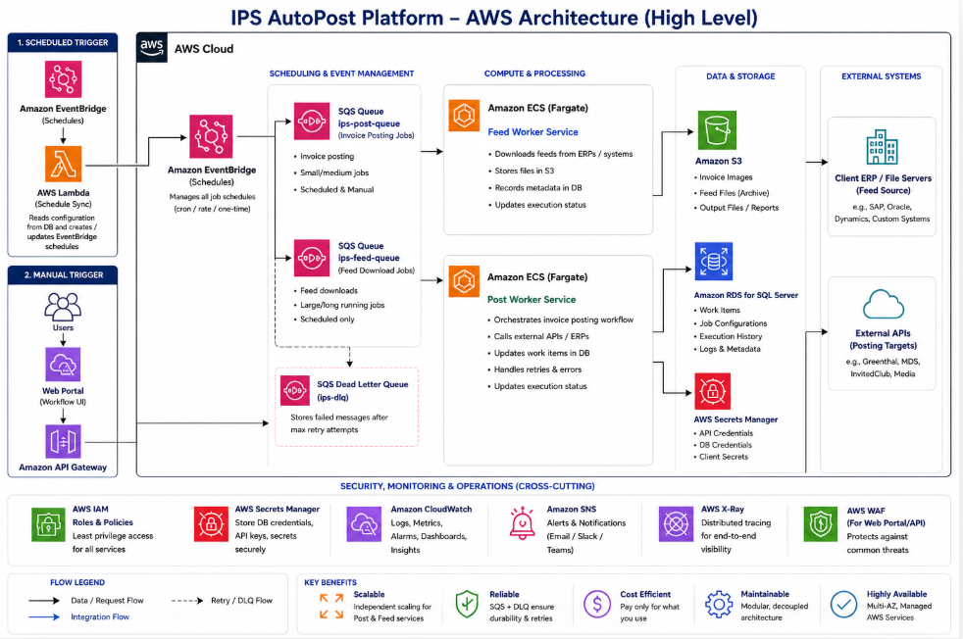

1. Executive Summary
The IPS AutoPost Platform is being modernized from a Windows server-based architecture to a cloud-native AWS architecture to achieve:
- Improved scalability and performance
- Reduced infrastructure cost (~80–90% savings)
- Elimination of server dependency
- Better observability and reliability
- Faster onboarding of new clients
The new architecture leverages managed AWS services such as:
- Amazon ECS (core processing)
- Amazon SQS (decoupling & reliability)
- Amazon EventBridge (scheduling)
- AWS Lambda (schedule management only)
- Amazon RDS (workflow database)
- Amazon S3 (file storage)

2. Current State Challenges
The existing system has the following limitations:
- ❌ 40+ Windows services running on dedicated servers
- ❌ Manual scheduling per client
- ❌ Tight coupling between components
- ❌ High infrastructure and maintenance cost
- ❌ Limited scalability
- ❌ Difficult monitoring and debugging

3. Target Architecture Overview
3.1 Key Design Principles
- Event-driven architecture
- Loose coupling using queues
- Stateless compute
- Separation of concerns (Feed vs Post)
- Scalable and fault-tolerant design

3.2 Core Components
1. Scheduling Layer
- Amazon EventBridge triggers jobs based on schedule
- AWS Lambda syncs schedules from DB
2. Queue Layer
- Amazon SQS:
  - Feed Queue
  - Post Queue
  - Dead Letter Queue (DLQ)
3. Compute Layer
- Amazon ECS (Fargate):
  - Feed Worker Service
  - Post Processing Service
4. Data Layer
- Amazon RDS (SQL Server)
- Amazon S3

4. High-Level Architecture Flow
4.1 Scheduled Execution Flow
- EventBridge triggers based on cron schedule
- Message sent to SQS (Feed/Post queue)
- ECS service picks up message
- Job is processed
- Results stored in DB and logs

4.2 Manual Execution Flow
- User triggers via UI
- Request goes through API
- Message pushed to SQS
- ECS processes job asynchronously

5. Detailed Component Design

5.1 Scheduling Layer
Services Used:
- Amazon EventBridge
- AWS Lambda
Responsibilities:
- Maintain job schedules dynamically
- Trigger jobs per client configuration
- Support timezone-aware scheduling
Design Decision:
Lambda is NOT used for processing, only for:
- Reading DB schedule table
- Creating/updating EventBridge rules

5.2 Queue Layer
Service:
- Amazon SQS
Queues:
Queue | Purpose
Feed Queue | Feed download jobs
Post Queue | Invoice posting jobs
DLQ | Failed messages
Benefits:
- Decoupling between trigger and processing
- Built-in retry mechanism
- Fault tolerance

5.3 Compute Layer
Service:
- Amazon ECS (Fargate)

5.3.1 Feed Worker Service
Responsibilities:
- Download feeds from external ERP systems
- Process large datasets (batch processing)
- Store raw files in S3
- Insert metadata into DB
Characteristics:
- Long-running jobs (20–40 minutes)
- High memory usage
- Batch-oriented

5.3.2 Post Processing Service
Responsibilities:
- Fetch work items from DB
- Process 100–1000+ records per job
- Call external APIs
- Upload/download images
- Update workflow status

5.4 Post Processing Logic (Important Section)
Each job processes multiple records:
Flow:
- Fetch records from DB
- Process in batches
- For each record:
  - Fetch additional data
  - Call external API
  - Handle attachments/images
  - Apply business rules
  - Update DB

Parallel Processing Strategy
- Controlled concurrency (e.g., 10 threads)
- Batch size (e.g., 50 records)
- Retry for transient failures

Why ECS is Used Instead of Step Functions
Factor | ECS | Step Functions
Bulk processing | ✅ Excellent | ❌ Inefficient
Cost | ✅ Low | ❌ High
Performance | ✅ High | ❌ Slower
Complexity | ✅ Simple | ❌ Complex
Conclusion:
ECS is better suited for high-volume batch processing workloads.

6. Data Layer
6.1 Database
- Amazon RDS
Stores:
- Job configurations
- Work items
- Execution history
- Logs

6.2 Storage
- Amazon S3
Stores:
- Invoice images
- Feed files
- Output reports

7. Security Architecture
7.1 IAM
- Least privilege access
- Separate roles for each service
7.2 Network
- Private subnets for ECS & RDS
- NAT Gateway for outbound calls
7.3 Encryption
- TLS for data in transit
- AES-256 for data at rest

8. Observability
Services:
- Amazon CloudWatch
- Amazon SNS
Features:
- Centralized logging
- Metrics & dashboards
- Alerts for failures

9. Scalability & Performance
- ECS auto-scales based on SQS queue depth
- Parallel processing for large datasets
- Horizontal scaling supported

10. Cost Optimization
The proposed AWS-based architecture for the IPS AutoPost platform is designed to significantly reduce infrastructure costs while improving scalability, performance, and operational efficiency.
The solution adopts a hybrid, event-driven model using services such as Amazon ECS (with AWS Fargate), Amazon SQS, Amazon EventBridge, and AWS Lambda. This ensures that compute resources are utilized only when required, eliminating unnecessary idle infrastructure costs.
Cost Structure Overview
The architecture includes:
- Baseline (Always-On ECS Tasks): Ensures immediate response for user-triggered and API-based operations
- Auto-Scaling (Queue-Based Execution): Dynamically provisions additional compute capacity during peak workloads
- Managed Services: Minimal operational overhead with pay-per-use pricing
Estimated Monthly Cost
- Hybrid Model (Recommended): ~$720 – $1,100 per month
- Fully Serverless Model (No Always-On Compute): ~$70 – $160 per month (with trade-offs in latency)

11. Key Benefits
- ✅ Scalable architecture
- ✅ Highly reliable
- ✅ Cost-efficient
- ✅ Easy to maintain
- ✅ Faster onboarding of new clients

12. Final Architecture Summary
The IPS AutoPost platform is redesigned as a cloud-native, event-driven system using:
- Amazon EventBridge for scheduling
- Amazon SQS for decoupling
- Amazon ECS for processing
- Amazon RDS for data
- Amazon S3 for storage

13. Manual Processing & User Notification Design

13.1 Manual Post Execution Flow (From UI)
Manual posting is triggered when a user clicks “Post Now” in the Workflow UI.

Step-by-Step Flow
User → UI → API → SQS → ECS → DB → Notification → UI Update

Step 1: User Action
- User selects one or more invoices in UI
- Clicks “Post Now”
POST /api/post/{jobId}/items/{itemIds}

Step 2: API Layer
API (hosted behind Amazon API Gateway or .NET backend):
- Validates request
- Generates ExecutionId (GUID)
- Stores execution entry in DB
- Pushes message to Amazon SQS (Post Queue)
Message Example:
{
"ExecutionId": "abc-123",
"JobId": 371,
"ItemIds": [456,789,1023],
"TriggerType": "Manual"
}

Step 3: Immediate UI Response
UI does NOT wait for processing
Response:
{
"ExecutionId": "abc-123",
"Status": "Queued",
"Message": "Processing started"
}
👉 This avoids:
- Timeouts
- Long waits
- Poor UX

Step 4: ECS Processing
Amazon ECS Post Service:
- Picks message from SQS
- Fetches records
- Processes each record
- Updates DB per record

13.2 Execution Tracking Model (VERY IMPORTANT)
Introduce Execution Tracking Table
Table: generic_execution_tracking
Column | Purpose
ExecutionId | Unique tracking ID
JobId | Job reference
TotalRecords | Count
ProcessedRecords | Progress
SuccessCount | Success
FailCount | Failures
Status | Running / Completed / Failed
StartTime | Execution start
EndTime | Execution end

13.3 UI Notification Options (Client Decision)
There are 3 approaches. You should present these to client.

✅ Option 1: Polling (Recommended for MVP)
How It Works
UI calls status API every few seconds:
GET /api/execution/{executionId}/status
Response:
{
"Status": "Running",
"Processed": 45,
"Total": 100,
"Success": 42,
"Failed": 3
}

Pros:
- Simple to implement
- No infrastructure change
- Reliable
Cons:
- Slight delay (2–5 seconds)
- Repeated API calls

🚀 Option 2: Real-Time (WebSocket / SignalR)
How It Works
- Backend pushes updates to UI in real-time
- Uses:
  - SignalR
OR
  - WebSockets via API layer

Flow:
ECS → DB update → Event → SignalR → UI

Pros:
- Real-time updates
- Best user experience
Cons:
- More complex
- Requires persistent connections

⚖️ Option 3: Hybrid (BEST PRACTICE)
- Polling for backend reliability
- SignalR for real-time enhancement
👉 This is what most enterprise systems use

13.4 UI Experience (What Client Sees)

When User Clicks “Post Now”
✔ Request accepted
✔ Status: Processing started
✔ Progress bar appears

During Processing
Processing 45 / 100 invoices...
Success: 42
Failed: 3

On Completion
✔ Completed
✔ 95 Success, 5 Failed
✔ Download error report

13.5 Failure Handling & Retry
If records fail:
Option 1:
- User clicks Retry Failed
Option 2:
- System pushes failed records to:
  - Retry Queue (Amazon SQS)

13.6 Notification Enhancements
Optional:
- Email notification via Amazon SNS
- Slack alerts for failures
- UI toast notifications

13.7 Why Asynchronous is Mandatory
❌ Synchronous approach:
- UI waits 30–60 sec
- Risk of timeout
- Bad UX
✅ Asynchronous approach:
- Instant response
- Background processing
- Scalable

