ASSIGNMENT-08

NAME:B.MANISHWAR
HALLTICKET NO:2303A51276
BATCH:05
Task 1: Developing a Utility Function Using TDD
Scenario
You are working on a small utility library for a larger software system. One of the required functions should calculate the square of a given number, and correctness is critical because other modules depend on it.
Task Description
Following the Test Driven Development (TDD) approach:
- First, write unit test cases to verify that a function correctly returns the square of a number for multiple inputs.
- After defining the test cases, use GitHub Copilot or Cursor AI to generate the function implementation so that all tests pass.
Ensure that the function is written only after the tests are created.
Expected Outcome
- A separate test file and implementation file
- Clearly written test cases executed before implementation • AI-assisted function implementation that passes all tests •
Demonstration of the TDD cycle: test → fail → implement → pass Code:
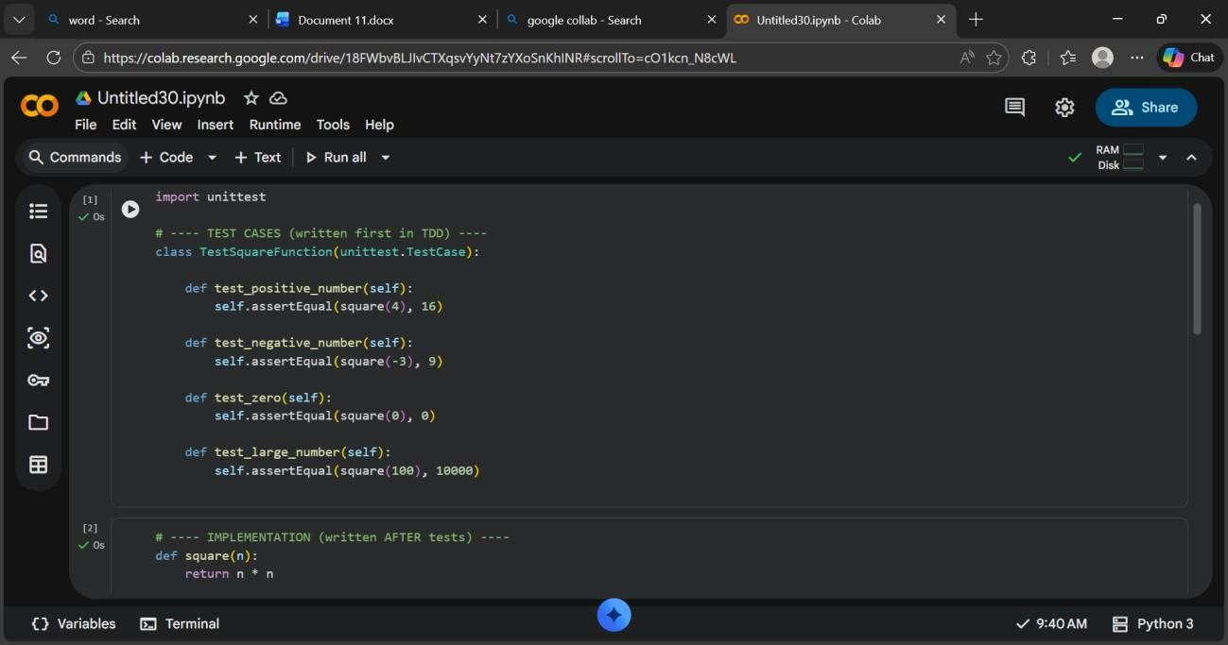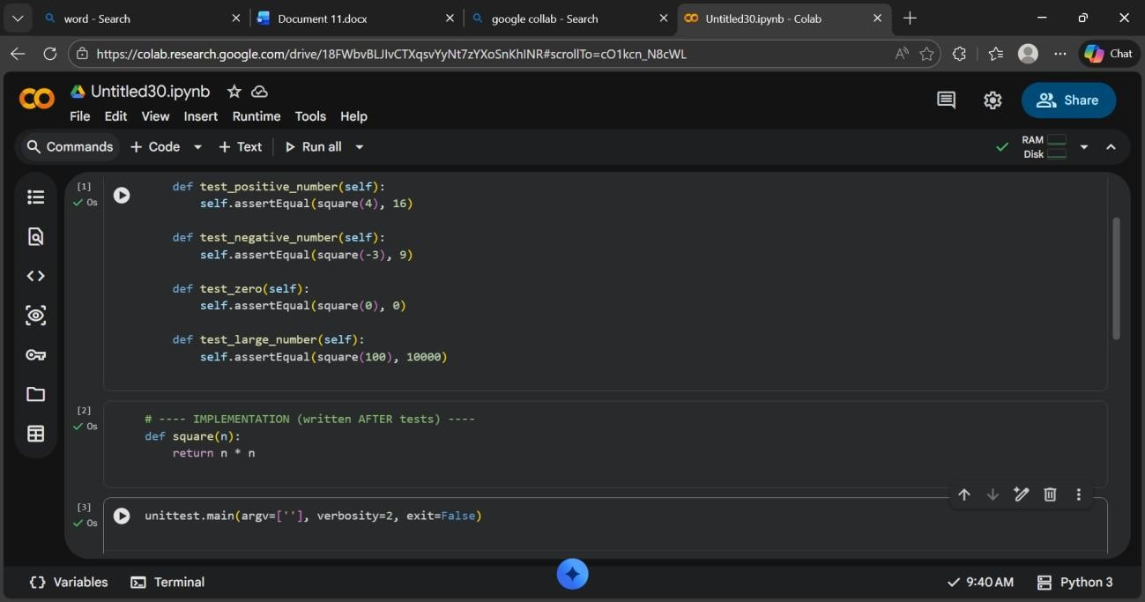
Output:
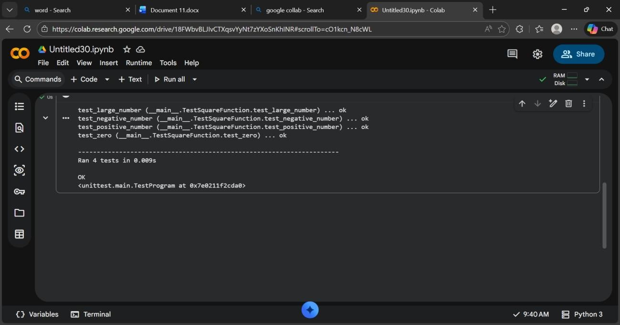

Task 2: Email Validation for a User Registration System
Scenario
You are developing the backend of a user registration system. One requirement is to validate user email addresses before storing them in the database.
Task Description
Apply Test Driven Development by:
- Writing unit test cases that define valid and invalid email formats (e.g., missing @, missing domain, incorrect structure).
- Using AI assistance to implement the validate_email() function based strictly on the behavior described by the test cases.
The implementation should be driven entirely by the test expectations.
Expected Outcome
- Well-defined unit tests using unittest or pytest
- An AI-generated email validation function
- All test cases passing successfully

Clear alignment between test cases and function behavior
Code:
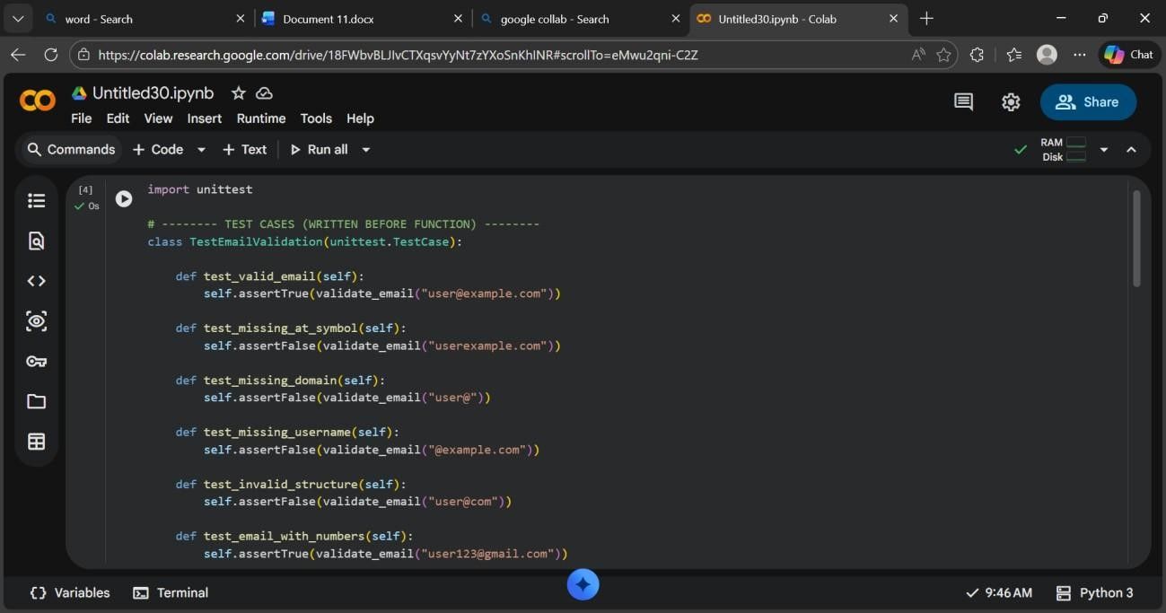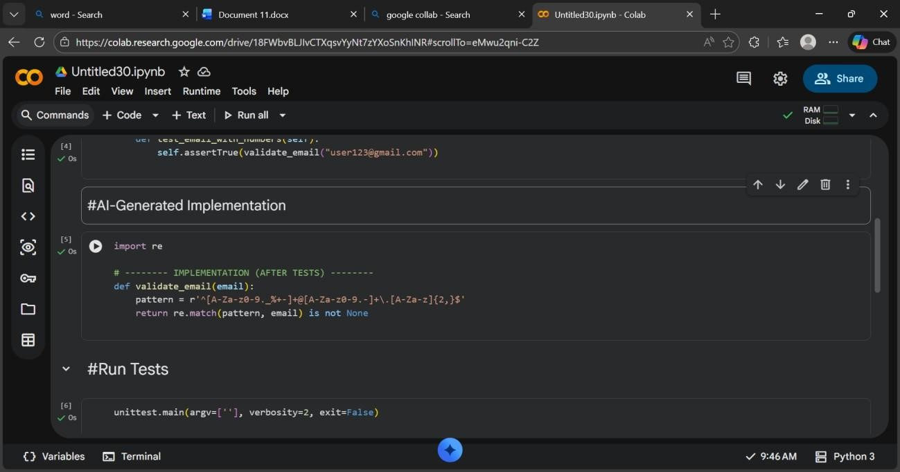
Output:
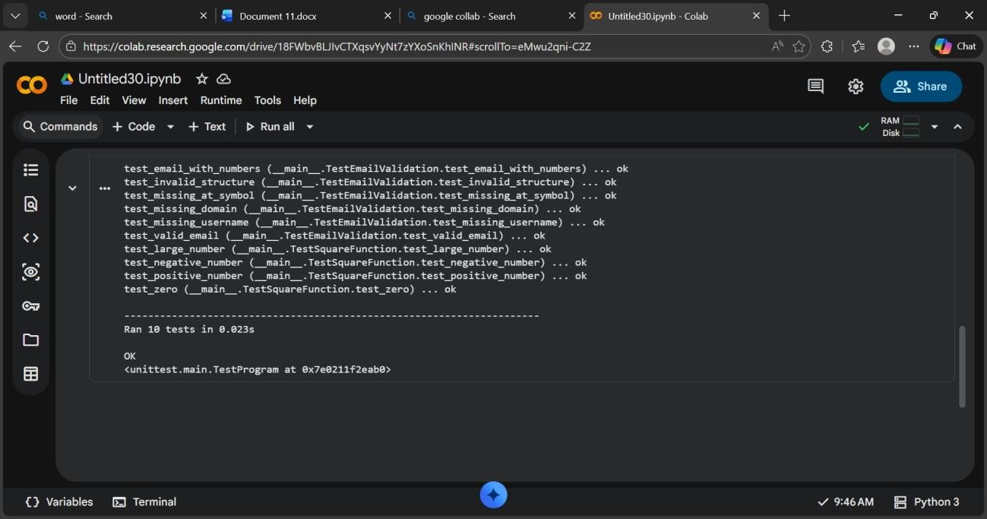

Task 3: Decision Logic Development Using TDD
Scenario
In a grading or evaluation module, a function is required to determine the maximum value among three inputs. Accuracy is essential, as incorrect results could affect downstream decision logic.
Task Description
Using the TDD methodology:
- Write test cases that describe the expected output for different combinations of three numbers.
- Prompt GitHub Copilot or Cursor AI to implement the function logic based on the written tests.
Avoid writing any logic before test cases are completed.
Expected Outcome
- Comprehensive test cases covering normal and edge cases
- AI-generated function implementation
- Passing test results demonstrating correctness
Evidence that logic was derived from tests, not assumptions

Code:
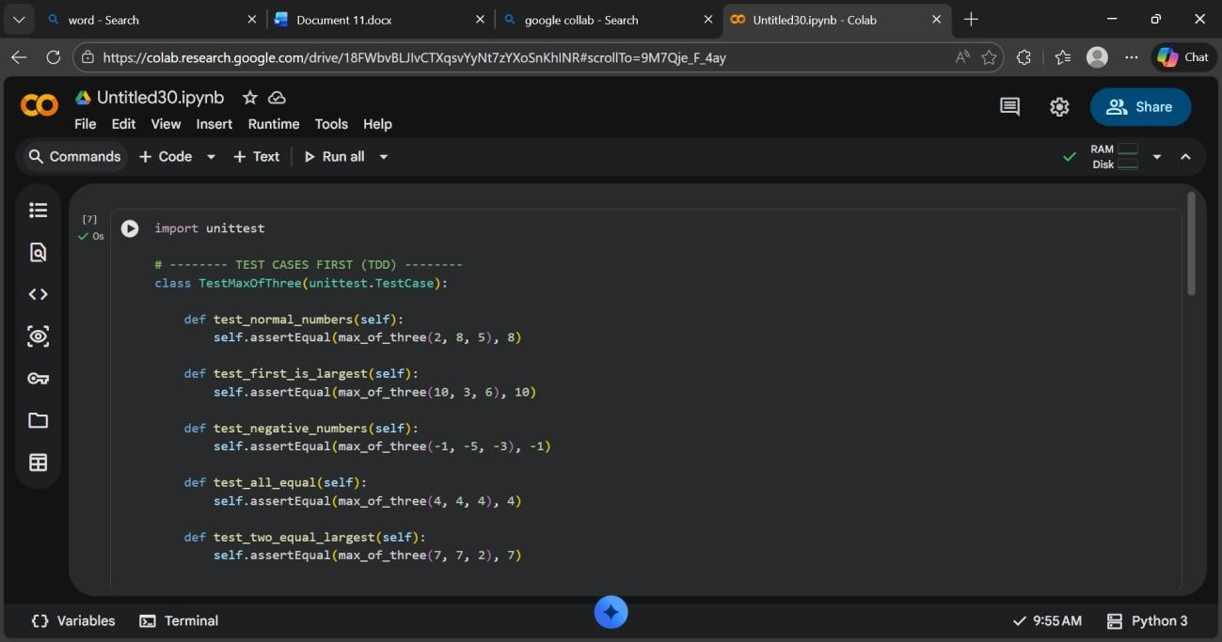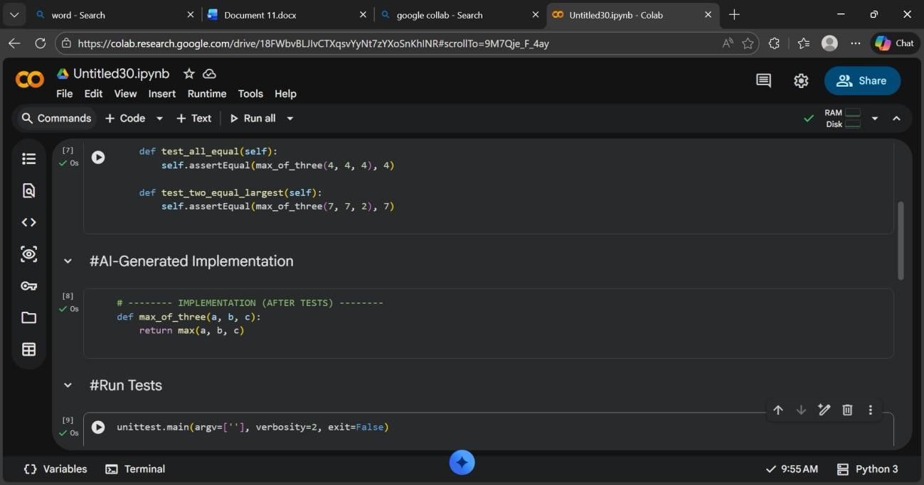

Output:
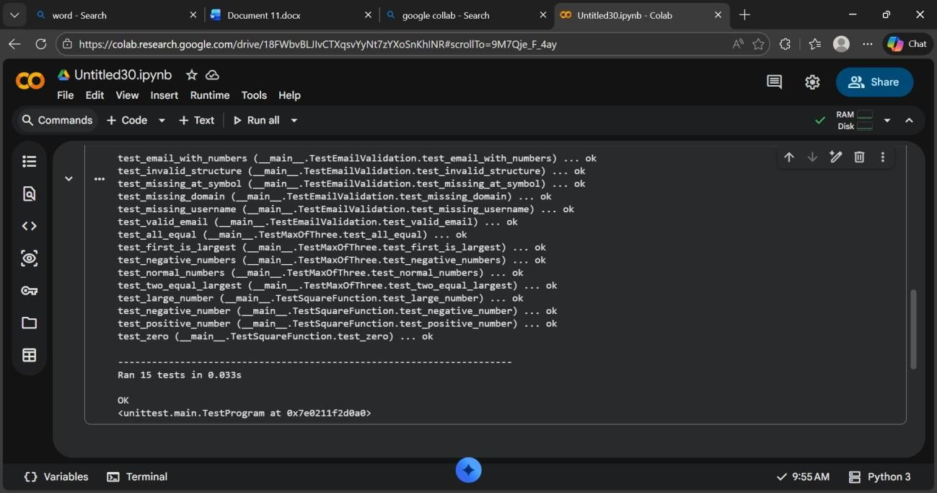

Task 4: Shopping Cart Development with AI-Assisted TDD
Scenario
You are building a simple shopping cart module for an e-commerce application. The cart must support adding items, removing items, and calculating the total price accurately.
Task Description
Follow a test-driven approach:
1. Write unit tests for each required behavior:
o Adding an item o Removing an item o Calculating the total price
2. After defining all tests, use AI tools to generate the ShoppingCart class and its methods so that the tests pass.
Focus on behavior-driven testing rather than implementation details.
Expected Outcome
- Unit tests defining expected shopping cart behavior
AI-generated class implementation
- All tests passing successfully
- Clear demonstration of TDD applied to a class-based design

CODE:
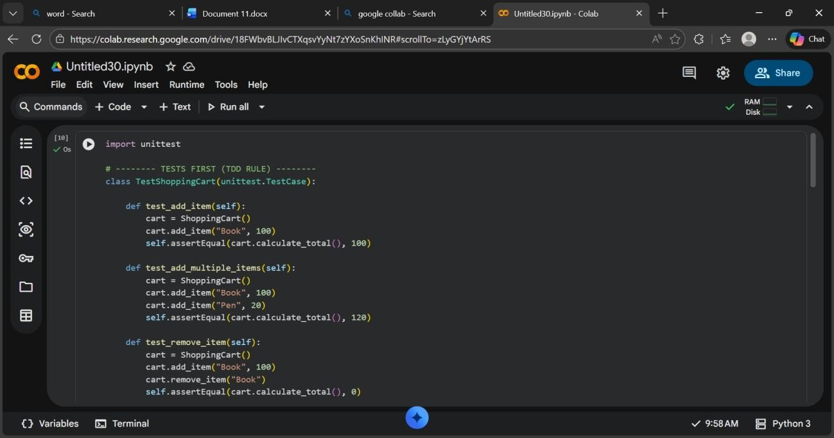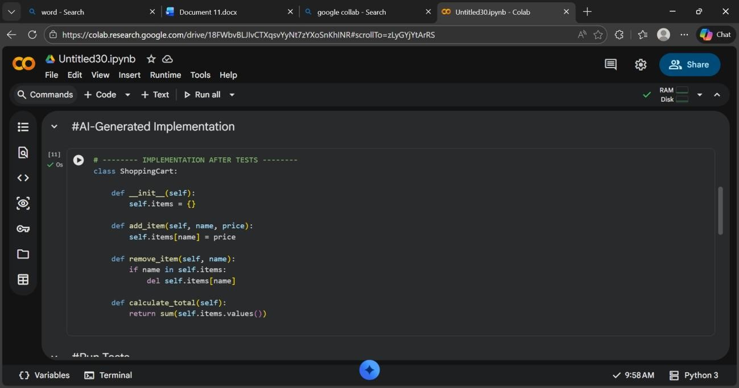
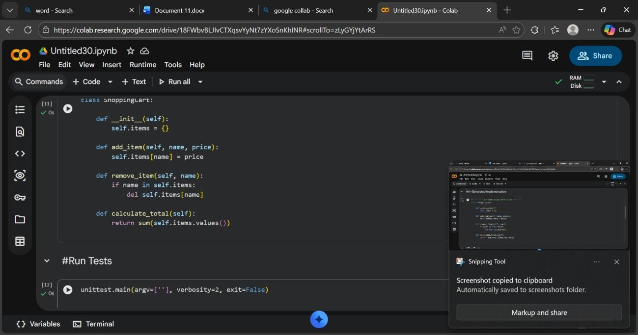

Output:
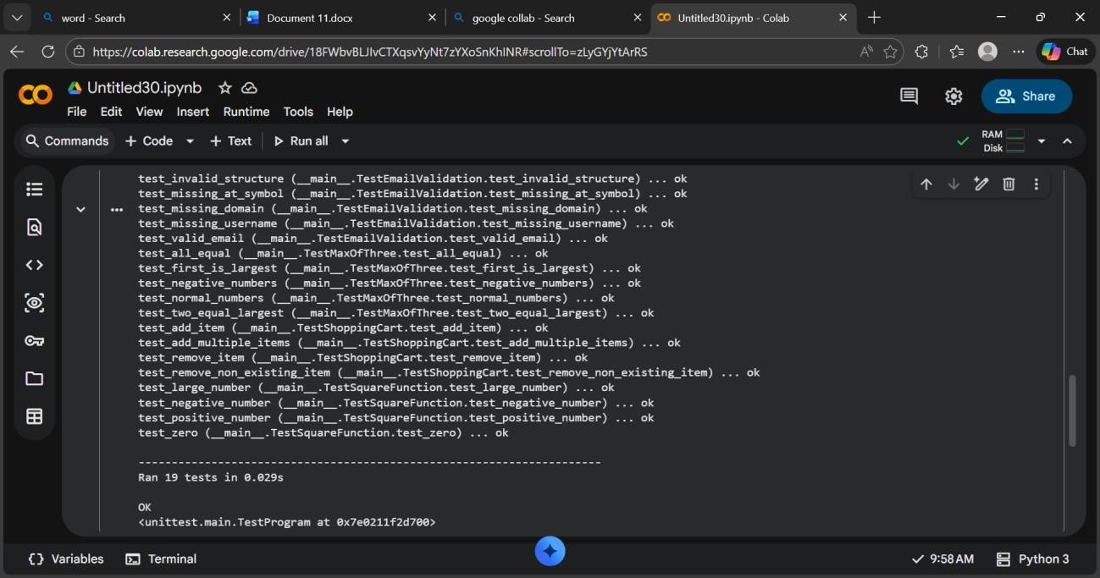

Task 5: String Validation Module Using TDD
Scenario
You are working on a text-processing module where a function is required to identify whether a given string is a palindrome. The function must handle different cases and inputs reliably.
Task Description
Using Test Driven Development:
1. Write test cases for a palindrome checker covering:
o Simple palindromes o Non-palindromes o
Case variations
2. Use GitHub Copilot or Cursor AI to generate the is_palindrome() function based on the test case expectations.
The function should be implemented only after tests are written.
Expected Outcome
- Clearly written test cases defining expected behavior
- AI-assisted implementation of the palindrome checker
All test cases passing successfully • Evidence of TDD methodology applied correctly
CODE: 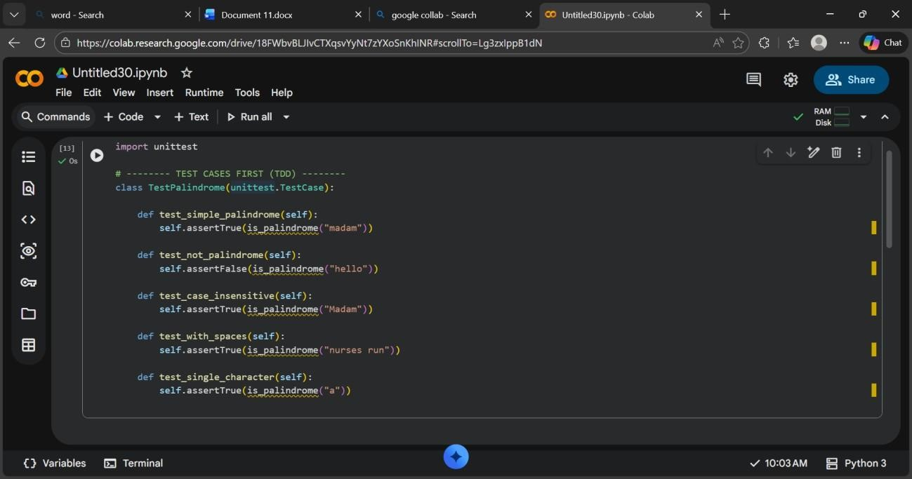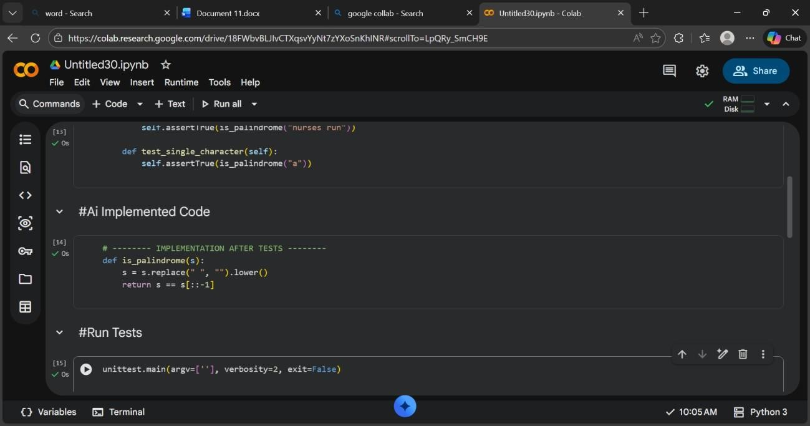

Output:

