FITBUDDY
AI FITNESS PLAN GENERATOR
Professional Project Documentation

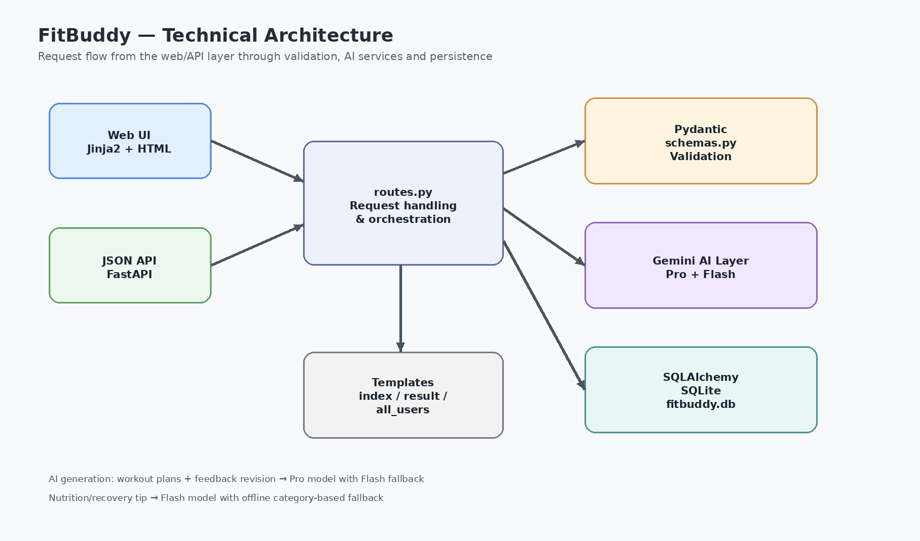
Figure 1. Technical architecture of the FitBuddy application.
Technology: Python • FastAPI • Google Gemini • SQLAlchemy • SQLite • Jinja2 • Pydantic • Pytest

Contents
- Project Description
- Objectives and Scenarios
- Technical Architecture
- Prerequisites and Environment Setup
- Project Structure
- Milestone 1 — Model Selection and Architecture
- Milestone 2 — Core Functionality Development
- Milestone 3 — API and Route Development
- Milestone 4 — Frontend Development
- Milestone 5 — Deployment and Testing
- API Reference
- Database Design
- Security, Reliability and Error Handling
- Screenshots and Implementation Evidence
- Conclusion

1. Project Description
FitBuddy is a FastAPI-based web application that uses Google Gemini models to generate personalized 7-day workout plans and concise nutrition or recovery tips. The current implementation accepts user profile information such as name, user ID, age, weight, fitness goal and workout intensity, validates the data, sends an appropriate prompt to Gemini, stores the resulting plan in SQLite, and renders the result through Jinja2 templates.
A feedback loop allows an existing plan to be revised. The current plan is retrieved from the database, combined with the user’s feedback, and sent back through the Gemini generation layer. The application also exposes JSON endpoints for programmatic use and an administrative page for viewing stored users and plans.
The uploaded reference documentation follows a milestone-based project-report structure; this document keeps that organization while updating the technical content to match the supplied project archive.

2. Objectives and Scenarios

2.1 Objectives
- Generate structured, personalized 7-day workout plans from a user’s goal, intensity, age and weight.
- Provide a concise nutrition or recovery tip using a fast Gemini model, with a built-in fallback when the AI service is unavailable.
- Allow users to revise an existing plan through natural-language feedback.
- Persist user profiles and original/updated plans in SQLite through SQLAlchemy.
- Provide both browser-based HTML workflows and JSON API endpoints.
- Provide automated tests using a fake Gemini client so the test suite does not require an API key or network access.

2.2 Main Scenarios
Scenario | Description
Scenario 1 — Plan generation | User enters profile data and receives a personalized 7-day plan.
Scenario 2 — Plan revision | User submits feedback such as adding cardio or changing difficulty; the current plan is revised by Gemini.
Scenario 3 — Nutrition tip | The system generates a short nutrition/recovery tip for the selected goal; an offline category-based tip is used if Gemini fails.
Scenario 4 — Administration | A local admin page lists registered users, original plans, updated plans and provides deletion actions.
Scenario 5 — API integration | External clients can call JSON endpoints for workout generation, nutrition tips, plan creation, plan updates and user deletion.

3. Technical Architecture
Figure 2. Application architecture derived from the supplied source code.

3.1 Architecture Layers
Layer | Technology | Responsibility
Presentation | HTML + Jinja2 + static assets | Collect input, display generated plans, feedback form and user table.
Web/API | FastAPI | Routes requests, validates inputs and orchestrates services.
Validation | Pydantic | Enforces ranges, lengths and allowed intensity values.
AI | Google Gen AI SDK / Gemini | Generates workout plans, nutrition tips and feedback-based revisions.
Persistence | SQLAlchemy + SQLite | Stores users and original/updated workout plans.
Testing | Pytest + fake Gemini | Exercises web and API flows, validation and AI failure paths.
The architecture is modular: routes.py coordinates the request flow, while AI prompting, persistence, validation and configuration are separated into dedicated modules. This reduces coupling and makes the application easier to test and maintain.

4. Prerequisites and Environment Setup
- Python 3.10 or newer
- Visual Studio Code with the Python extension
- Google AI Studio / Gemini API key
- Basic Python, FastAPI, HTML/Jinja2 and SQLAlchemy knowledge
- Git for version control (recommended)

4.1 Installation
- Open the FitBuddy project folder in Visual Studio Code.
- Create a virtual environment: python -m venv .venv
- Activate it on Windows: .venv\Scripts\Activate.ps1
- Install dependencies: pip install -r requirements.txt
- Copy .env.example to .env and set GEMINI_API_KEY.
- Start the server: uvicorn app.main:app --reload
- Open http://127.0.0.1:8000 and the interactive API documentation at /docs.
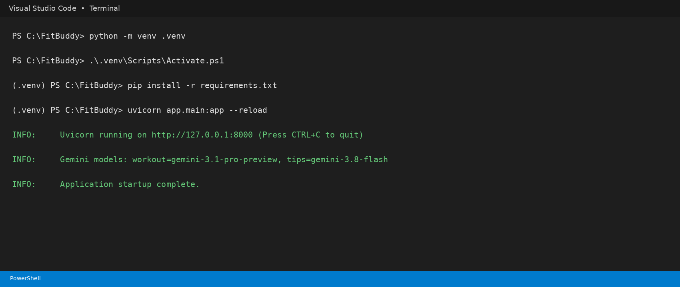
Figure 3. VS Code-style terminal showing the documented local setup and Uvicorn launch sequence.

4.2 Configuration
Variable | Default / Requirement | Purpose
GEMINI_API_KEY | Required | Authentication for Google Gemini.
GEMINI_PRO_MODEL | gemini-3.1-pro-preview | Workout plans and feedback revisions.
GEMINI_FLASH_MODEL | gemini-3.8-flash | Nutrition tips and fallback model.
GEMINI_TIMEOUT_SECONDS | 90 | Gemini request timeout in seconds.
DATABASE_URL | sqlite:///fitbuddy.db | SQLAlchemy database connection.
Model names are configurable because Gemini model availability changes over time. The project README explicitly recommends updating these environment variables if a configured model is retired or unavailable.

5. Project Structure
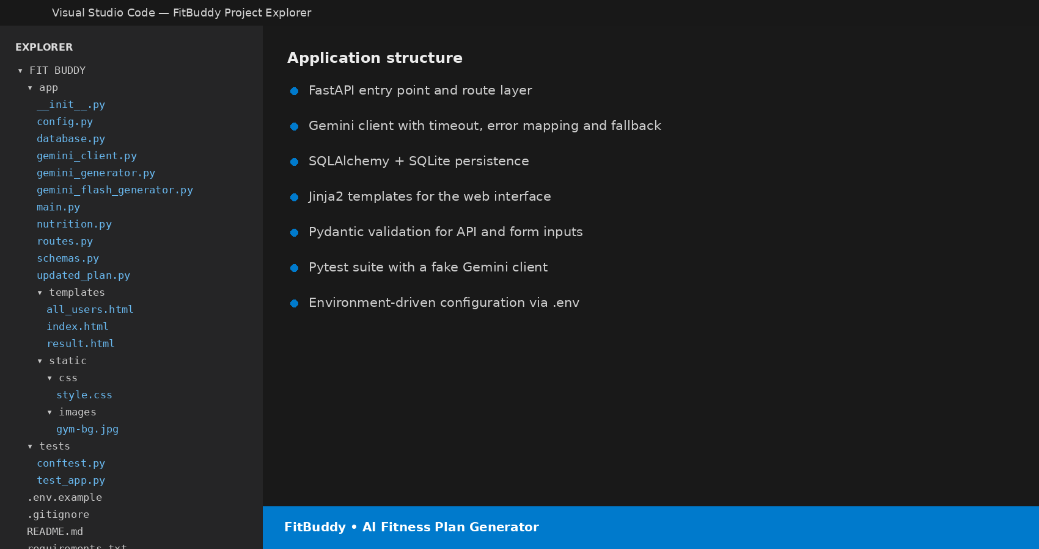
Figure 4. Project structure represented in a VS Code Explorer-style view.
Path | Purpose
app/main.py | FastAPI application entry point, startup lifecycle and /health endpoint.
app/routes.py | JSON API routes and HTML page routes.
app/config.py | Environment-driven configuration and Gemini model settings.
app/database.py | SQLAlchemy models and database helper functions.
app/schemas.py | Pydantic request models and input validation.
app/gemini_client.py | Central Gemini SDK wrapper, error mapping, timeout and fallback.
app/gemini_generator.py | Workout prompt construction and plan generation.
app/gemini_flash_generator.py | Short nutrition/recovery tip generation.
app/updated_plan.py | Feedback-based workout plan revision.
app/nutrition.py | Nutrition helper and offline fallback tips.
app/templates/ | Jinja2 pages: index, result and all_users.
app/static/ | CSS and fitness background image assets.
tests/ | Pytest fixtures and end-to-end application tests.
requirements.txt | Runtime and testing dependencies.
fitbuddy.db | SQLite persistence file.

6. Milestone 1 — Model Selection and Architecture

6.1 Model Selection
The supplied reference document describes an earlier evaluation of Hugging Face models and a previous Gemini model selection. The current project archive supersedes those model names: its configuration defaults are gemini-3.1-pro-preview for the Pro role and gemini-3.8-flash for the Flash role. The model names are not hard-coded into the business logic; they are read from environment variables.

6.2 Why the AI layer is centralized
- All Gemini calls pass through generate_text(), which creates the client lazily and avoids requiring a key just to start the application.
- SDK/network errors are converted into GeminiError messages that are suitable for application handling.
- Empty Gemini responses are treated as errors rather than silently becoming empty plans.
- Workout generation and feedback revision use generate_with_fallback(), allowing a non-fatal Pro-model failure to retry through the Flash model.
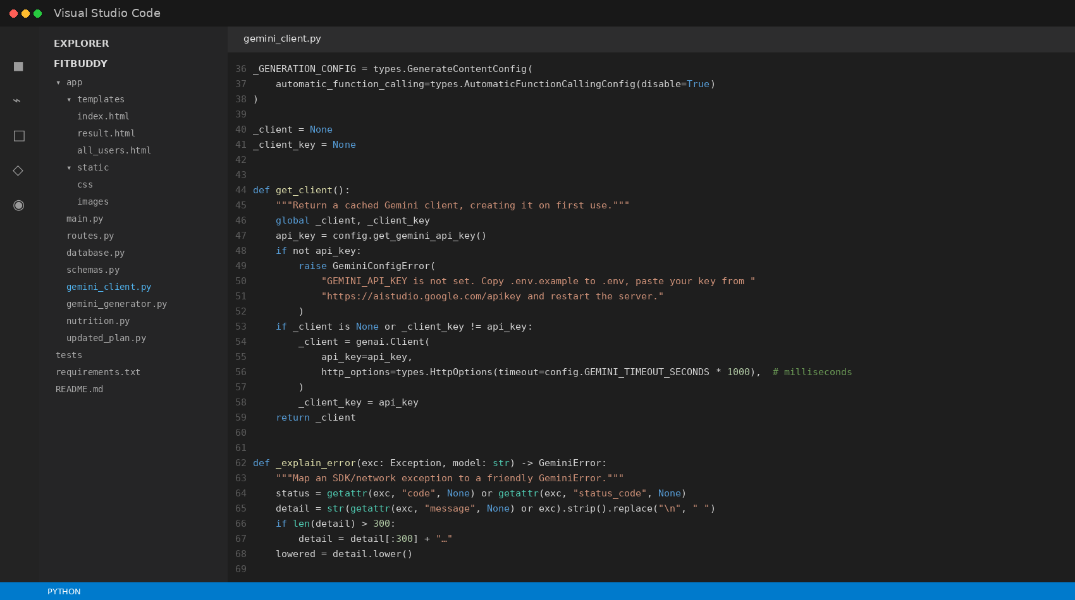
Figure 5. Gemini client implementation in a VS Code-style view, showing the centralized AI service layer.

7. Milestone 2 — Core Functionality Development

7.1 Workout Plan Generation
generate_workout_gemini() builds a structured prompt containing the user goal, intensity and optional age/weight. The prompt asks Gemini for seven days, with warm-up, main workout, cooldown/recovery guidance and important notes. The generated text is returned to the route layer and displayed in the result template.
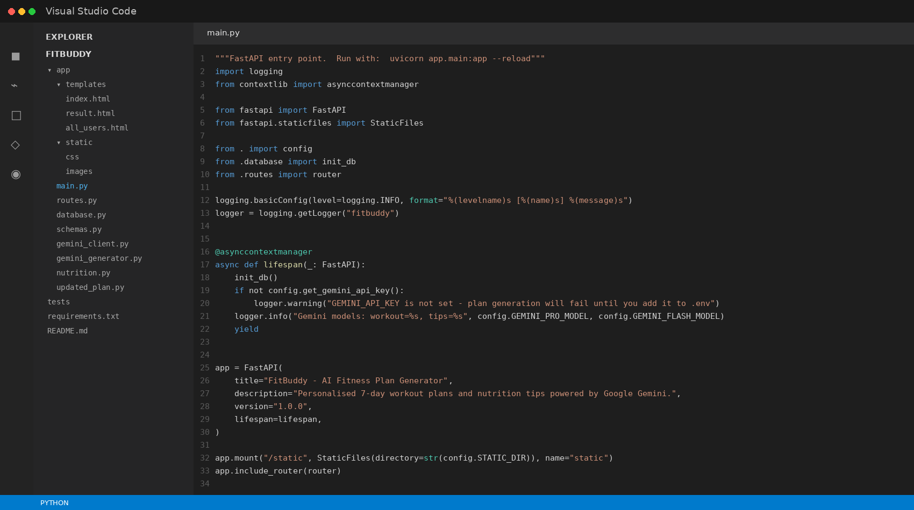
Figure 6. FastAPI application startup and routing setup from app/main.py.

7.2 Nutrition and Recovery Tips
get_nutrition_tip_with_source() first attempts Gemini Flash. If a GeminiError occurs, the nutrition module categorizes the free-text goal using keywords and selects a built-in fallback tip for weight loss, muscle gain, flexibility or general wellness.

7.3 Feedback-Based Plan Updating
update_workout_plan() combines the current plan and user feedback into a revision prompt. The route then stores the returned text in updated_plan while preserving the original plan.

7.4 User and Plan Storage
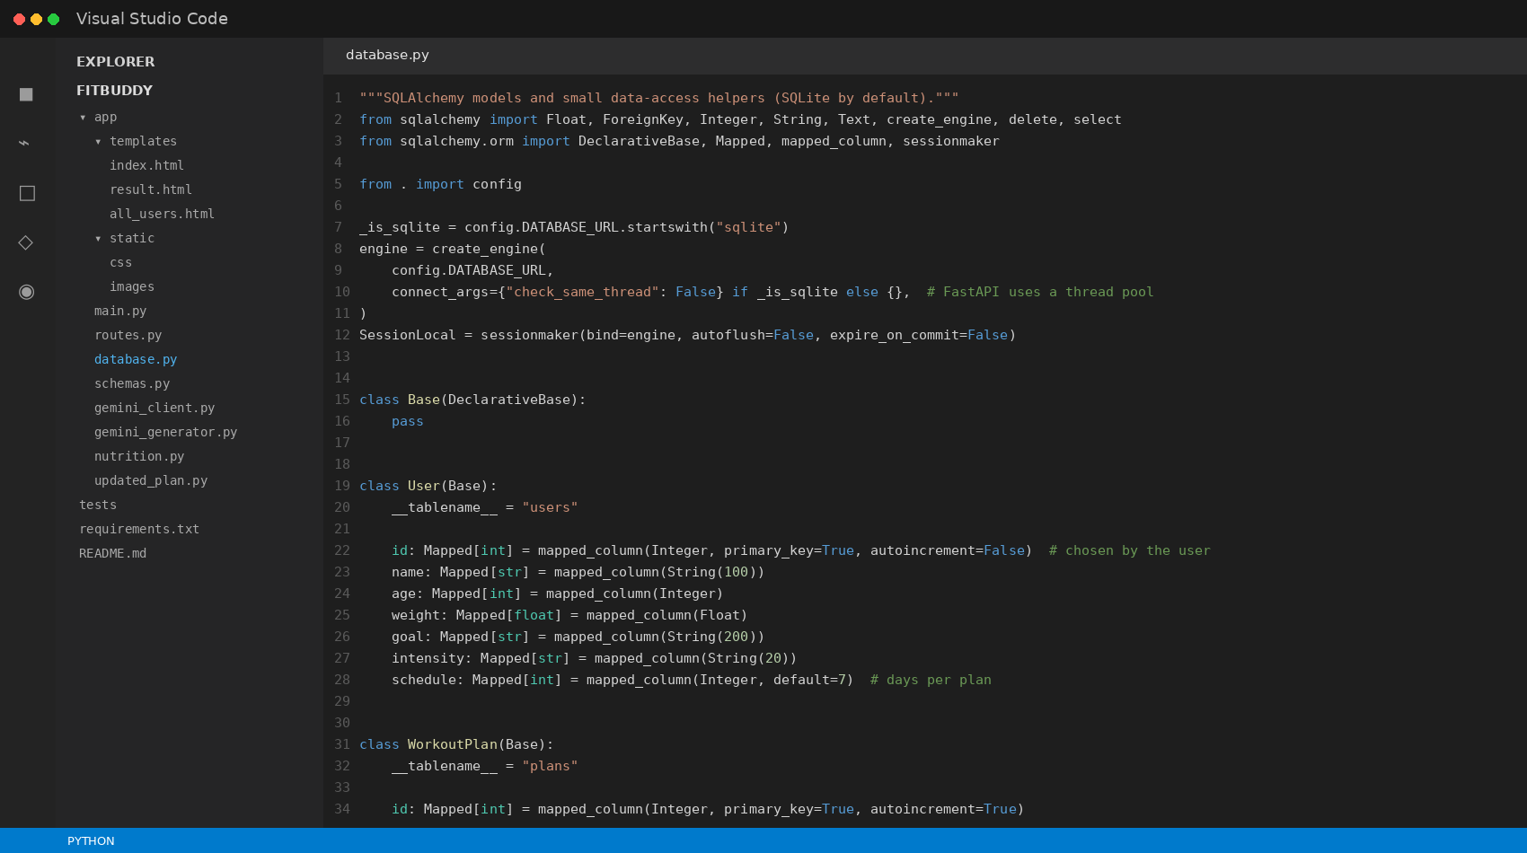
Figure 7. SQLAlchemy models and data-access helpers from app/database.py.
The User table stores the profile and workout intensity. The WorkoutPlan table stores original_plan and an optional updated_plan. Regenerating a user plan replaces the current original plan and clears a previous update, keeping one current plan per user.

8. Milestone 3 — API and Route Development
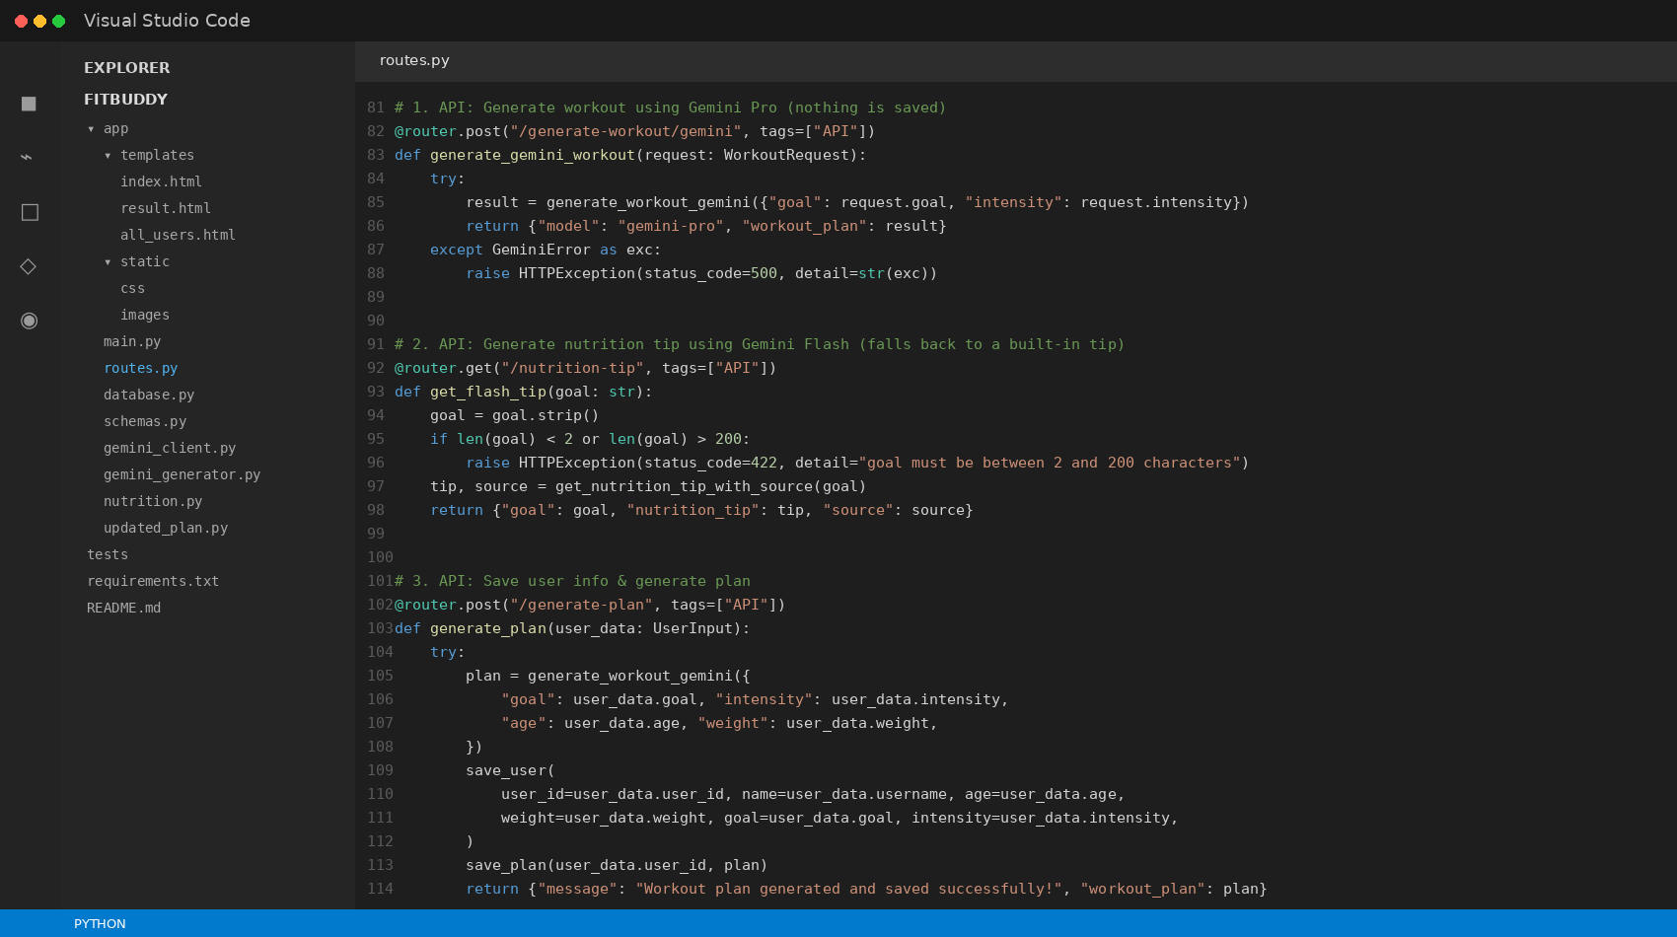
Figure 8. Core JSON API routes in app/routes.py.

8.1 Route Summary
Method | Endpoint | Purpose
GET | / | HTML input form.
POST | /generate | Submit web form and generate/store a plan.
POST | /submit-feedback | Revise a stored plan using feedback.
GET | /view-all-users | Local admin table of users and plans.
POST | /delete-user/{user_id} | Delete a user from the web admin page.
POST | /generate-workout/gemini | Stateless JSON workout generation.
GET | /nutrition-tip | JSON nutrition/recovery tip.
POST | /generate-plan | Create/save user and generated plan.
POST | /update-plan/{user_id} | Update the current plan through feedback.
DELETE | /users/{user_id} | Delete user and plans through JSON API.
GET | /health | Returns {"status":"ok"}.
GET | /docs | FastAPI interactive API documentation.

8.2 Validation
Pydantic models enforce required fields and sensible ranges. User IDs must be positive, ages are constrained to 10–100, weight must be greater than zero and no more than 500 kg, goals have a 2–200 character range, and feedback is limited to 3–1000 characters. Workout intensity is normalized to Low, Medium or High.
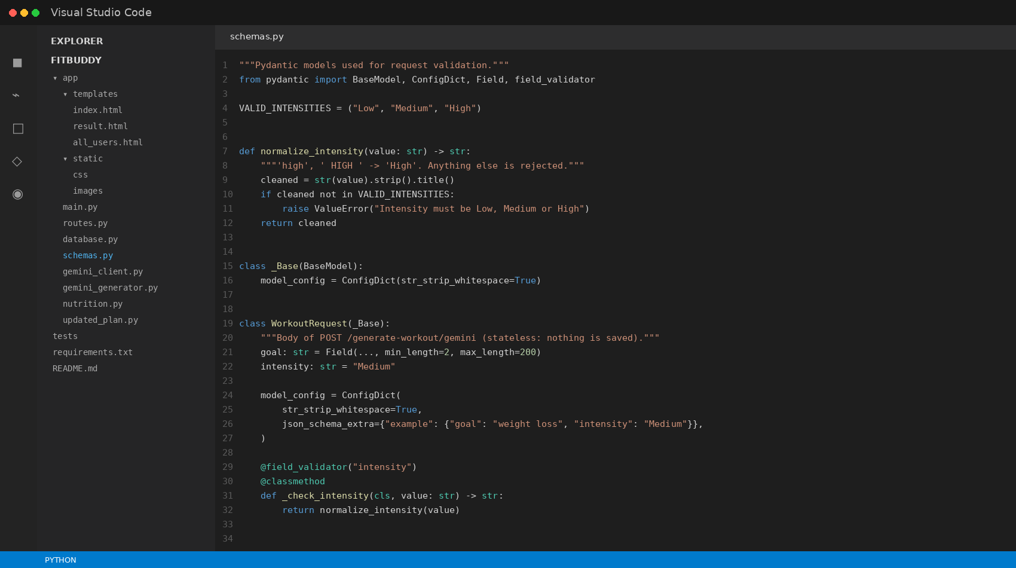
Figure 9. Pydantic validation models from app/schemas.py.

9. Milestone 4 — Frontend Development

9.1 Input Page
index.html collects name, user ID, age, weight, fitness goal and intensity. The form posts to /generate. JavaScript disables the submit button and changes its label while a potentially slow AI request is running.
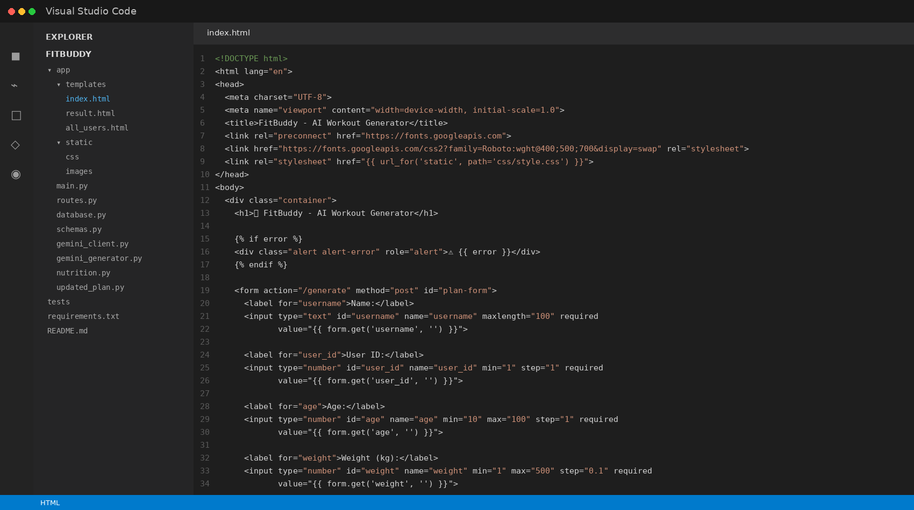
Figure 10. Jinja2 input form source from index.html.

9.2 Result Page
result.html displays the user information, generated or updated plan, nutrition tip and a feedback form. The nutrition tip is carried as a hidden field so a feedback submission can reuse the current tip without making another nutrition-model call.
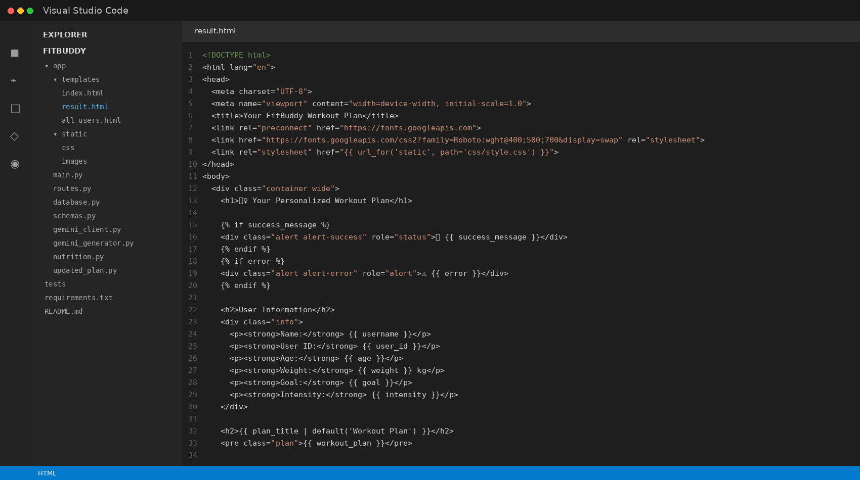
Figure 11. Jinja2 result and feedback interface source from result.html.

9.3 Admin View
all_users.html renders all stored users and their original/updated plans in a table. The page also provides a delete action. Because the project explicitly documents this page as having no login, it should be kept local unless authentication and authorization are added.

10. Milestone 5 — Deployment and Testing

10.1 Local Deployment
- Create and activate .venv.
- Install requirements.txt.
- Configure GEMINI_API_KEY in .env.
- Run uvicorn app.main:app --reload.
- Open the browser at 127.0.0.1:8000.
- Use /docs to test the JSON API interactively.

10.2 Testing Strategy
The supplied project contains a pytest suite with 26 tests. The test fixture replaces the Gemini client with a fake implementation and uses a temporary database. The tests cover page rendering, static assets, health checks, API validation, plan generation, database persistence, feedback updates, HTML form flow, escaping, missing users, Gemini errors, fallback behavior, empty responses and missing API keys.
During preparation of this documentation, the execution environment did not have the project’s google-genai package installed and network access was unavailable, so the full test suite was not independently re-run here. The test coverage described above is taken from the supplied tests and README, not presented as a newly verified pass result.

11. API Reference
Endpoint | Request example | Response / behavior
POST /generate-workout/gemini | {"goal":"weight loss","intensity":"Medium"} | Returns model name and generated workout plan.
GET /nutrition-tip | ?goal=muscle%20gain | Returns goal, tip and source (gemini-flash or fallback).
POST /generate-plan | User profile JSON | Generates and saves user + plan.
POST /update-plan/7 | {"feedback":"Add more core exercises"} | Returns updated_plan.
DELETE /users/7 | No body | Deletes user and associated plans.
GET /health | None | {"status":"ok"}.
The README also provides curl examples for the JSON endpoints and recommends /docs as the easiest interactive testing surface.

12. Database Design
Table | Column | Type / role
users | id | Integer primary key selected by user.
users | name | String(100).
users | age | Integer.
users | weight | Float, kilograms.
users | goal | String(200).
users | intensity | String(20).
users | schedule | Integer, default 7.
plans | id | Autoincrement integer primary key.
plans | user_id | Foreign key to users.id.
plans | original_plan | Text containing generated plan.
plans | updated_plan | Nullable Text containing latest revision.
The database helper opens short-lived SQLAlchemy sessions, commits changes explicitly and retrieves the latest plan for a user by descending plan ID. Deleting a user also deletes associated plans.

13. Security, Reliability and Error Handling
- API keys are read from environment variables and are not intended to be embedded in source code.
- The .env.example file contains a placeholder rather than a real key; the actual .env file should remain private and should not be committed.
- Gemini errors are mapped to clearer messages for invalid keys, forbidden requests, missing models, rate limits and server-side failures.
- Fatal errors such as invalid credentials are not retried through another model. Non-fatal model failures may use the configured Flash fallback.
- The web feedback route validates the User ID and verifies that a plan exists before calling Gemini.
- Jinja2 template rendering provides HTML escaping for user-supplied values.
- The admin view has no login according to the source comments; it should therefore remain local until proper authentication/authorization is implemented.
- The application is not medical advice. Generated exercise or nutrition content should be treated as general AI-generated wellness information and reviewed appropriately before use.

14. Screenshots and Implementation Evidence
Figure 12. Project structure and module organization.
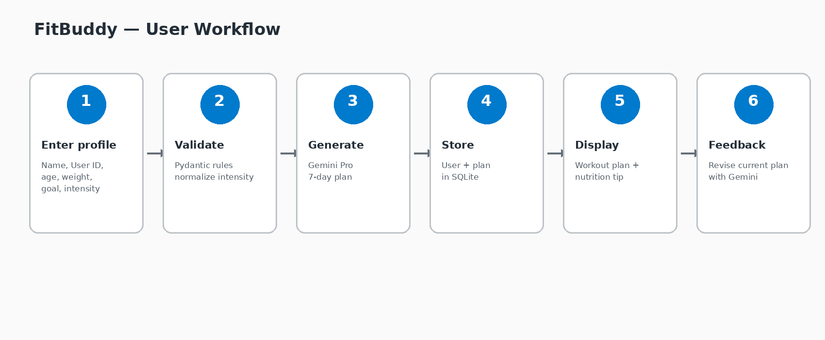
Figure 13. End-to-end user workflow.
Figure 14. Local development commands and Uvicorn startup sequence.
The code screenshots in this report are generated from the actual files in the supplied FitBuddy project archive and presented in a VS Code-style visual frame for documentation readability. They are intended as implementation evidence rather than a claim that VS Code itself was captured from the user’s machine.

15. Conclusion
FitBuddy demonstrates a complete AI-enabled web application workflow: user input is validated, a structured workout plan is generated through Gemini, a nutrition/recovery tip is produced through a fast AI path with an offline fallback, the result is persisted in SQLite, and user feedback can trigger a new revision of the current plan. The separation of routes, schemas, database helpers, Gemini services, templates and tests gives the project a clear modular structure.
The supplied reference documentation describes the same overall product idea and milestone progression, while the current project archive provides a more detailed implementation with configurable current Gemini model names, a centralized Google Gen AI client, JSON APIs, validation, deletion, fallback handling and automated tests. This report therefore preserves the reference document’s professional project-report style while grounding technical details in the current codebase.

