Problem with connection of socket on live server   
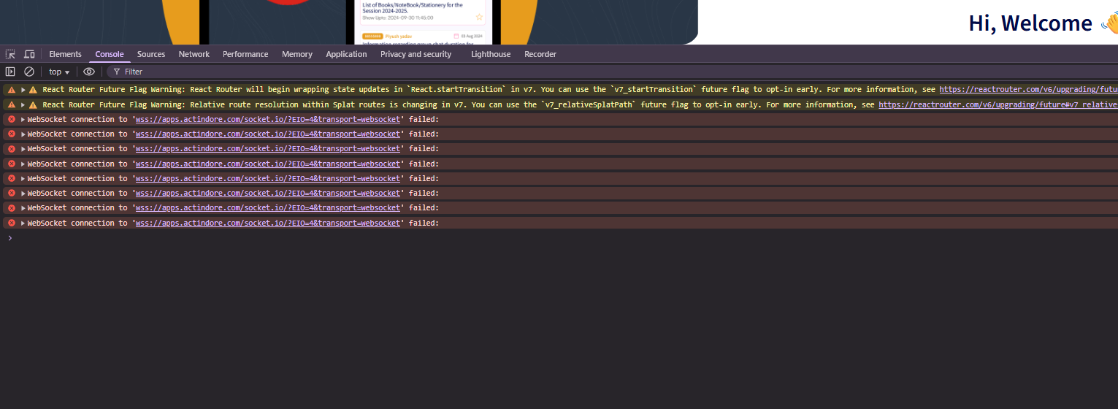  
  
this error will shown in the terminal of socket connection failed and our api base path is   
<https://apps.actindore.com/> and the port we assign is 3550   
  
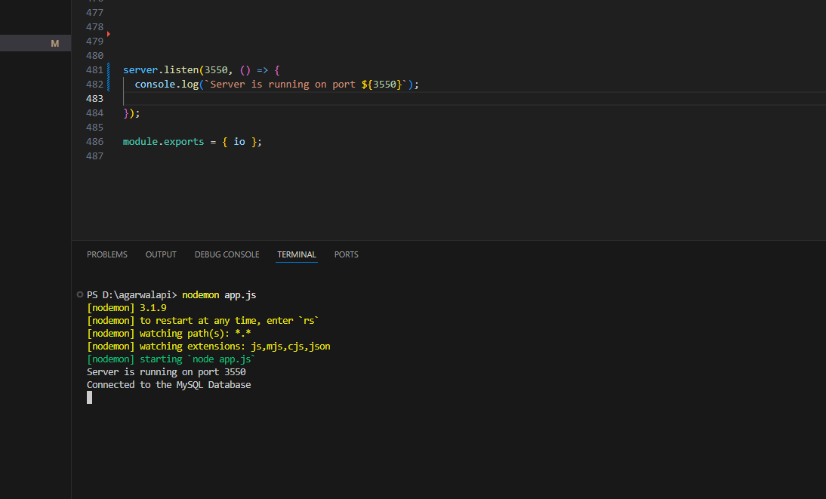  
this code is uploaded on live server where we can see the port 3550   
and when I check the port is allowed on this domain so this is not showing  
  
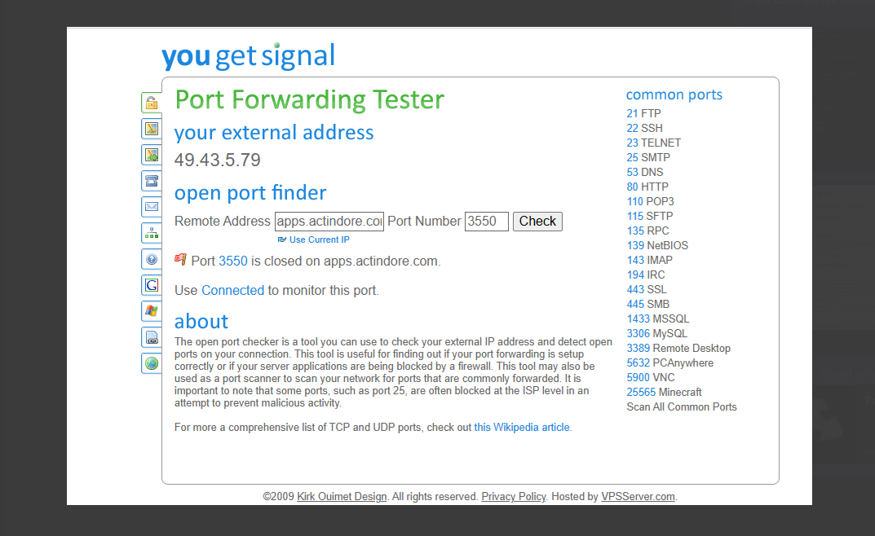  
  
Here we can see the port 3550 is closed for this domain but we cant cross check by our end because we cant access the ssh and cant run any command on terminal so we are not able to debug in our side that api code is working on port 3550 or not but the api is working  
  
but the socket connection is not working so please check the issue