**Dt.29.08.2025**

**Superadmin panel** :

1. Import student karne par - (is delete all old record first – Tik karne par) old data delete nahi ho raha hai ( Student ID & Mobile No.).
2. User Management – App user list main actived time aana chaiye (jab 1 st time user ne app login kiya tha.
3. Create message – Message id 72 ka show upto date 31/08/2025 kiya tha dt.28.08.2025 ko but by defalt wo date 02/09/2025 show ho raha tha dt.29.08.2025 ko.

**Mobile & Web app** :

1. Mobile app par - Logout nahi karne par bhi next day login ka aa raha hai
2. **Mobile & Web app par -** create message - 70 & 72 message id ka message subgroup 2026-2027 main banaya but inbox main 2025-2026 main show ho raha hai.

3 . **Mobile & Web app -** create message – checkbox main jo tik (select) kiya wo send reply ke baad bhi show hona chahiye ki kya option tik kiya hai aur ek baar send reply ke baad phir agin tik nahi hona chahiye

1. **Mobile & Web app -** view id main dono student id navya & harshita ko black ya blue karne par – dono ko send huye message show hote hai (Wereas jis id ko blue kiya usi id ke hi message show hote hai – agar navya ko black aur harshita ko blue kiya to)
2. **Mobile & Web app** : chat message main available Teacher show nahi ho raha aur @ karne par available Teacher name nahi aa raha aur na hai chat ka reply student ko aa raha hai aur na hi student ki chat teacher ko send (show) nahi ho rahi hai refresh karne par bhi bina refresh kiye chat dikhayi deni chahiye.
3. **Mobile app par bhi chat main @ kabhi aa raha hai kabhi nahi aa raha chat main**
4. **Mobile & Web app par - Chat message main - @only available teacher hi aana chahiye aur bhi name aa rahe hai**
5. **Mobile & Web app par – Group Chat message main - @ available teacher & Student name aana chahiye**

Web app par - 9302100760 se login but student id 11200783 Amir khan – show ho raha hai

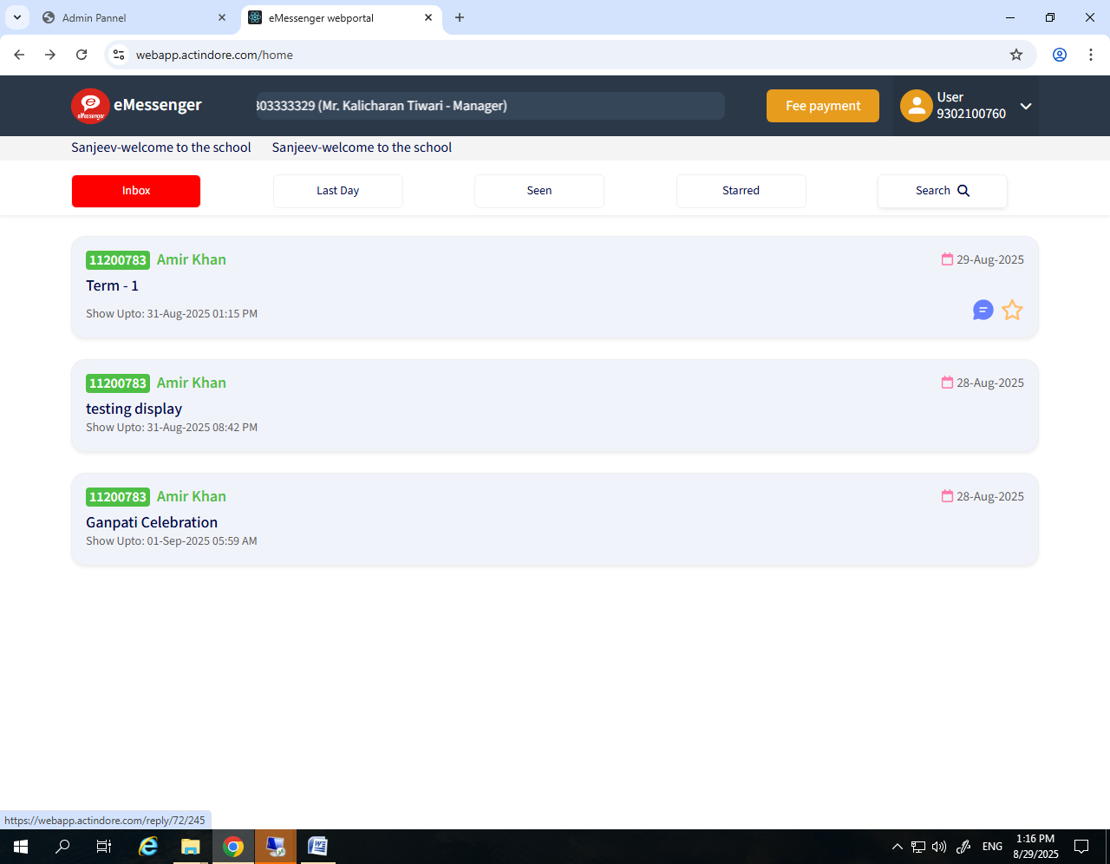

Aur chat karne par id sanjeev ki show ho rahi hai & Available teacher show nahi ho raha

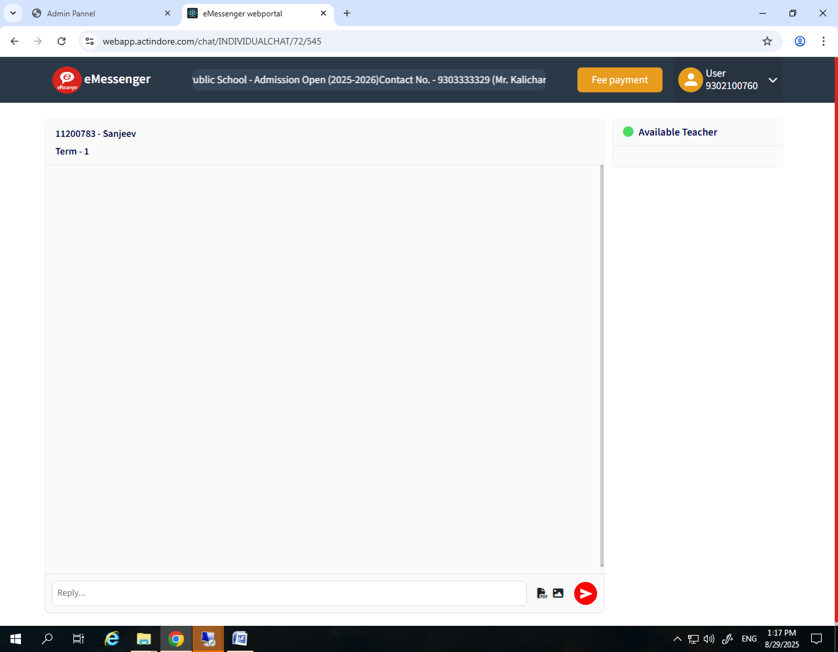

Chat main @ karne par koi name nahi aa raha jabki pahle koi chat message kiye the usme (Webapp par) aur id jisse chat karna tha aa raha tha

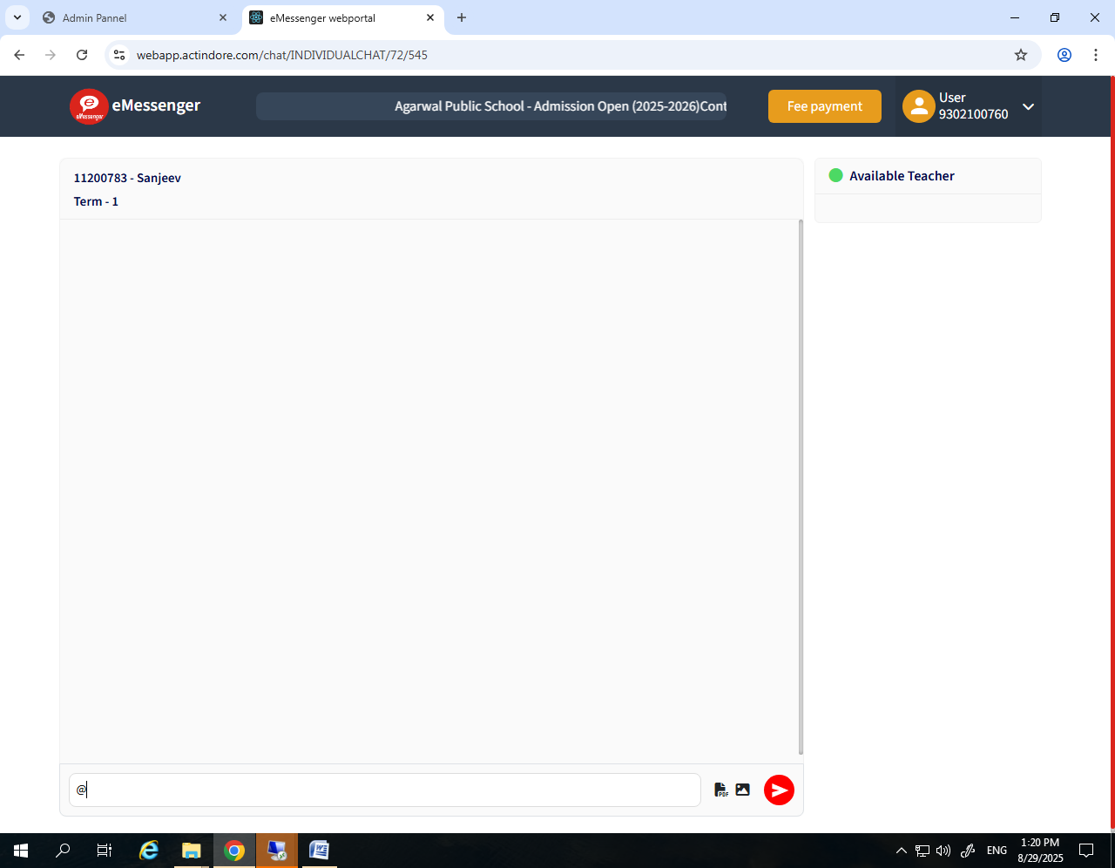

Send reply ke baad bhi tik (Select ho raha hai)

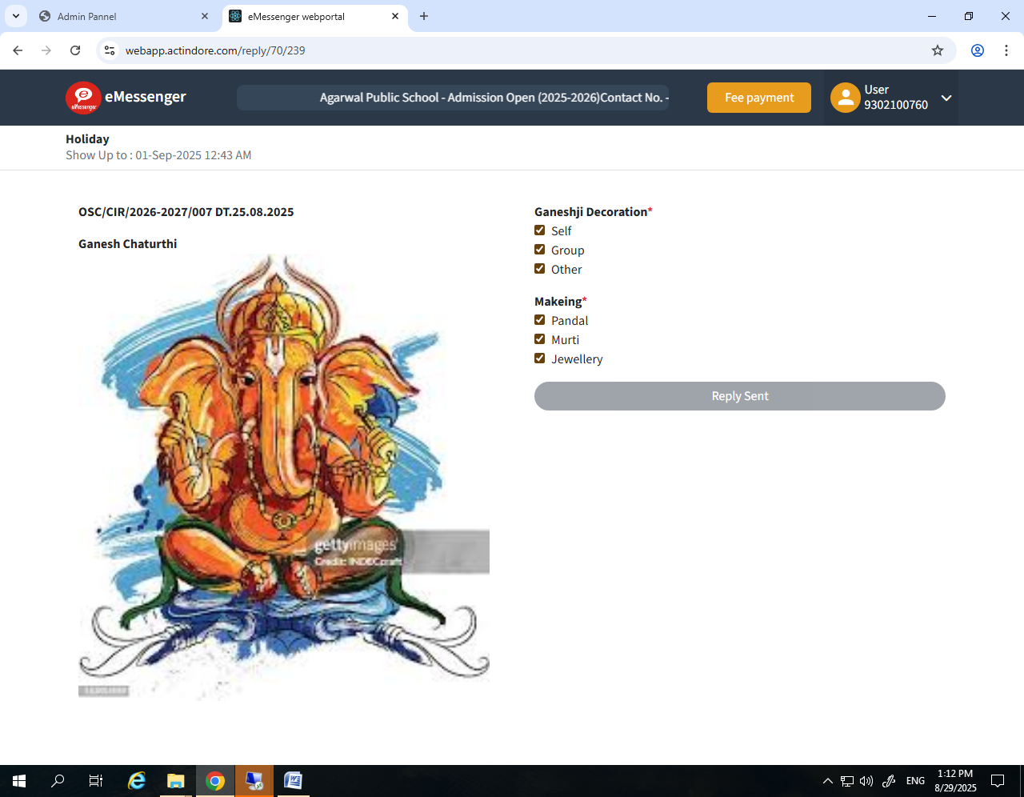

7879944903 - amir khan se login karne par – same not available teacher

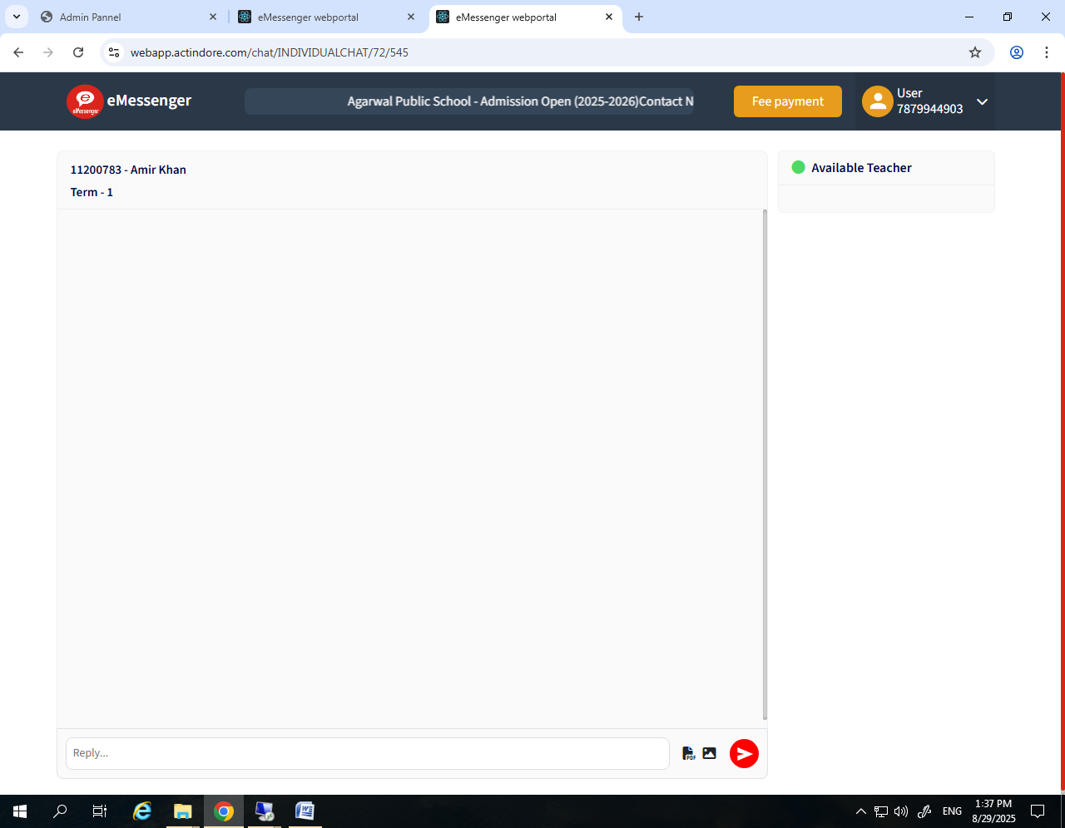

Chant par type message ke baad send karne par

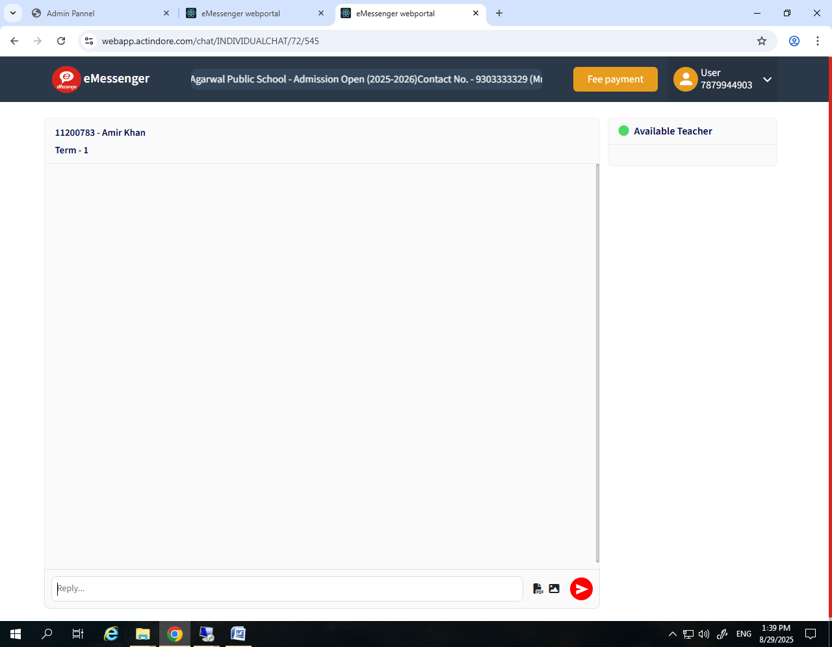

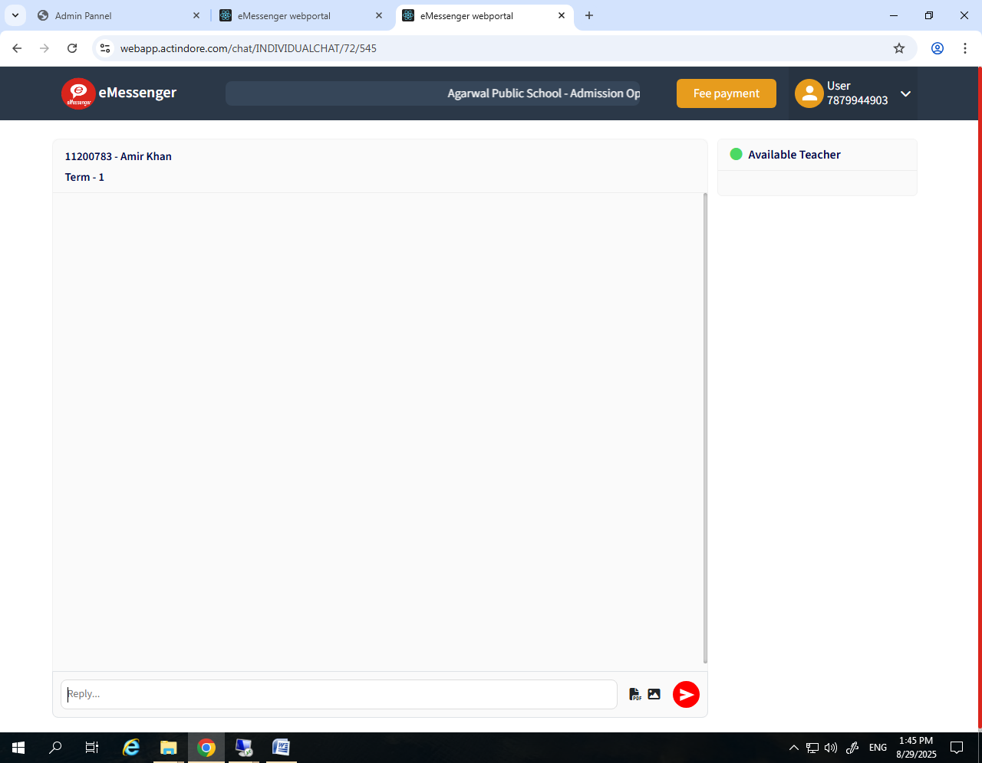

Refresh ke baad bhi

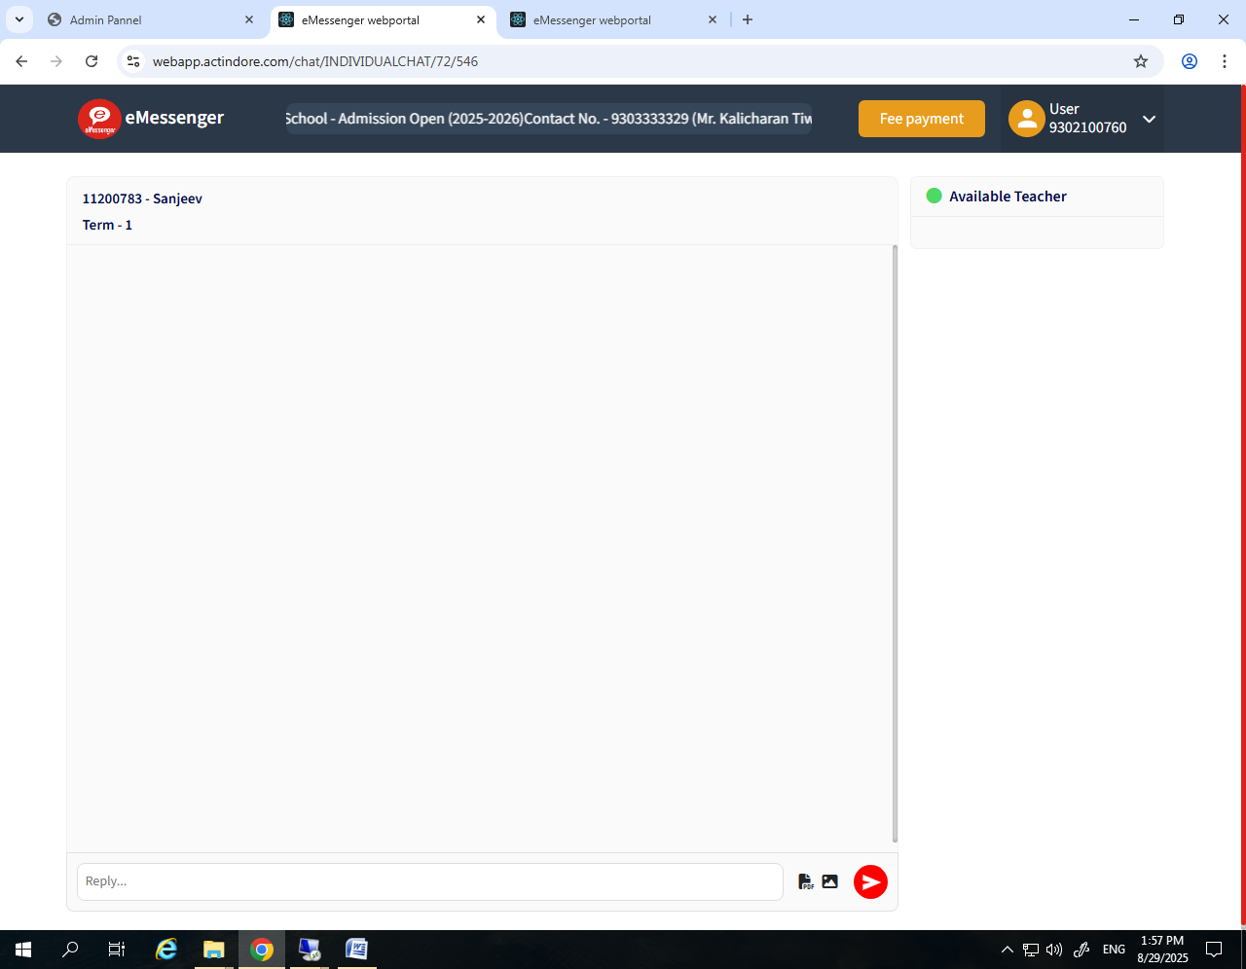

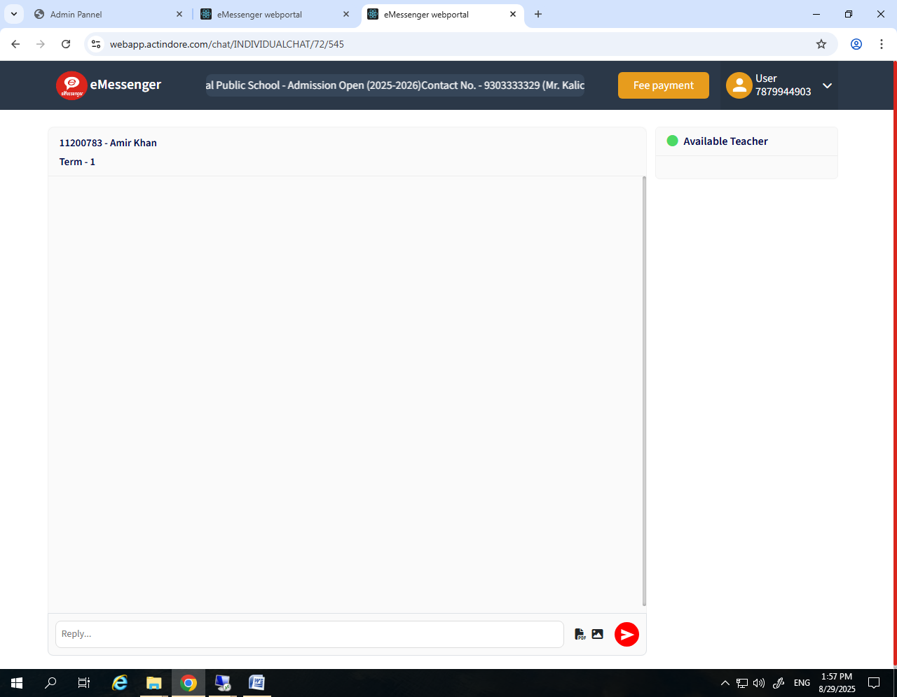

Not send any message on available teacher – 9303333326 – Vikram sir

