EduFlux System Diagrams
Figure 5.1.1. Context Level DFD: 0 Level
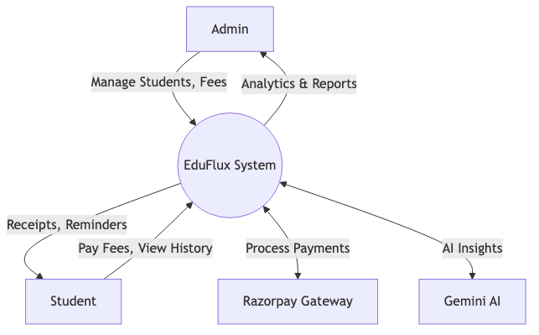

Figure 5.2.1. Admin Side DFD: 1st Level
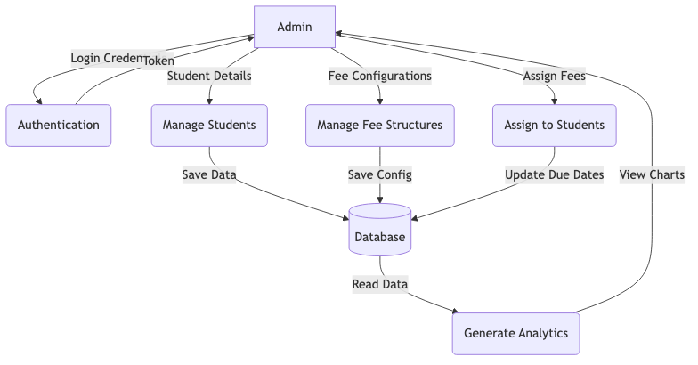

Figure 5.2.2. Student Side DFD: 1st Level
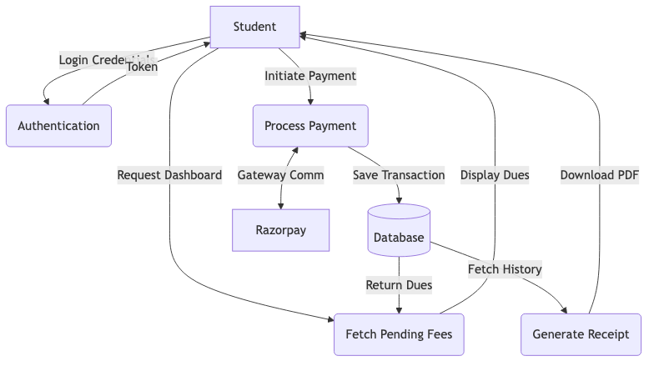

Figure 5.3.1. Admin Side DFD: Manage Fees 2nd Level
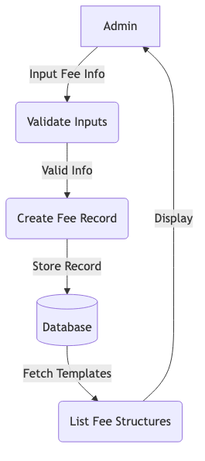

Figure 5.3.2. Student Side DFD: Payment Process 2nd Level
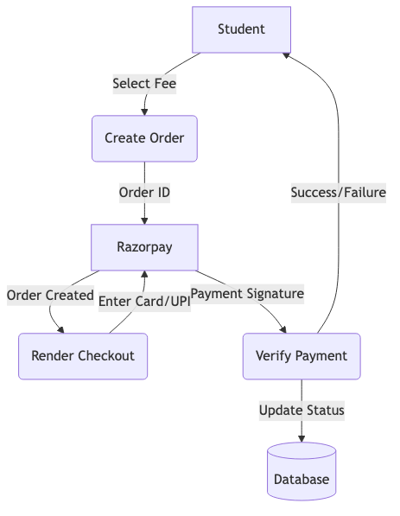

Figure 5.3.3. DFD: Login Process 2nd Level
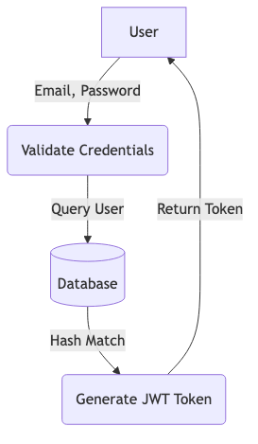

Figure 6.0.1. Admin Use Case Diagram
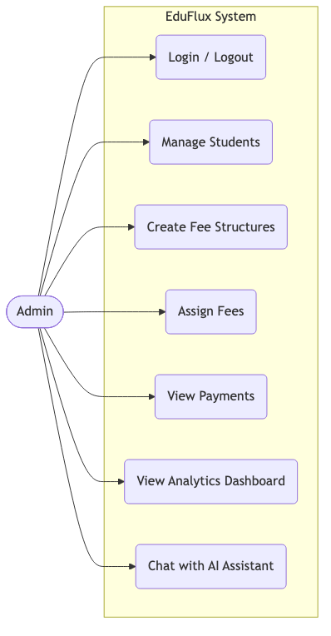

Figure 6.0.2. Student Use Case Diagram
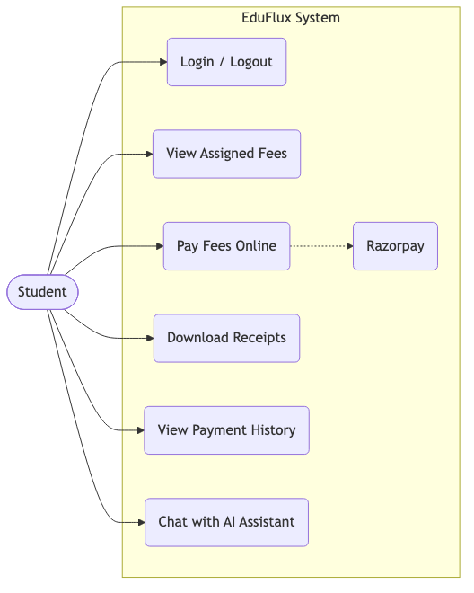

Figure 7.0.1. Class Diagram
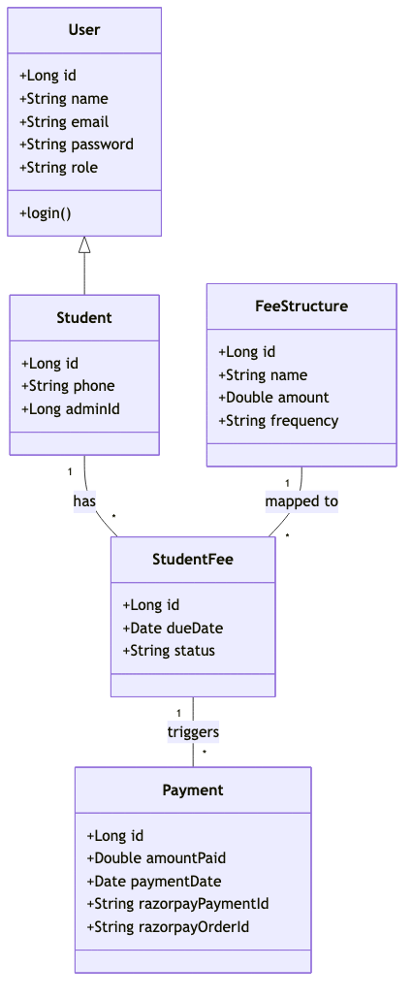

Figure 8.0.1. Admin Activity Diagram
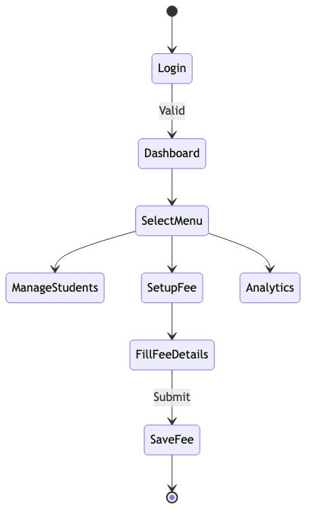

Figure 8.0.2. Student Activity Diagram
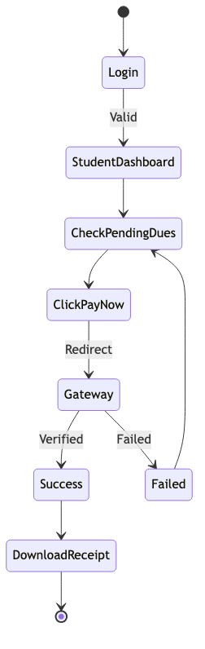

Figure 9.0.1. E-R Diagram
