Smart Tution Fee Portal Project Documentation

1. Abstract
The Smart Tution Fee Portal is a web-based platform designed to simplify and automate the collection, management, and tracking of tuition fees for educational institutions or private coaching centers. It provides a centralized database for administrators to easily monitor payments, pending dues, and generate financial reports. For students and parents, the portal offers a convenient and secure way to pay fees online, view payment history, and receive timely notifications for upcoming dues. The system reduces manual paperwork, minimizes errors, and enhances transparency in financial transactions.

2. Comparison of New System with Existing System

Existing System
- Manual record keeping in registers or basic excel sheets.
- Prone to human errors during calculation.
- Time-consuming receipt generation.
- Difficult to track defaulters and pending dues.

New System
- Automated digital records and secure cloud database.
- Error-free automated calculations.
- Instant digital receipts and online secure payments.
- Automated reminders and instant defaulter list generation.

3. Hardware and Software Requirement Specification

Software Requirements:
- Frontend: HTML5, CSS3, JavaScript (React/Bootstrap)
- Backend: Python (Django/Flask) or Node.js / PHP
- Database: MySQL / PostgreSQL / MongoDB
- Server: Apache / Nginx / Node server

Hardware Requirements:
- Processor: Intel Core i3 or above
- RAM: 4 GB or higher
- Storage: 50 GB free space
- Internet Connection for online payments

4. Modules and their short description
- Admin Module: Manage students, teachers, courses, fee structures, and view financial reports.
- Student/Parent Module: View fee details, pay online, download receipts, check payment history.
- Payment Gateway Integration: Secure processing of online transactions.
- Notification Module: Send automated SMS/Email reminders for pending fees.

5. Users and their role description
- Admin: Has full control over the system. Can add/remove students, configure fees, and view reports.
- Student/Parent: Can log in to view their specific fee dues, make payments, and download receipts.

6. Diagrams

6.1 Data Flow Diagrams (DFD)
Context Level DFD (Level 0):
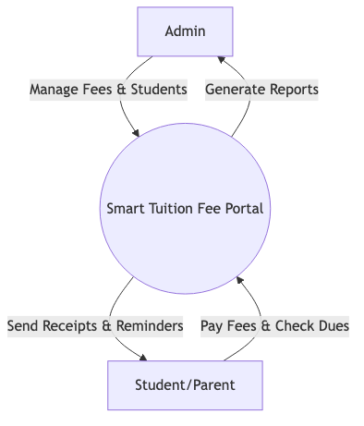
Level 1 DFD (Admin):
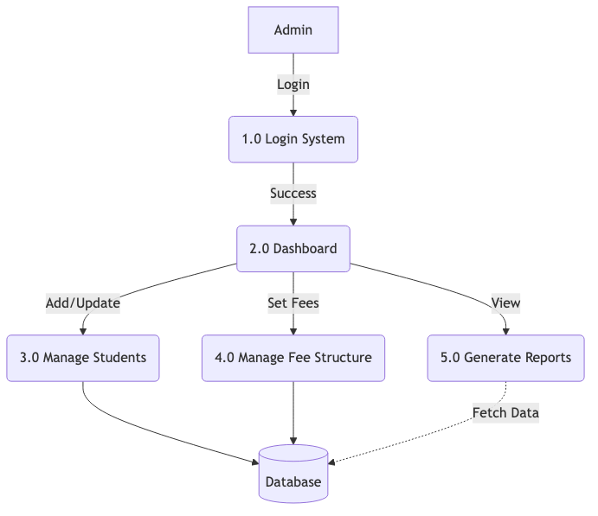
Level 1 DFD (Student):
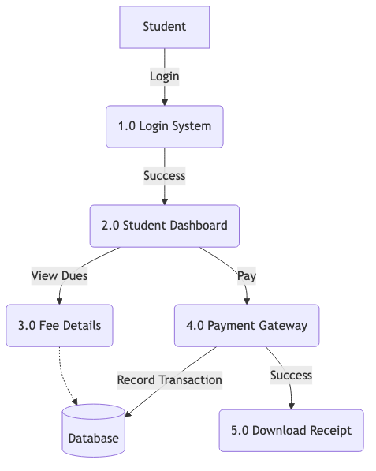

6.2 Use Case Diagram
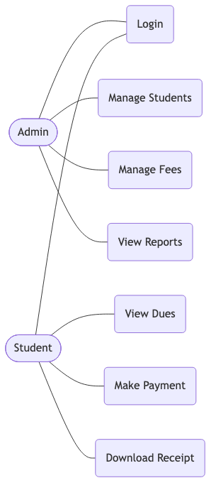

6.3 Class Diagram
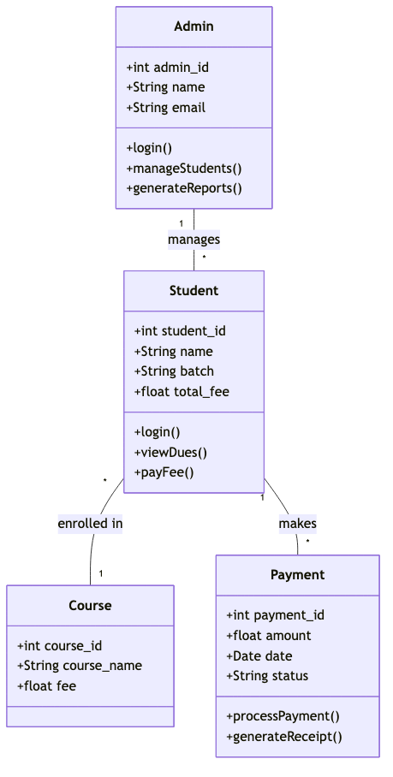

6.4 Activity Diagram
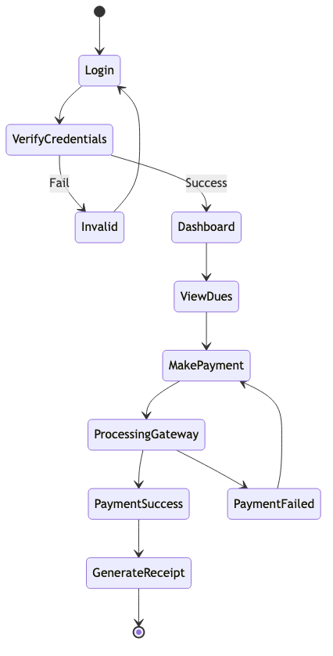

6.5 E-R Diagram
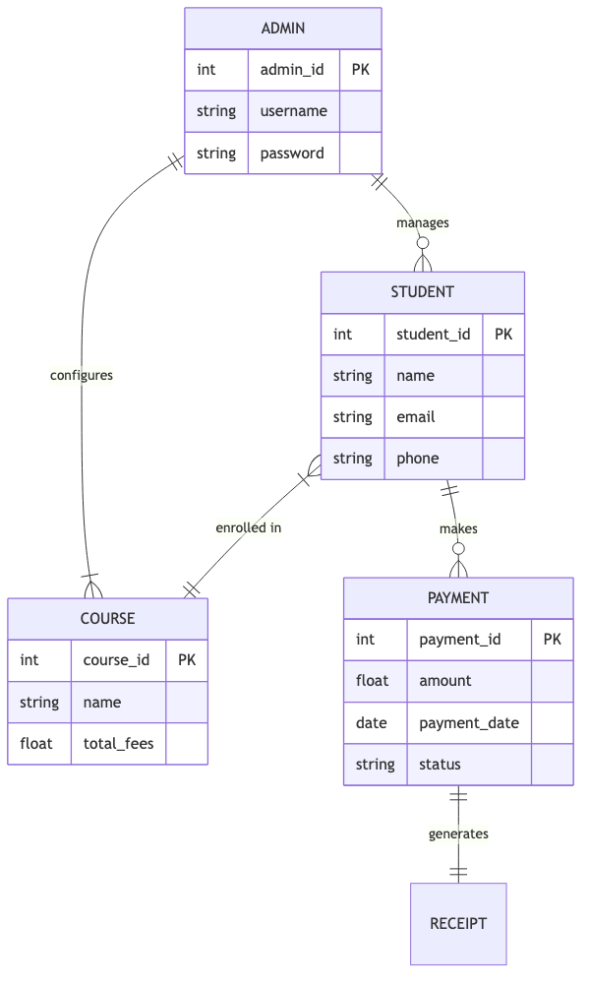

7. Description of E-R Diagram
This ER (Entity Relationship) Diagram represents the model of Smart Tution Fee Portal. The entity-relationship diagram shows all the visual instruments of database tables and the relations between Admin, Teacher, Students, Courses, Fee Transactions, and Notifications. It uses structured data to define the relationships between these entities.
The main entities of the system are Admin, Student, Course, Fee_Structure, Payment_Transaction, and Notification. The system revolves around Admin and Students entities. The Admin can manage courses, fee structures, and student records. Students belong to specific courses, which determines their fee structure. Students can perform Payment Transactions, generating digital receipts.

