**Technologies**

[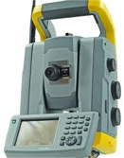**Total Surveys Station**](http://www.lqsurveys.com/technologies.php)

The total station is mounted on a tripod and leveled before use. The other part of a total station, the electronic distance measuring device, measures the distance from the instrument to its target. The total station allows measurement of this type to be taken by simply targeting someone as they move down the avalanche chute (assuming it's safe to do so). The total station provides a quicker solution to this measurement by allowing a light beam to measure the distance instead of a tape measure.

[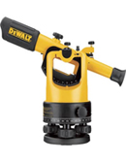**Leveling Station**](http://www.lqsurveys.com/technologies.php)

Surveyor's level, instrument used in surveying to measure the height of distant points in relation to a bench mark (a point for which the height above sea level is accurately known). It consists of a telescope fitted with a spirit level and, generally, mounted on a tripod. It is used in conjunction with a graduated rod placed at the point to be measured and sighted through the telescope.

[**GPS**](http://www.lqsurveys.com/technologies.php)

[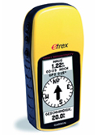](http://www.lqsurveys.com/technologies.php)The Global Positioning System (GPS) is a satellite-based navigation system made up of a network of 24 satellites. GPS satellites circle the earth twice a day in a very precise orbit and transmit signal information to earth. GPS receivers take this information and use triangulation to calculate the user's exact location. Essentially, the GPS receiver compares the time a signal was transmitted by a satellite with the time it was received. The time difference tells the GPS receiver how far away the satellite is. Now, with distance measurements from a few more satellites, the receiver can determine the user's position and display it on the unit's electronic map.