No Objection Certificate (NOC)

Laxmi Devi Institute of Engineering & Technology, Alwar
Department of Computer Science & Engineering
Bikaner Technical University

Subject: Issue of No Objection Certificate for Internship

Respected Sir/Madam,

This is to certify that Mr. Rajat Singh, a bona fide student of the Department of Computer Science, Laxmi Devi Institute Of Engineering And Technology College, Alwar , is pursuing his Bachelor of Technology(B.Tech.) under Bikaner Technology University.
The institute hereby confirms that it has no objection to Mr. Rajat Singh pursuing an internship with Prof. Subodh Vishnu Sharma at the Indian Institute of Technology (IIT) Delhi for the duration 1-Jan-2026 to 1-April-2026.
This internship is an integral part of his academic curriculum and will contribute to his professional growth and practical learning.
We wish him every success in his internship and future endeavors.


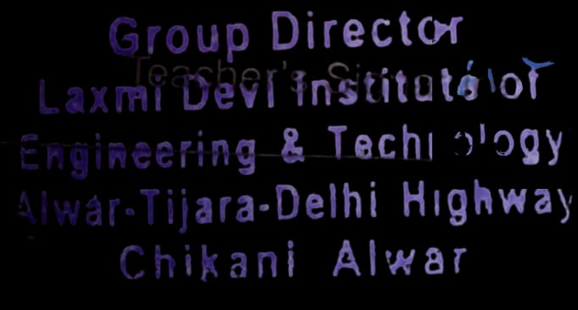
Authorized Signatory
Head of Department / Principal
Laxmi Devi Institute Of Engineering And Technology College, Alwar

