CANDIDATES DECLARATION

This is to certify that work, which is being presented in the project entitled "ROAD CULVERT" submitted by undersigned students of final year B.Tech in Civil Engineering in partial fulfillment for award of degree of Bachelor of Technology is a record of our own work carried out by us under guidance and supervision of Mr. Kapil Kaler (H.O.D) Department of Civil Engineering

Date: Name Of Students
Place: LIET, ALWAR Dushyant Sharma
Sameer Yadav
Sanjay Saini
Ramesh

A
PROJECT REPORT ON
“ROAD CULVERT
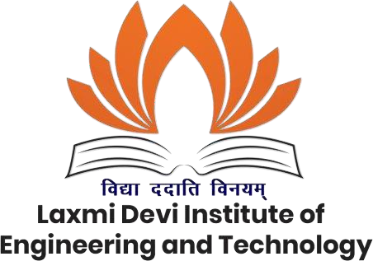

Guided by: - Submitted by: -
Mr. Kapil Kaler (H.O.D) Dushyant Sharma (23ELDCE207)
Department of Civil Engineering Sameer Yadav (23ELDCE233)
(LIET, ALWAR) Sanjay Saini (23ELDCE234)
Ramesh (23ELDCE230)

Submitted to:-
Department of Civil Engineering
Laxmi Devi Institute of Engineering & Technology, Chikani,
Alwar
Session: 2024-25

