National Cooperative Database (NCD)
Comprehensive User Manual
Silver Touch Technologies Ltd.

Revision History
Date | Version | Description | Author
2026-07-03 | 1.0 | Initial Draft generated by Bot | Documentation Team

Table of Contents
[Right-click and select 'Update Field' in Word to generate TOC]

1. Screen 1 Interface
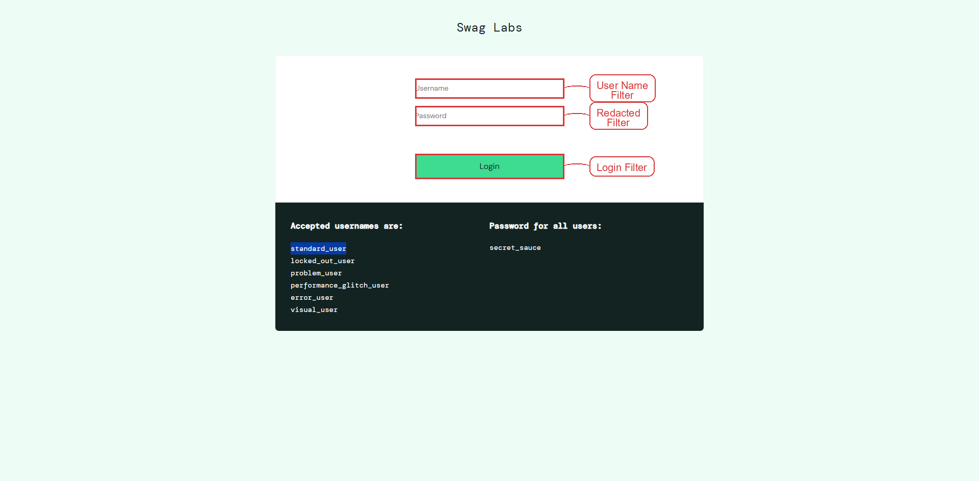
Figure 1: Screen 1 View

Procedure Steps
1. Enter the desired user name in the **User Name Filter** to restrict the search to that particular user; if the field is left empty, the system displays the error “User Name filter cannot be empty”.
2. Enter the appropriate value in the **Redacted Filter** to indicate whether redacted records should be included; if a non‑numeric or out‑of‑range value is entered, the system shows the error “Invalid redacted value – please enter a numeric value between 0 and 1”.
3. Enter the login identifier in the **Login Filter** to further narrow the results to a specific account; if the entry contains illegal characters, the system presents the error “Login must contain only letters and numbers”.

Field Details
Field Name | Description
User Name Filter -> user-name | Enter the username you use to sign in (e.g., email or login ID). Optional; up to 50 characters.
Redacted Filter -> [REDACTED] | Enter your password. Optional; characters will be hidden as you type.
Login Filter -> Login | Tap the **Login** button to submit the credentials and access the system.

2. Screen 2 Interface
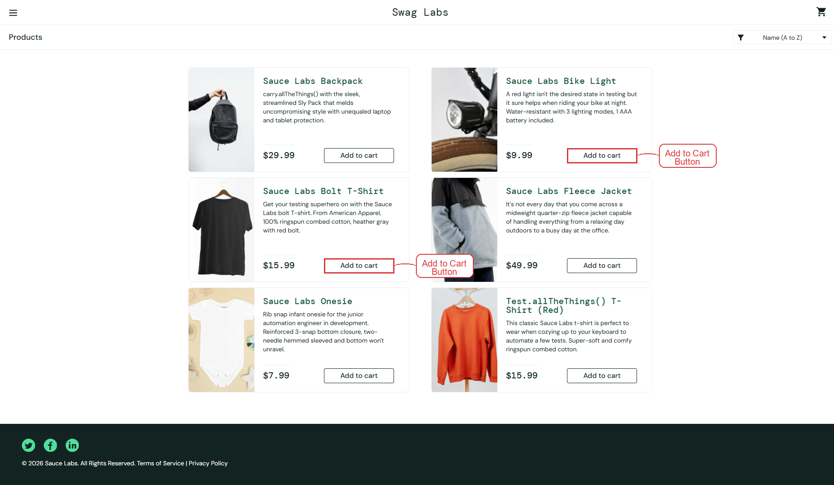
Figure 2: Screen 2 View

Procedure Steps
1. Click the **Add to Cart** button to place the selected product into the shopping cart, establishing the item for purchase.
2. Click the **Add to Cart** button again to increase the product’s quantity in the cart; if duplicate entries are not allowed, the system displays the validation message “Item already in cart.”

Field Details
Field Name | Description
Form Field -> Name (A to Z)  Name (Z to A)  Price (low to high)  Price (high to low) | Select the desired sort order for the list: “Name (A‑Z)”, “Name (Z‑A)”, “Price (low to high)” or “Price (high to low)”. This field is optional.

3. Screen 3 Interface
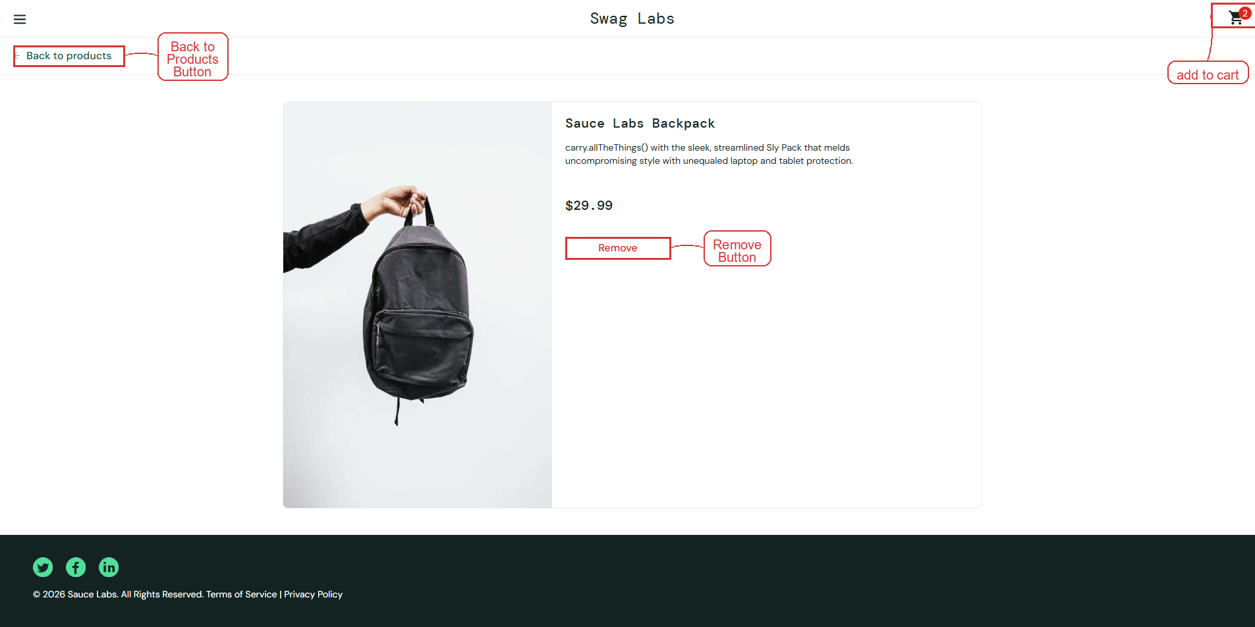
Figure 3: Screen 3 View

Procedure Steps
1. Click the **Back to Products** button to navigate from the current screen to the product listing page, allowing the user to select additional items.
2. Click the **Remove** button to delete the selected product from the shopping cart; a confirmation message “Item removed from cart” is displayed on success, while an error message “Unable to remove item” appears if the removal fails.
3. Review the data in the **Add to Cart** section to confirm that the removed product no longer appears, ensuring the cart contents are accurate; no validation or error messages are shown during this review.

4. Screen 4 Interface
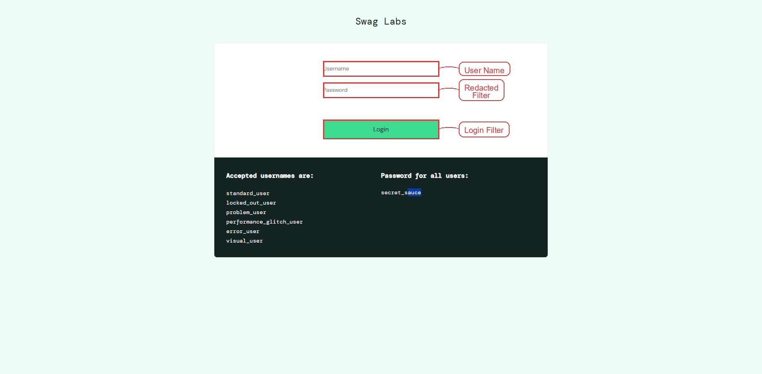
Figure 4: Screen 4 View

Procedure Steps
1. Click the **User Name** field and type the user’s login identifier to identify the account (the system shows “User Name is required” if the field is left blank).
2. Click the **Redacted Filter** field and enter the required secret value to provide the primary credential for verification (an invalid entry triggers the error message “Invalid Redacted Filter”).
3. Click the **Login Filter** field and supply the secondary verification data (such as a captcha or OTP) to complete multi‑factor authentication (incorrect input results in the warning “Login Filter is incorrect”).

Field Details
Field Name | Description
User Name -> user-name | Enter your username (optional). No specific length or format restrictions.
Redacted Filter -> [REDACTED] | Enter your password (optional); the field masks characters for security.
Login Filter -> Login | Tap the Login button to submit the entered credentials and sign in.

5. Screen 5 Interface
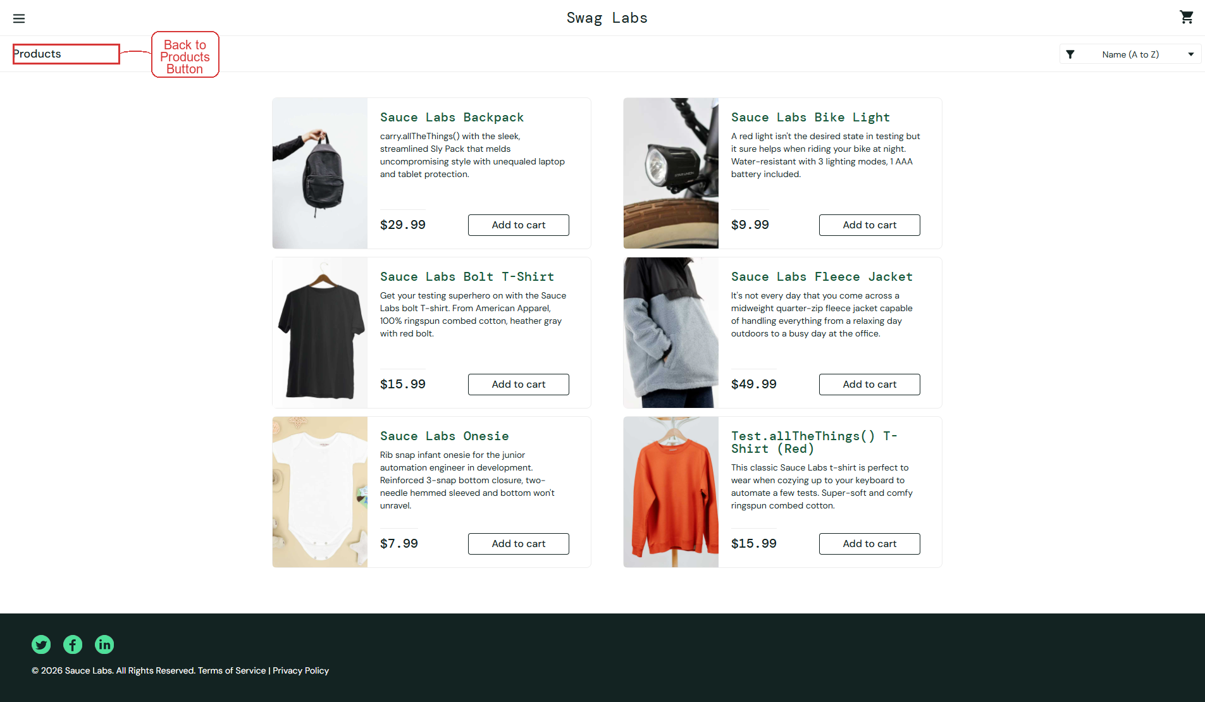
Figure 5: Screen 5 View

Procedure Steps
--> Paste Claude's Response directly here <--

6. Screen 6 Interface
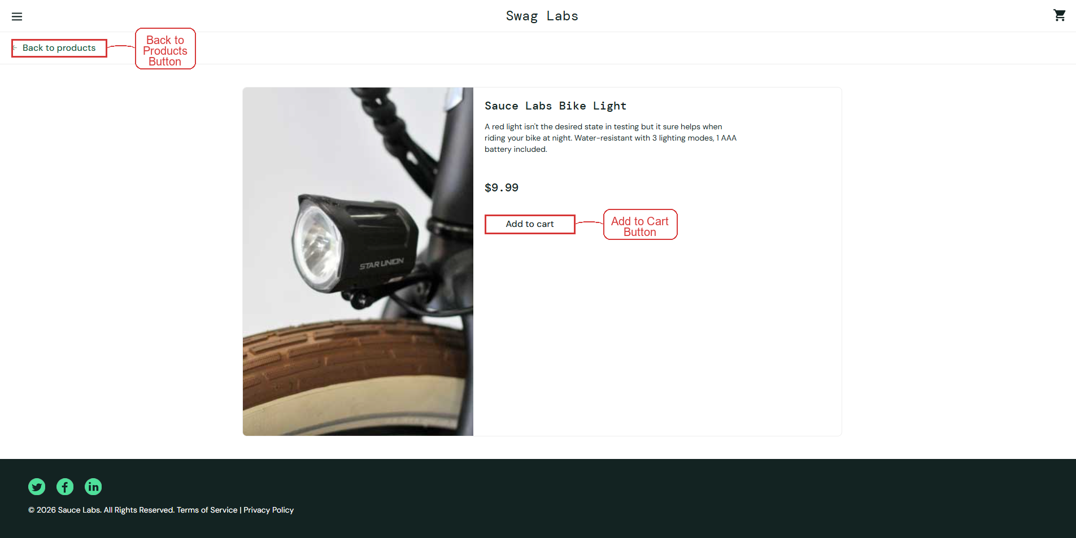
Figure 6: Screen 6 View

Procedure Steps
1. Click the Back to Product button to return to the product catalogue, allowing the user to select a different item if desired.
2. Click the Add to Cart button to place the currently displayed product into the shopping cart; if the product is out of stock, the system will display the error message “Unable to add to cart – item is out of stock.”

