

ORANGEHRMS
Comprehensive User Manual
OrangeHRM Portal
Comprehensive User Guide & Technical Documentation

DOCUMENT VERSION:  1.0 (Official Draft)  PUBLISHED DATE:  July 07, 2026  GENERATED BY:  Documentation Automation Engine | CONFIDENTIAL

Revision History
Ver. | Date | Author | Approved By | Details of Changes
1.0 | 2026-07-07 | Automation Bot | Quality Lead | Initial generated manual — Version 1.0

Table of Contents
This Table of Contents is dynamically generated using native Microsoft Word index fields. Please right-click the block below and select 'Update Field' to refresh page numbers.
[Right-click here and select 'Update Field' to generate Table of Contents]

Google Search Homepage

Detailed procedural steps and interface dictionary for the Google Search Homepage module.

1. Google Search Homepage

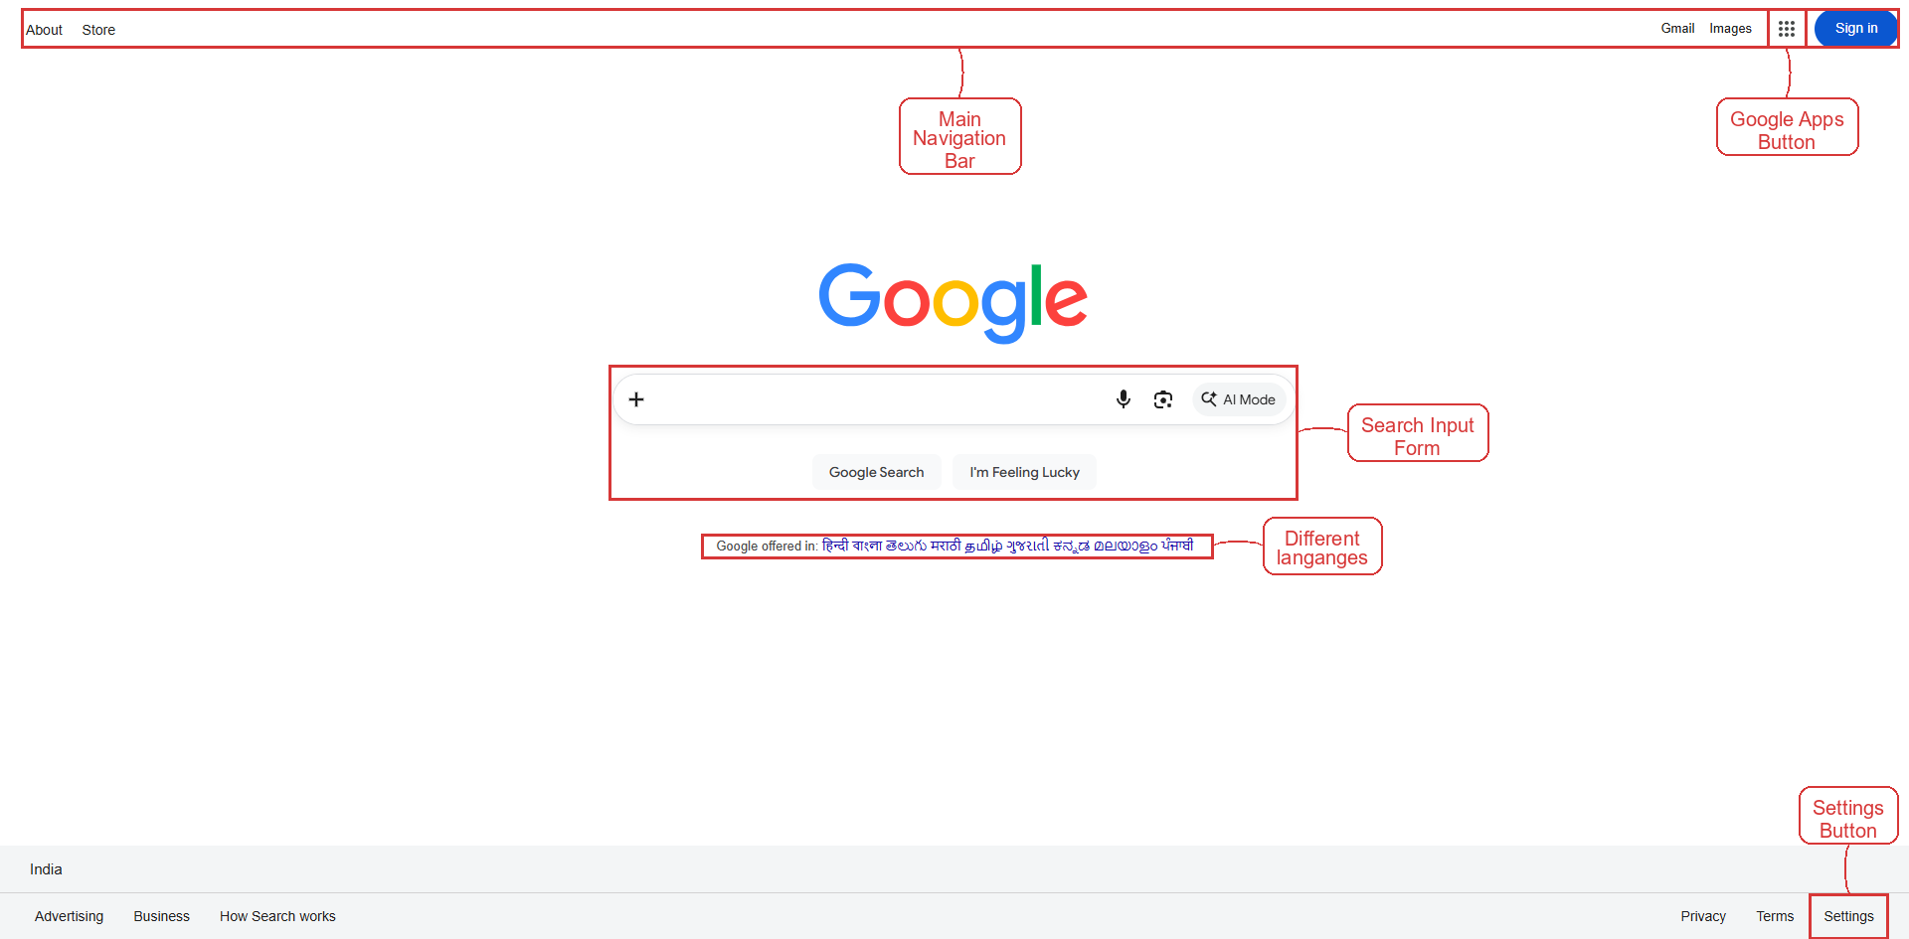
Figure 1: Google Search Homepage

Procedure

Purpose
Enable the user to perform a web search, access Google applications, adjust settings, and review content in different languages from the Google Search Homepage, thereby enhancing information retrieval efficiency.

Prerequisites
- Internet connection
- Supported web browser installed

Steps
- Navigate to the Google Search Homepage by selecting the appropriate option on the Main Navigation Bar.
- Enter the desired query text into the Search Input Form.
- Click the Google Apps Button to open the applications menu.
- Click the Settings Button to open the settings panel.
- Review and select the preferred language options listed under Different languages.

Expected Outcome
The search query is processed, the selected language settings are applied, and the user can view search results and access Google applications in the chosen language.
NOTE: Language changes apply only to the current browsing session unless saved to your Google account.

Interface Element Dictionary
UI Element / Field | Purpose & Functional Description
Search | Enter the search terms you want to query; the textbox accepts free‑text and is optional.
Google Search | Click the Google Search button to submit the query and display the results page.
I'm Feeling Lucky | Click I’m Feeling Lucky to submit the query and be taken directly to the first matching website.

