CONFIDENTIAL
AIRA

System Architecture & Deployment Specification
Single-client Self-hosted Deployment

June 2026
Version 1.0

1. What is AIRA
AIRA is an AI-powered voice receptionist. When someone calls a business phone number, an AI agent answers the call, understands what the caller is saying in Indian languages, responds intelligently using the company’s own knowledge base, and logs the full conversation transcript automatically.

Technologies used:
- LiveKit — real-time audio transport (WebRTC + SIP)
- Sarvam AI — speech-to-text in 6 Indian languages (English, Hindi, Tamil, Telugu, Kannada, Malayalam)
- Google Gemini / OpenAI GPT — the large language model that generates the agent’s replies
- Cartesia / ElevenLabs — text-to-speech (the agent’s voice)
- ChromaDB — vector database for knowledge base (RAG — Retrieval Augmented Generation)
- PostgreSQL — stores call logs, transcripts, summaries, and settings
- FastAPI — REST API backend
- Next.js — web dashboard for the client

2. Architecture Diagram
The diagram below shows all components of the AIRA system and how they communicate. The VM boundary (centre column) is where all services are self-hosted. External callers enter from the left; external APIs are called out to the right.

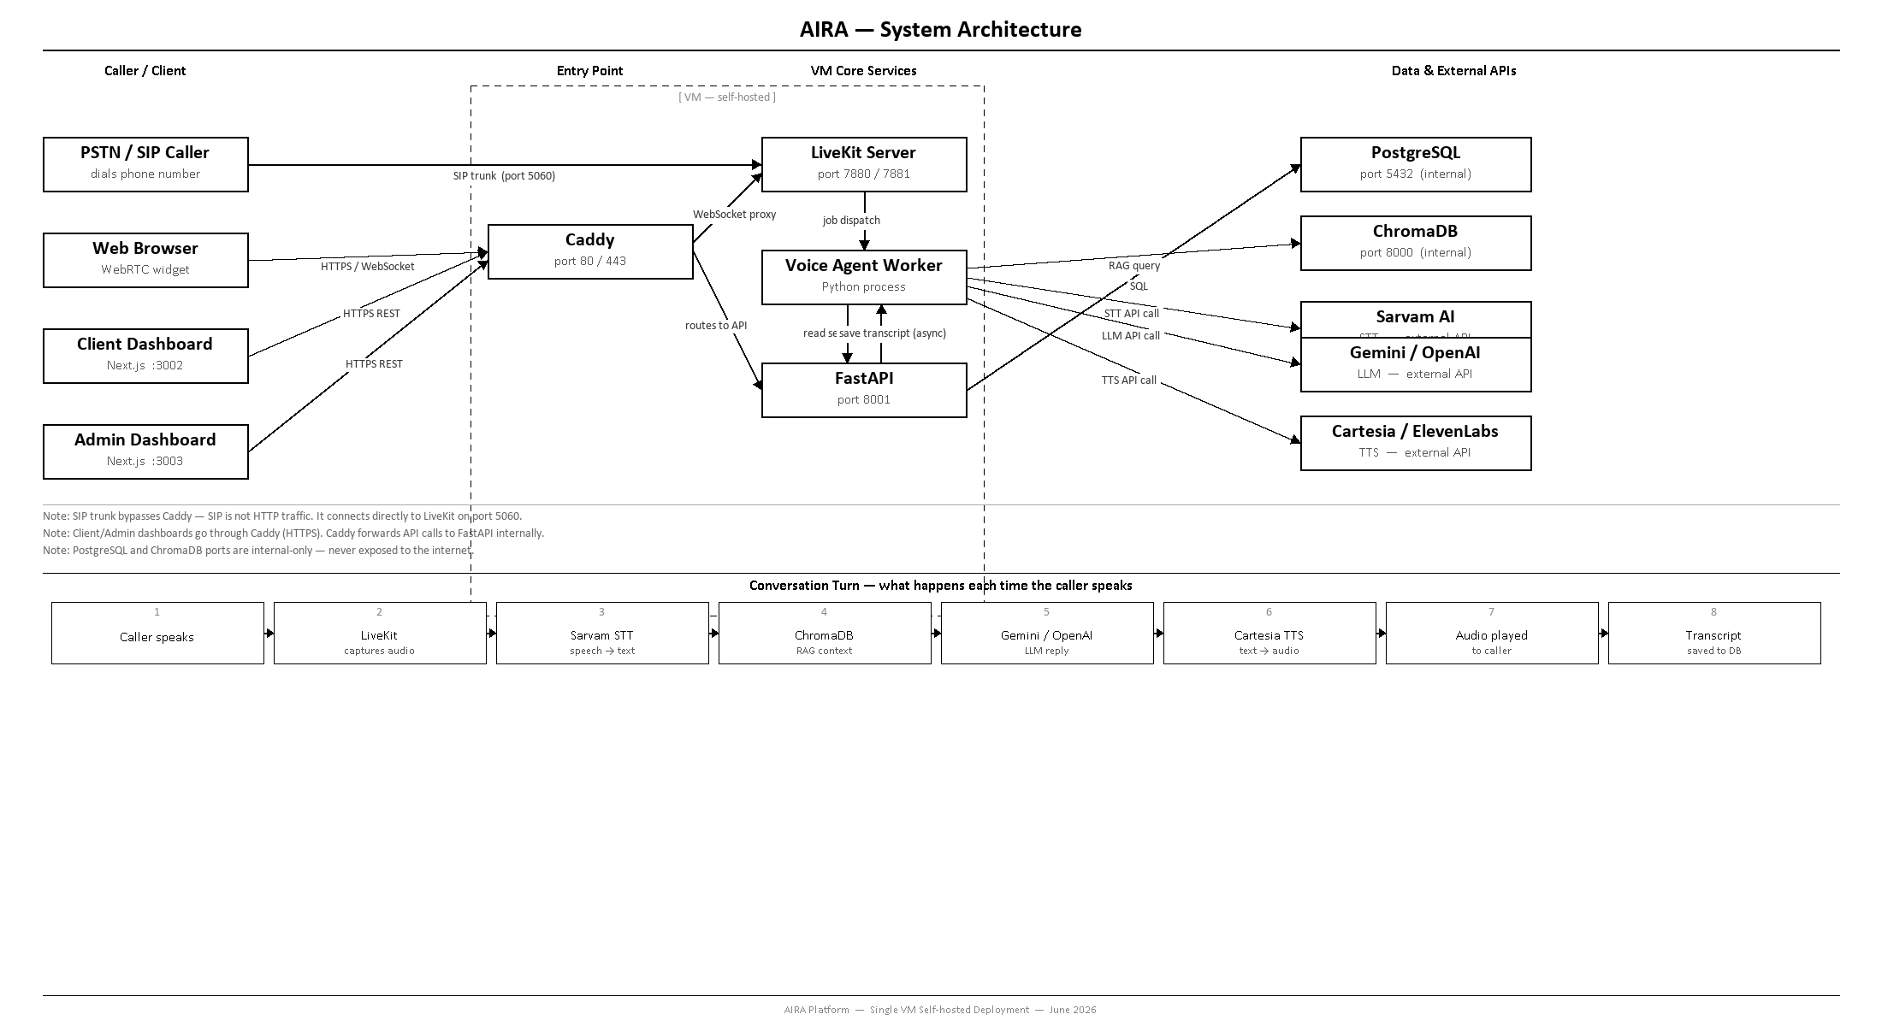

Figure 1 — AIRA system architecture. All services in the centre column run on one VM.

3. System Components
All components run on a single VM. The table below lists each component, its technology, role, and the port it uses.

Component | Technology | Role | Port
Reverse Proxy | Caddy | TLS termination, routes all web traffic by subdomain | 80, 443
Media Server | LiveKit (self-hosted) | WebRTC + SIP, manages calls, dispatches jobs to agent worker | 7880, 7881, 50000–60000 UDP
Voice Agent | Python / LiveKit Agents SDK | STT → LLM → TTS pipeline, reads caller audio, generates response | Outbound only
REST API | FastAPI + Uvicorn | Call logs, transcripts, settings, KB upload, token generation | 8001
Database | PostgreSQL 15 (Docker) | All persistent data: calls, transcripts, summaries, settings | 5432 (internal)
Vector Store | ChromaDB (Docker) | Knowledge base RAG — stores embedded docs, answers queries | 8000 (internal)
Web Dashboard | Next.js 14 | Client UI: calls, transcripts, KB upload, agent settings | 3002
OS | Ubuntu 22.04 LTS | Base operating system on the VM | —

4. How a Call Works — Step by Step
The following sequence describes a complete call from the moment the caller dials to the transcript being saved.

- Caller dials the business phone number via SIP trunk, or opens the web widget (WebRTC).
- LiveKit server receives the call and creates a room.
- LiveKit dispatches a job to the Voice Agent Worker.
- Worker connects to the room and starts listening.
- Caller speaks — audio is captured as a PCM stream.
- Audio is sent to Sarvam AI (STT) and returned as text.
- Text is sent to Gemini/OpenAI (LLM) along with relevant knowledge base context fetched from ChromaDB.
- LLM generates a reply.
- Reply text is sent to Cartesia (TTS) and returned as audio.
- Audio is played back to the caller through LiveKit.
- Both the caller’s words and the agent’s reply are saved to PostgreSQL as transcript rows. This is async and non-blocking — it does not add latency to the conversation.
- Steps 5–11 repeat for every conversation turn until the caller hangs up.
- On call end, a summary and call category are generated by the LLM and saved to PostgreSQL.

Non-blocking transcript writes
The transcript is saved using asyncio.create_task() — a background coroutine. The voice pipeline does not wait for the database write to complete before processing the next turn. This keeps conversation latency low.

5. Processes Running on the VM
The table below lists every process that runs on the VM, its memory footprint, CPU requirement, and key notes.

Process | RAM Usage | CPU Usage | Notes
Caddy | 30–50 MB | Negligible | Auto TLS via Let's Encrypt
LiveKit server | 150–400 MB | 0.2 core base + 0.1 / active call | UDP 50000–60000 must be open in firewall
Voice agent worker | 200–500 MB | 0.3 core per active call | One Python process handles ~5 concurrent calls
FastAPI (uvicorn) | 80–200 MB | Low (I/O bound) | Run 2–4 uvicorn workers
PostgreSQL (Docker) | 100–300 MB | Low | Data on persistent Docker volume
ChromaDB (Docker) | 100–400 MB | Spikes on document upload | Data on persistent Docker volume
Next.js dashboard | 150–250 MB | Minimal | Served with npm start or PM2
TOTAL — idle | ~1.0–2.0 GB | ~1.0 core
TOTAL — 5 concurrent calls | ~2.5–3.5 GB | ~2.5–3.0 cores
TOTAL — 10 concurrent calls | ~3.5–5.0 GB | ~4.0–5.0 cores

Scaling the voice agent worker
The voice agent worker is the first bottleneck. One Python process handles approximately 5 concurrent calls. For 10 concurrent calls, run 2 worker instances. Workers are stateless and can be added without downtime.

6. Storage Requirements
All persistent data lives on a separate data volume mounted at /data. This allows the data disk to be resized independently of the OS disk.

Data | Location | Pilot Size | Growth Rate
Call logs & transcripts | PostgreSQL | 5–10 GB | ~3–5 GB per month (depends on call volume)
Call summaries & settings | PostgreSQL | < 1 GB | Slow growth
Knowledge base vectors | ChromaDB | 1–5 GB | ~500 MB per 1000 uploaded documents
Raw uploaded files | /data/uploads | 5–20 GB | PDF, DOCX, TXT; archive after processing
LiveKit state | /data/livekit | < 1 GB | Config only; audio is not recorded or stored
OS + application code | OS disk | 8–12 GB | Static

Recommended disk layout:
- OS disk: 80 GB SSD — Ubuntu OS, Docker images, application code
- Data volume: 50 GB separate persistent volume mounted at /data — PostgreSQL, ChromaDB, file uploads

Backup policy
Run pg_dump daily to a separate location (object storage such as Backblaze B2 or Cloudflare R2). Snapshot /data/chroma periodically via the VM snapshot feature. The uploads directory should be mirrored to object storage in real time.

7. Network & Firewall Rules
Only the ports listed as Public should be open in the VM’s firewall. All other ports must be blocked from external access.

Port | Protocol | Open to | Purpose
80 | TCP | Public | HTTP — redirects to HTTPS
443 | TCP | Public | HTTPS — all web traffic entry point
7881 | TCP | Public | LiveKit WebRTC TCP fallback
50000–60000 | UDP | Public | LiveKit RTP audio — CRITICAL: must be open or calls fail
5060 | UDP + TCP | Public | SIP signalling from SIP trunk provider
8001 | TCP | Internal only | FastAPI — proxied by Caddy, not directly accessible
3002 | TCP | Internal only | Next.js dashboard — proxied by Caddy
5432 | TCP | BLOCK | PostgreSQL — never expose to internet
8000 | TCP | BLOCK | ChromaDB — never expose to internet

CRITICAL — UDP port range 50000–60000
This UDP range is used by LiveKit for all real-time audio (RTP). If this range is blocked in your firewall or VPS network ACL, voice calls will fail or fall back to TCP with severe latency. This is the most common deployment mistake. Verify this range is open before testing.

8. VM Specification

Pilot — Single client, up to 10 concurrent calls

Provider: Vultr Mumbai (or any VPS with India region)
CPU: 4 vCPU
RAM: 8 GB
OS Disk: 80 GB SSD
Data Volume: 50 GB separate persistent volume
Bandwidth: 5 TB / month (included)
Estimated cost: $40–$50 per month
Concurrent calls: Up to 10 comfortably

When to upgrade
Upgrade to 8 vCPU / 16 GB RAM (~$90–$110/mo) when consistently hitting 10+ concurrent calls or when total storage on the data volume exceeds 40 GB.

Audio bandwidth is not a concern
LiveKit streams audio at 50–80 kbps per call leg. At 10 concurrent calls that is approximately 1.5 Mbps sustained. The 5 TB/month included on Vultr is far more than sufficient.

9. Technology Stack
The full technology stack for the self-hosted single deployment:

Layer | Technology | Notes
Media server | LiveKit | Self-hosted binary. Apache 2.0 license, free to self-host.
Agent framework | LiveKit Agents SDK | Python library for building real-time voice agents.
Speech-to-text | Sarvam AI | External API. 6 Indian languages. Per-deployment API key.
LLM | Google Gemini 2.0 Flash / OpenAI GPT-4o | Configurable. Gemini recommended for cost efficiency.
Text-to-speech | Cartesia / ElevenLabs / Sarvam | Configurable per deployment.
REST API | FastAPI + SQLAlchemy | Python, async. Uvicorn ASGI server.
Database | PostgreSQL 15 | Docker container with persistent volume.
Vector store | ChromaDB | Docker container with persistent volume.
Web dashboard | Next.js 14 | TypeScript. App Router. Port 3002.
Reverse proxy | Caddy 2 | Auto TLS via Let’s Encrypt. Subdomain routing.
Containerisation | Docker + Docker Compose | PostgreSQL and ChromaDB run as Docker containers.
OS | Ubuntu 22.04 LTS | Supported until 2027.

10. Deployment Steps
Follow these steps in order to bring up a fresh AIRA deployment on a new VM.

- Provision the VM — 4 vCPU / 8 GB RAM, Ubuntu 22.04 LTS. Attach a 50 GB data volume and mount it at /data.
- Configure the firewall — open ports 80, 443, 7881 TCP; 50000–60000 UDP; 5060 UDP+TCP. Block all other ports including 5432 and 8000.
- Install Docker Engine and Docker Compose v2. Add the deploy user to the docker group.
- Install the LiveKit server binary. Configure livekit.yaml with the VM’s public IP, API key/secret, and SIP trunk settings.
- Start PostgreSQL with docker compose up -d postgres. Run Alembic migrations to create the database schema.
- Start ChromaDB with docker compose up -d chromadb. Verify it responds at localhost:8000.
- Deploy FastAPI — install Python dependencies, populate the .env file (DATABASE_URL, LIVEKIT_URL, LIVEKIT_API_KEY, API keys), and start uvicorn with 2–4 workers.
- Deploy the voice agent worker — install Python dependencies, populate .env, start 2 worker processes. Verify they appear as connected agents in the LiveKit admin panel.
- Build and start the Next.js dashboard: npm run build then npm start (or use PM2 for process management).
- Configure Caddy with subdomain routing: api.domain.com → FastAPI, app.domain.com → Dashboard, livekit.domain.com → LiveKit. Caddy auto-provisions TLS via Let’s Encrypt.
- Point DNS A records for all subdomains to the VM’s public IP address.
- Configure the SIP trunk provider (Twilio / Exotel / any SIP provider) to route inbound calls to the VM’s public IP on port 5060.
- Make a test call via the browser widget and via the phone number. Verify the transcript appears in the dashboard.
- Set up a daily pg_dump cron job to back up PostgreSQL to object storage.

11. What the Dashboard Provides
The Next.js web dashboard is the client’s interface to AIRA. It provides the following capabilities:

- Live call monitor — see active calls in real time with live status indicators
- Call log — full history of all calls with caller details, duration, and status
- Transcripts — full conversation text for every call, speaker-attributed
- Call summaries — AI-generated summary, call category (Sales / Support / Appointment / etc.), and action items
- Knowledge base management — upload PDF, DOCX, or TXT files; the system embeds them into ChromaDB for RAG
- Agent settings — configure the agent’s name, language, voice, persona, and greeting
- Call metrics — LLM token usage, STT audio duration, TTS characters billed per call

