e-Invoice Header Printout
Extension for Zoho Books
Marketplace Review Submission — Documentation, Flow Document and Questionnaire Responses
Extension name | e-Invoice Header Printout (widget panel: "e-Invoice Print")
Platform | Zoho Books (India edition / e-invoicing organizations)
Distribution | Public — Zoho Marketplace, all organizations
Pricing | Free
Data access | Read-only: single scope ZohoBooks.invoices.READ; no writes, no external services, no data stored outside Zoho

1. Purpose and business use-case
The extension produces a printable copy of an already e-invoiced Zoho Books invoice with the e-invoice band — QR code, IRN, Ack No., Ack Date and status — placed at the top of every page of the PDF.

Business use-case
GST-registered businesses in India push their invoices to the Invoice Registration Portal (IRP) from Zoho Books. Books records the IRN, acknowledgement details and the signed QR against the invoice. In day-to-day trade — exports, shipping documentation, plant gate copies, bank submissions — the printed invoice must show these e-invoice credentials prominently, and on every page of a multi-page invoice, not once in the body where they can be missed or separated from continuation pages.
Zoho Books prints these details once, wherever the organization’s template places them. This extension closes that gap:
- The user opens an invoice that has been pushed to the IRP and clicks Print e-Invoice in the sidebar panel.
- The extension fetches the invoice PDF exactly as the organization’s own customised Books template renders it — it does not invent a layout — and stamps the e-invoice band into a strip freed at the top of each page. The original page is embedded unchanged and scaled slightly; nothing is redrawn or distorted.
- The result opens in a new tab, ready to print or save.

Key properties
- Zero configuration. Every value comes from the e-invoice record Zoho Books already holds. Nothing is entered at install time; there is no settings screen. No organization-specific value is hardcoded — the extension works identically for every organization that installs it.
- Read-only. The single connection scope is ZohoBooks.invoices.READ. Nothing in Zoho Books is created, updated or deleted.
- No external services. Every API call goes to Zoho’s own endpoints through declared API Configurations. No customer data leaves Zoho, and the extension stores no data anywhere.

2. Documentation of the extension

What the user sees
After installation, an "e-Invoice Print" panel appears in the invoice detail sidebar (and in the invoice edit view). Its behaviour:
- On an invoice that has not been e-invoiced, the panel states that the invoice has no e-invoice on record.
- On an e-invoiced invoice, the panel displays the IRN, Ack No., Ack Date, Status, and whether the QR will be embedded in the print — all read automatically from Zoho Books.
- Print e-Invoice opens a new tab containing the organization’s own invoice PDF with the e-invoice band stamped at the top of every page, ready to print or save. The saved PDF is self-contained: the QR is embedded, not linked.

How the band is produced
- The invoice detail record is read through the getinvoice API configuration; the einvoice_details block provides the IRN, Ack No., Ack Date and status.
- The e-invoice record is read through the geteinvoiceqr configuration. Where it carries the signed QR text, the QR is rendered from that text; otherwise the QR image Zoho Books issued is fetched through the getqrimage configuration.
- The invoice PDF is fetched through the getinvoicepdf configuration — the organization’s own customised template, rendered by Zoho Books itself.
- Each page of that PDF is embedded unchanged into a new document, scaled slightly to free a strip at the top, and the band (title, IRN, Ack No., Ack Date, Status, QR) is drawn into that strip. Page count, aspect ratio and the organization’s artwork are preserved exactly.

Installation
- Install the extension from the Zoho Books Marketplace listing.
- Select the organization and authorize the single Zoho Books connection when prompted.
- Done. There are no configuration fields — the install action records the organization automatically.

Note for organizations whose template already prints the IRN
Templates that already print e-invoice details in the body will show them twice on the printed copy. The extension adds to a rendered PDF and cannot remove content from it; remove that block from the organization’s invoice template so the header band is the only e-invoice display.

Sample output — page 1 and page 2 of the same invoice (demonstration data)
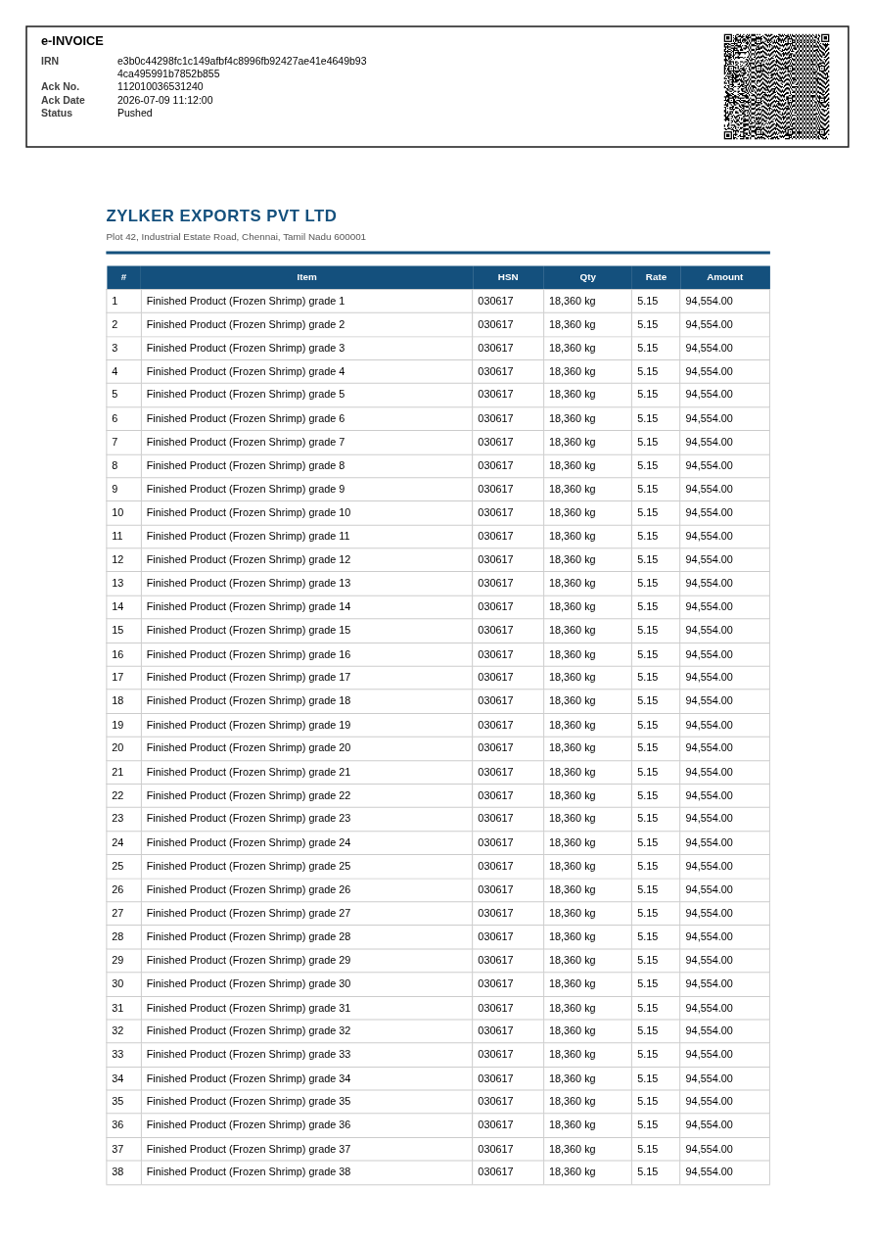
Page 1 — the band occupies a strip freed at the top; the organization’s template is untouched beneath it.
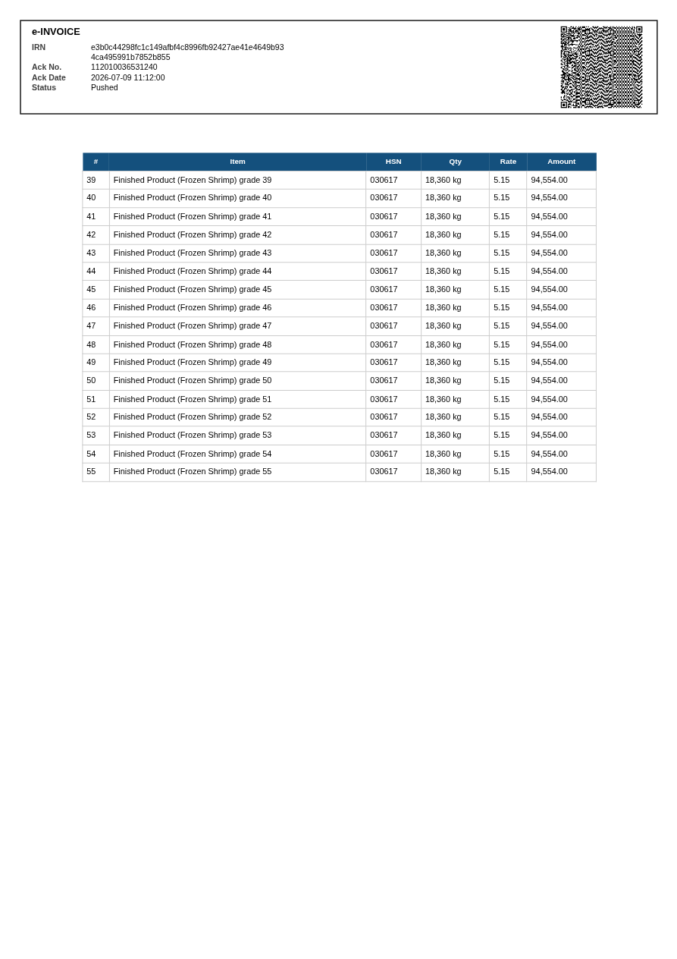
Page 2 — the band repeats on every page. All names and identifiers shown are fictional demonstration data.

3. Explanatory video — flow document and component inventory
The explanatory video follows the flow below. Every component in the extension appears in it.

Complete component inventory
# | Component | Name | Purpose
1 | Widget (invoice details sidebar) | e-Invoice Print | Panel on the invoice detail page: shows IRN, Ack No., Ack Date, Status and QR read from Zoho Books, with the Print e-Invoice button.
2 | Widget (invoice edit view sidebar) | e-Invoice Print (Edit View) | The same panel surfaced on the invoice creation/edit view.
3 | Connection (Zoho OAuth) | zbooks | Authorizes the API configurations. Scope: ZohoBooks.invoices.READ only — read-only.
4 | API Configuration | ac__in_wyw1vx3_getinvoice | GET /books/v3/invoices/${url_param.invoice_id}?organization_id=${url_param.organization_id}&accept=json — invoice detail record including einvoice_details.
5 | API Configuration | ac__in_wyw1vx3_getinvoicepdf | Same endpoint with accept=pdf — the invoice PDF exactly as the organization’s own template renders it.
6 | API Configuration | ac__in_wyw1vx3_geteinvoiceqr | GET /books/v3/invoices/${url_param.invoice_id}/einvoice — the e-invoice record (source of the signed QR text where the organization stores it).
7 | API Configuration | ac__in_wyw1vx3_getqrimage | GET https://books.zoho.in/einvoice/qrcode?eInvoiceID=${url_param.eInvoiceID} — the QR image Zoho Books issued, embedded permanently in the printed PDF.
8 | Global Field (Hidden) | vl__in_wyw1vx3_organization_id | Stores the installing organization’s ID, written once by the install action. Hidden, so installation asks the user nothing.
9 | Global Field (Hidden) | vl__in_wyw1vx3_invoice_ids | Reserved field from the same design; Hidden, never shown to the user.
10 | Install Action (Deluge) | Install_Function | On install/upgrade, reads organization.get("organization_id") and stores it in the organization_id global field. This is the entire install-time logic.

At runtime the widget passes invoice_id and organization_id — taken live from the widget context, which is what makes the extension multi-organization — as url_param values; the API configurations substitute them into the stored URLs. No URL is constructed in widget code.

Video flow (shot by shot)
- Developer portal — components. The extension in the Zoho Books Developer Portal: the two widgets, the zbooks connection, the four API configurations (each opened to show URL and parameters), the two Global Fields (Hidden visibility shown), and the Install Action Deluge script.
- Installation. Installing into a Zoho Books organization: select organization, authorize the zbooks connection, installation completes with no configuration questions.
- Non e-invoiced invoice. An ordinary invoice is opened; the e-Invoice Print panel states the invoice has no e-invoice on record (shows the details-sidebar widget).
- E-invoiced invoice. An invoice pushed to the IRP is opened; the panel shows IRN, Ack No., Ack Date, Status and "QR: embedded in print", all read from Zoho Books with no user input.
- Print. Print e-Invoice opens a new tab with the organization’s own invoice template carrying the e-invoice band at the top of every page; a multi-page invoice is scrolled to show the band repeating.
- Edit view widget. The same panel shown on the invoice edit view (the second widget).

4. Marketplace or organization-specific
Developed for publishing on the Zoho Marketplace, for all Zoho Books organizations (India edition / e-invoicing users). It is not restricted to any specific organization: no organization ID is hardcoded anywhere, and the install action derives the installing organization’s ID automatically.

5. Paid or free
Free.

6. Extension Review Guidelines
The extension was developed following the Extension Review Guidelines:
- Least privilege: a single Zoho OAuth connection with the single read-only scope ZohoBooks.invoices.READ. No write scopes, no other Zoho services.
- No external or third-party services: every API configuration points at Zoho’s own endpoints; no customer data leaves Zoho; the extension stores no data anywhere (no external storage, analytics or tracking).
- All API access goes through declared API Configurations with the declared connection — no raw URLs in widget code.
- Global fields are Hidden and the install action is a minimal Deluge function, so installation asks the user for nothing.
- Built with the ZET toolkit and the ZFAPPS SDK v2.0; zet validate passes.
There are no open difficulties with the guidelines. One small piece of portal feedback, not a blocker: on an API configuration form, a header row that has been removed re-appears in the UI after saving; unrecognised headers appear to be ignored server-side, so this did not affect the extension’s behaviour.

