**Goal: Provide Confirmation & Personalized Direction**

|  |
| --- |
| **Resume Extraction** |
| **Udemy Recommendation** |

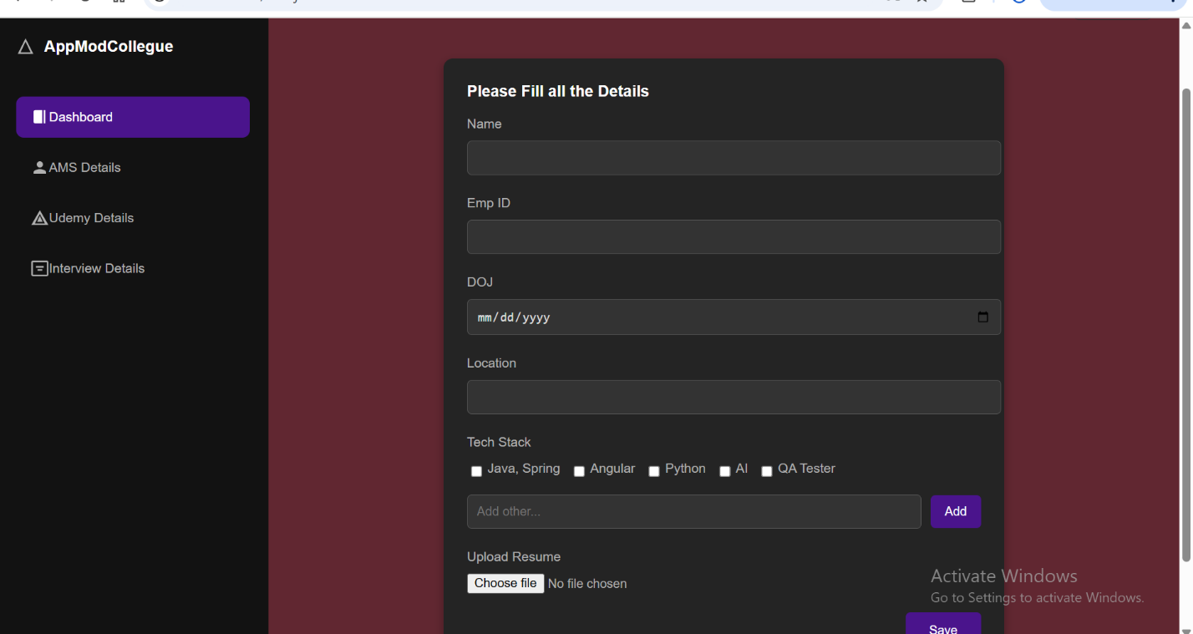

Remove tech stack and check boxes, Extract the skills from uploaded resume

Fetch it like Naukri and LinkedIn

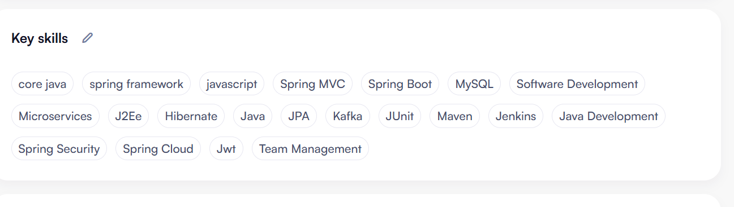

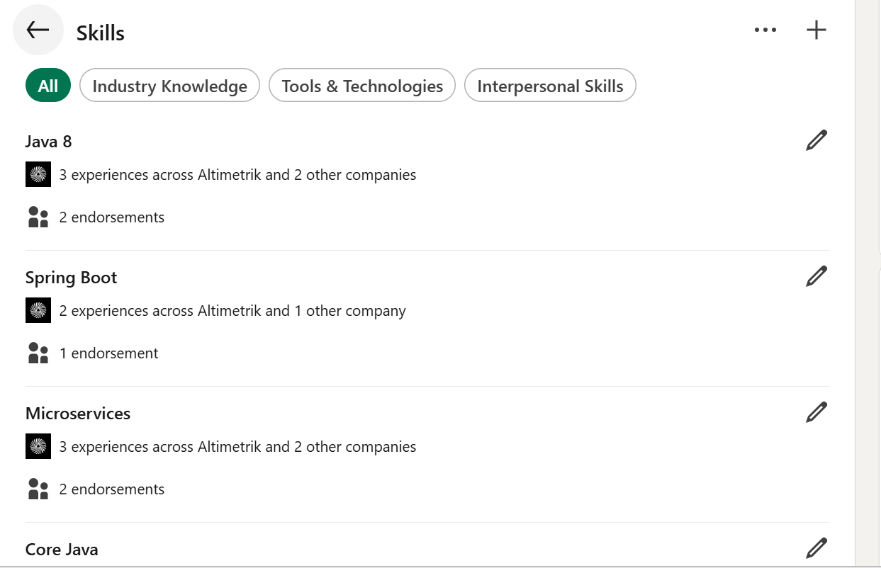

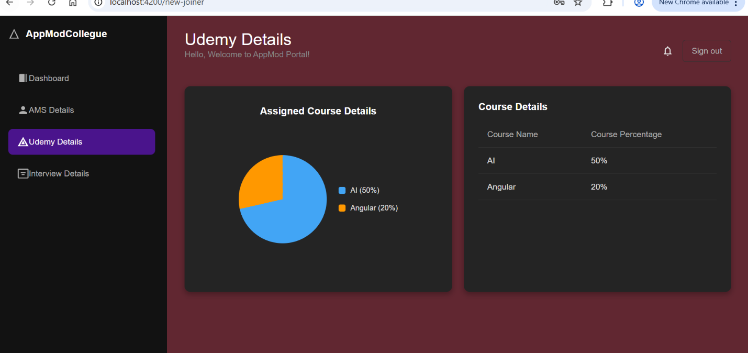

Change like below

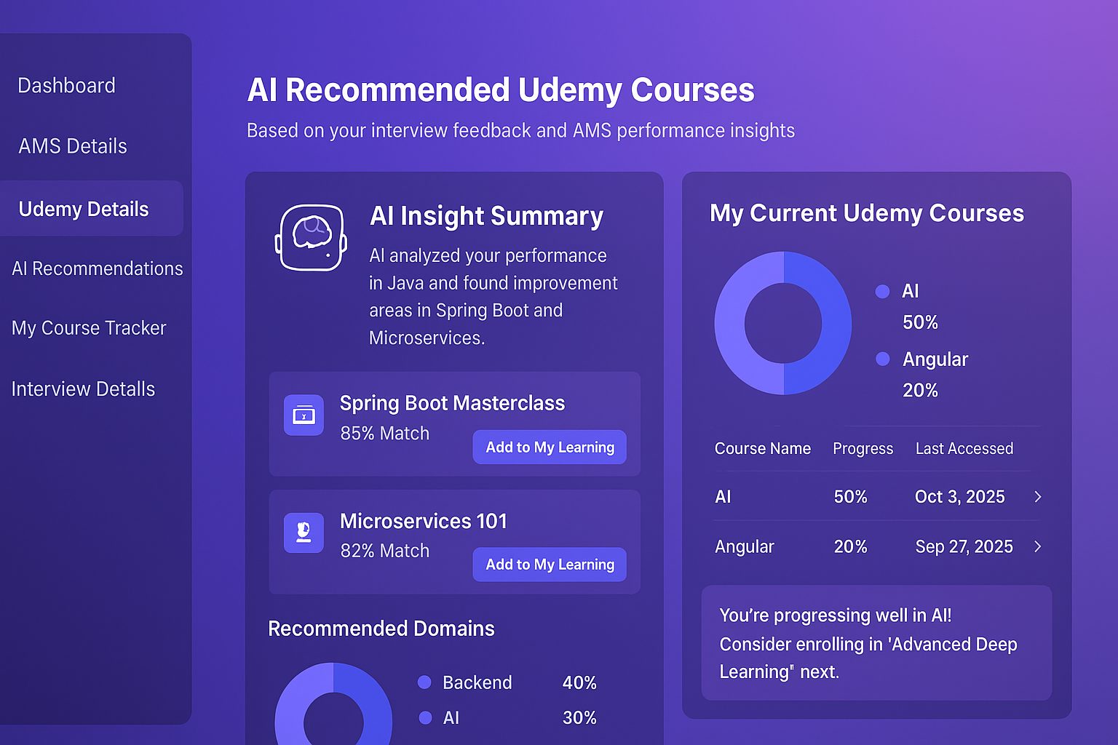

**2. Business Associate (BA) Dashboard**

|  |  |
| --- | --- |
|   **Pie chart:**  **Low risk -**  **High risk**  **Medium risk**  **Billed**  **No risk** |  |

AMS:

Click the row add AMC manually and update it

Click the row show all the AMCs details

AMC name:

Location:

DOJ:

Feedback:

Add one search box , search by ID, Name.

Rename [ Recent AMC interview Details -> Over All AMC interview Details ]

Id, Name[sort], Client Name[sort] , Feedback[Sort], Bench Risk[Sort]

Bench Risk:  
0-15 days – no risk

15-30 days – Low risk

30-60 days – Medium risk

60 days + - High risk

If feedback is not yet received, add hyper link label[update the feedback]

[update box] -> update it DB as well

Client name

Overall feedback: false / positive

Detailed feedback : [copy paste the client feedback]

[update and cancel]

Click the row(in dialog box):

Name [Mani] Resume.docx

1. Client name:

Over all feedback:

Detailed Feedback:

2. Client name:

Over all feedback:

Detailed Feedback:

AMC:

Search box:

Id, emp name

Emp id emp name Resume RecentFeedback[filter] client name AMS[sort] Bench Score [filter]

Click dialog:

Emp name:

Udemey overall details

Manager:

Location

**3. AMS Dashboard (AppModSupervisor)**

**Goal: Facilitate Proactive Mentoring and Risk Mitigation**

| Tab/Card | Essential UI Modification | Feature Showcase |
| --- | --- | --- |
| **Dashboard (Home)** | **ADD a new Card: "Team Action Summary"** at the top. Display actionable insights: *Example: "2 AMCs require attention: 1 High Bench Risk, 1 Lagging Training."* | **Bench Prediction** |
| **AMC Details (Team List)** | **CRITICAL: ADD a new column to the table:** **Bench Risk** (Badge/Color: Red/Yellow/Green). This directs the supervisor's attention immediately. | **Bench Prediction** |
| **Udemy Track** | **MODIFY the table to include two new indicators:** 1. **Recommendation Origin:** *Example: "System Recommendation"* 2. **Stalled Progress Indicator:** A small icon (e.g., ⏰) if course progress hasn't changed in the last 7 days. | **Udemy Recommendation** |

Workflow

User-> login -> newjoiner portal->

DOJ:

Location:

DB store -> Flag : new