Admin panel Changes

City List

Alexandria الإسكندرية

Asyut أسيوط

Aswan أسوان

Beheira البحيرة

Bani Sweif بني سويف

Cairo القاهرة

Dakahlia الدقهلية

Giza الجيزة

Damietta دمياط

Fayoum الفيوم

Gharbia الغربية

Ismailia الإسماعيلية

Kafr El Sheikh كفر الشيخ

Matrouh مطروح

Menia المنيا

North Sinai شمال سيناء

Monoufia المنوفية

new Valley الوادي الجديد

Port Said بورسعيد

Qalyubia القليوبية

Qena قنا

Red Sea البحر الاحمر

Sharqia الشرقية

Sohag سوهاج

South of Sinaa جنوب سيناء

Suez السويس

Luxor الأقصر

in add main category screen make the one page to show 100 entries as default as other screens

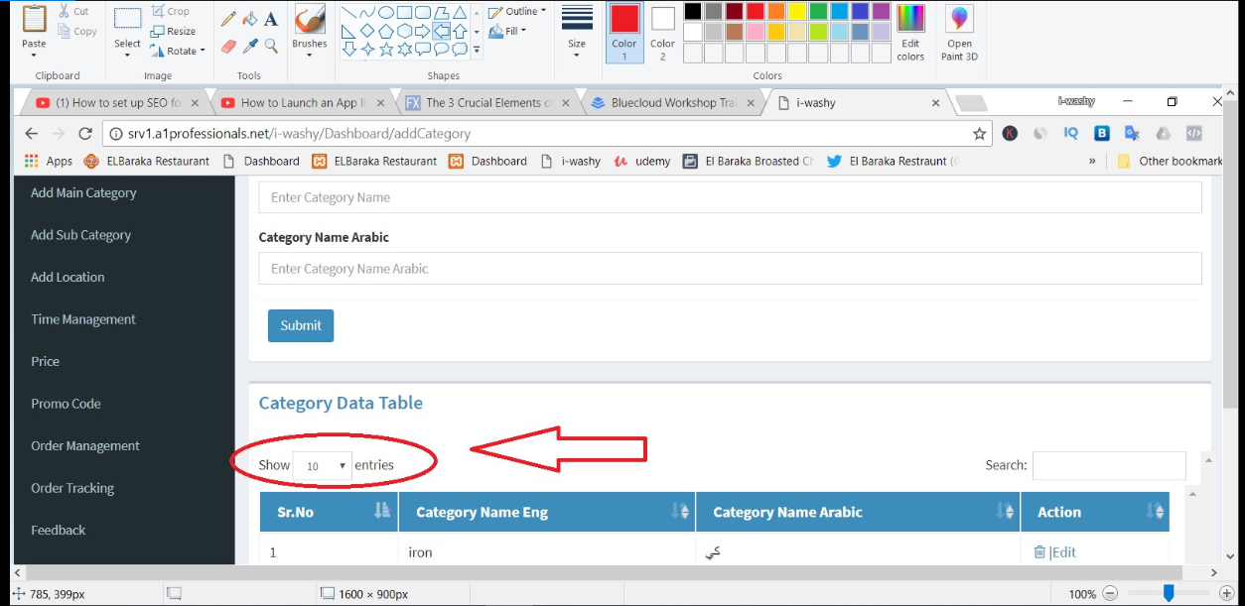

in add sub category screen when edit the name not updated

in add location screen when edit the Area Arabic field not appear

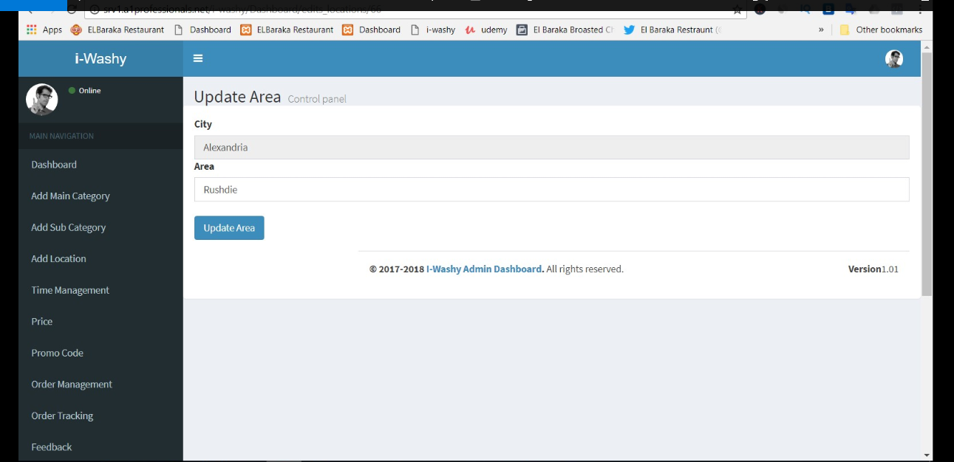

when I press edit button in time management screen an error 404 page appears

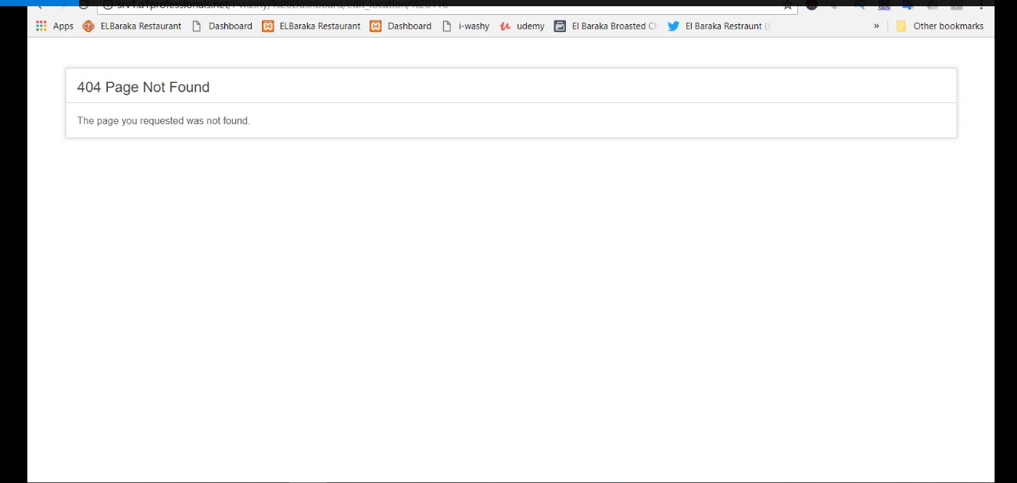

arrange the user ascending in promo code screen

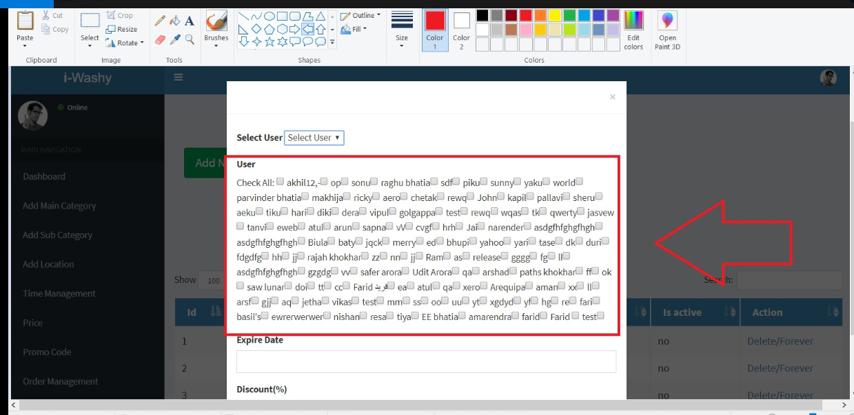

arrange the location & subcategory ascending in price screen

when place an order with Arabic language it appears as ?????? in admin panel and order&tracking screen in app

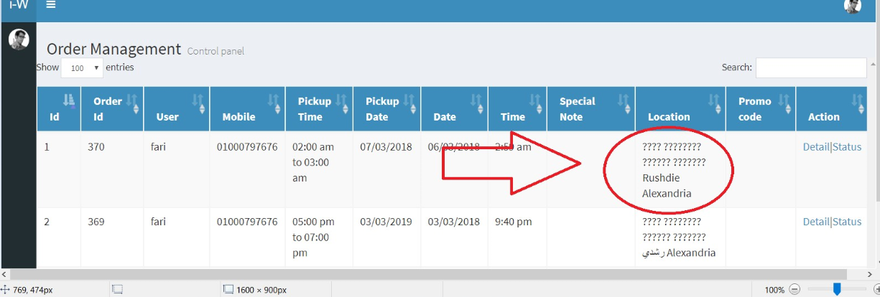

in order management screen increase column for user language as explained before

when place an order sometimes nothing send to email as order 370

**can you send me the messages & emails & static words sent or appears to user so that I give you the translation**