Certitude Water Distribution Controller

Table of Contents
1. Project Overview
2. Project Details
a) Water Circuit List (Spread Sheet)
b) Top Level Block Diagram
c) Tank Level Block Diagram
d) Present Water Distribution Operational Details
e) Proposed Automated System
3. Hardware Design
4. Software Design
4a) Source Code Control
5. System Level Test
6. Lab Test
7. Field Test
8. Installation

REVIEW:
No of Review | Date of Review
1 | 2-9-15
2 | 4-9-15

Project Overview
The project outline is to design, build and test an embedded control system to sequence the distribution of the water from the main bore wells to all the residential water storage tanks in Certitude community. The sequence of valve control as currently operated will be documented first. This sequence today is executed in order to properly match the water pressure in the water pump and flow control into one or two houses at a time to push the water up to the overhead tanks. In order to stop the overflow and cut off the intake valve at a residence, water level sensors in each tank will be installed. As each overhead tank is full, its intake valve is closed by the controller and when all the overhead tanks have been filled, the pump motor is automatically turned off. A timer is started when the controller is turned on. The pump motor should not ever run more than x (predetermined) duration and when that time duration is exceeded, the motor also will be switched off and an alarm Lamp indicator turn-on.

Project Details

a) Water Circuit List (Spread Sheet) – this list will provide the details on how a water pipeline is running from the bore-well to a residence. The valves that are on this water line that have to be operated are listed. The time to fill up the overhead tank on each circuit is also listed.
b) Top Level Block Diagram – this diagram shows the overall Inputs and Outputs to the controller.
c) Tank Level Block Diagram – this diagram shows the specific control for each residential tank.
d) Present Water Distribution Operational Details – show the community water valves' sequence.
e) Proposed Automated System – will replace the manual operations described in item d) plus provide support for power-on test of the controller itself. During operation the controller will also check tank fill time against predetermined minutes so that defective signaling does not waste water.

a) Water Circuit List
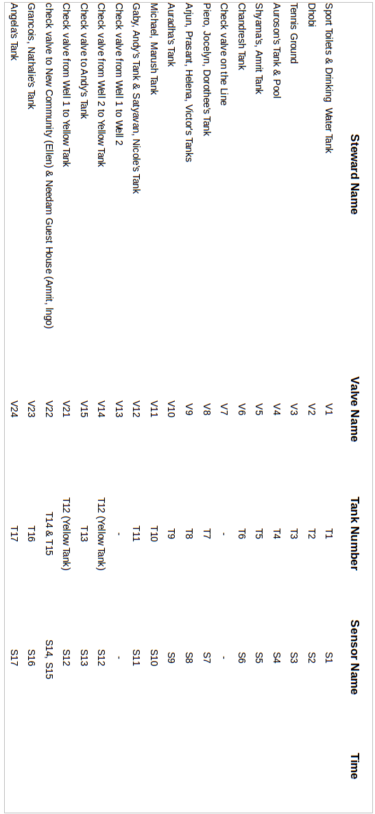

b) Top level Block Diagram
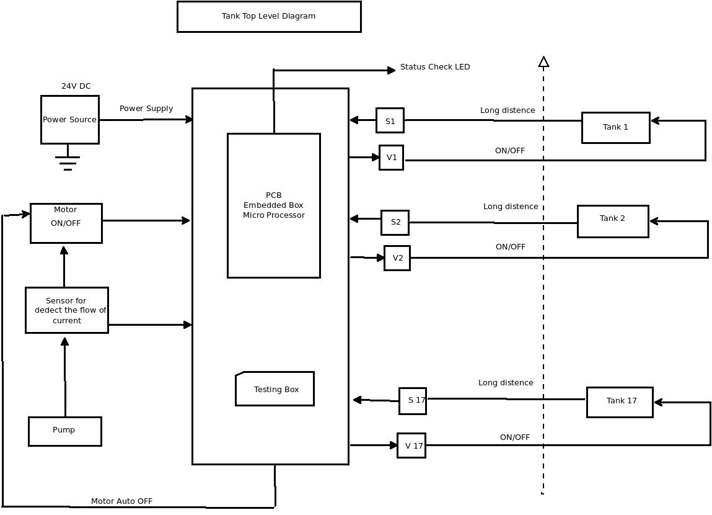

c) Tank Level Block Diagram

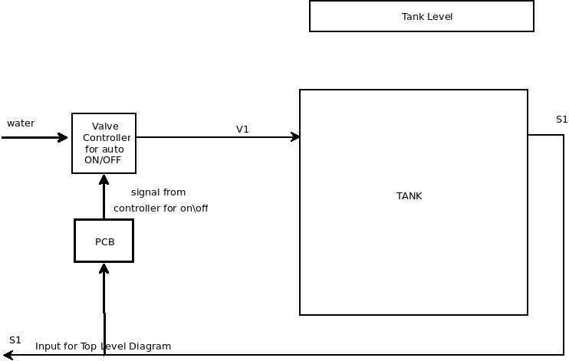
d) Current Operation
Currently the certitude water distribution handled by manually. A man can control the system manually.
- A man whose name is Anbazagan goes and turn on the motor and then goes to the first tank and manually opens the first valve. After which he monitors the tank overflow outlet until the tank is filled. At that point, he will turn on the second tank's valve and turn off the first tank's valve. Thus he fills the seventeen tanks in sequence. While doing this process lots of water would be wasted when the sequence is not monitored diligently.
The time he turns on the tank's valve and the duration for which the valve is operating will be measured by our engineering team. These measurements are captured for using as a means to not overflow a particular tank during automated operations.

e) Proposed System
In our project proposed system is going to handle the systems artificially ie. the help of the automatic water controlling system and sensors. Suppose if water flows continuously without any intimation when the sensors will use to avoid that. In time and the frequency is the major sources of our project .It will calculate rate of water flows every hours. We use here some of the embedded concepts also.
The time he turns on the tank's valve and the duration for which the valve is operating will be measured by our engineering team. These measurements are captured for using as a means to not overflow a particular tank during automated operations.
In here our controller is used to sense the water in the tank and based on that it will control the tank's valves to fill the tank. If the tank is filled then the sensor will send the signal to the controller and that tank's valve is closed automatically by the controller. After that the next tank's valve is turned on by the controller and the water is passed to the next tank's valve to fill the next tank. This process is continuing till the last tank. When all the tanks are filled then the controller turn off the motor's switch automatically.
The Water control System is used to avoid the wastage of water and current. It is used to help the humans to control the motor and water regulation process(manually on\off).

3. Hardware Design
1. Inputs:
1a. Sensors:
The Sensor that can be used to detect the water Level. In this Project we are using the Float Switch Sensor. It is used to detect whether the water in the tank is reached the top or not. sensor will send the signal to the controller,If the water is touched by the sensor which is place in the top of the tank .
1b. Timer:
Timer is used to check the duration of the tank's filling time. We have to set an approximate time to fill the tank.
1c. PCB Box:
A printed circuit board (PCB) mechanically supports and electrically connects electronic components using conductive tracks, pads and other features etched from copper sheets laminated onto a non-conductive substrate which is used to control and co-ordinate the process.
PCB is the main controller of our project which is used to check and control each tank's sensors and valves.
PCB is turn on and turn off the valves based on the sensors input. Each sensor will send the signal to the PCB, based on that it will operate each tank's valves.
When all the tanks are filled then the PCB will turn off the motor switch automatically.
PCB is also used to check a particular tank is full or not.
1d. CAT 5 Wires:
Category 5 cable, commonly referred to as cat 5, is a twisted pair cable for carrying signals. This type of cable is used to pass the signals from source to destination.
Here the sensor's signal is passed by the help of this cable which will transmit the signal with less lose.
1e. Motor Pump:
Electric motor pump is used to provide water flow. The HP rating for the motor in the field is xx. The reed-switch module has to be rated for controlling xx amps.

2. Outputs:
2a. Valves:
In Water Distribution System Valve is used to turn on and off automatically. Solenoid valve 24v DC will be used. The pipe size will be xx.
The Solenoid 24v DC valve is used to control the flow of water into the tank with help of the controller.
2b. Alarm:
In this Project Alarm is used to indicate the Pump/Motor is not automatically off in a certain time duration.
2c. LED's
LED's are used as an indicator which is used to show the project's status. The Green color LED is used to indicate that it is working in good and the Red color LED is used to indicate that there was some interrupt occurred in the process's steps.

4. Software:
4a) Operational Flow Chart
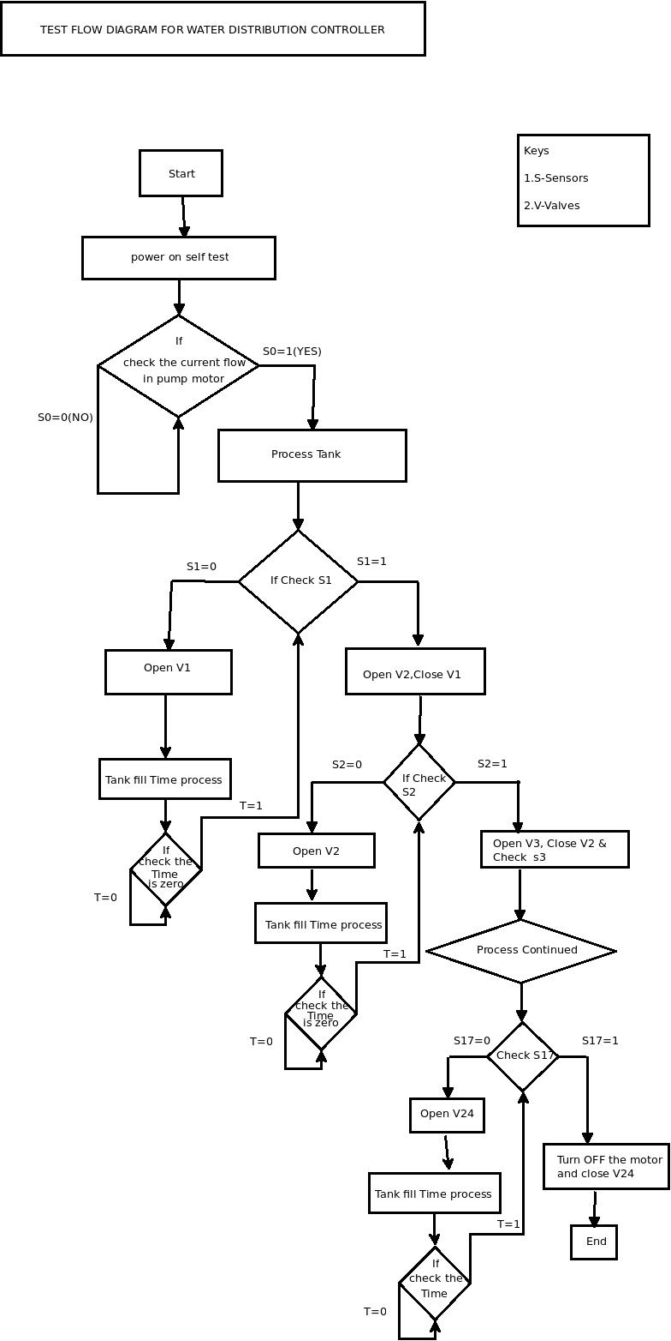
4b) Source Code Control:
Source control, also known as version control, stores software code files with a detailed history of every modification made to those files .Version control systems allow developers to modify code without worrying about permanently screwing something up. Unwanted changes can be easily rolled back to previous working versions of the code.
Source control also makes team software development easier. One developer can combine her code modifications with other developers' code through different views that show line-by-line changes then merge the appropriate code into the main code branch.
Version control is a necessity on all software projects regardless of development time, code base size or the programming language used. Every project should immediately begin by using a version control system such as Git or Mercurial
Path to git hub repository for this project: waterprojectteam/water_control.git
4c) Software Modules
In this Software Modules is used to test the Codings, and make a array list of values
4ci) Power-on self test module
In this module is used to test the proper power ON maintenance.
User selected test module
In this module is used to check the user options based on I/O modules in the test field.
Main controller module
In this module used to check the main PCB controller Activities.

5. System level test / Integration:
5a) Power-on self test
The power-on self test is used to test the initial project is read to work. This test is mainly used to check the controller and the entire system is ready to process. It helps to know that the entire PCB is ready.

6. Lab Test
6a) Valves Test – this test is used to check the valves are working properly
during the project execution time.
While getting the current signal form the sensor the valve should be opened automatically. This process should be held with the help of PCB.
We have to check if the PCB sends the current to the valve, it will turn on the valve.
6b) Sensors Test – this test is used to check the sensors are properly senses the water level in the tank.
Checking the sensor whether it sense the water or not and it would pass the signal to the PCB. The current loop is used to transmit the signals for long distance(Tank to PCB).
6c) Main Controller PCB Test – this test is used to check the Controller control all the valves and motor auto on and off.
Check the PCB is controlling all the valves by giving the current through each valve circuit.
6d) I/O modules Test – this test is used to check the input and the
outputs elements and their work status.

Based on PCB
1. The input signal of the sensor s1 getting.
2.The signal tells tank1 is fill then valve v2 open, v1 closed .
3.Process done up to s17-v17.

Based on Tank
1. The input of the valve v1 open
2.After tank is fill, the signal goes to sensor s1
3. The sensor s1 consider here as a output, it will provide the signal form of LED
4. After completing the process v2 open
5.The process done up to v17-s17.
7. Field Test
7a) Current flow Test – this test is used to check the flow of the current through the circuit. This is handled my the help of multimeter.
7b) Valves Test – this test is used to check the valves are installed properly and working properly. Giving the power to the valve we have to go and check it is on or off. If we give the signal form the PCB it should work.
7c) Sensors Test – this test is used to check the sensors are sensing the water level. Check the sensor is placed properly on the tank's top and giving signal if it teach the water.
7d) PCB Test – this test is used to test the PCB which is controlling all the process. Check the PCB is installed and which control all the valves after initialization.
7e) Check Box Test – this test is used to analyze and check the tanks and valves are filled and closed.

8. Installation
To implement the project in the real environment.

