AWS Hospital Care Notification System
Step-by-Step Project Documentation

Project Objective
This project demonstrates how to run an EC2 application/server inside a custom AWS VPC without a public IPv4 address and securely allow it to communicate with AWS services using VPC endpoints, IAM, and Amazon SNS. A test notification is published from the EC2 instance using the AWS CLI and the SNS topic has a confirmed email subscription.
Outcome: A private EC2 instance can publish an SNS notification without a public IPv4 address, using AWS service connectivity through VPC endpoints and permissions supplied by an IAM role.

1. Project Overview and Architecture
The solution is designed around a private EC2 instance inside a custom VPC. The instance does not have a public IPv4 address. AWS service access is provided through VPC endpoints, while IAM controls what the instance is allowed to do. Amazon SNS is used for notification delivery.
Component | Configuration / Purpose
VPC | hospital-care-vpc — IPv4 CIDR 10.0.0.0/16
EC2 | hospital-care — t3.micro in a private subnet; private IP 10.0.131.174
IAM Role | Hospital-Report — used by the EC2 instance
IAM Policies | AmazonSNSFullAccess and AmazonSSMManagedInstanceCore
VPC Endpoints | S3 Gateway + SNS, SSM, SSM Messages, EC2 Messages interface endpoints
SNS | hospital-care — Standard topic with confirmed email subscription
Test | AWS CLI sns publish from the EC2 instance; MessageId returned successfully
Logical flow: EC2 (private subnet) → IAM role → SNS VPC endpoint → SNS topic → confirmed email subscription.
Management path: EC2 → SSM-related VPC endpoints → AWS Systems Manager. The project also includes an S3 Gateway endpoint.

Step 1 — Create and verify the VPC
Create a dedicated VPC for the Hospital Care environment. The project VPC is named hospital-care-vpc and uses the private IPv4 range 10.0.0.0/16. DNS resolution and DNS hostnames are enabled, which supports AWS service communication and private name resolution.
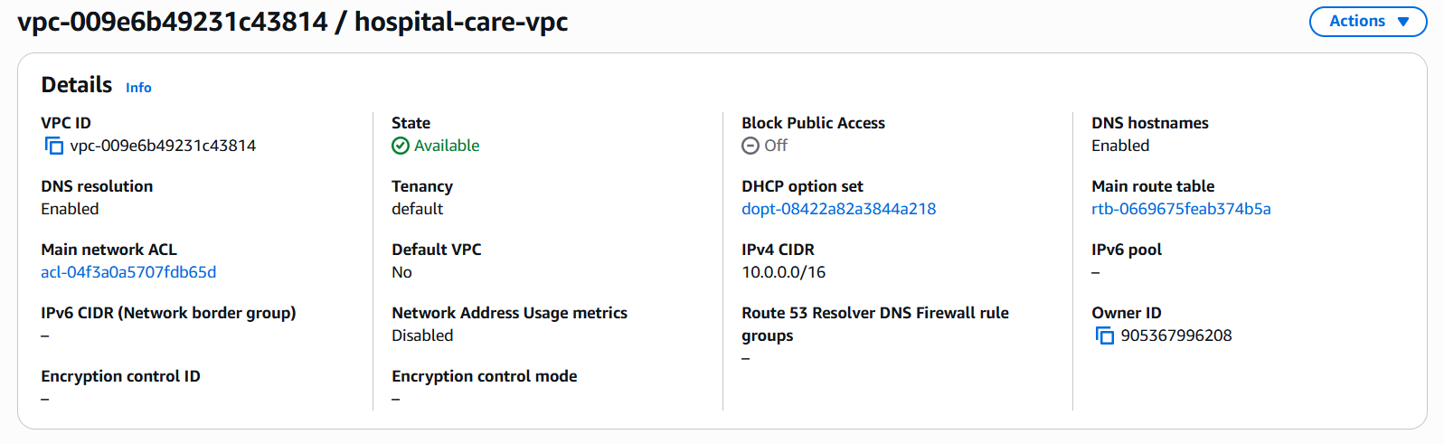
Figure 1. Custom VPC details.
Step 2 — Create the IAM role for EC2
Create/attach an IAM role named Hospital-Report and associate it with the EC2 instance. The screenshot shows two AWS managed policies: AmazonSNSFullAccess, which permits SNS operations, and AmazonSSMManagedInstanceCore, which allows Systems Manager management of the instance. Using an instance role avoids putting long-term AWS access keys on the server.
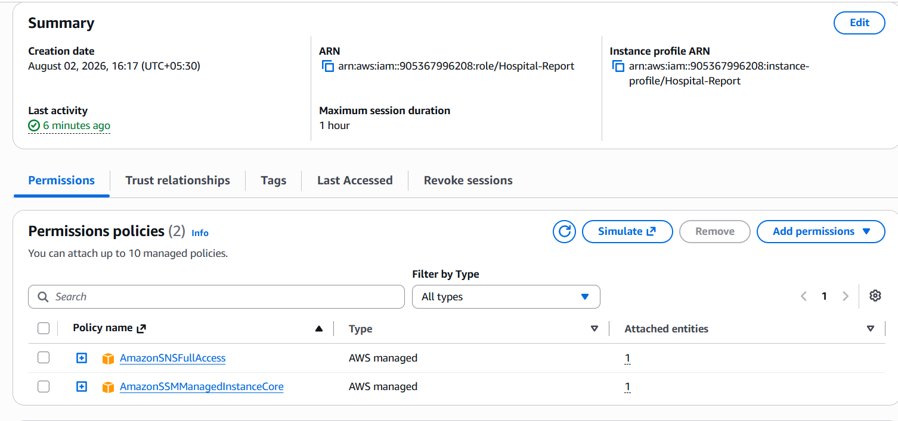
Figure 2. IAM role permissions.

Step 3 — Configure VPC endpoints
Because the EC2 instance is in a private subnet and has no public IPv4 address, VPC endpoints provide private connectivity to AWS services. The screenshot shows five endpoints: an S3 Gateway endpoint and Interface endpoints for SNS, SSM, SSM Messages, and EC2 Messages. The endpoints are shown as Available.
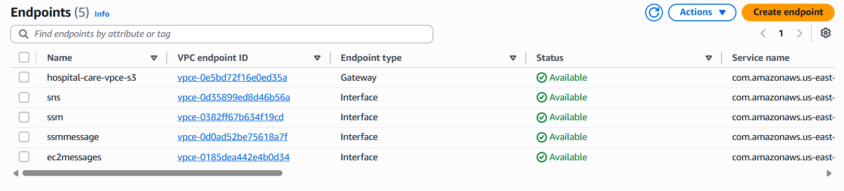
Figure 3. VPC endpoints used by the project.
Step 4 — Create the SNS topic and subscription
Create a Standard Amazon SNS topic named hospital-care. Add an email subscription and confirm the subscription from the email inbox. The project screenshot shows the subscription endpoint as maniyaram...@gmail.com and its status as Confirmed. Once confirmed, the topic can deliver published messages to that email endpoint.
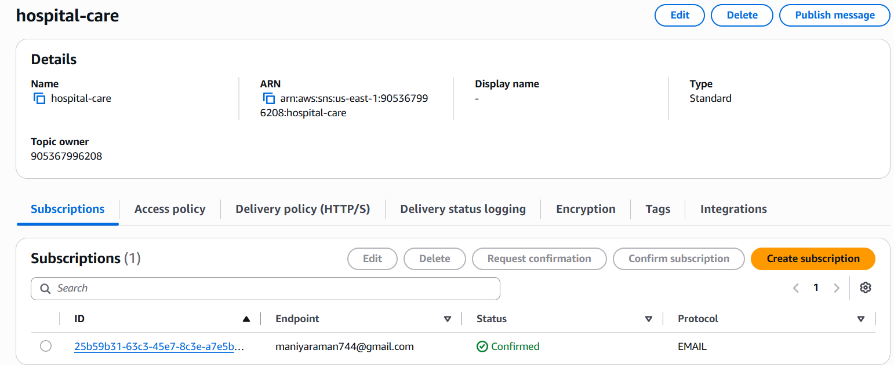
Figure 4. SNS topic and confirmed subscription.

Step 5 — Launch and verify the EC2 instance
Launch the EC2 instance in the private subnet and attach the Hospital-Report IAM role. The instance shown is t3.micro with private IPv4 address 10.0.131.174. It has no public IPv4 address or public DNS name, confirming that it is operating without direct Internet exposure. The instance is in the hospital-care-vpc VPC and uses the private subnet shown in the screenshot.
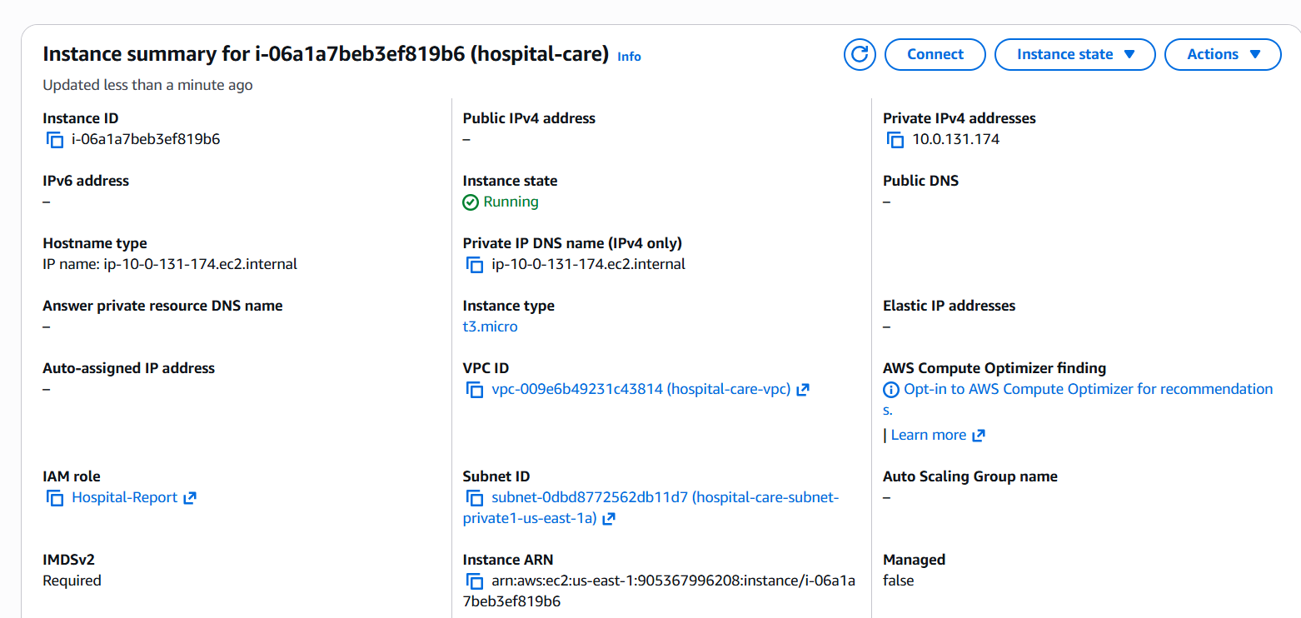
Figure 5. EC2 instance running in the private subnet.

Step 6 — Publish a test SNS message from EC2
From the EC2 shell, use the AWS CLI to publish a test message to the hospital-care SNS topic. The command shown uses the topic ARN and the us-east-1 region. AWS returns a MessageId, which confirms that the publish API request succeeded.
AWS CLI command used
aws sns publish \
--topic-arn arn:aws:sns:us-east-1:905367996208:hospital-care \
--message "testing the application - from EC2" \
--region us-east-1
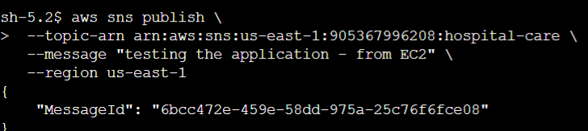
Figure 6. Successful AWS CLI SNS publish.

7. Verification and Expected Result
Use the following checklist after completing the configuration:
• VPC status: Available; CIDR 10.0.0.0/16.
• EC2 instance: Running; t3.micro; private IP 10.0.131.174; no public IPv4 address.
• IAM role: Hospital-Report attached to the EC2 instance.
• IAM permissions: AmazonSNSFullAccess and AmazonSSMManagedInstanceCore.
• VPC endpoints: all shown as Available.
• SNS topic: hospital-care; Standard topic.
• SNS subscription: Email subscription shown as Confirmed.
• SNS test: AWS CLI publish returned a MessageId successfully.
Expected notification flow
The EC2 instance runs in the private subnet.
The AWS CLI uses the EC2 instance role credentials.
The request reaches SNS through the SNS VPC interface endpoint.
SNS accepts the message and returns a MessageId.
SNS delivers the message to the confirmed email subscription.

8. Troubleshooting and Project Summary
Common troubleshooting
SNS publish fails with AccessDenied
Check that the EC2 instance is using the Hospital-Report role and that the role has the required SNS permission.
SNS publish times out from a private subnet
Check the SNS interface VPC endpoint, its security group, route/DNS settings, and that the endpoint is Available.
SSM cannot connect to the instance
Verify AmazonSSMManagedInstanceCore is attached and the SSM, SSM Messages, and EC2 Messages endpoints are available.
Email notification is not received
Check the SNS subscription status. If it is PendingConfirmation, confirm the subscription from the email.
AWS CLI cannot find the topic
Verify the topic ARN and region. The screenshots show the project using us-east-1.
Security notes
Keep the EC2 instance private when public access is not required. Prefer IAM roles over storing AWS access keys on the instance. Limit IAM permissions to only the actions required by the application when moving from a training project to production. Review VPC endpoint security groups and SNS topic access policies before production use.
Conclusion
The completed project demonstrates a practical AWS cloud architecture in which a private EC2 instance communicates with Amazon SNS through VPC endpoints. IAM provides identity and permissions, while SNS handles notification delivery. The successful CLI publish and returned MessageId provide the final verification of the end-to-end configuration.

