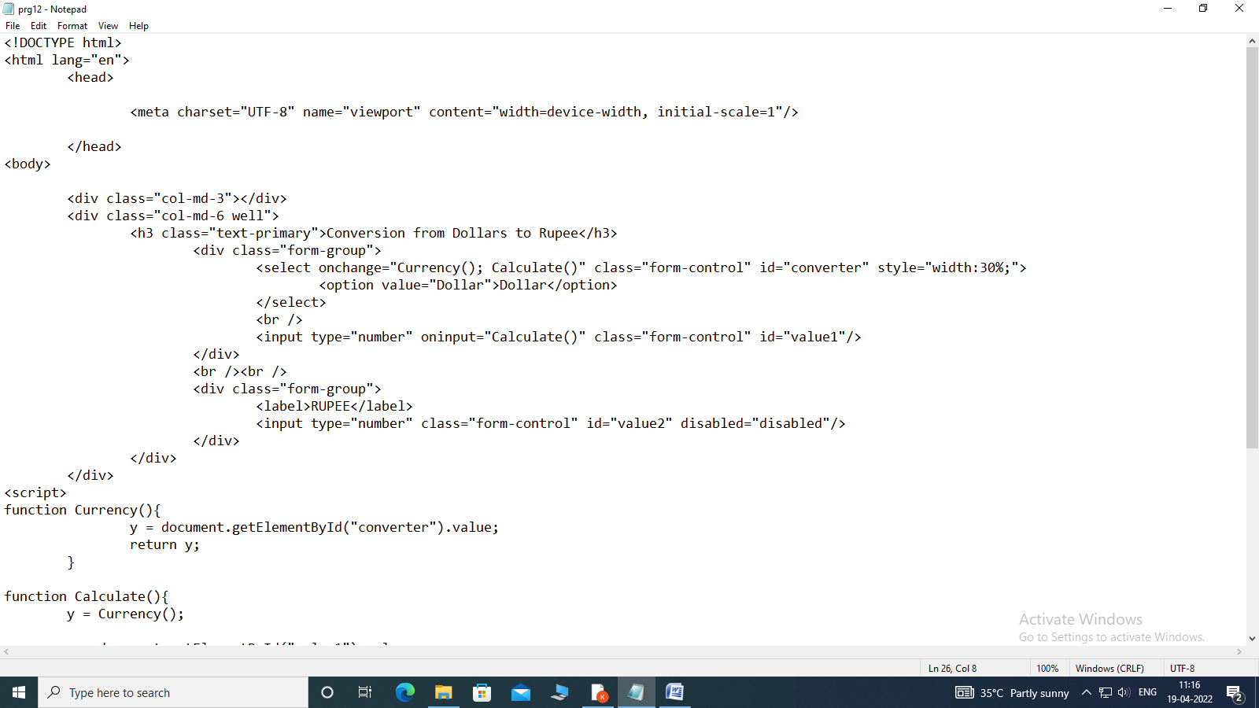

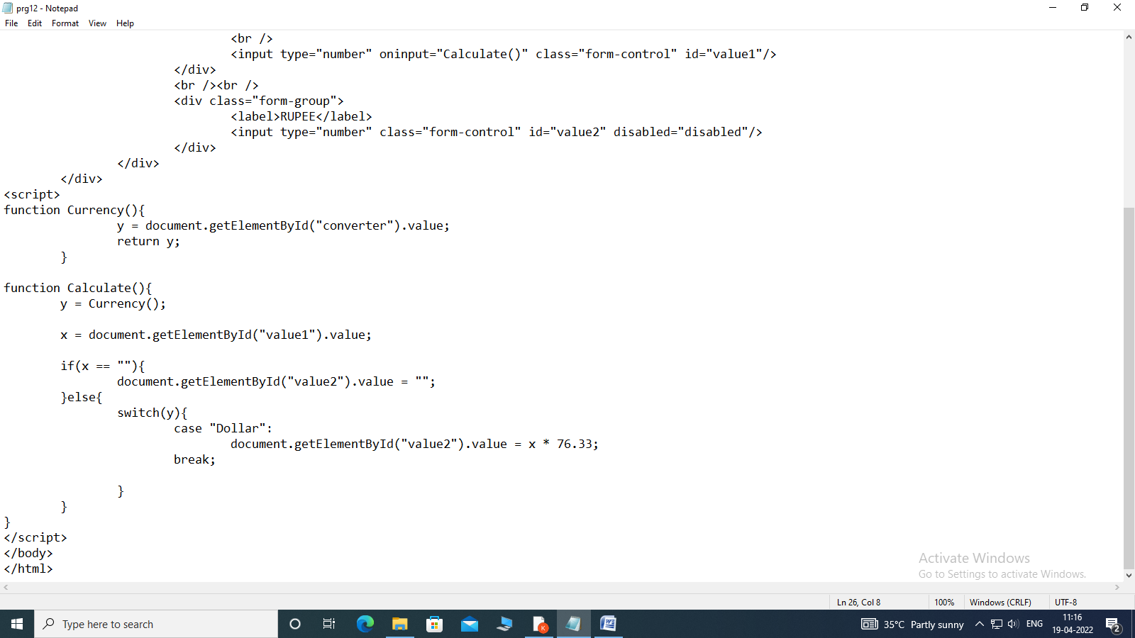

<!DOCTYPE html>

<html lang="en">

<head>

<meta charset="UTF-8" name="viewport" content="width=device-width, initial-scale=1"/>

</head>

<body>

<div class="col-md-3"></div>

<div class="col-md-6 well">

<h3 class="text-primary">Conversion from Dollars to Rupee</h3>

<div class="form-group">

<select onchange="Currency(); Calculate()" class="form-control" id="converter" style="width:30%;">

<option value="Dollar">Dollar</option>

</select>

<br />

<input type="number" oninput="Calculate()" class="form-control" id="value1"/>

</div>

<br /><br />

<div class="form-group">

<label>RUPEE</label>

<input type="number" class="form-control" id="value2" disabled="disabled"/>

</div>

</div>

</div>

<script>

function Currency(){

y = document.getElementById("converter").value;

return y;

}

function Calculate(){

y = Currency();

x = document.getElementById("value1").value;

if(x == ""){

document.getElementById("value2").value = "";

}else{

switch(y){

case "Dollar":

document.getElementById("value2").value = x \* 76.33;

break;

}

}

}

</script>

</body>

</html>