**Question 1:**

Suppose our input data to a map-reduce operation consists of integer values (the keys are not important). The map function takes an integer i and produces the list of pairs (p, i) such that p is a prime divisor of i. For example, map (12) = [(2,12), (3,12)]. The reduce function is addition. That is, reduce (p, [ i1, i2, ..., ik]) is (p, i1+i2+...+ik). Compute the output, if the input is the set of integers 15, 21, 24, 30, 49.

**Answer:**

The output of map function is

map (15) = [(3, 15), (5, 15)]

map (21) = [(3, 21), (7, 21)]

map (24) = [(2, 24), (3, 24)]

map (30) = [(2, 30), (3, 30), (5, 30)]

map (49) = [(7, 49)]

These are the respective prime divisors of inputs The output of reduce function is reduce (2, 54), reduce (3,90), reduce (5,45), reduce (7, 70).

**Question 2:**

Consider three Web pages with the following links:

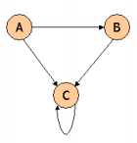

Suppose we compute PageRank with a β of 0.7, and we introduce the additional constraint that the sum of the Page Ranks of the three pages must be 3, to handle the problem that otherwise any multiple of a solution will also be a solution. Compute the Page Ranks a, b, and c of the three pages A, B, and C, respectively.

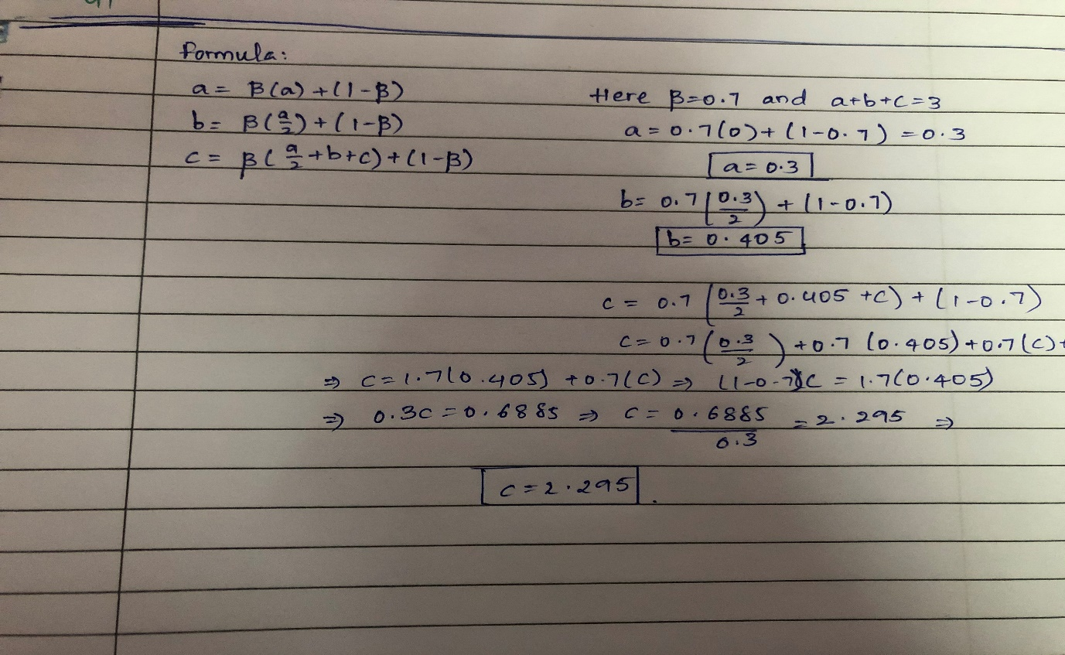

**Question 3:**

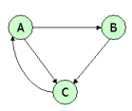

Suppose we compute PageRank with β=0.85. Write the equations for the Page Ranks a, b, and c of the three pages A, B, and C, respectively.

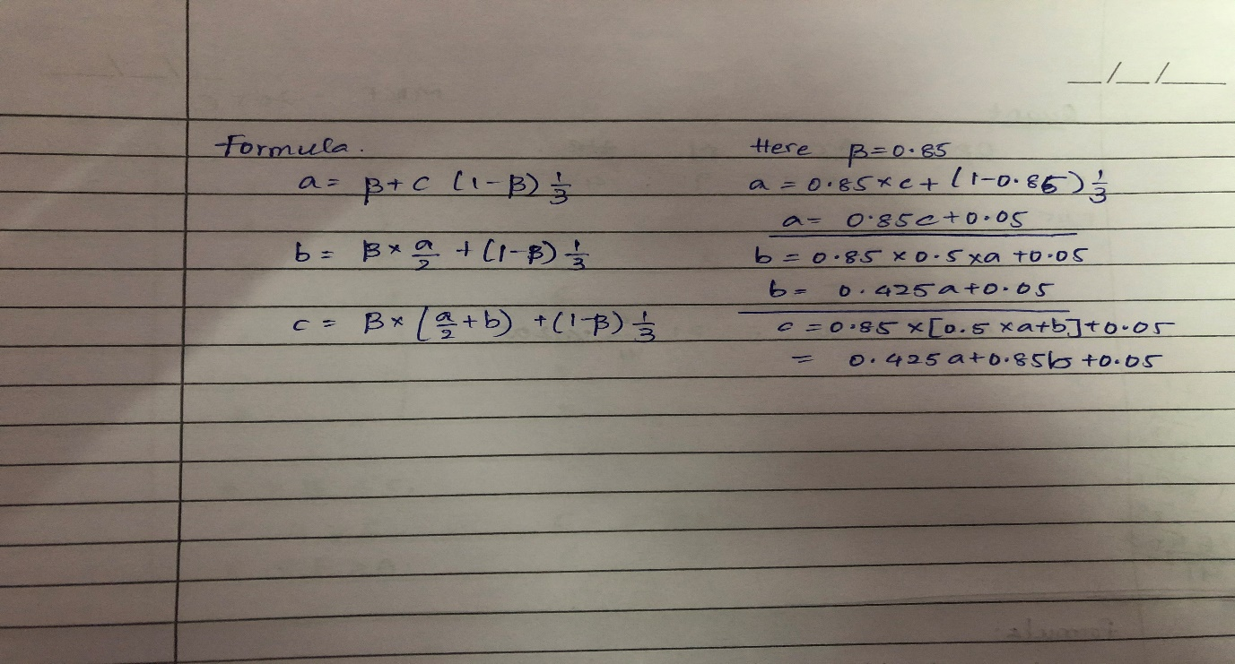

**Question 4:**

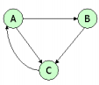

Assuming no "taxation," compute the Page Ranks a, b, and c of the three pages A, B, and C, using iteration, starting with the "0th" iteration where all three pages have ranked a = b = c = 1. Compute as far as the 5th iteration, and also determine what the Page Ranks are in the limit.

