**Question 1:**

Here is a matrix representing the signatures of seven columns, C1 through C7.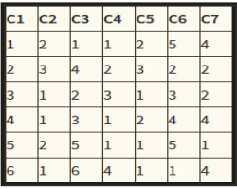

Suppose we use locality-sensitive hashing with three bands of two rows each. Assume there are enough buckets available that the hash function for each band can be the identity function (i.e., columns hash to the same bucket if and only if they are identical in the band). Find all the candidate pairs.

**Answer:**

The candidate pairs are:

In Band1 → C1 and C4, C2 and C5

In Band2 → C1 and C6

In Band3 → C4 and C7, C1 and C3

**Question 2:**

Suppose we have computed signatures for a number of columns, and each signature consists of 24 integers, arranged as a column of 24 rows. There are N pairs of signatures that are 50% similar (i.e., they agree in half of the rows). There are M pairs that are 20% similar, and all other pairs (an unknown number) are 0% similar. We can try to find 50%-similar pairs by using Locality-Sensitive Hashing (LSH), and we can do so by choosing bands of 1, 2, 3, 4, 6, 8, 12, or 24 rows. Calculate approximately, in terms of N and M, the number of false positive and the number of false negatives, for each choice for the number of rows. Then, suppose that we assign equal cost to false positives and false negatives (an atypical assumption). Which number of rows would you choose if M: N were in each of the following ratios: 1:1, 10:1, 100:1, and 1000:1?

**Answer:**

**If M: N = 1: 1, then the number of rows = 3**

**If M: N = 10: 1, then the number of rows = 2**

**If M: N = 100: 1, then the number of rows = 1**

**If M: N = 1000: 1, then the number of rows = 1**

**Question 3:**

Find the set of 2-shingles for the "document":

ABRACADABRA

and also, for the "document":

BRICABRAC

Answer:

Set of 2 shingles for ABRACADABRA is [(AB,2), (BR,2), (RA,2), (AC,1), (CA,1), (AD,1), (DA,1)]

Set of 2 shingles for BRICABRAC is [(BR,2), (RI,1), (IC,1), (CA,1), (AB,1), (RA,1), (AC,1)]

Answer the following questions:

1. How many 2-shingles does ABRACADABRA have? Seven (7)

2. How many 2-shingles does BRICABRAC have? Seven (7)

3. How many 2-shingles do they have in common? Five (5)

4. What is the Jaccard similarity between the two documents"?

**Jaccard similarity = sets intersection / sets union = 5/9.**

**Question 4:**

Consider the following matrix:

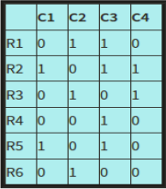

Compute the Jaccard similarity between each pair of columns.

**Answer:**

Jaccard similarity of C1 and C2 is SIM (C1, C2) = 0/5

Jaccard similarity of C2 and C3 is SIM (C2, C3) = 1/6

Jaccard similarity of C3 and C4 is SIM (C3, C4) = 1/5

Jaccard similarity of C4 and C1 is SIM (C4, C1) = 1/3

Jaccard Similarity of C1 and C3 is SIM (C1, C3) = 2/4

Jaccard Similarity of C2 and C4 is SIM (C2, C4) = 1/4

**Question 5:** Consider the following matrix:

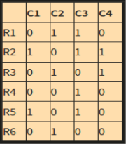

Perform a min hashing of the data, with the order of rows: R4, R6, R1, R3, R5, R2.

**Answer:**

|  |  |  |  |  |
| --- | --- | --- | --- | --- |
|  | **C1** | **C2** | **C3** | **C4** |
| **R4** |  |  | **R4** |  |
| **R6** |  | **R6** | **R4** |  |
| **R1** |  | **R6** | **R4** |  |
| **R3** |  | **R6** | **R4** | **R3** |
| **R5** | **R5** | **R6** | **R4** | **R3** |
| **R2** | **R5** | **R6** | **R4** | **R3** |