RELIEFBRIDGE

Week 1 — Evidence
Lead Intake, Assignment Routing & Duplicate Management — screenshot record of the working pipeline
1. Internal Assignment Notification
A high-value Lead (Government/Nonprofit, $100K+ range) is submitted via the Web-to-Lead form. The Assignment Rule routes it to the Senior_Coordinators queue, which receives this branded notification with the key details needed to act.
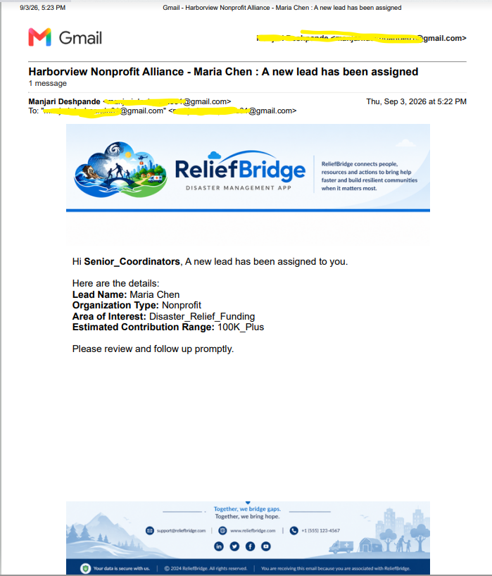
Branded internal notification sent to the Senior_Coordinators queue
2. Lead Record — Correct Routing Confirmed
Opening the Lead record confirms Owner = Senior_Coordinators, matching the assignment criteria.
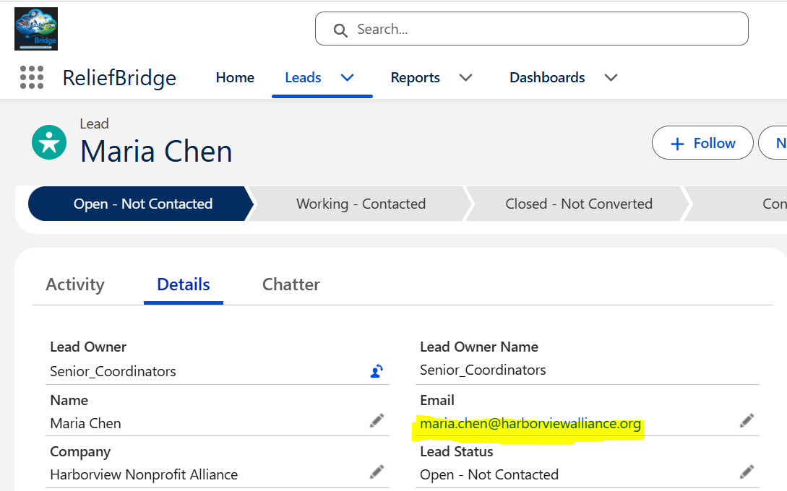
Maria Chen's Lead record showing correct queue ownership
3. External Auto-Response
Simultaneously, the prospect receives a branded confirmation that their inquiry was received.
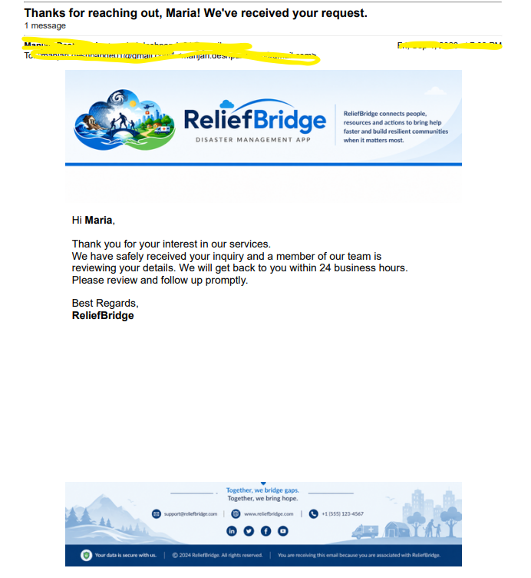
Branded auto-response confirmation sent to the prospect
4. Duplicate Submission Test
To test the Duplicate Rule, a second Lead was submitted using the same email address as Maria Chen's original Lead, but with a different name and company.
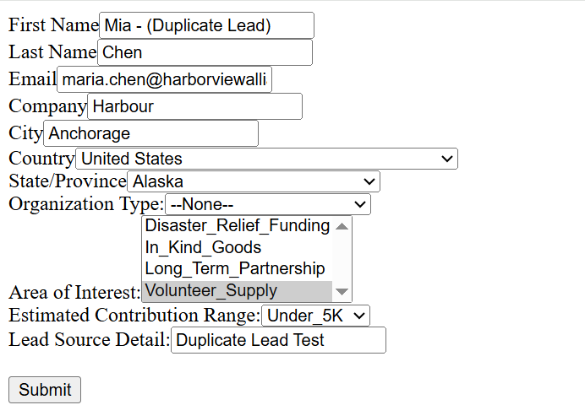
Web-to-Lead form submitted with a matching email address
5. Duplicate Lead — Created, Not Blocked
Consistent with the Allow + Report configuration, the duplicate submission still creates a Lead record rather than failing silently. It's independently routed to General_Partnership_Pool based on its own (lower) contribution range.
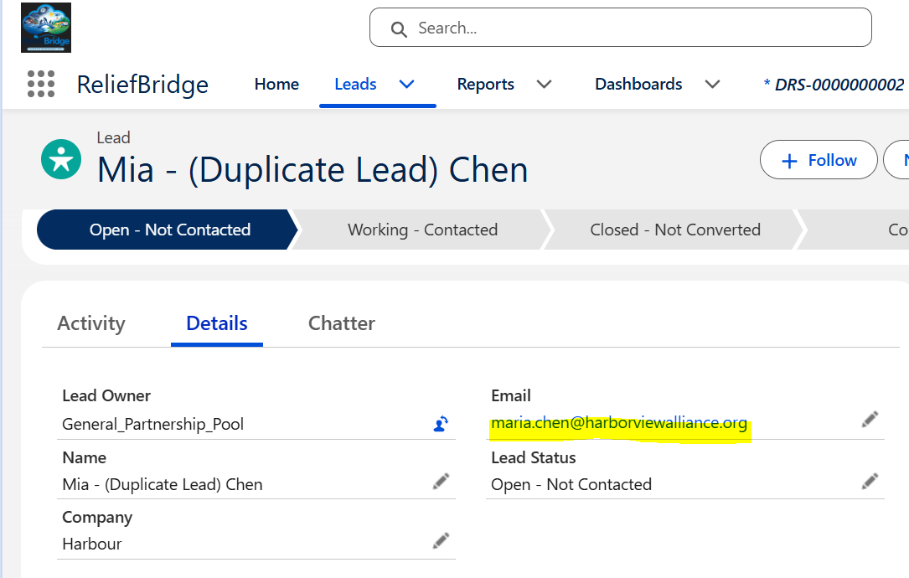
Duplicate Lead record — created successfully, routed independently
6. Duplicate Flagged for Review
Salesforce's Automated Process detects the match and generates a Duplicate Record Set and Duplicate Record Item, surfacing it for manual review/merge rather than silently dropping or silently duplicating the record.
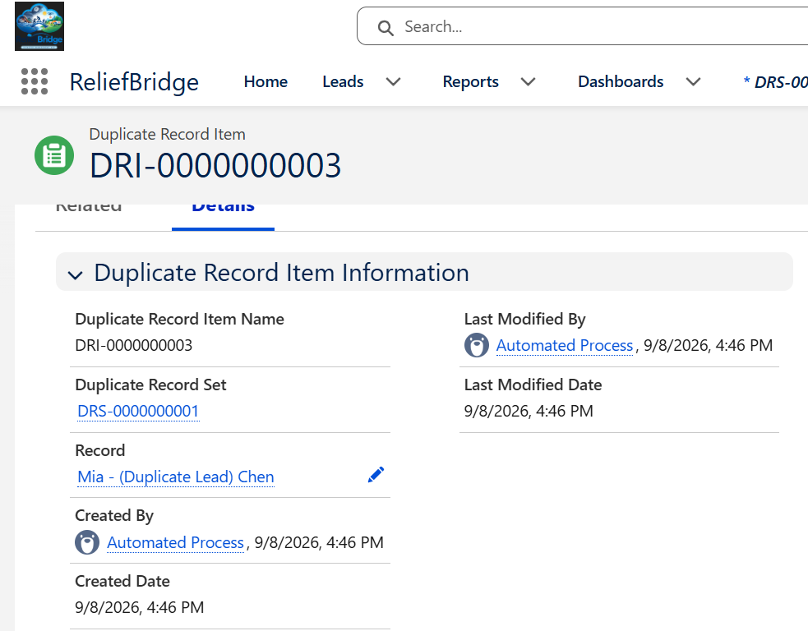
Duplicate Record Item auto-generated by Salesforce's Automated Process
Part of the ReliefBridge Salesforce portfolio project — Week 1 documentation.

