ANSIBLE

.Ansible server is being used to receive the bulit and complied source code and successfully deploy it on the web server for the end users to intercept.
.Ansuible server was configured using the similar instance creation as in the case of jenkins(AMI(AMAZON MACHINE IMAGE) of RedHat Enterprise Linux) which was configured by installing Ansible on it.
.For installing ansible the following command was used:
.’amazon-linux-extras install ansible2 ‘ command was used for preparing the ansible server.

.A playbook was created in the ansible server with the name playbook.yml file which stored the file to be sent to the web server.

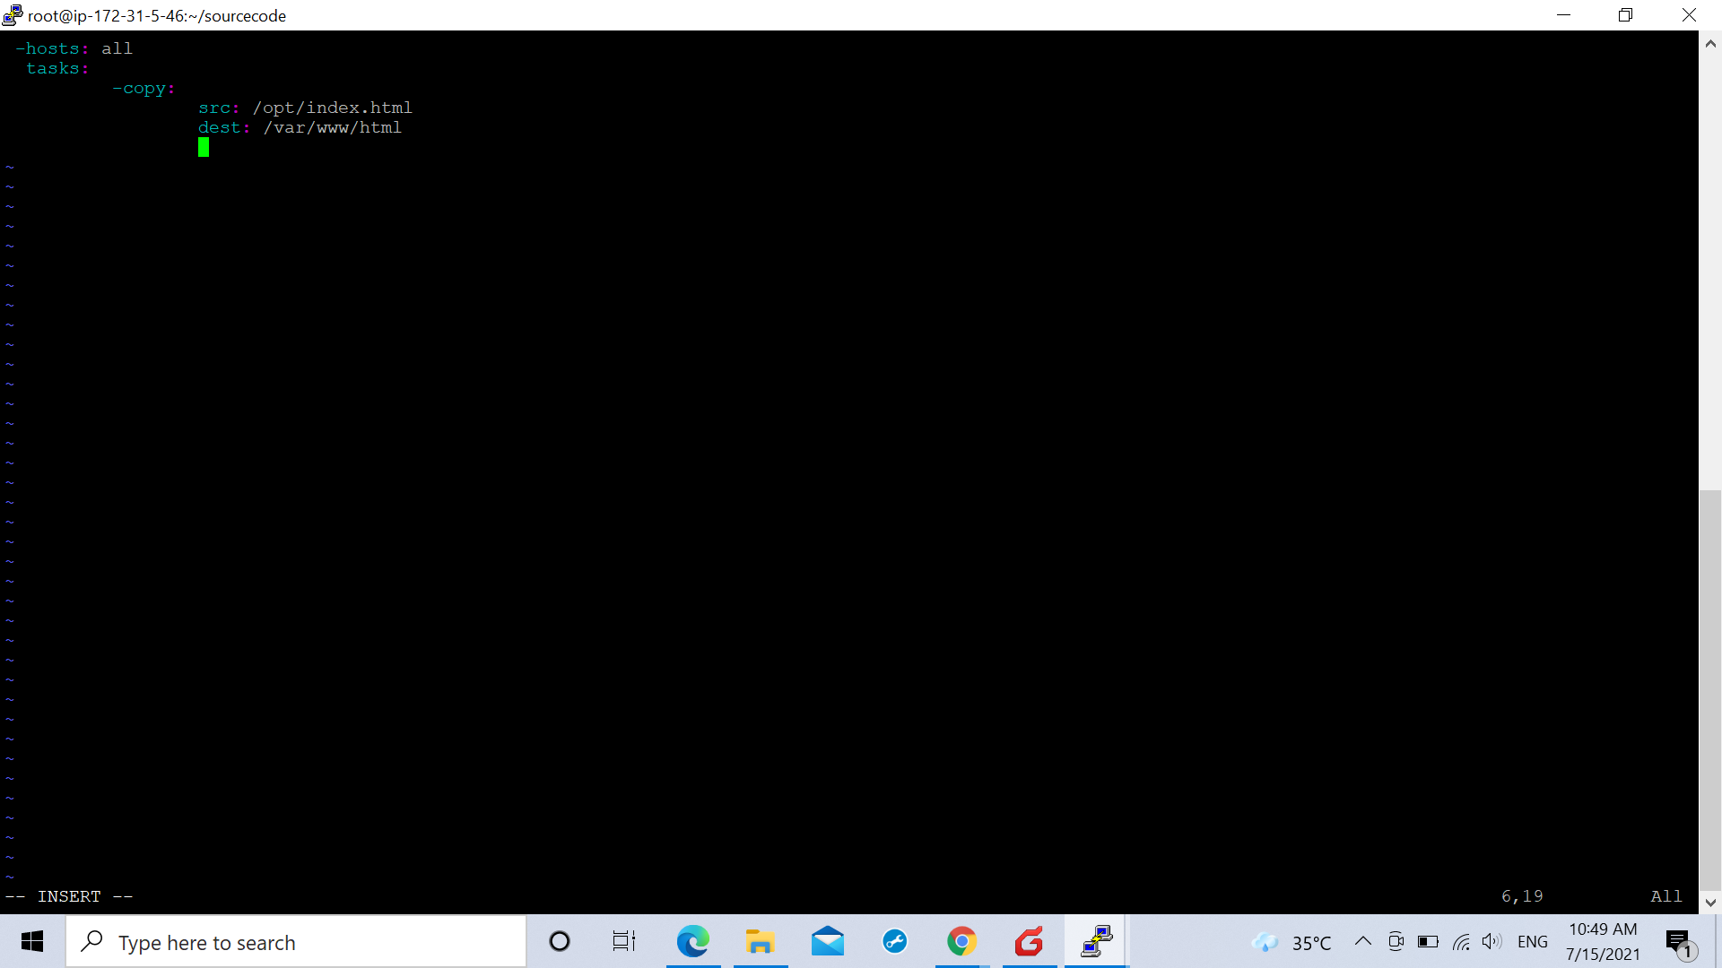

.The web server was entered in an inventory file on the web server using the command:
. ‘vim/etc/ansible/hosts’.
A group named [web] was created and the private ip of our web server was listed .

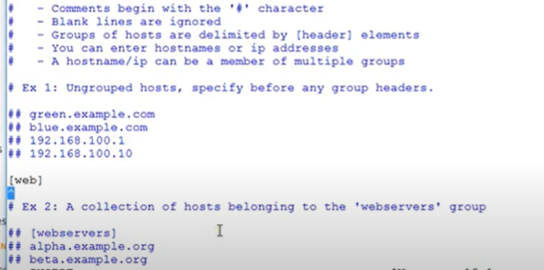
Similarly many such ip’s could be listed there in the group of trusted server ip’s.

.In the similar manner as was in the jenkins and ansible server communication mode, the communication mode between the ansible server and the web server was also made password less by generating a key to be shared with the ansible server, setting up the root password on the web server and adding the ip of the ansible server as a known ip to the web server, thus making the connection password-less between the ansible and the web server.
.The source code file that the ansible server will receive from the jenkins server will be deployed on the web server.

