JENKINS

. Our jenkins server will be setup through an Amazon Web Service (AWS) EC2 Instance AMI(AMAZON MACHINE IMAGE) of RedHat Enterprise Linux.
on which all the basic and patch files of jenkins was installed through (sudo yum install jenkins)command using our putty application to configure settings of our Jenkins server.

.For this initially java was installed on this server (using yum install java) command followed by the following commands to successfully install jenkins on the server .

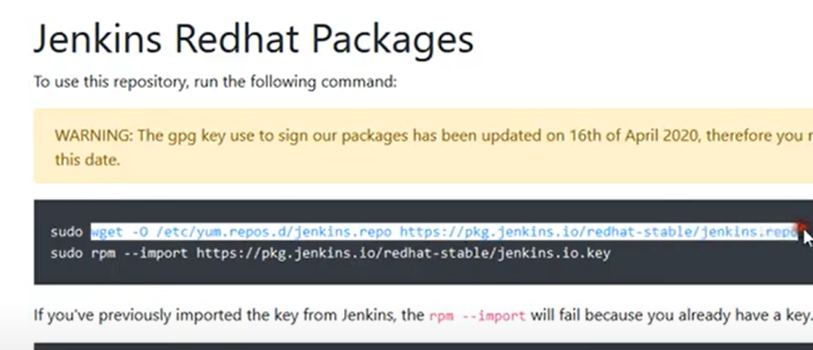

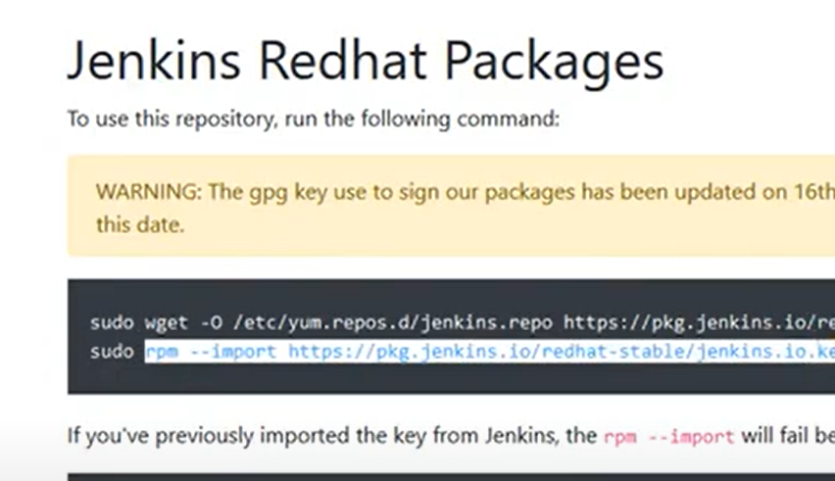
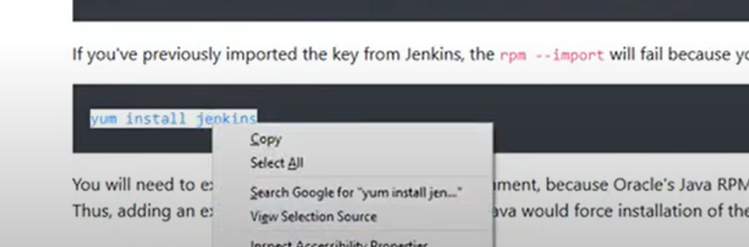
And then enabling and starting jenkins on this server using the commands
.systemctl enable jenkins
.systemctl start jenkins

Followed by accessing the jenkins browser by going on the following url {(public ip):(port number)} in the url box. Follwed by creating an account/signing up on it.
Thus, this prepared our jenkins server.

.By opening and logging into the jenkins through the public ip address of this machine as the url with port number 8080 where our Pipeline project was created.

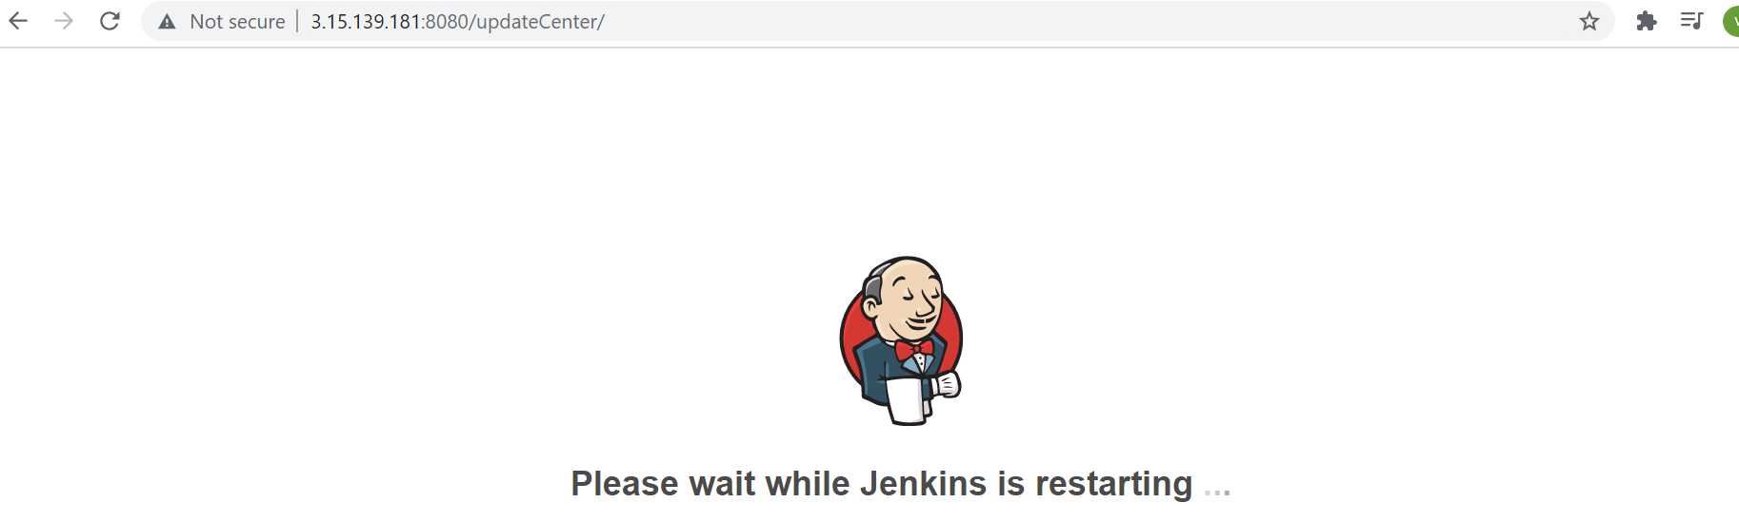
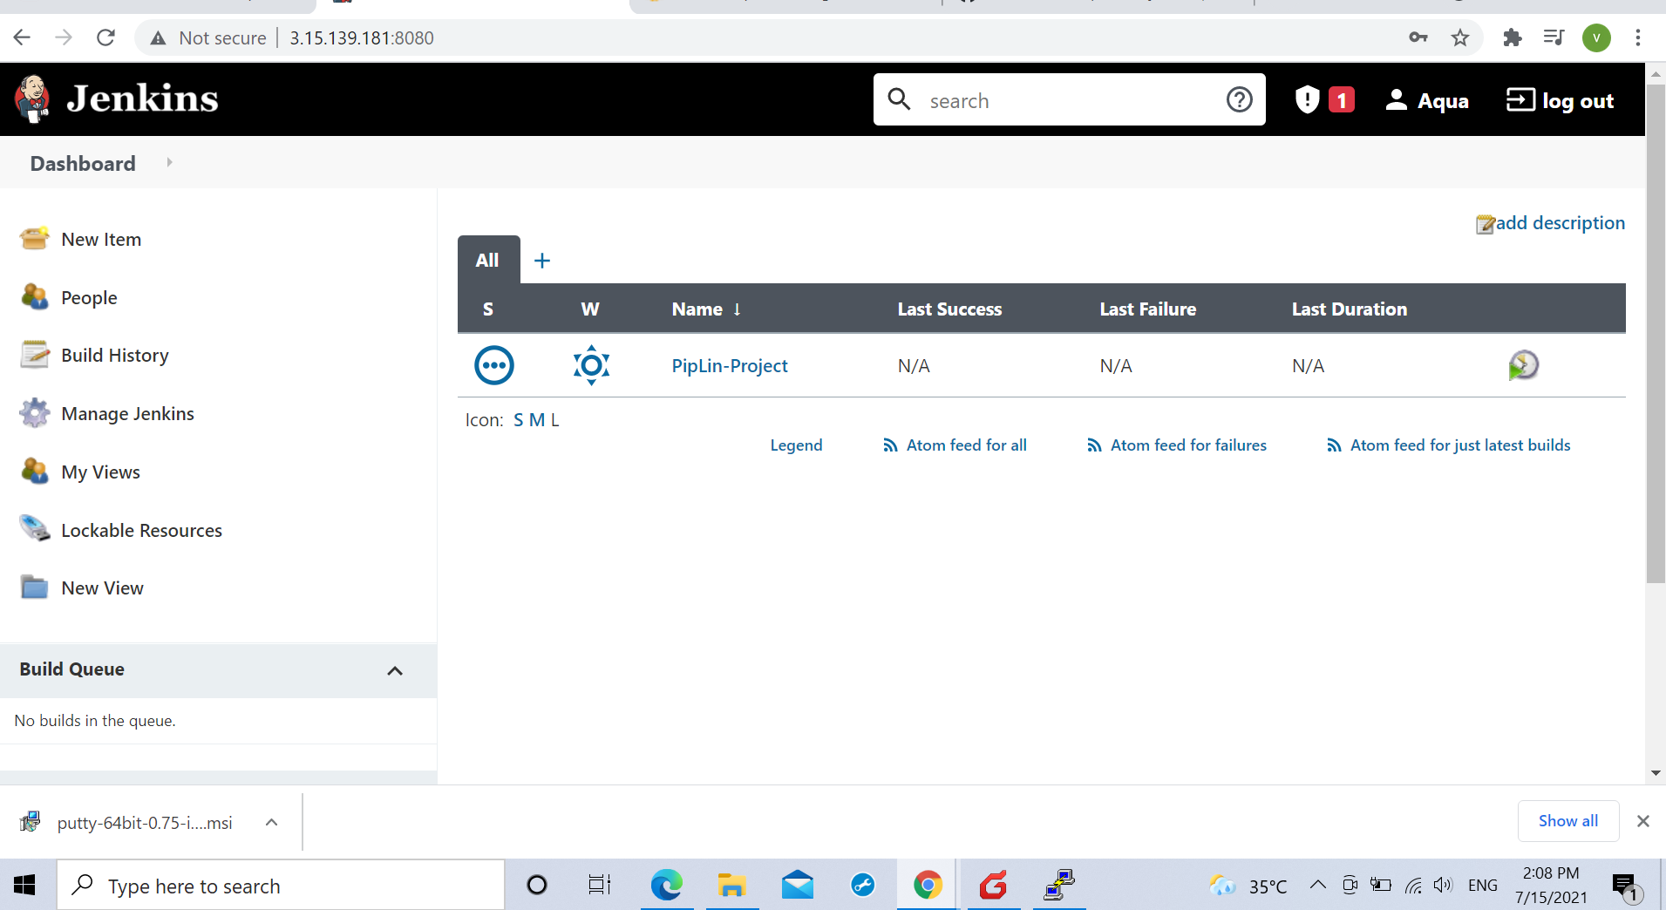

.For the complete and successful deployment of the job on the web server this stage is instrumental for successful building of the source code and then pushing the result on the playbook.yml file on the Ansible server which inturn gets pushed on the web server for the end user to receive.

.A password less communication mode was created with the ansible server through keygen command which was shared with the ansible server and by visiting the (sshd_config) settings
on the ansible server after generating root id password and enabling the PermitRootLogin and password authentication.

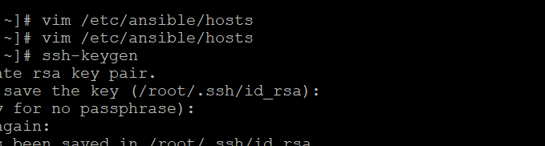
.
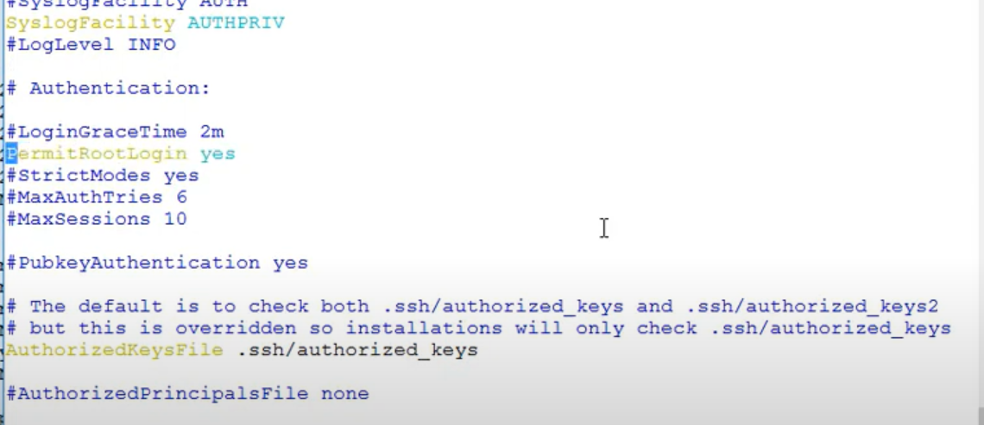
.Followed by a Restart.

.Following the above step it becomes the first time password setting post which it will always connect to the ansible server without a password requirement with ssh root@172.31.7.110(Private I.P of our jenkins instance) command.

.The source code created by the developer is sent to the github server. Hence to receive it on the jenkins a webhook was created to hook jenkins and github servers by generating a passkey for the same.

