WEB SERVER
. This is final stage of our pipeline where the final deployment takes place for the end users to intercept.
.The web server will receive the built source code file form the ansible server in its apt file and will deploy .

.Our web server was prepared on an AWS EC2 instance (Amazon Machine Image AMI Red hat Linux) where apache was intsalled using the following command.
.yum install httpd.
And enabling/starting the same service on the server.
.systemctl enable hhtd.
.systemctl start httpd.
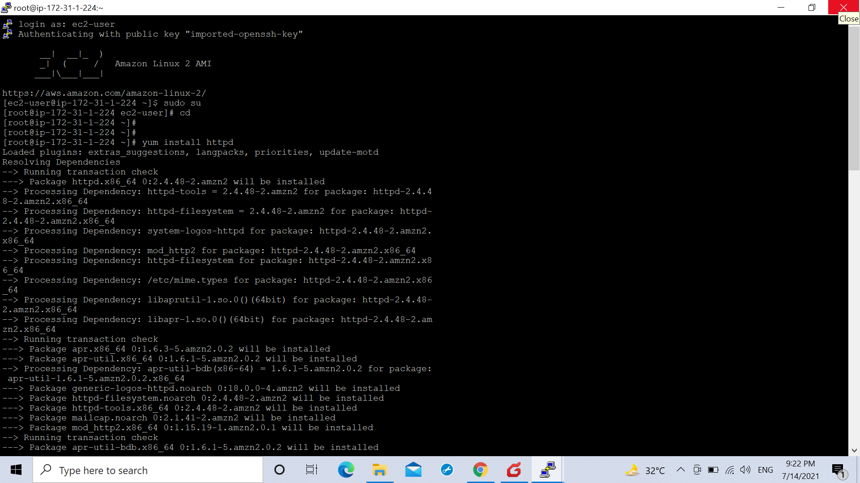
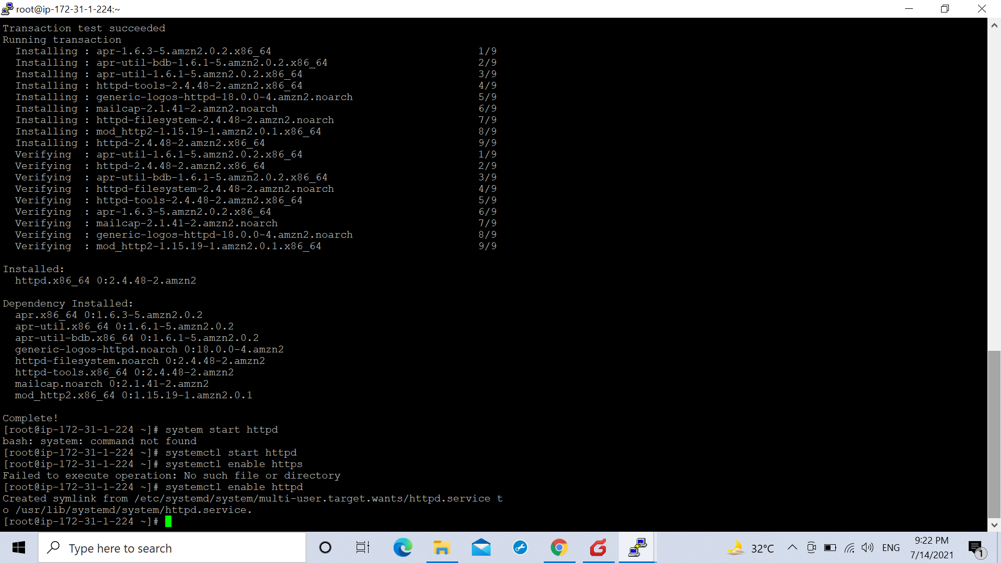
.After the above the communication mode between the ansible server and the web server was made password less by generating a key on asnible server using the command :
.ssh-keygen
And sharing the same with the web server using the command:
.ssh-copy-id root@(private ip of web server).Thus making the communication mode password less.
Where the private ip of the web server was entered .
.For this root login was enabled on the web server by using the following commands and steps:
.’passwd root’-For setting root password.
.’vim/etc/ssh/sshd_config’-For accessing the configuration file of ssh and enabling the PermitRootLogin option and Password Authentication.

.The server finally received a code to be deployed on it from the playbook.yml file from the ansible server which was projected on the web server for the end users to intercept.

