**ITC 6460 CLOUD ANALYTICS LAB - 1**

**Faculty: Prof. Sergiy Shevchenko**

**Module 1: LAB 3**

**Date: 2nd February 2021**

**Submitted by:**

Mohit Manjaria

Crawler Added

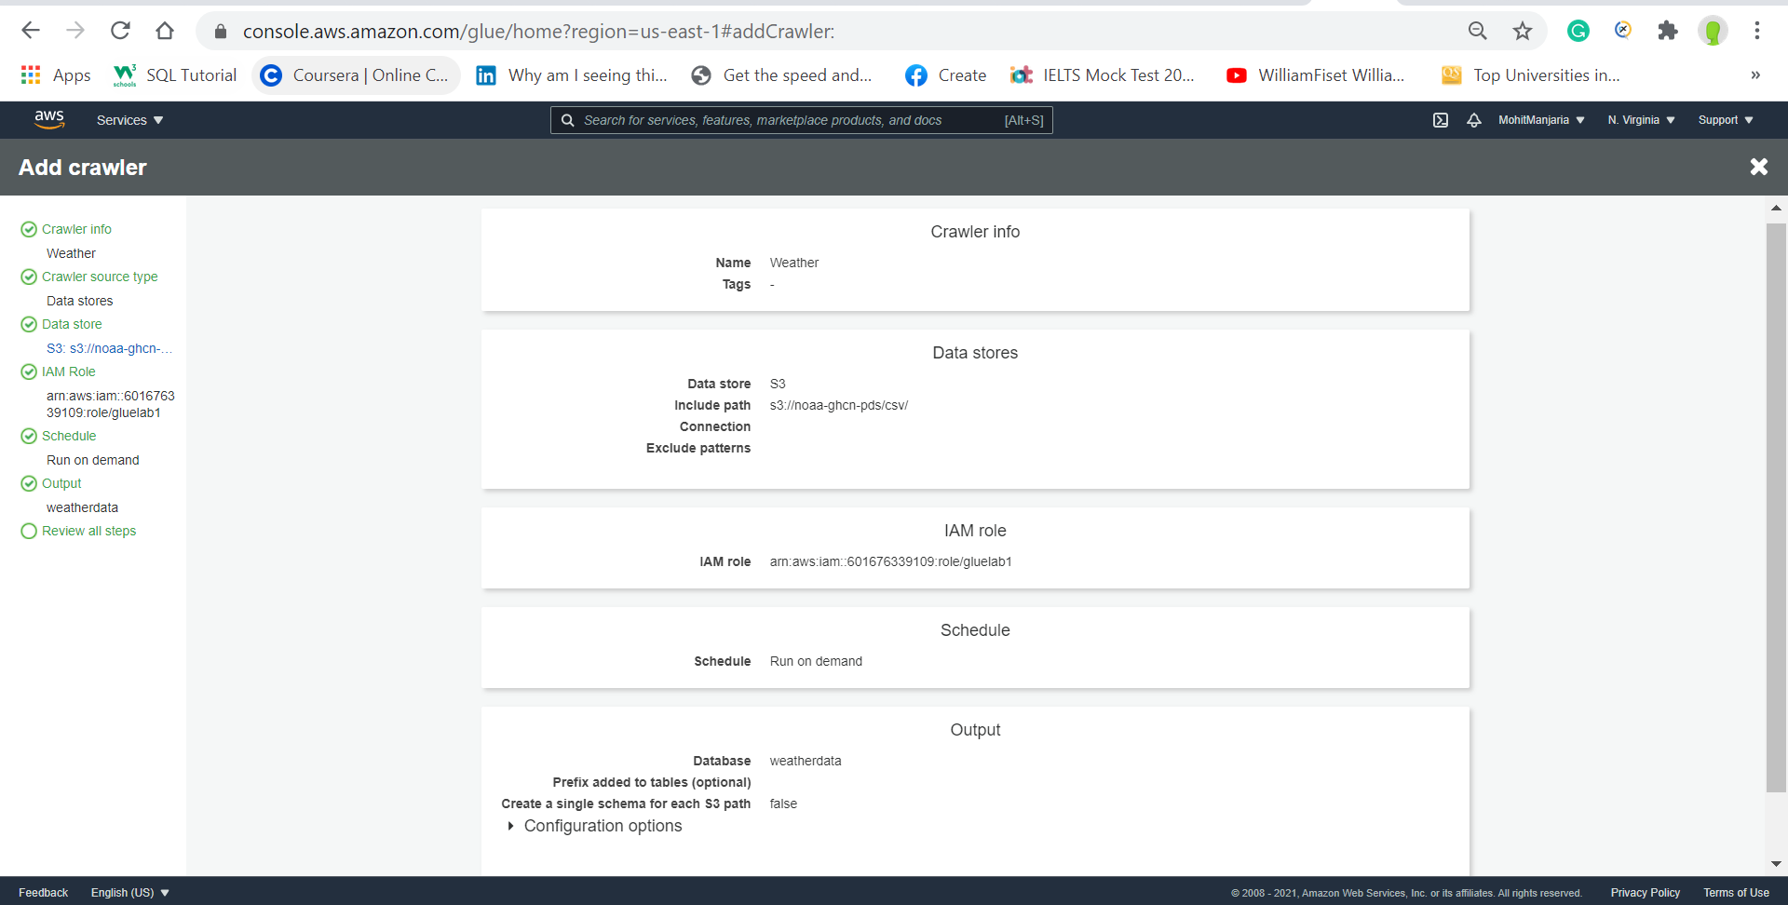

Crawlers:

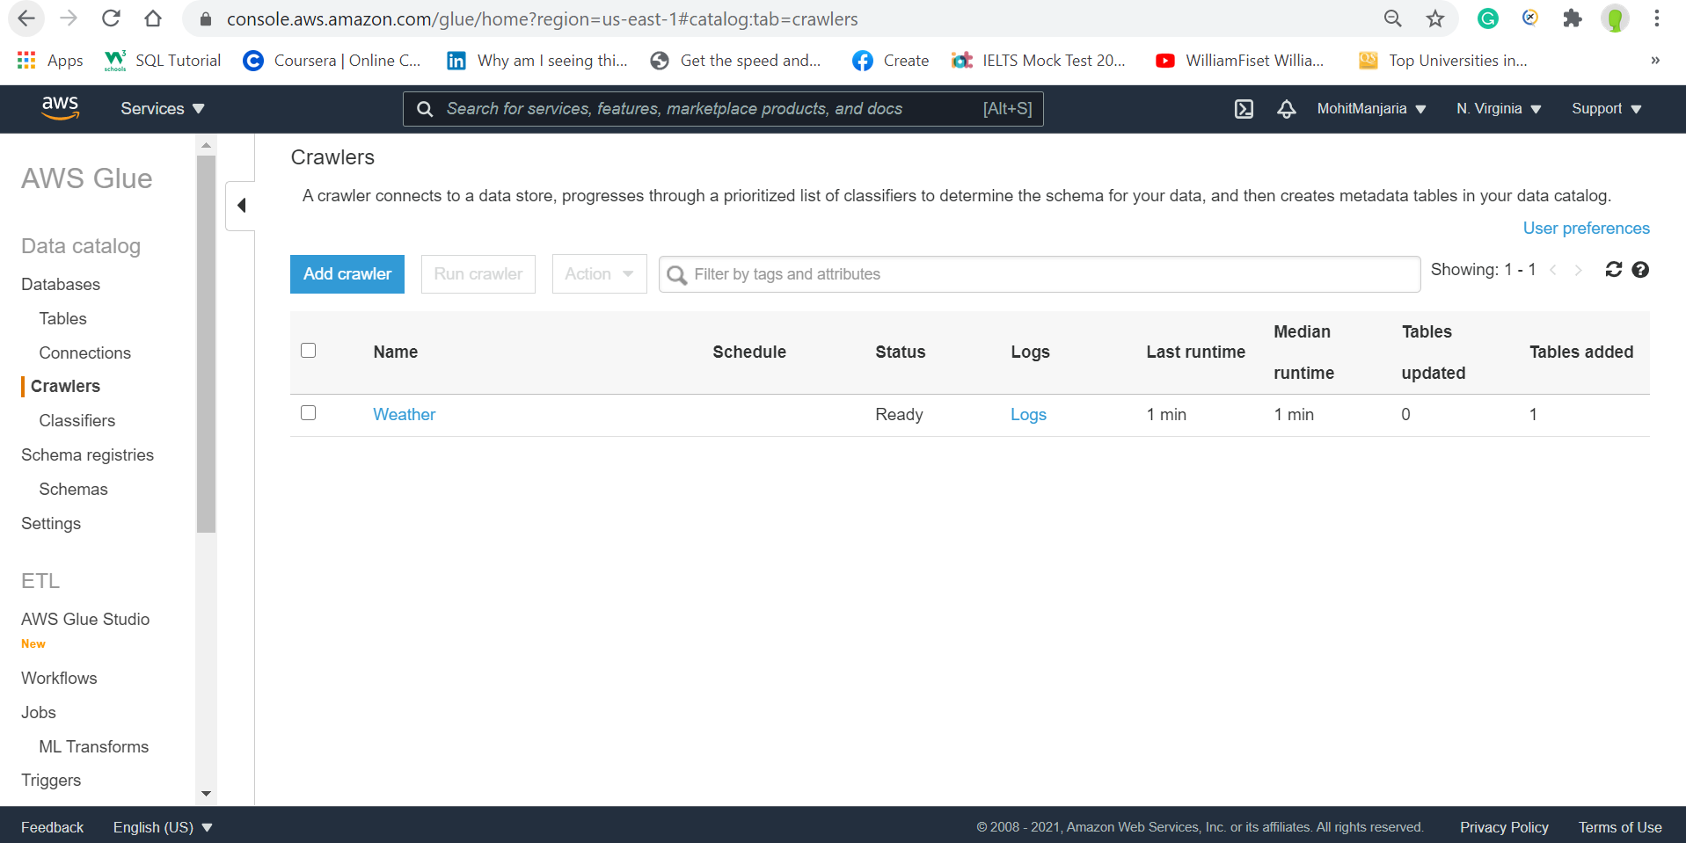

Tables Created:

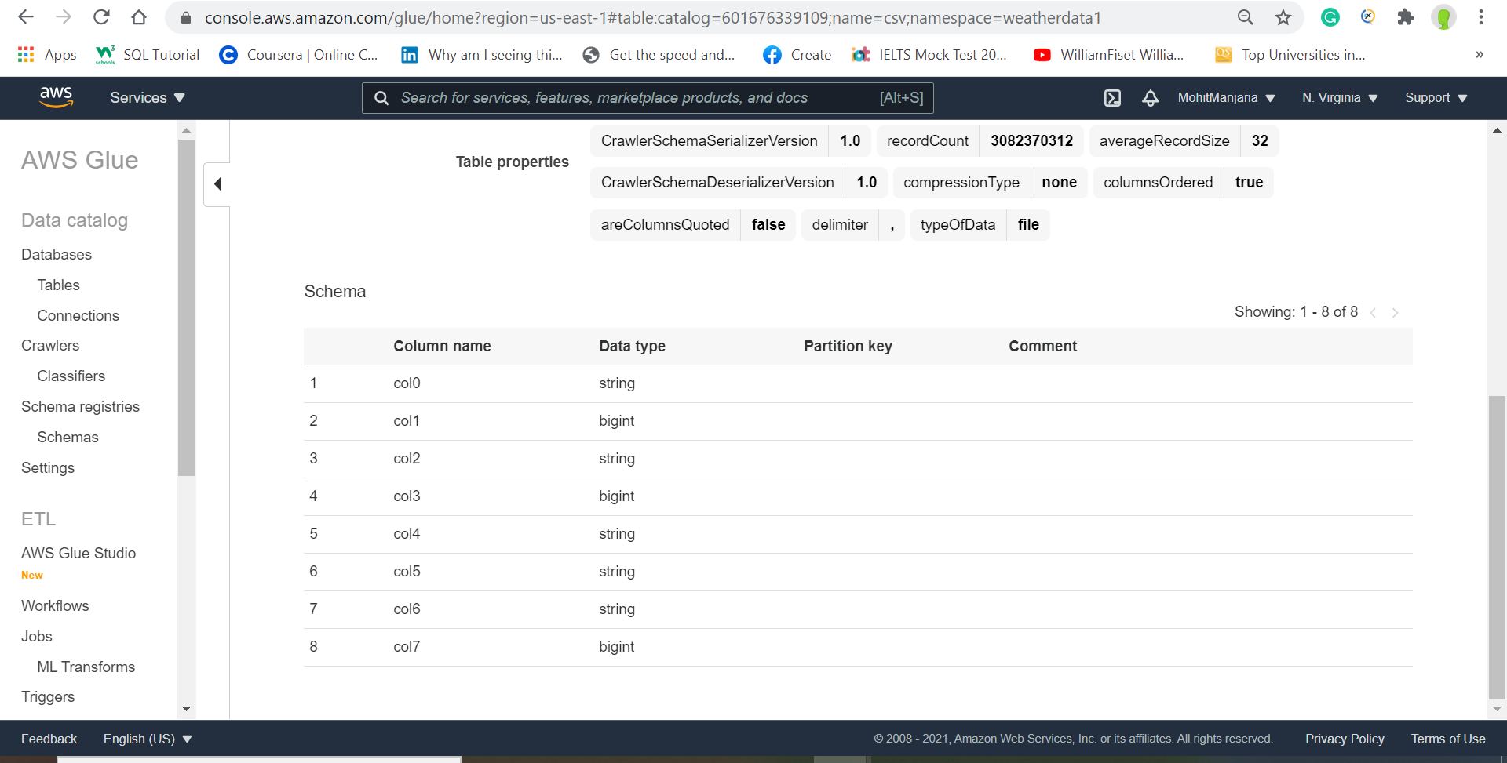

Athena query opens up:

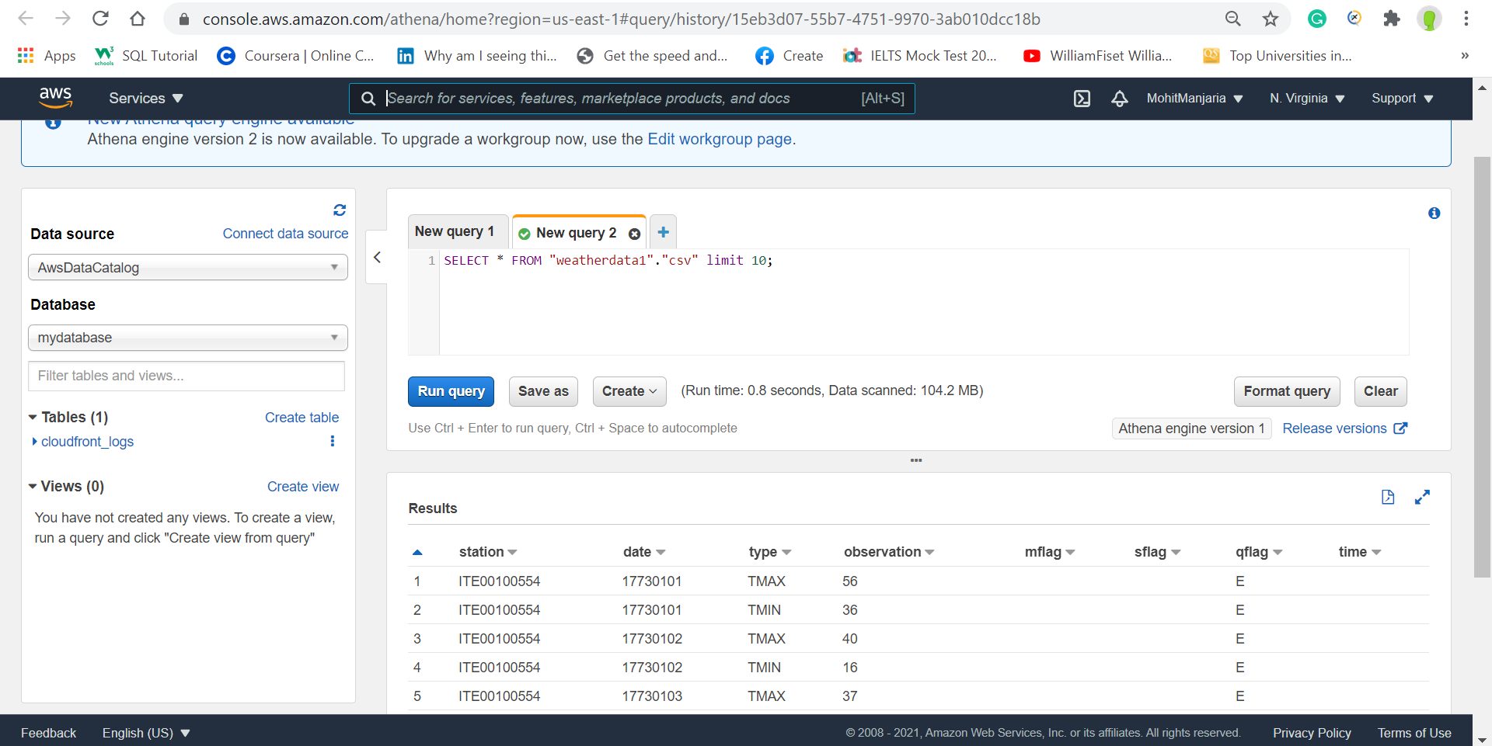

Bucket ARN: arn:aws:s3:::awsmohitcloudhww1

Ran a ATHENA SQL query for first 10 rows from the table

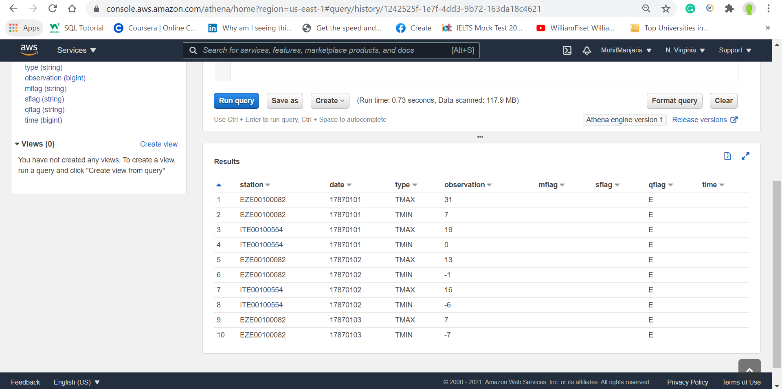

Apache Parquet

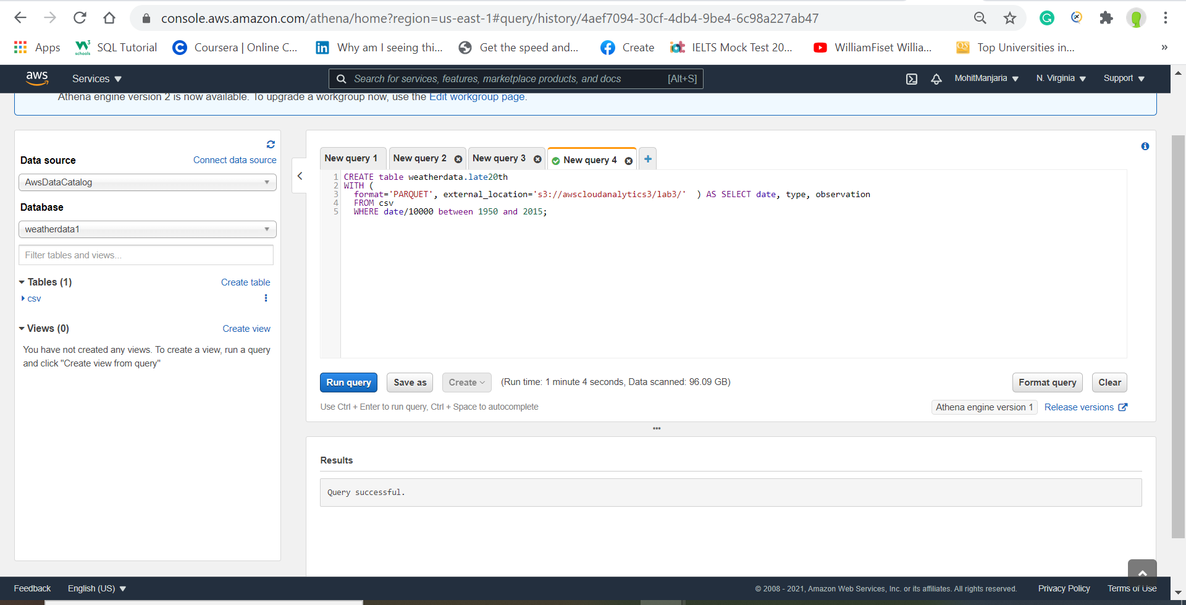

Run a query

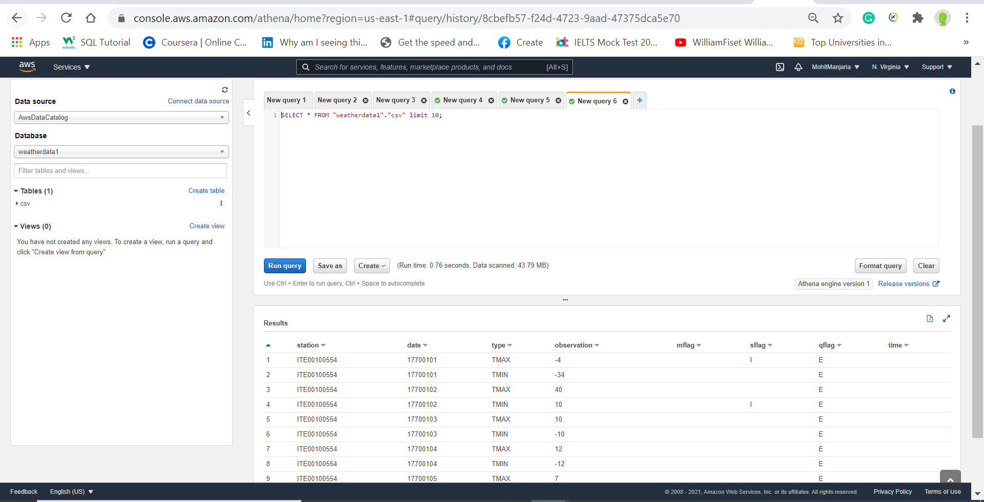

Late20th Table

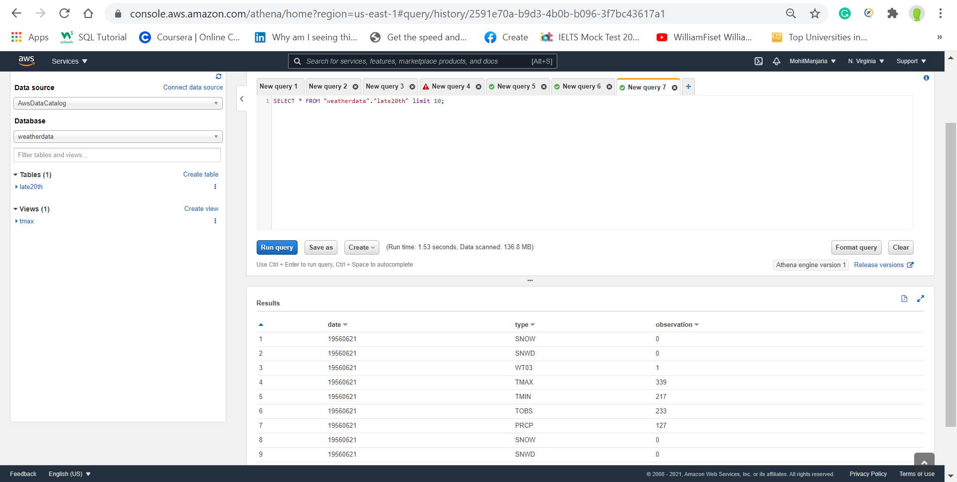

Tmax View

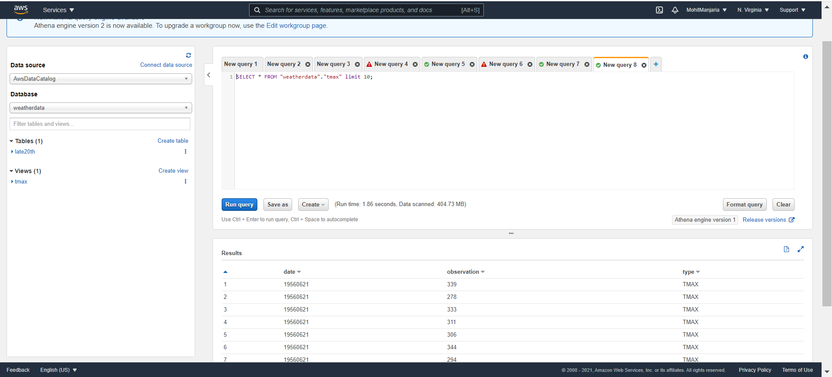

Query data from 1950 to 2018

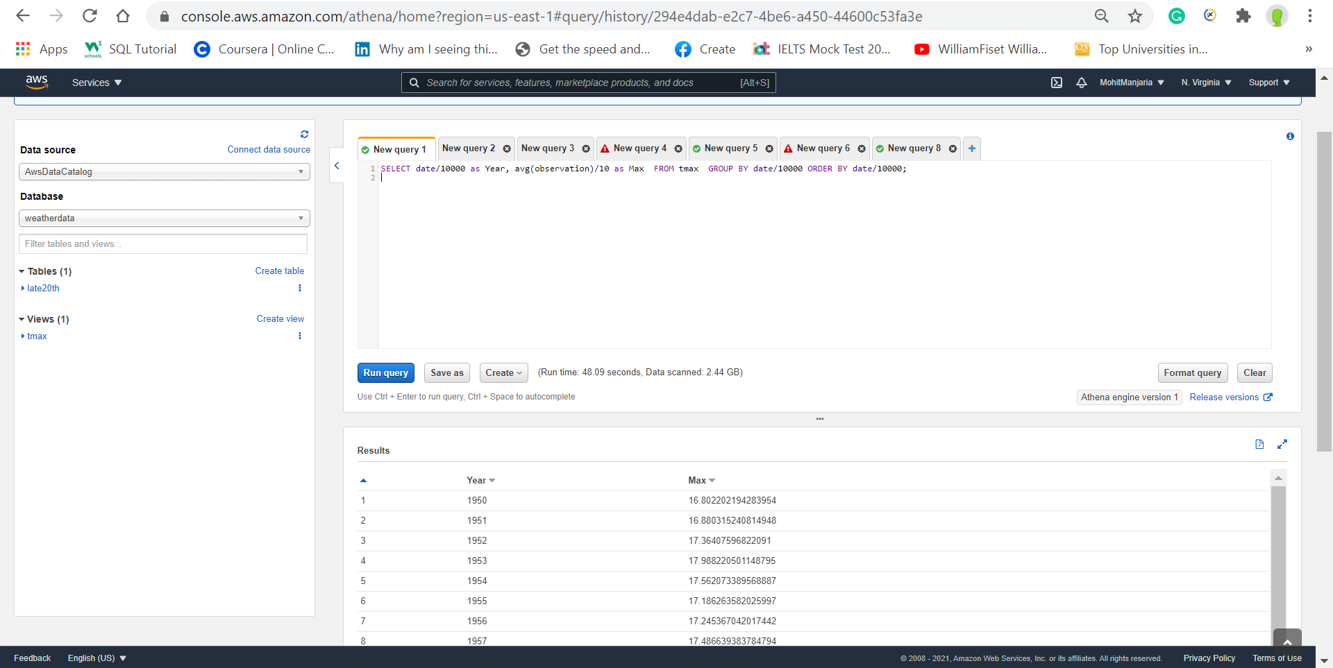

Challenge Question

