**ITC 6460 CLOUD ANALYTICS LAB - 5**

**Faculty: Prof. Sergiy Shevchenko**

**Module 3: LAB 5**

**Date: 7th February 2021**

**Submitted by:**

Mohit Manjaria

**SageMaker Notebook**

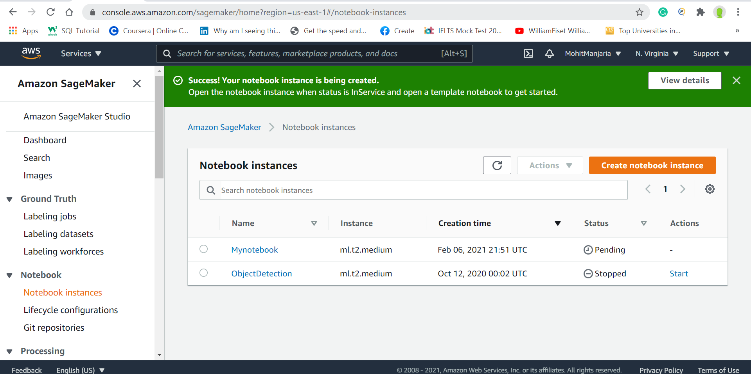

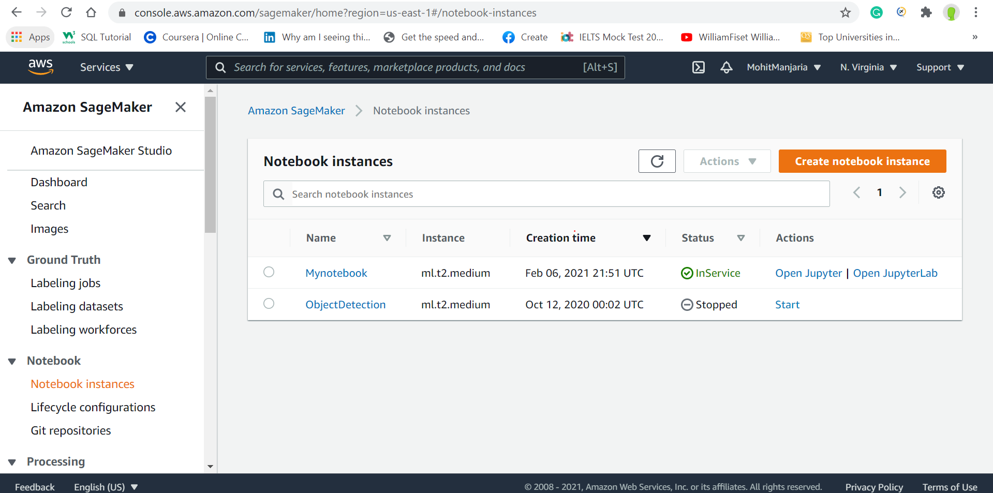

**Jupyter Lab**

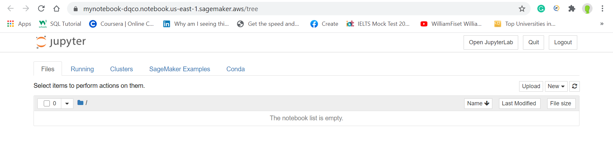

**Create Line graph**

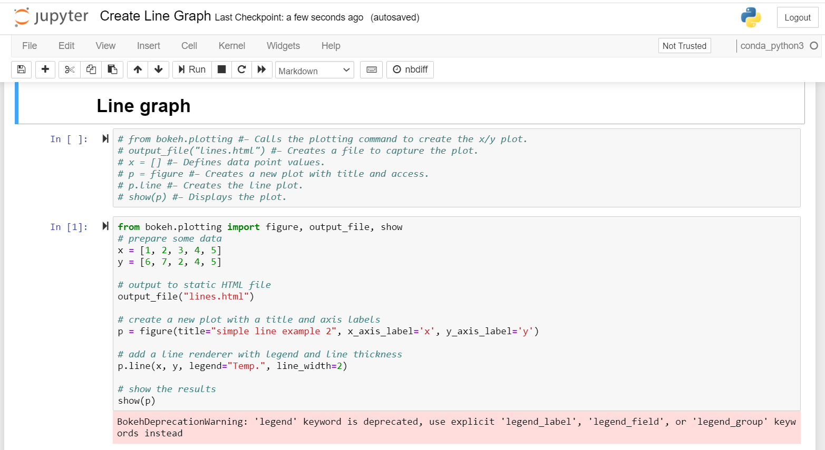

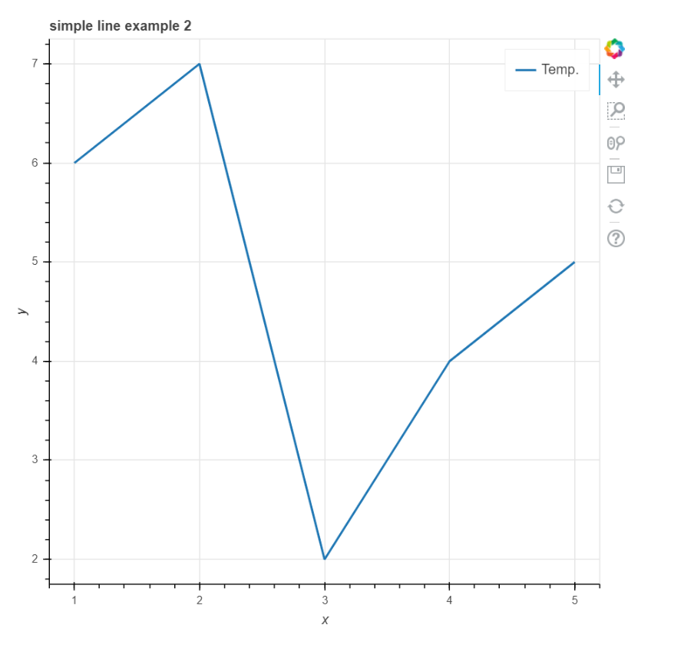

**BAR CHART**

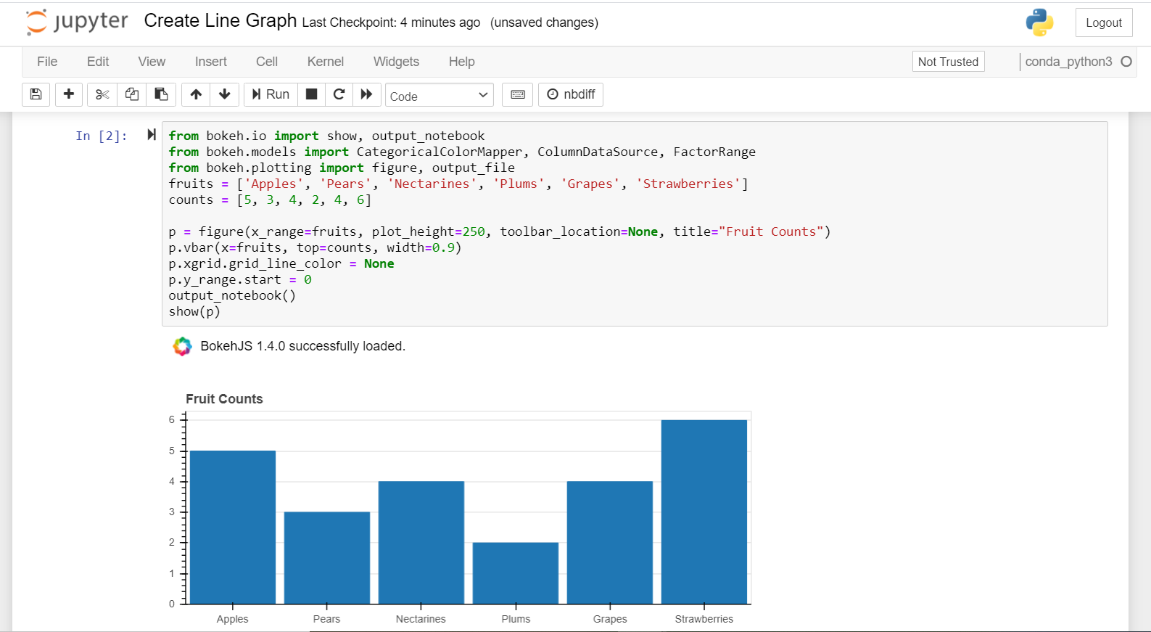

**Grouped Bar Chart**

