**ITC 6460 CLOUD ANALYTICS LAB - 1**

**Faculty: Prof. Sergiy Shevchenko**

**Module 4: LAB 7**

**Date: 16th February 2021**

**Submitted by:**

Mohit Manjaria

Elastic IP Address

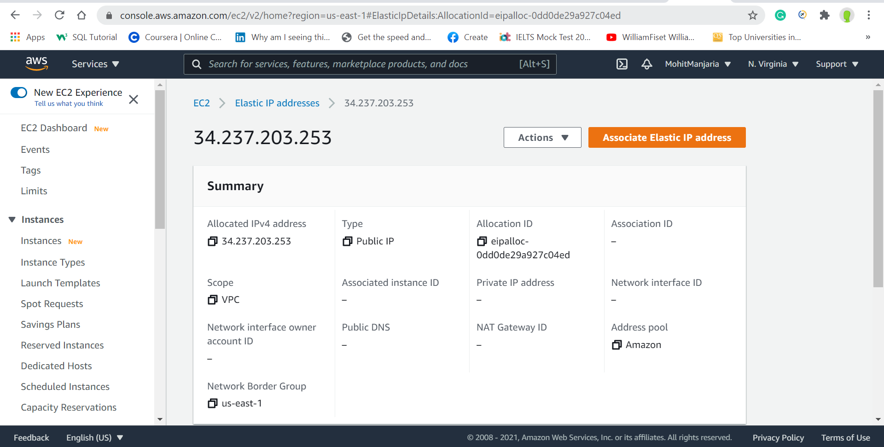

Created Ec2

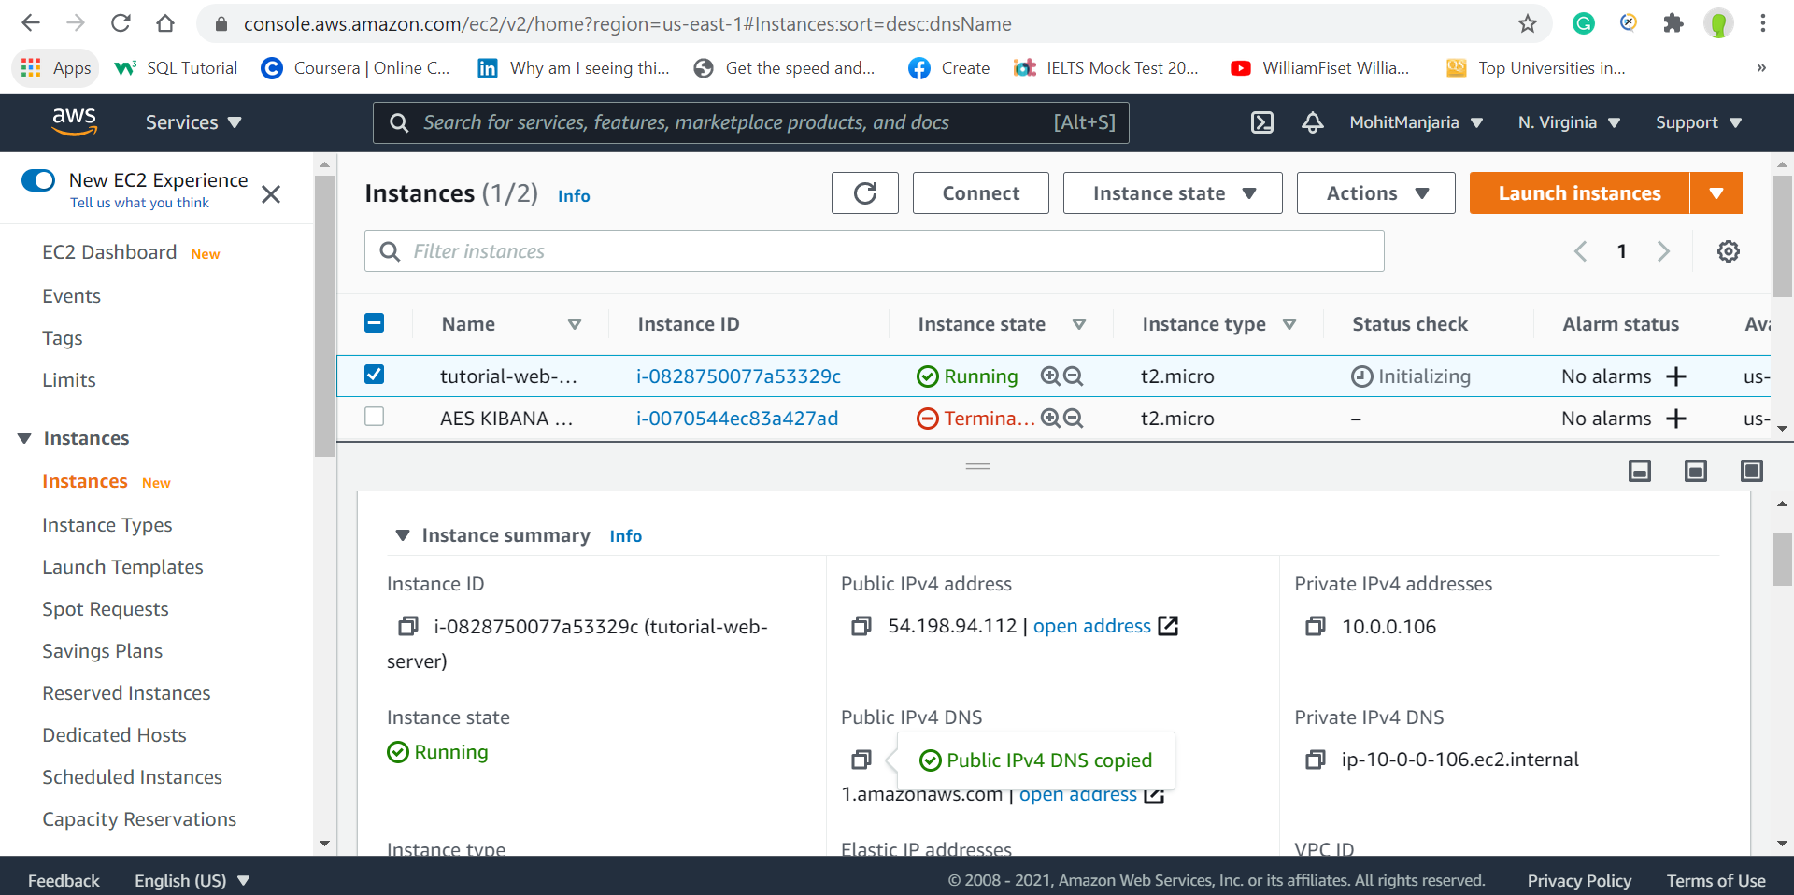

Connected to Linux using Putty

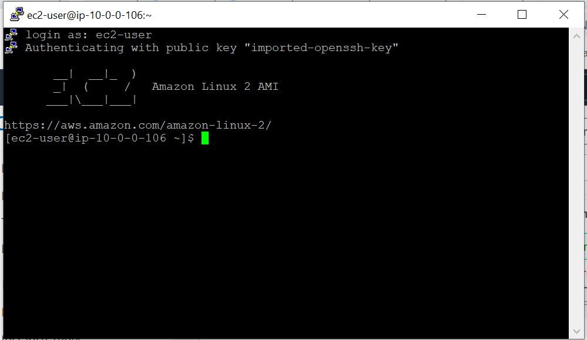

Php Installed

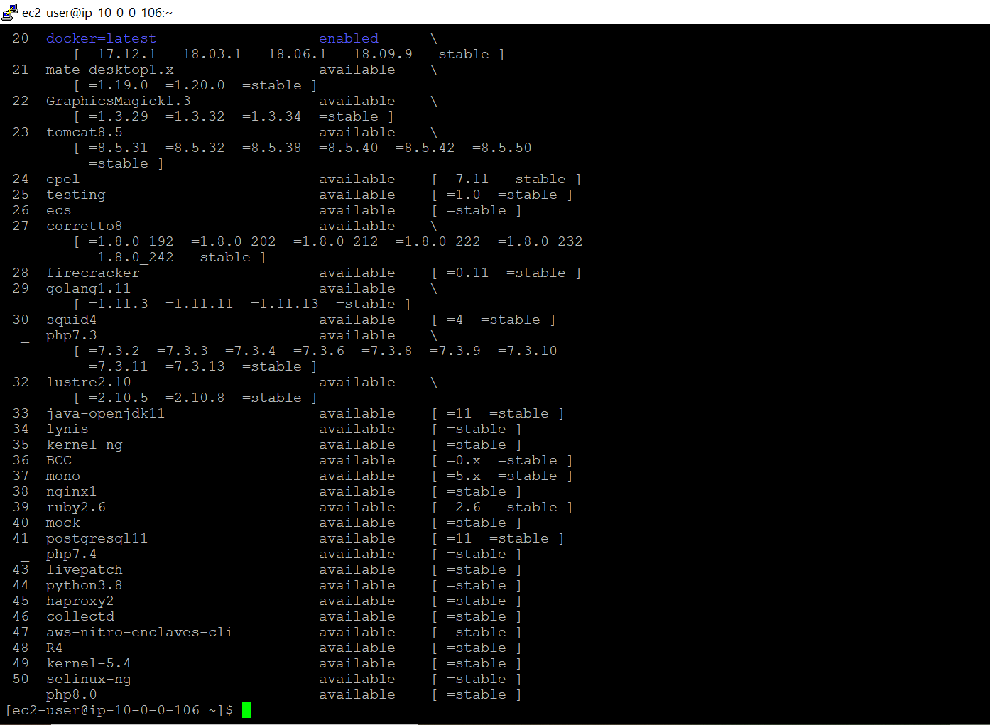

Installed Apache Web server

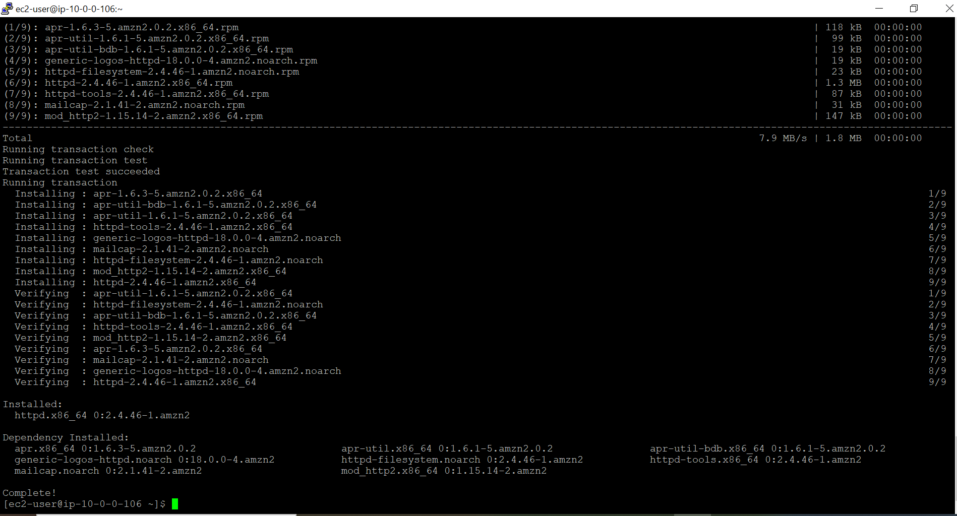

Testing Webserver (successfully launched Apache test page)

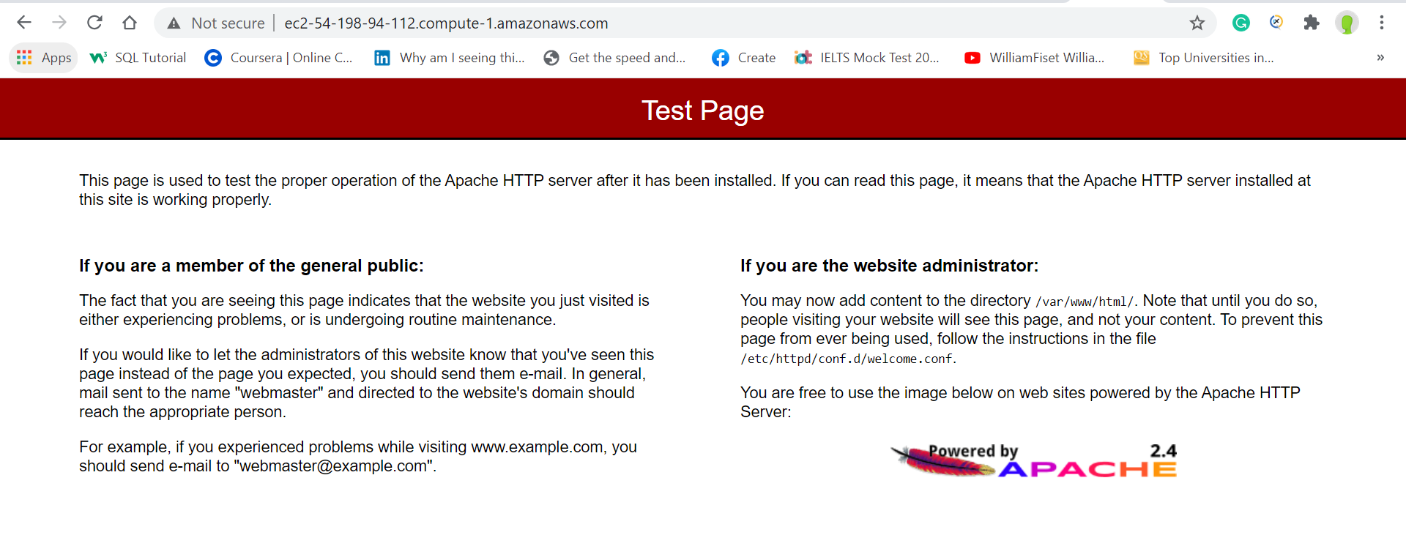

Setting File Permission for Apache (Added www group)

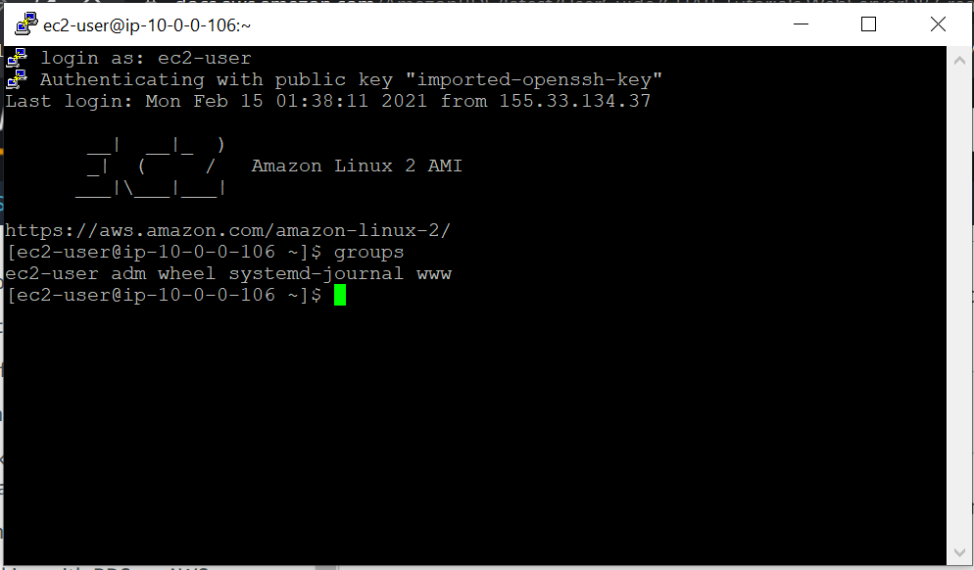

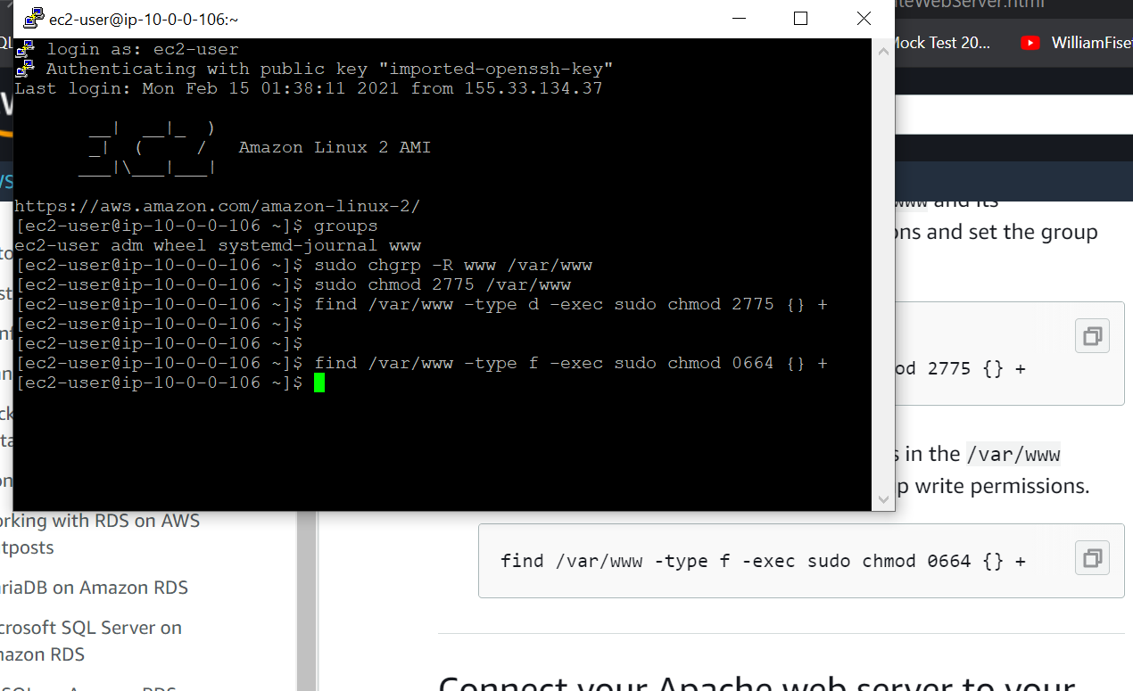

**Public IPv4 DNS**: ec2-54-198-94-112.compute-1.amazonaws.com

Created Data Firehose

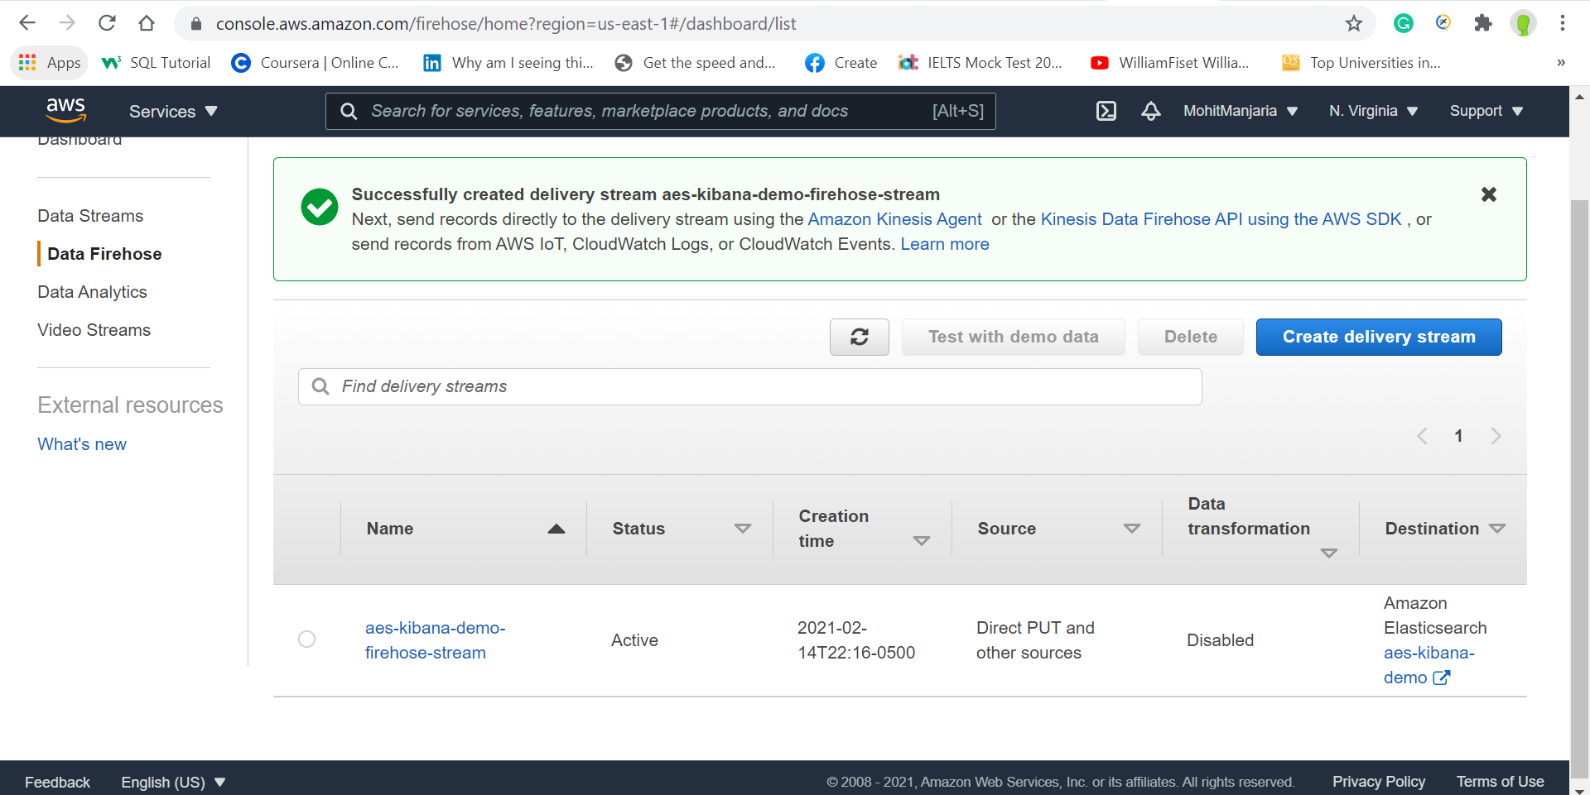

Created Elastic Search

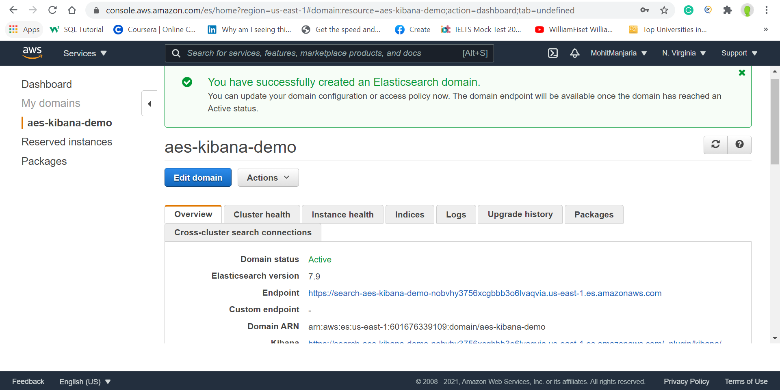

Copied Kibana Entry From ES Cluster: <https://search-aes-kibana-demo-nobvhy3756xcgbbb3o6lvaqvia.us-east-1.es.amazonaws.com/_plugin/kibana/>

**Logged into Kibana:**

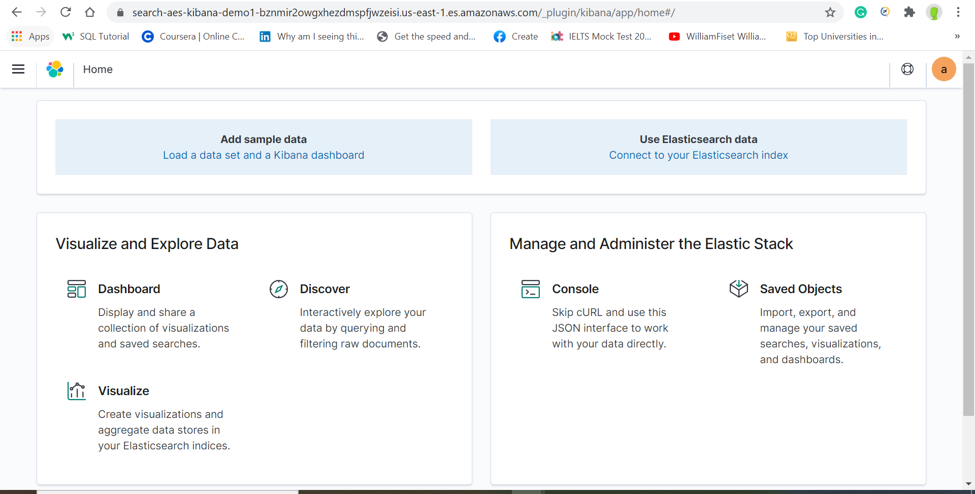

Throwing Error 400 while adding Queries in the Console:

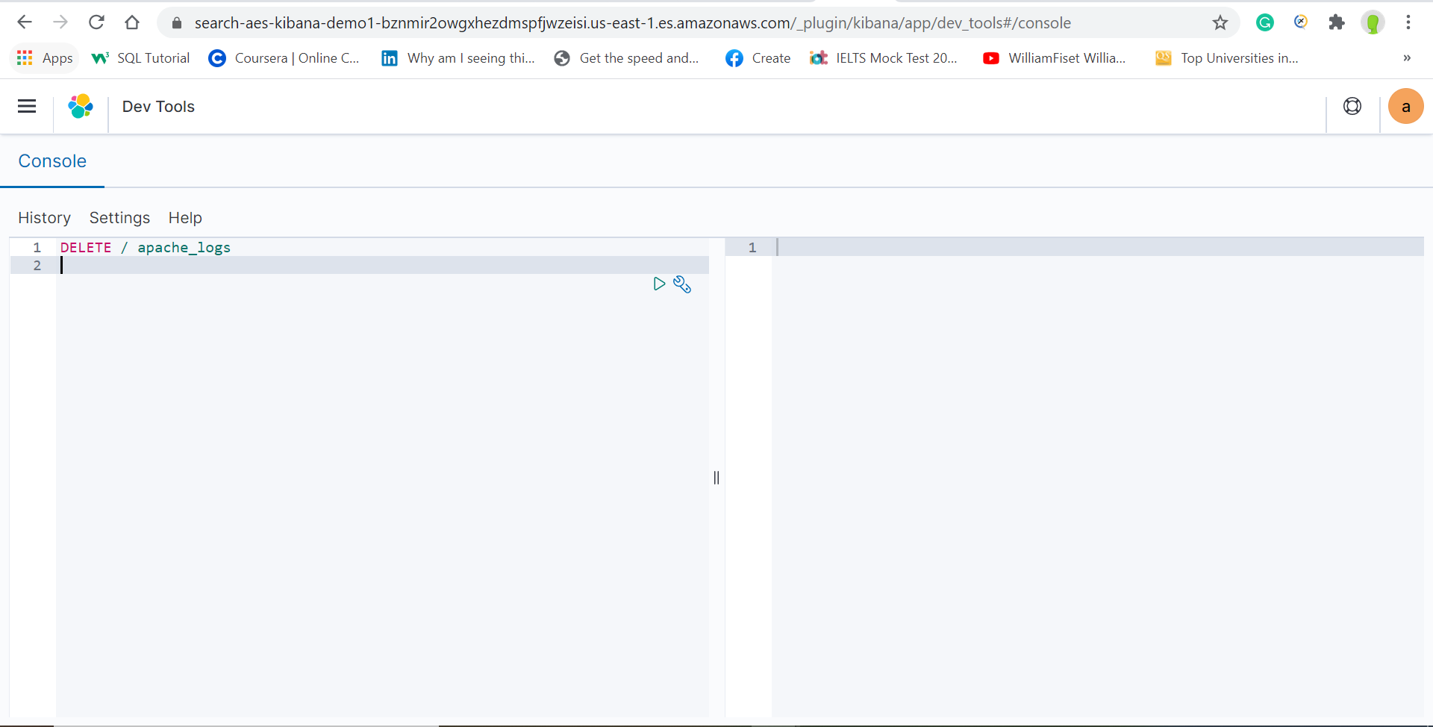

After Refreshing Page Kibana crashed

