**ITC 6460 CLOUD ANALYTICS LAB - 1**

**Faculty: Prof. Sergiy Shevchenko**

**Module 5: LAB 8**

**Date: 22nd February 2021**

**Submitted by:**

Mohit Manjaria

**Task 1: Create a Channel**

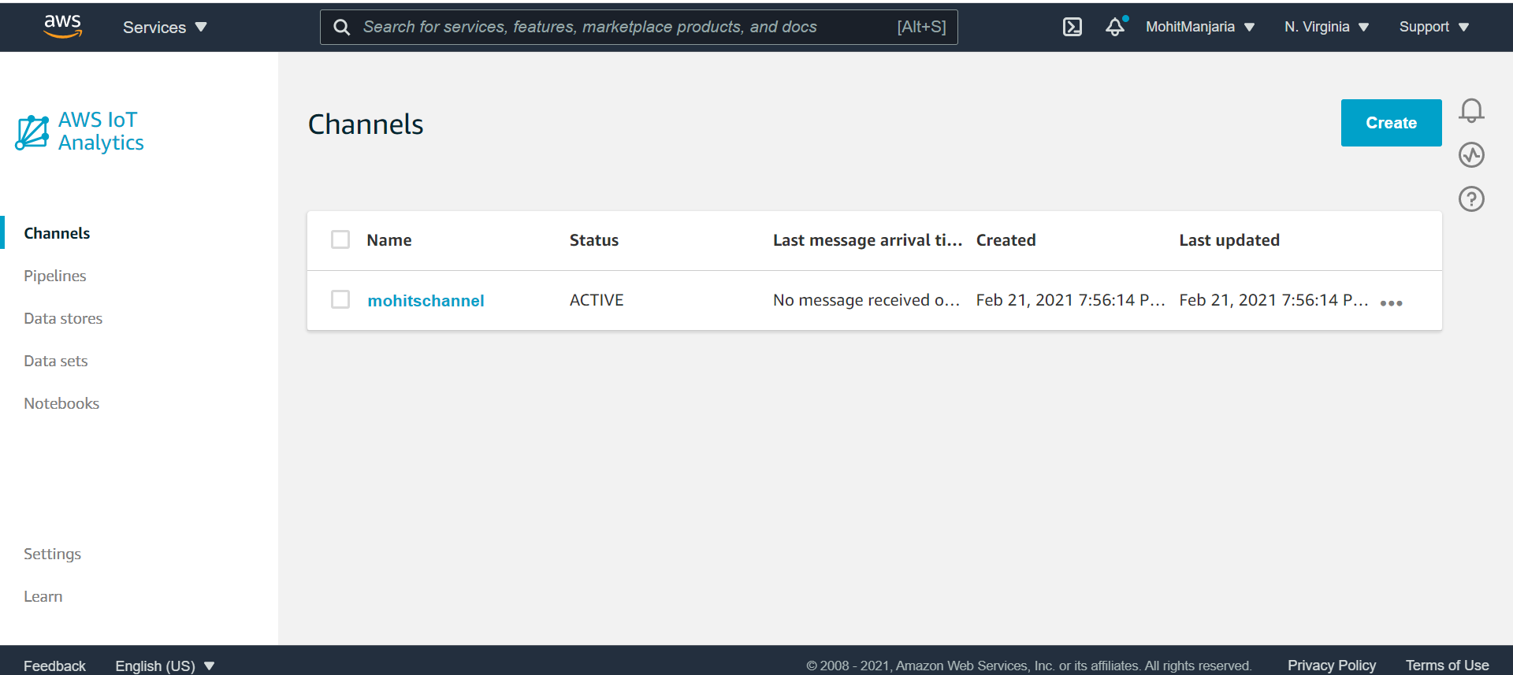

Task 2: Create a data store

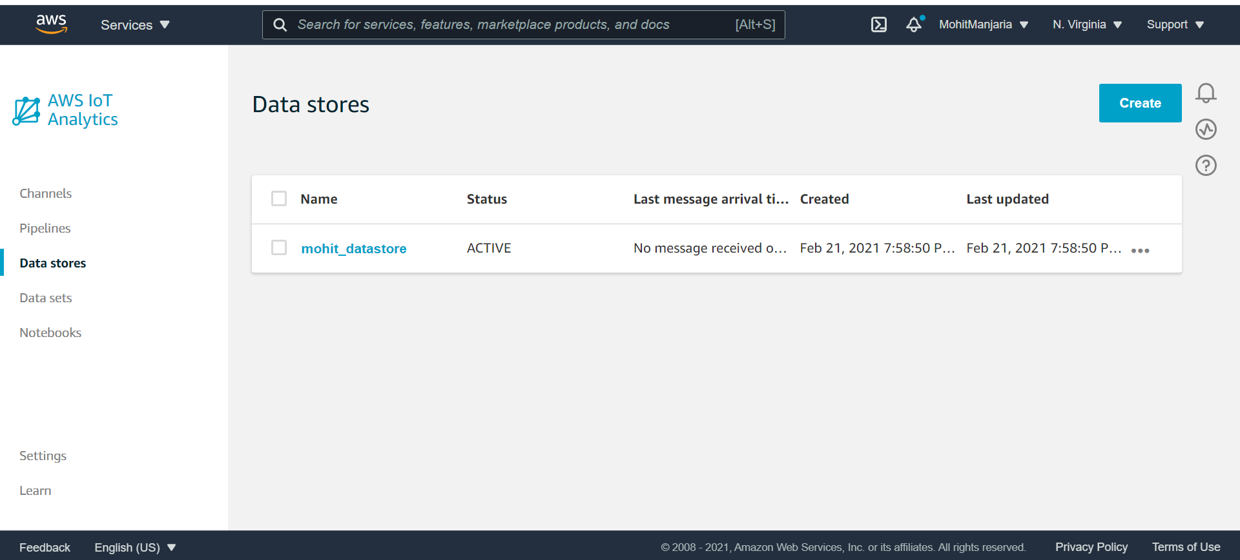

Task 3: Create a pipeline

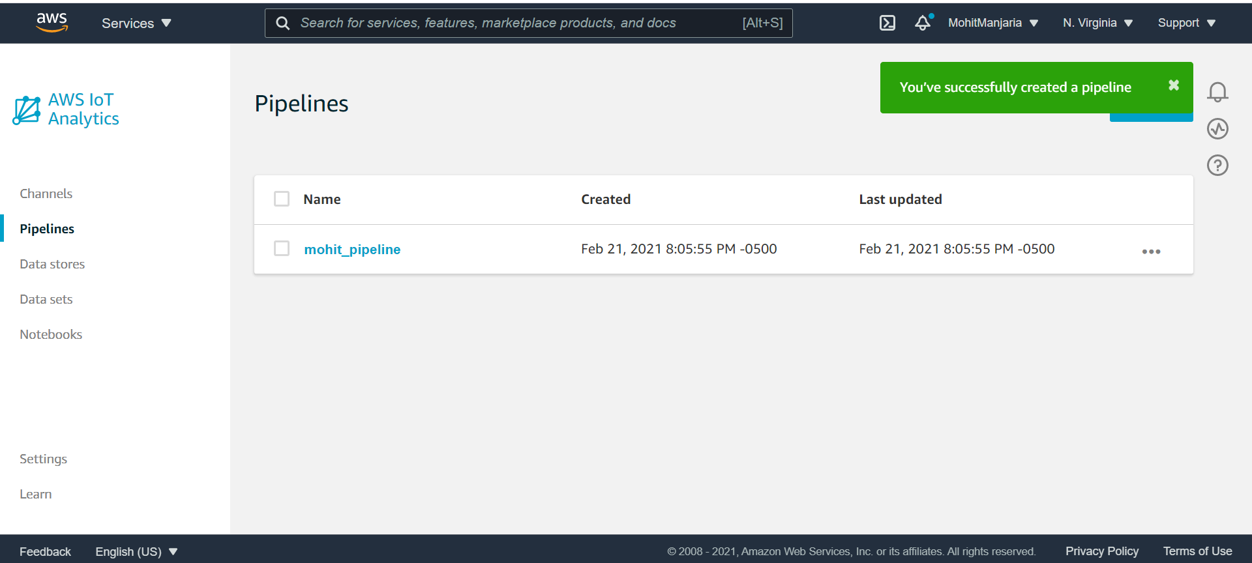

Task 4: Create an AWS IoT Core rule

Task 4.1 Create the AWS IoT Core rule

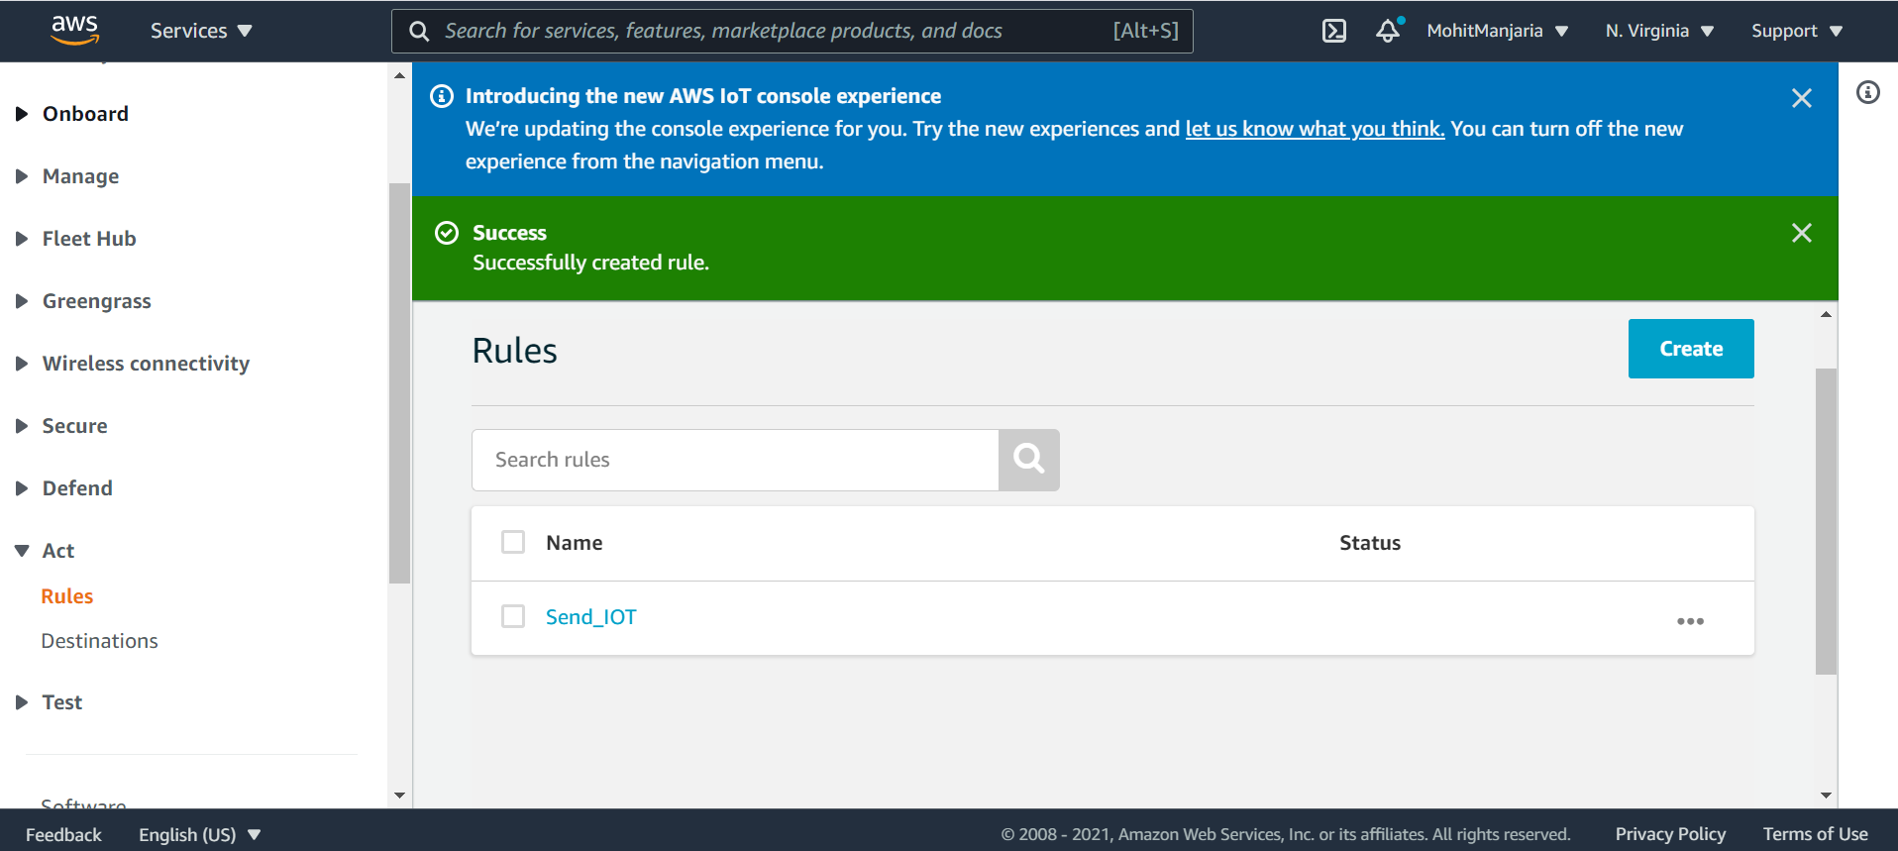

Task 4.2 Configure your environment to run the Python script

Task 4.2.1: Windows users – Use SSH to connect

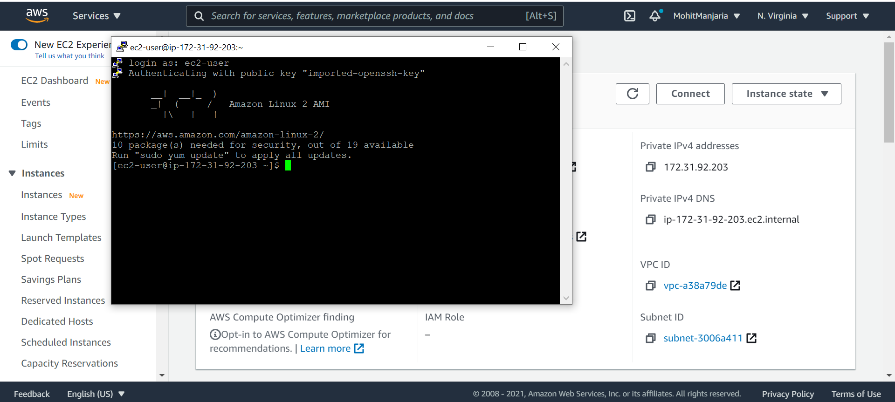

Task 4.2.2: macOS and Linux users

Task 4.3: Configure the Amazon EC2 environment

Task 4.3.1: Set the AWS CLI credentials

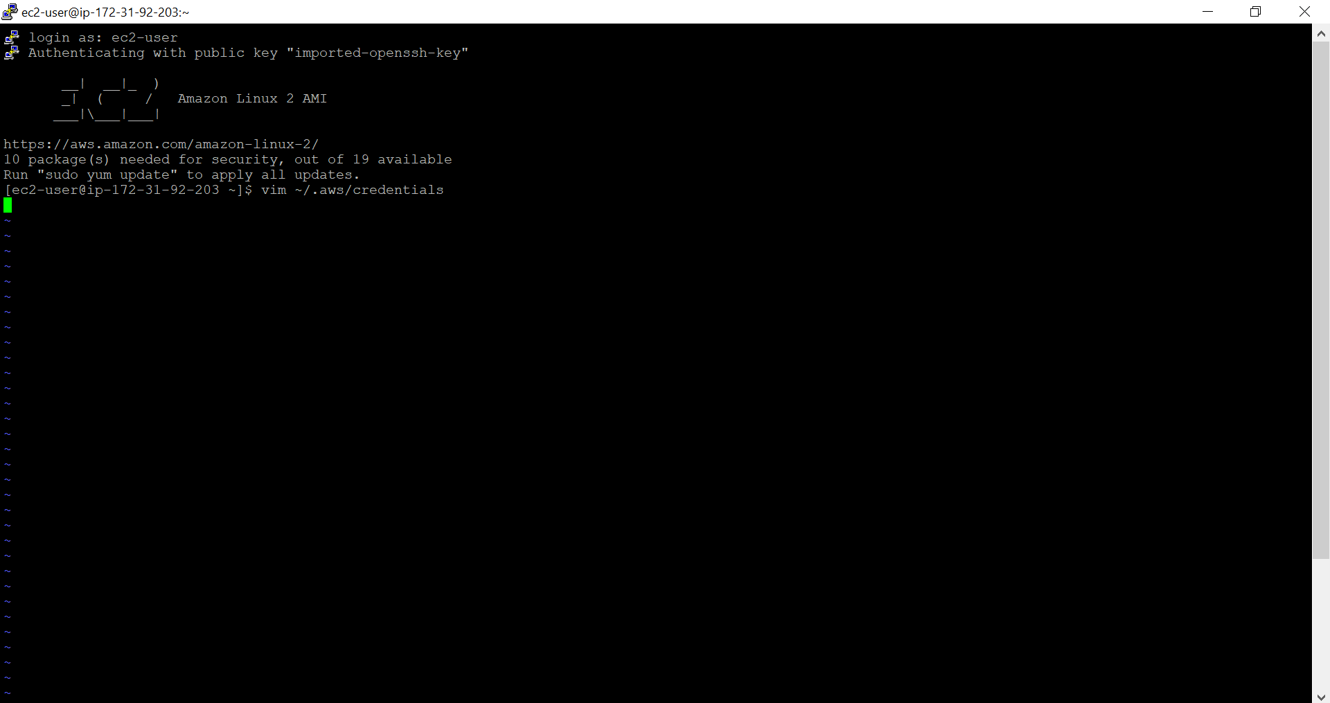

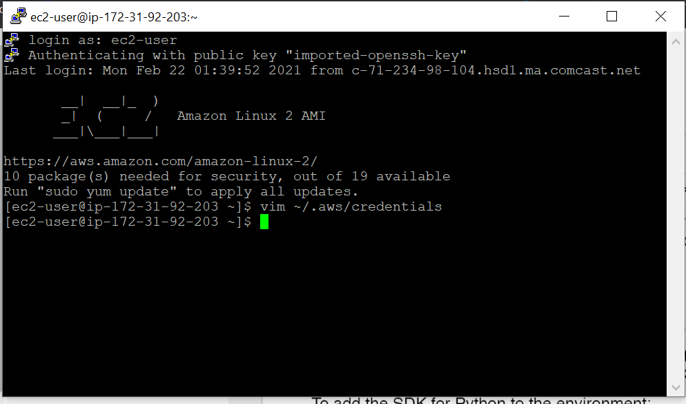

Task 4.3.2: Install the AWS SDK for Python (boto)

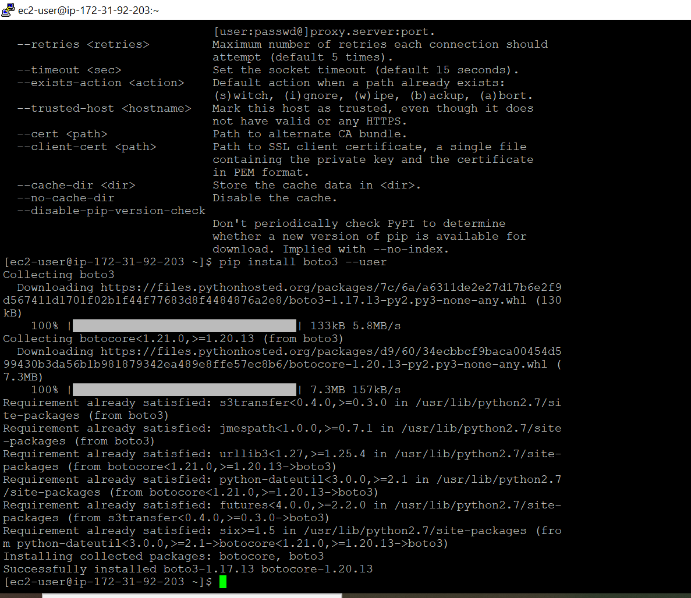

Task 4.3.3 : Download the dataset

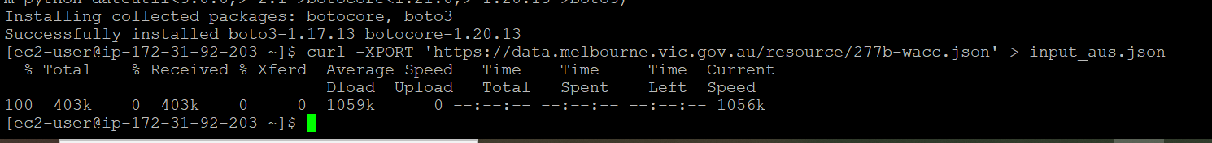



Task 4.4: Create the Python script

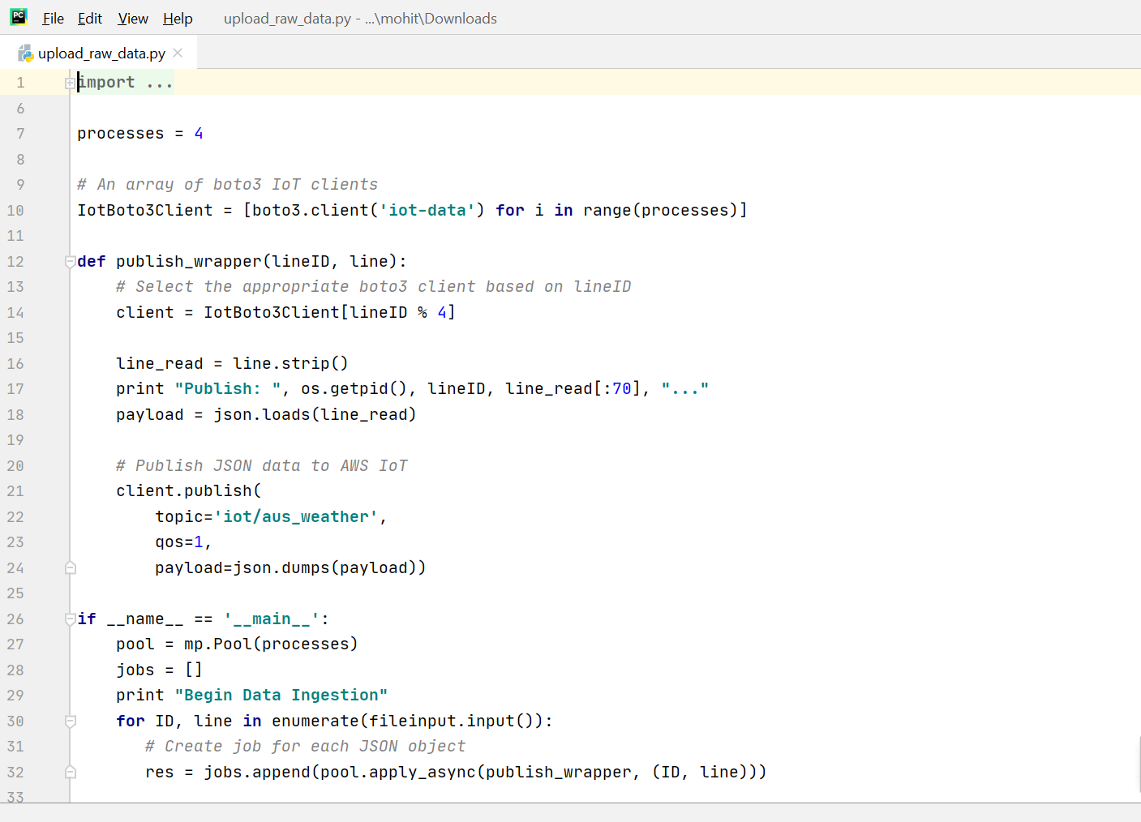



Task 5: Create a dataset

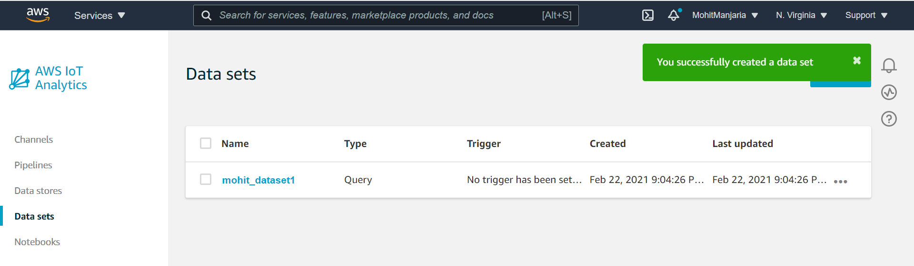

Task 5.1: Load the data to the MQTT topic

JQ File not found

Task 6: Access the query results in your dataset

Task 6.1: Check that the messages have finished publishing

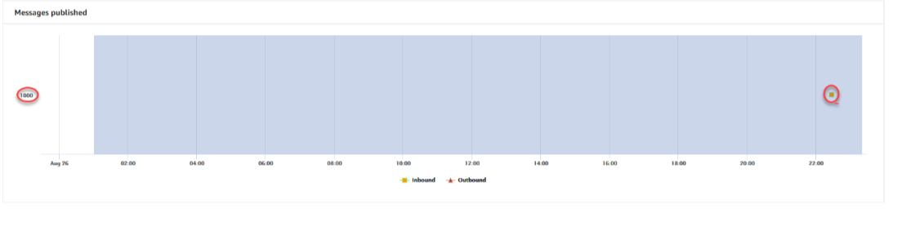

Task 6.2: Access the query results

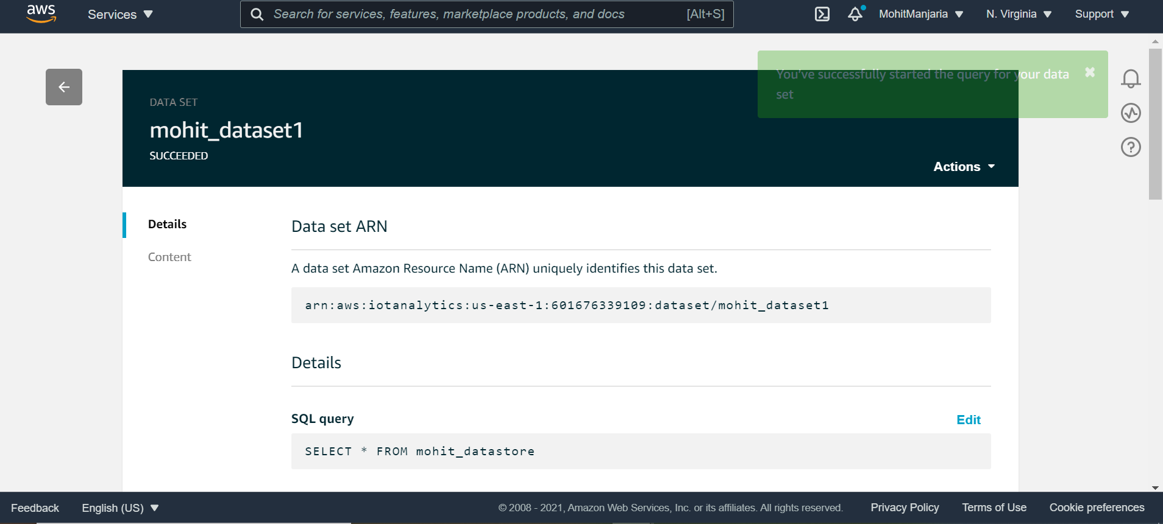

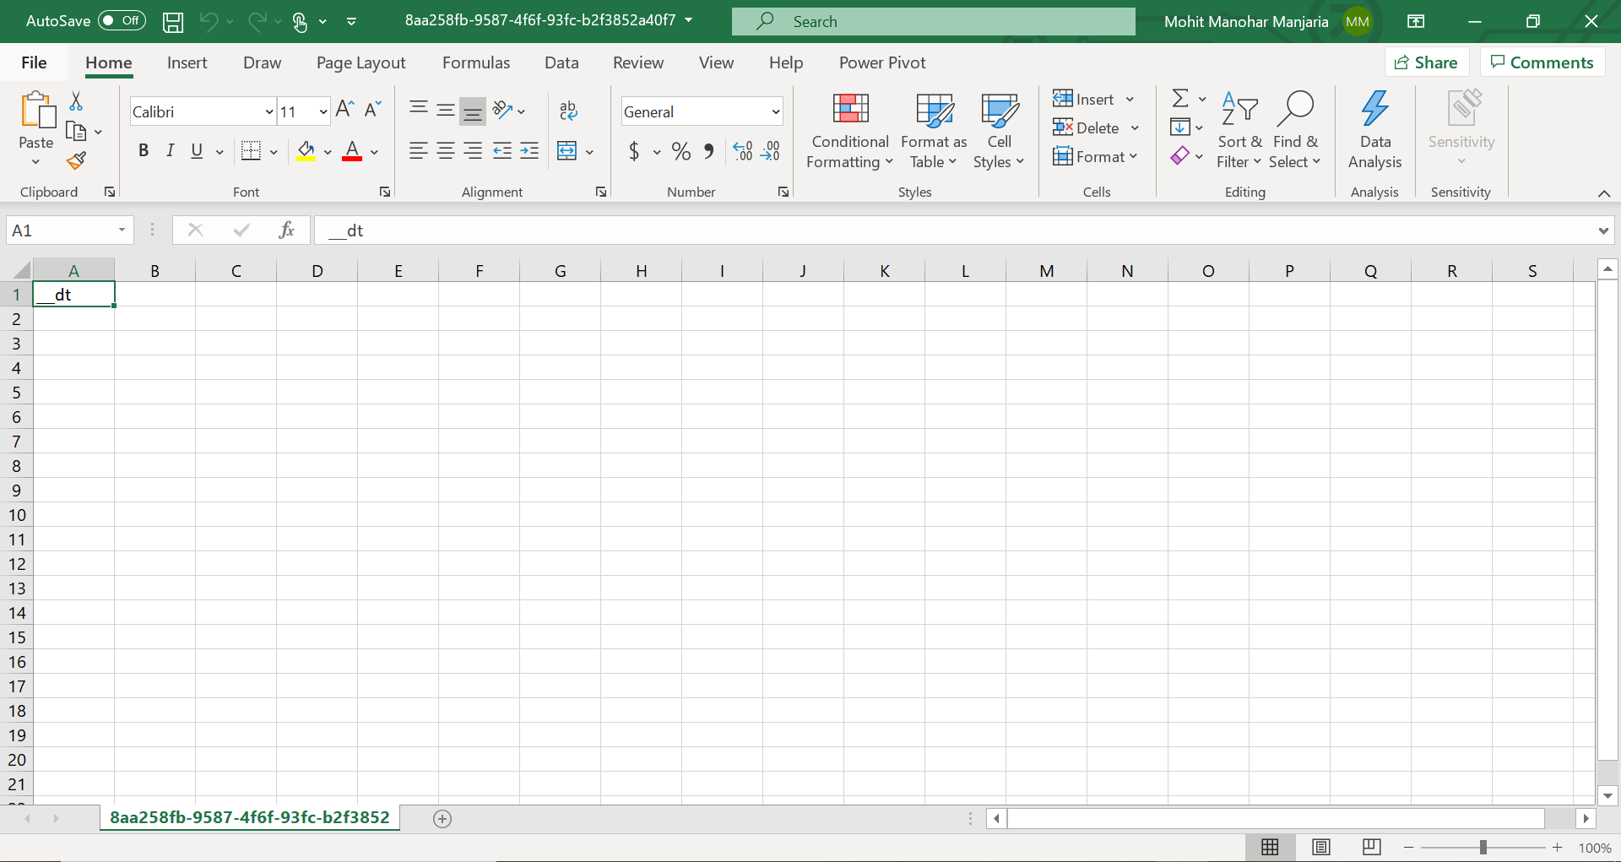

Task 7: Query the dataset

Task 7.1 Create a dataset to find the average maximum temperature

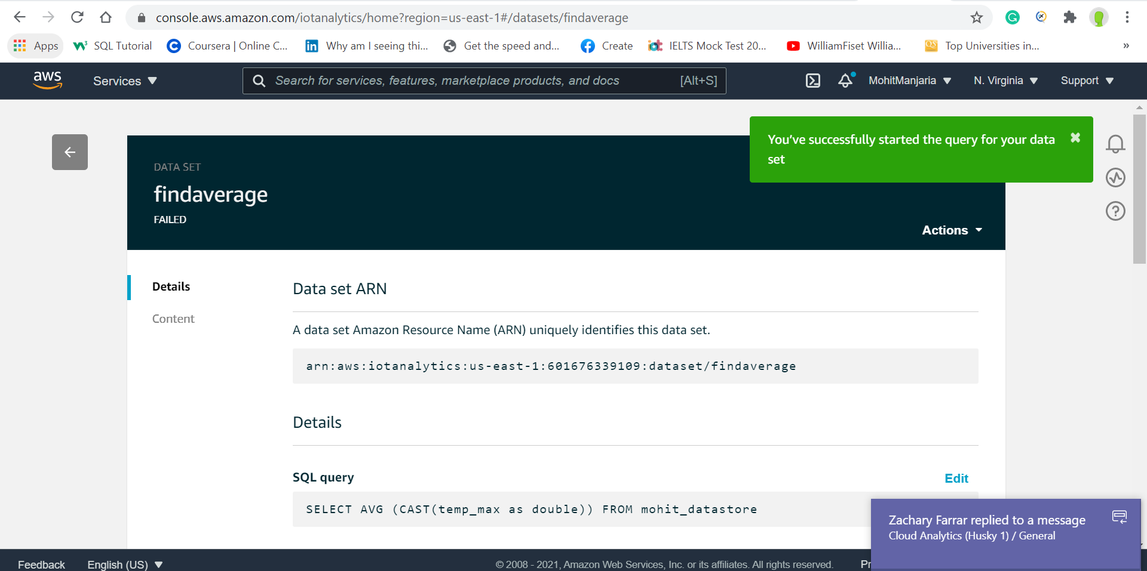

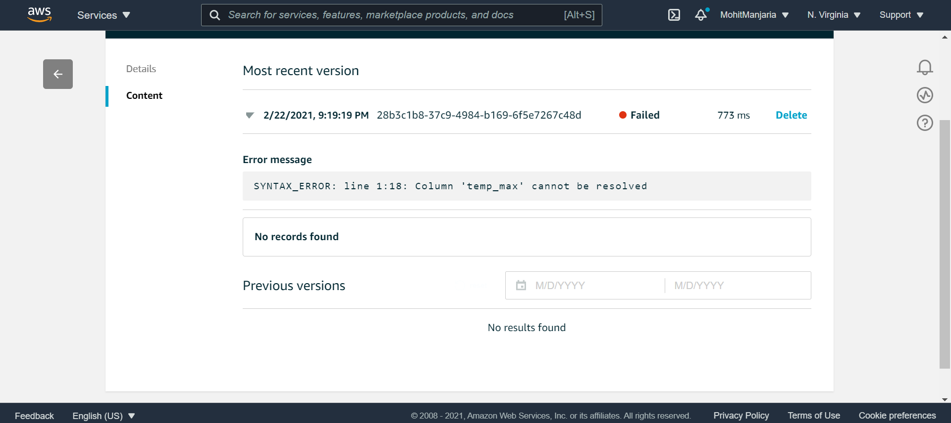

Lab complete